Supplementary Figure 1. Selection of the study population from the National Health and Nutrition Examination Survey (NHANES) from 2003 to 2018.
Supplementary Figure 2. Association of healthy LCD and unhealthy LCD scores (per 5-point increase) with insulin and HOMA-IR by subgroups.
Supplementary Figure 3. Association of healthy LCD and unhealthy LCD scores (per 5-point increase) with CRP by subgroups.
Supplementary Figure 4. Association of healthy LCD and unhealthy LCD scores (per 5-point increase) with HDL-C and LDL-C by subgroups.
Supplementary Table 1. Development of the low-carbohydrate diet scores.
Supplementary Table 2. Age-adjusted characteristics of the participants by quartiles of overall, plant-based, and animal-based LCD scores.
Supplementary Table 3. Percentage change (%) and 95% confidence interval in plasma markers on metabolic profile by quartiles of overall, plant-based, and animal-based LCD scores.
Supplementary Table 4. Percentage change (%) and 95% confidence interval in plasma markers on lipid profile by quartiles of overall, plant-based, and animal-based LCD scores.
Supplementary Table 5. Percentage change (%) and 95% confidence interval in plasma markers on metabolic profile by quartiles of healthy and unhealthy LCD scores among participants who are free of major cardiovascular diseases.
Supplementary Table 6. Percentage change (%) and 95% confidence interval in plasma markers on lipid profile by quartiles of healthy and unhealthy LCD scores among participants who are free of major cardiovascular diseases.
Supplementary Table 7. Percentage change (%) and 95% confidence interval in plasma markers of cardiometabolic risk by percentage of energy from carbohydrates in the NHANES (2003-2018).

Supplementary Figure 1. Selection of the study population from the National Health and Nutrition Examination Survey (NHANES) from 2003 to 2018
Individuals were excluded if they had only single 24-h dietary recall (n=4,654) or had missing data of all biomarkers (n=1,277)
Individuals were excluded if they had no data on each individual plasma biomarker in the corresponding analysis
Individuals were excluded if they had missing dietary data (n=5,294) or had implausible energy intake (n=1,753)
Individuals were excluded if they were younger than 18 years older (n=32,549)
NHANES 2003-2018
(n=80,312)
n=47,763
n=40,716
n=34,785
Insulin-resistant biomarker
Insulin (n=16,524)
C-peptide (n=2,042)
HOMA-IR (n=16.504)

Cardiometablic biomarker
TG (n=16,586)
TC (n=34,359)
HDL-C (n=30,150)
LDL-C (n=16,301)
ApoB (n=12,636)

Inflammatory biomarker
CRP (n=23,169)

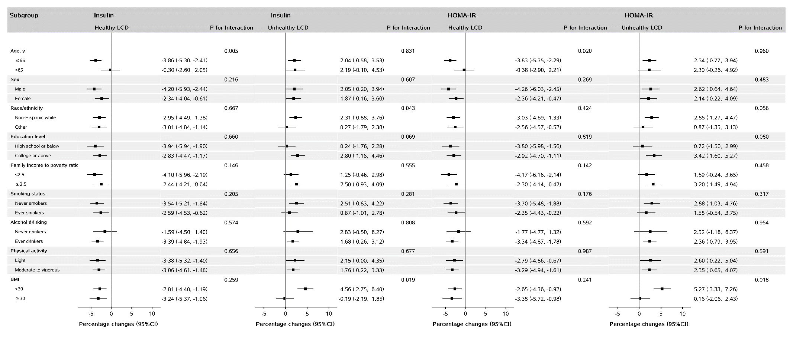 Supplementary Figure 2. Association of healthy LCD and unhealthy LCD scores (per 5-point increase) with insulin and HOMA-IR by subgroups*
* Covariates in the models were adjusted for age (18-29, 30-39, 40-49, 50-59, and ≥ 60 years), sex (male, female), total energy intake (kcal/day, tertile), race/ethnicity (non-Hispanic white, non-Hispanic black, or other races), education (≤ 12th grade, high school graduate, or more than high school), marital status (married, widowed/divorced/separated, or never married), ratio of family income to poverty (<1.30, 1.30-3.49, or ≥3.50), physical activity (<8.3, 8.3-16.7, or >16.7 METS-h/week), smoking (never smoker, former smoker, or current smoker), alcohol drinking (never drinker, former drinker, or current drinker), hypertension (yes/no), diabetes (yes/no), cancer (yes/no), CVD (yes/no), family history of CVD (yes/no), family history of diabetes (yes/no), BMI (<18.5, 18.5-24.9, 25.0-29.9, and ≥30.0), and survey cycle (assigned values from 1 to 8). Linear trend test was conducted by treating each LCD as a continuous variable in the models.
Abbreviations: BMI, body mass index; CI, Confidence interval; LCD, Low-carbohydrate diet; METS, Metabolic equivalent tasks; NHANES, National Health and Nutrition Examination Survey; HOMA-IR, Homeostatic Model Assessment of Insulin Resistance; CVD, cardiovascular disease.

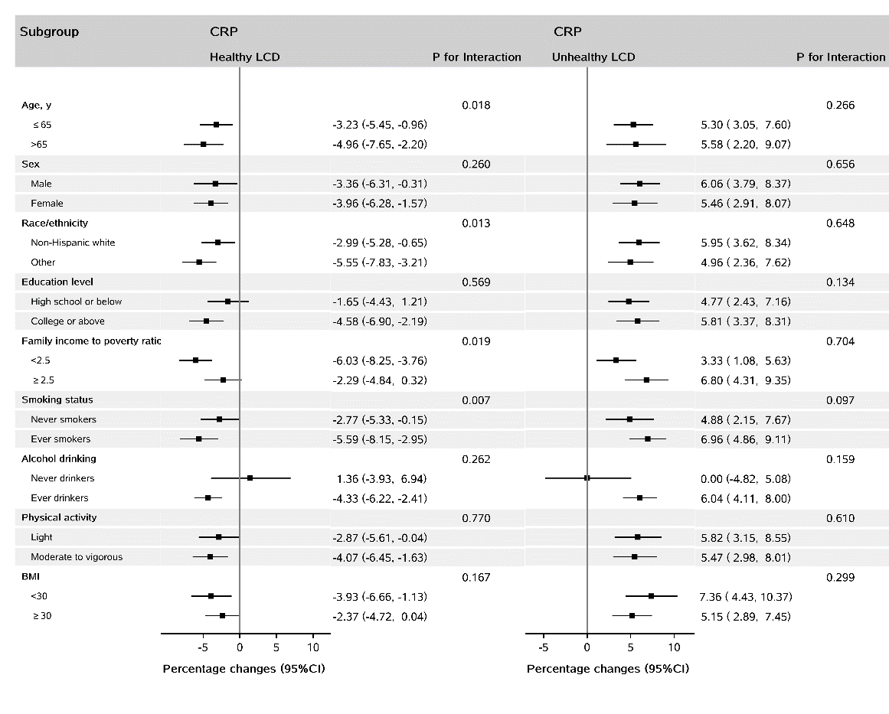
Supplementary Figure 3. Association of healthy LCD and unhealthy LCD scores (per 5-point increase) with CRP by subgroups*
* Covariates in the models were adjusted for age (18-29, 30-39, 40-49, 50-59, and ≥ 60 years), sex (male, female), total energy intake (kcal/day, tertile), race/ethnicity (non-Hispanic white, non-Hispanic black, or other races), education (≤ 12th grade, high school graduate, or more than high school), marital status (married, widowed/divorced/separated, or never married), ratio of family income to poverty (<1.30, 1.30-3.49, or ≥3.50), physical activity (<8.3, 8.3-16.7, or >16.7 METS-h/week), smoking (never smoker, former smoker, or current smoker), alcohol drinking (never drinker, former drinker, or current drinker), hypertension (yes/no), diabetes (yes/no), cancer (yes/no), CVD (yes/no), aspirin use (yes/no), family history of CVD (yes/no), family history of diabetes (yes/no), BMI (<18.5, 18.5-24.9, 25.0-29.9, and ≥30.0), and survey cycle (assigned values from 1 to 8). Linear trend test was conducted by treating each LCD as a continuous variable in the models.
Abbreviations: BMI, body mass index; CI, Confidence interval; LCD, Low-carbohydrate diet; METS, Metabolic equivalent tasks; NHANES, National Health and Nutrition Examination Survey; CRP, C-reactive protein; CVD, cardiovascular disease.

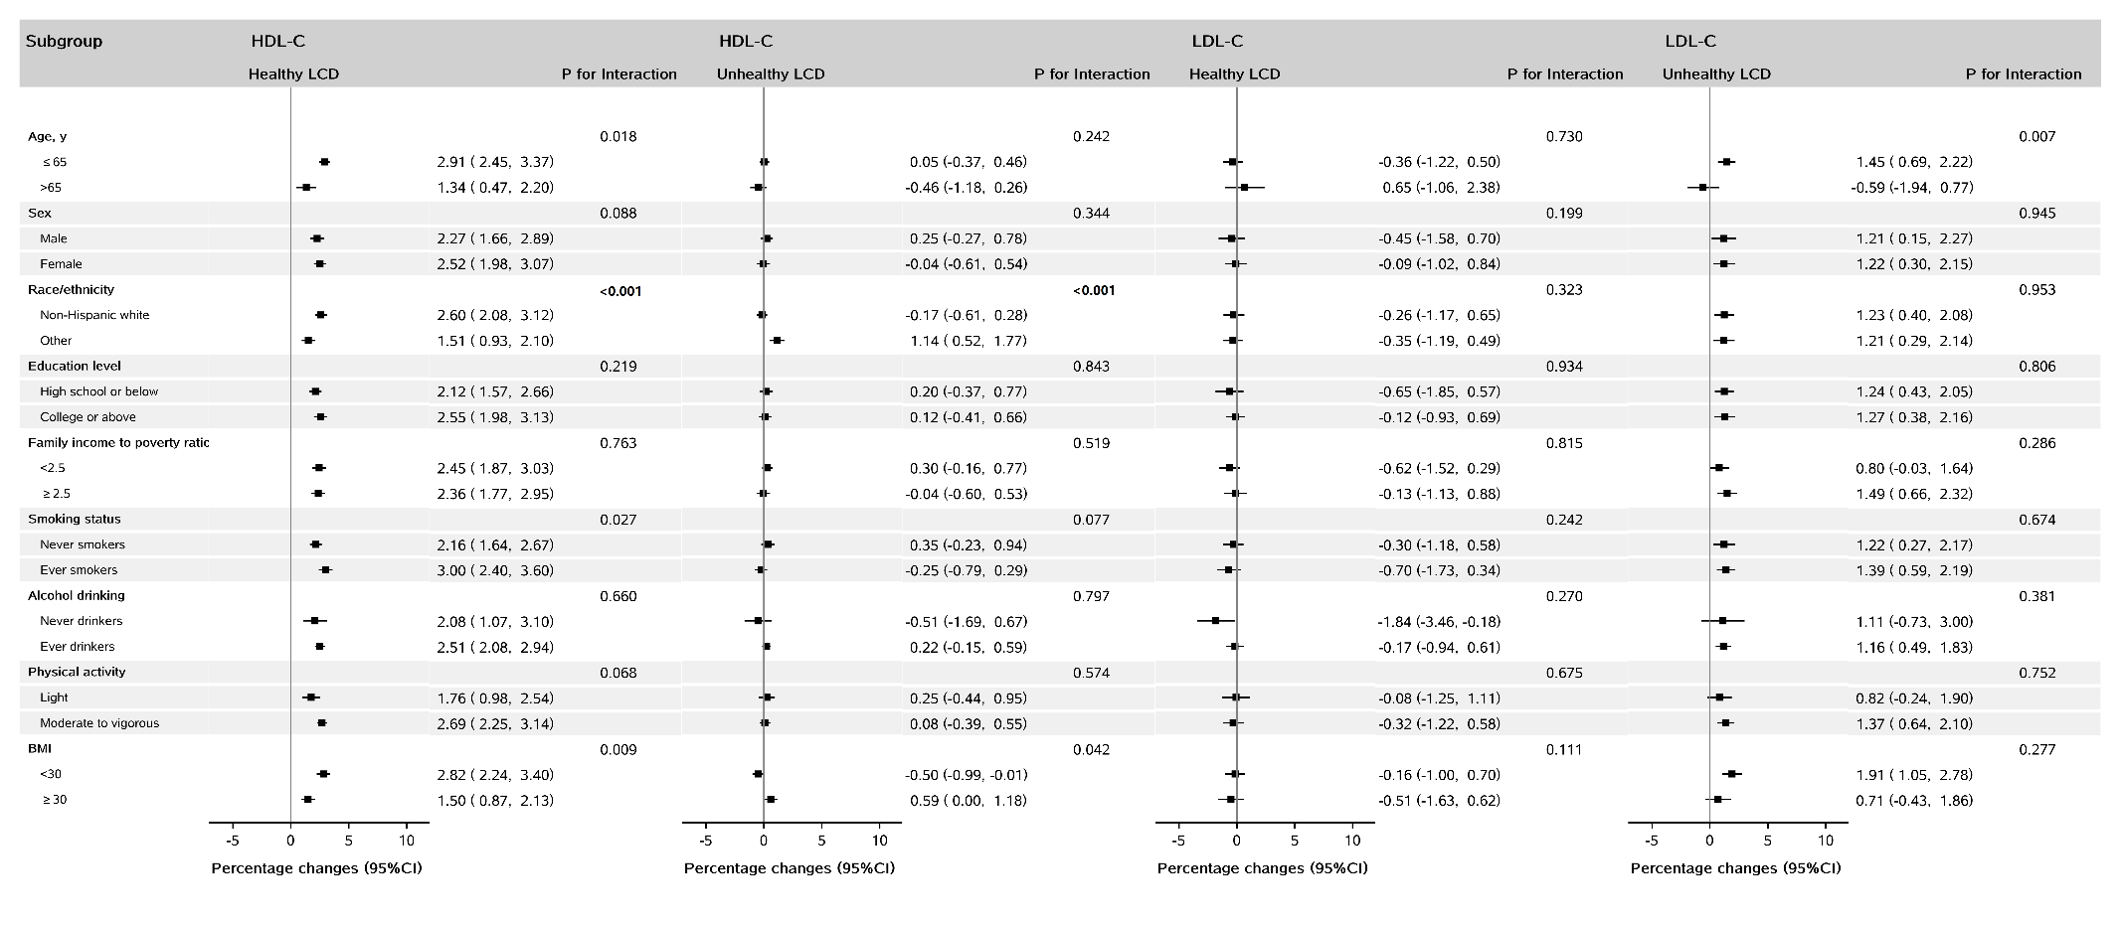
Supplementary Figure 4. Association of healthy LCD and unhealthy LCD scores (per 5-point increase) with HDL-C and LDL-C by subgroups*
* Covariates in the models were adjusted for age (18-29, 30-39, 40-49, 50-59, and ≥ 60 years), sex (male, female), total energy intake (kcal/day, tertile), race/ethnicity (non-Hispanic white, non-Hispanic black, or other races), education (≤ 12th grade, high school graduate, or more than high school), marital status (married, widowed/divorced/separated, or never married), ratio of family income to poverty (<1.30, 1.30-3.49, or ≥3.50), physical activity (<8.3, 8.3-16.7, or >16.7 METS-h/week), smoking (never smoker, former smoker, or current smoker), alcohol drinking (never drinker, former drinker, or current drinker), hypertension (yes/no), diabetes (yes/no), cancer (yes/no), CVD (yes/no), family history of CVD (yes/no), family history of diabetes (yes/no), BMI (<18.5, 18.5-24.9, 25.0-29.9, and ≥30.0), and survey cycle (assigned values from 1 to 8). Linear trend test was conducted by treating each LCD as a continuous variable in the models. P values lower than Bonferroni-corrected significance level of 0.0001 were highlighted in bold.
Abbreviations: BMI, body mass index; CI, Confidence interval; LCD, Low-carbohydrate diet; METS, Metabolic equivalent tasks; NHANES, National Health and Nutrition Examination Survey; HDL-C, high-density lipoprotein cholesterol; LDL-C, low-density lipoprotein cholesterol; CVD, cardiovascular disease.

Supplementary Table 1. Development of the low-carbohydrate diet scores
Points | Overall LCD score |  |  | Healthy LCD score |  |  | Unhealthy LCD score |  |  | Animal-based LCD score |  |  | Plant-based LCD score
 | Total carbohydrate | Total fat | Total protein | Low-quality carbohydrate | Unsaturated  fat | Plant  protein | High-quality carbohydrate | Saturated fat | Animal  protein | Total carbohydrate | Animal  fat | Animal  protein | Total carbohydrate | Plant fat | Plant  protein
0 | RS | PS | PS | RS | PS | PS | RS | PS | PS | RS | PS | PS | RS | PS | PS
1
2
3
4
5
6
7
8
9
10
LCD, Low-carbohydrate diet.
Participants were divided into 11 sex-specific strata by percentage of energy from carbohydrate, protein, and fat.
Reverse scoring (RS): Score from 10 (the lowest stratum) to 0 (the highest stratum).
Positive scoring (PS): Score from 0 (the lowest stratum) to 10 (the highest stratum).
High-quality carbohydrate: Carbohydrate from non-starchy vegetables, whole fruit, whole grains, and legumes.
Low-quality carbohydrate: Carbohydrate from potato, other starchy vegetables, fruit juice, refined grains, and other sources.
Unsaturated fatty acids: Monounsaturated fat and polyunsaturated fat.
Plant protein: Protein from legumes, nuts, seeds, grains, fruits, vegetables, and other plant sources.
Animal protein: Protein from dairy products, meat, poultry, fish/seafood, egg, and other animal sources.

Supplementary Table 2. Age-adjusted characteristics of the participants by quartiles of overall, plant-based, and animal-based LCD scores*
 | Overall LCD |  |  | Plant-based LCD |  |  | Animal-based LCD
 | Quartile 1 | Quartile 4 |  | Quartile 1 | Quartile 4 |  | Quartile 1 | Quartile 4
Median score (IQR) | 6.0 (3.0, 8.0) | 24.0 (22.0, 26.0) |  | 8.0 (5.0, 9.0) | 23.0 (21.0, 25.0) |  | 5.0 (3.0, 7.0) | 25.0 (23.0, 27.0)
Age, years | 47.0 (19.7) | 49.2 (18.0) |  | 47.4 (19.5) | 47.4 (18.0) |  | 47.1 (19.2) | 49.1 (18.1)
Female, % | 52.8 | 53.2 |  | 53.6 | 53.7 |  | 52.7 | 52.8
BMI, kg/m² | 28.4 (6.6) | 30.0 (7.3) |  | 29.2(7.1) | 29.1(6.8) |  | 28.1(6.4) | 30.1(7.4)
Diabetes, % | 12.7 | 20.1 |  | 14.7 | 17.4 |  | 13.3 | 19.3
Race/ethnicity, %
Non-Hispanic white | 41.2 | 47.7 |  | 40.3 | 49.0 |  | 41.5 | 45.6
Non-Hispanic black | 20.6 | 22.0 |  | 25.9 | 15.1 |  | 17.3 | 26.3
Mexican American | 18.3 | 14.7 |  | 15.9 | 18.4 |  | 19.9 | 13.0
Other Hispanic | 10.0 | 6.6 |  | 10.2 | 7.3 |  | 9.4 | 6.9
Others | 10.0 | 9.0 |  | 7.7 | 10.3 |  | 11.8 | 8.1
Marital status, %
Married | 56.7 | 57.5 |  | 54.1 | 60.9 |  | 58.4 | 55.7
Widowed/divorced | 22.0 | 20.2 |  | 23.6 | 18.4 |  | 20.7 | 21.6
Never married | 18.1 | 18.4 |  | 18.9 | 17.0 |  | 17.6 | 18.9
Education level, %
≤ 12th grade | 29.7 | 20.4 |  | 30.7 | 19.2 |  | 27.9 | 23.0
High school graduate | 23.4 | 23.9 |  | 26.0 | 21.4 |  | 21.8 | 25.1
College or higher | 46.8 | 55.7 |  | 43.2 | 59.4 |  | 50.3 | 51.9
Physical activity, METS-h/week
<8.3 | 40.0 | 37.7 |  | 42.2 | 35.7 |  | 38.4 | 39.2
8.3-16.7 | 11.3 | 11.2 |  | 11.1 | 11.6 |  | 11.3 | 11.2
>16.7 | 48.1 | 50.6 |  | 46.2 | 52.3 |  | 49.8 | 49.2
Ratio of family income to poverty
<1.30 | 32.9 | 25.3 |  | 35.2 | 23.5 |  | 29.9 | 28.3
1.30-3.49 | 34.7 | 34.9 |  | 35.1 | 34.2 |  | 34.1 | 34.6
≥3.50 | 23.9 | 33.0 |  | 21.3 | 35.4 |  | 27.3 | 29.8
Smoking, %
Never smokers | 53.7 | 52.5 |  | 50.7 | 54.9 |  | 56.5 | 50.6
Former smokers | 21.4 | 26.5 |  | 21.3 | 26.5 |  | 22.1 | 25.4
Current smokers | 19.5 | 17.6 |  | 22.6 | 15.6 |  | 16.7 | 20.3
Alcohol drinking, %
Never drinkers | 16.5 | 10.8 |  | 14.8 | 11.2 |  | 16.9 | 11.1
Former drinkers | 19.5 | 17.3 |  | 20.6 | 15.7 |  | 19.2 | 17.1
Current drinkers | 54.2 | 65.0 |  | 55.0 | 66.7 |  | 55.1 | 64.3
Total energy, kcal/d | 1936.4(705.1) | 1987.5(700.8) |  | 1876.5(695.6) | 2110.8(709.3) |  | 1988.5(718.8) | 1934.4(693.5)
Macronutrient (% total energy intake)

Total carbohydrate | 60.3(5.8) | 39.0(5.6) |  | 54.9(9.1) | 44.2(6.9) |  | 58.6(7.0) | 39.8(6.5)
High-quality carbohydrate | 15.2(12.1) | 8.9(6.9) |  | 12.7(10.7) | 10.3(8.1) |  | 15.2(12.0) | 8.9(7.1)
Low-quality carbohydrate | 45.1(11.8) | 30.1(7.7) |  | 42.2(11.6) | 33.9(9.1) |  | 43.4(11.9) | 30.9(8.4)
Total protein | 12.9(2.6) | 19.2(4.0) |  | 15.6(4.4) | 16.2(3.7) |  | 13.0(2.8) | 19.5(4.3)
Animal protein | 6.5(3.0) | 13.1(5.0) |  | 11.3(4.7) | 7.6(4.0) |  | 5.0(2.3) | 14.9(4.2)
Plant protein | 6.1(2.4) | 5.7(2.7) |  | 4.0(1.5) | 8.3(2.3) |  | 7.7(2.6) | 4.3(1.8)
Total fat | 26.8(5.1) | 40.8(5.5) |  | 29.2(6.7) | 38.6(6.2) |  | 29.0(6.4) | 38.9(6.5)
Saturated fat | 8.6(2.4) | 13.2(3.0) |  | 9.8(3.1) | 12.2(2.9) |  | 9.1(2.7) | 12.8(3.1)
Unsaturated fat | 15.7(3.6) | 24.0(4.5) |  | 16.6(4.2) | 23.1(5.0) |  | 17.3(4.5) | 22.5(4.7)
Monounsaturated  fat | 9.5(2.2) | 14.9(2.8) |  | 10.4(2.8) | 14.1(3.0) |  | 10.3(2.8) | 14.1(2.9)
Polyunsaturated | 6.2(2.0) | 9.1(3.0) |  | 6.3(2.2) | 9.0(2.9) |  | 7.0(2.4) | 8.4(2.9)
* Continuous variables were presented as means (SD) if they were normally distributed, otherwise median (IQR) estimate was used. All variables were standardized to the age distribution of the study population except for age and LCD scores. Of note, the summing proportions for some categories are not 100% due to missing values or rounding.
Abbreviations: IQR, Interquartile range; LCD, Low-carbohydrate diet; METS, Metabolic equivalent tasks; NHANES, National Health and Nutrition Examination Survey.

Supplementary Table 3. Percentage change (%) and 95% confidence interval in plasma markers on metabolic profile by quartiles of overall, plant-based, and animal-based LCD scores
 | Quartiles |  |  |  | Per 5-point increase | P_{trend} ‡
 | 1 | 2 | 3 | 4
Overall LCD
Insulin (n=16,524)
Model 1 * | Reference | -0.66 (-4.31, 3.14) | 3.06 (-0.71, 6.96) | 3.49 (-0.87, 8.04) | 1.15 (0.07, 2.24) | 0.037
Model 2 † | Reference | -2.59 (-5.87, 0.81) | -0.72 (-4.06, 2.75) | -5.55 (-8.92, -2.06) | -1.16 (-2.06, -0.24) | 0.014
C-peptide (n=2,042)
Model 1 * | Reference | 2.20 (-7.60, 13.04) | -7.72 (-14.46, -0.46) | 2.80 (-7.17, 13.84) | 0.16 (-2.57, 2.97) | 0.910
Model 2 † | Reference | 1.77 (-6.10, 10.30) | -8.46 (-14.88, -1.54) | -4.15 (-11.97, 4.36) | -1.59 (-3.60, 0.46) | 0.127
HOMA-IR (n=16,504)
Model 1 * | Reference | -0.84 (-4.62, 3.10) | 3.25 (-0.62, 7.28) | 4.49 (-0.09, 9.27) | 1.51 (0.33, 2.70) | 0.012
Model 2 † | Reference | -2.89 (-6.28, 0.62) | -0.56 (-4.10, 3.11) | -5.01 (-5.58, -1.30) | -0.93 (-1.92, 0.07) | 0.069
CRP (n=23,169)
Model 1 * | Reference | -0.67 (-5.94, 4.90) | 3.71 (-2.87, 10.74) | 11.95 (5.72, 18.56) | 3.19 (1.65, 4.76) | <0.001
Model 2 † | Reference | -0.16 (-5.34, 5.30) | -1.22 (-7.12, 5.05) | 2.47 (-2.90, 8.13) | 0.60 (-0.80, 2.01) | 0.402
Plant-based LCD
Insulin (n=16,524)
Model 1 * | Reference | -2.39 (-6.92, 2.35) | -1.47 (-5.64, 2.88) | -0.47 (-5.22, 4.52) | -0.32 (-1.68, 1.06) | 0.648
Model 2 † | Reference | -4.02 (-7.62, 0.29) | -2.57 (-6.06, 1.04) | -3.04 (-6.98, 1.06) | -0.93 (-2.09, 0.24) | 0.118
C-peptide (n=2,042)
Model 1 * | Reference | -6.84 (-15.10, 2.22) | -2.29 (-9.43, 5.40) | 1.14 (-6.20, 9.06) | 0.40 (-1.95, 2.80) | 0.742
Model 2 † | Reference | -8.03 (-16.05, 0.76) | -2.86 (-9.85, 4.66) | 0.47 (-4.48, 5.68) | 0.39 (-1.49, 2.30) | 0.687
HOMA-IR (n=16,504)
Model 1 * | Reference | -2.52 (-7.36, 2.57) | -1.70 (-6.01, 2.81) | -0.67 (-5.68, 4.60) | -0.34 (-1.77, 1.12) | 0.644
Model 2 † | Reference | -4.26 (-8.10, -0.26) | -2.81 (-6.42, 0.95) | -3.47 (-7.65, 0.91) | -1.00 (-2.24, 0.26) | 0.117
CRP (n=23,169)
Model 1 * | Reference | -4.81 (-9.78, 0.42) | -9.67 (-14.07, -5.06) | -5.73 (-10.69, -0.48) | -1.78 (-3.46, -0.07) | 0.042
Model 2 † | Reference | -4.24 (-8.78, 0.54) | -9.17 (-13.30, -4.84) | -6.05 (-10.47, -1.41) | -1.90 (-3.39, -0.39) | 0.014
Animal-based LCD
Insulin (n=16,524)
Model 1 * | Reference | 2.66 (-1.47, 6.96) | 1.72 (-2.63, 6.26) | 3.32 (-1.44, 8.31) | 0.95 (-0.11, 2.03) | 0.079
Model 2 † | Reference | -0.56 (-4.21, 3.23) | -1.39 (-4.96, 2.31) | -5.35 (-9.20, -1.33) | -0.96 (-1.86, -0.05) | 0.039
C-peptide (n=2,042)
Model 1 * | Reference | -4.06 (-10.83, 3.22) | -0.65 (-6.98, 6.11) | -1.47 (-12.07, 10.42) | 0.23 (-2.22, 2.73) | 0.856
Model 2 † | Reference | -5.01 (-11.12, 1.53) | -1.61 (-8.06, 5.30) | -8.11 (-15.91, 0.41) | -1.55 (-3.37, 0.30) | 0.099
HOMA-IR (n=16,504)
Model 1 * | Reference | 3.21 (-1.23, 7.85) | 2.21 (-2.51, 7.15) | 5.05 (-0.09, 10.45) | 1.32 (0.18, 2.47) | 0.024
Model 2 † | Reference | -0.27 (-4.29, 3.91) | -1.11 (-5.03, 2.97) | -4.25 (-8.48, 0.17) | -0.71 (-1.68, 0.28) | 0.157
CRP (n=23,169)
Model 1 * | Reference | 5.25 (-2.00, 13.04) | 12.20 (4.86, 20.06) | 18.67 (10.88, 27.00) | 4.27 (2.85, 5.70) | <0.001
Model 2 † | Reference | 3.87 (-2.65, 10.83) | 6.26 (-0.07, 12.98) | 6.91 (0.42, 13.81) | 1.68 (0.40, 2.98) | 0.010
* Model 1 was adjusted for age (18-29, 30-39, 40-49, 50-59, and ≥ 60 years), sex (male, female), total energy intake (kcal/day, tertile), race/ethnicity (non-Hispanic white, non-Hispanic black, or other races), education (≤ 12th grade, high school graduate, or more than high school), marital status (married, widowed/divorced/separated, or never married), ratio of family income to poverty (<1.30, 1.30-3.49, or ≥3.50), physical activity (<8.3, 8.3-16.7, or >16.7 METS-h/week), smoking (never smoker, former smoker, or current smoker), alcohol drinking (never drinker, former drinker, or current drinker), hypertension (yes/no), diabetes (yes/no), cancer (yes/no), CVD (yes/no), family history of CVD (yes/no), family history of diabetes (yes/no), and survey cycle (assigned values from 1 to 8).
† Model 2 was additionally adjusted for BMI (<18.5, 18.5-24.9, 25.0-29.9, and ≥30.0).
‡ Linear trend test was conducted by treating each LCD as a continuous variable in the models.
Abbreviations: CI, Confidence interval; LCD, Low-carbohydrate diet; NHANES, National Health and Nutrition Examination Survey; HOMA-IR, Homeostatic Model Assessment of Insulin Resistance; CRP, C-reactive protein; CVD, cardiovascular disease; BMI, body mass index.

Supplementary Table 4. Percentage change (%) and 95% confidence interval in plasma markers on lipid profile by quartiles of overall, plant-based, and animal-based LCD scores
 | Quartiles |  |  |  | Per 5-point increase | P_{trend} ‡
 | 1 | 2 | 3 | 4
Overall LCD
TG (n=16,586)
Model 1 * | Reference | -1.82 (-5.70, 2.21) | -3.37 (-6.94, 0.34) | -5.86 (-9.43, -2.16) | -1.58 (-2.50, -0.66) | 0.001
Model 2 † | Reference | -2.92 (-6.52, 0.81) | -5.16 (-8.48, -1.73) | -9.59 (-12.74, -6.33) | -2.56 (-3.40, -1.71) | <0.001
TC (n=34,359)
Model 1 * | Reference | 1.33 (0.41, 2.26) | 2.13 (1.27, 3.00) | 2.26 (1.36, 3.17) | 0.58 (0.35, 0.81) | <0.001
Model 2 † | Reference | 1.24 (0.33, 2.15) | 1.79 (0.94, 2.64) | 1.79 (0.89, 2.70) | 0.46 (0.23, 0.68) | <0.001
HDL-C (n=30,150)
Model 1 * | Reference | 4.25 (2.91, 5.60) | 4.04 (2.54, 5.57) | 5.91 (4.34, 7.51) | 1.29 (0.93, 1.64) | <0.001
Model 2 † | Reference | 4.45 (3.19, 5.73) | 5.27 (3.83, 6.74) | 7.81 (6.32, 9.33) | 1.79 (1.46, 2.13) | <0.001
LDL-C (n=16,301)
Model 1 * | Reference | 1.40 (-0.65, 3.49) | 3.34 (1.35, 5.37) | 2.84 (0.69, 5.03) | 0.83 (0.30, 1.36) | 0.002
Model 2 † | Reference | 1.00 (-1.05, 3.09) | 2.76 (0.77, 4.79) | 1.80 (-0.41, 4.06) | 0.59 (0.03, 1.14) | 0.038
ApoB (n=12,636)
Model 1 * | Reference | 1.87 (-0.06, 3.85) | 2.31 (0.62, 4.04) | 1.82 (-0.23, 3.91) | 0.45 (-0.04, 0.94) | 0.070
Model 2 † | Reference | 1.43 (-0.48, 3.37) | 1.56 (-0.07, 3.21) | 0.50 (-1.55, 2.59) | 0.12 (-0.37, 0.61) | 0.630
Plant-based LCD
TG (n=16,586)
Model 1 * | Reference | -2.17 (-5.70, 1.49) | -4.63 (-8.02, -1.11) | -5.32 (-9.18, -1.30) | -2.07 (-3.20, -0.92) | 0.001
Model 2 † | Reference | -2.87 (-6.21, 0.59) | -5.08 (-8.27, -1.78) | -6.31 (-9.83, -2.65) | -2.29 (-3.34, -1.22) | <0.001
TC (n=34,359)
Model 1 * | Reference | -0.61 (-1.48, 0.27) | -0.12 (-1.02, 0.79) | 0.49 (-0.42, 1.40) | 0.22 (-0.05, 0.49) | 0.105
Model 2 † | Reference | -0.66 (-1.53, 0.22) | -0.14 (-1.04, 0.77) | 0.40 (-0.51, 1.31) | 0.20 (-0.06, 0.47) | 0.135
HDL-C (n=30,150)
Model 1 * | Reference | 4.08 (2.69, 5.49) | 4.74 (3.34, 6.16) | 6.16 (4.79, 7.56) | 1.97 (1.58, 2.36) | <0.001
Model 2 † | Reference | 4.07 (2.80, 5.35) | 4.73 (3.43, 6.04) | 6.37 (5.15, 7.60) | 2.02 (1.66, 2.37) | <0.001
LDL-C (n=16,301)
Model 1 * | Reference | -0.15 (-2.14, 1.87) | -0.87 (-2.95, 1.24) | -0.02 (-1.97, 1.97) | -0.10 (-0.67, 0.48) | 0.742
Model 2 † | Reference | -0.36 (-2.31, 1.63) | -1.00 (-3.06, 1.10) | -0.29 (-2.26, 1.71) | -0.15 (-0.73, 0.43) | 0.603
ApoB (n=12,636)
Model 1 * | Reference | -1.56 (-3.60, 0.52) | -2.82 (-4.89, -0.70) | -1.19 (-3.18, 0.84) | -0.35 (-0.93, 0.24) | 0.244
Model 2 † | Reference | -1.59 (-3.57, 0.43) | -2.92 (-4.90, -0.89) | -1.50 (-3.46, 0.50) | -0.44 (-1.02, 0.15) | 0.141
Animal-based LCD
TG (n=16,586)
Model 1 * | Reference | -2.32 (-5.92, 1.42) | -0.67 (-4.22, 3.01) | -4.21 (-7.81, -0.47) | -0.73 (-1.56, 0.11) | 0.089
Model 2 † | Reference | -3.79 (-7.37, -0.06) | -2.25 (-5.69, 1.32) | -7.82 (-11.13, -4.39) | -1.56 (-2.32,-0.79) | <0.001
TC (n=34,359)
Model 1 * | Reference | 1.47 (0.57, 2.38) | 1.96 (1.08, 2.84) | 2.28 (1.37, 3.21) | 0.62 (0.41, 0.83) | <0.001
Model 2 † | Reference | 1.33 (0.43, 2.24) | 1.64 (0.78, 2.51) | 1.78 (0.86, 2.71) | 0.50 (0.29, 0.71) | <0.001
HDL-C (n=30,150)
Model 1 * | Reference | 1.84 (0.47, 3.23) | 2.63 (1.28, 3.99) | 3.27 (1.80, 4.77) | 0.79 (0.47, 1.12) | <0.001
Model 2 † | Reference | 2.51 (1.23, 3.82) | 3.76 (2.47, 5.06) | 5.54 (4.09, 7.00) | 1.28 (0.97, 1.60) | <0.001
LDL-C (n=16,301)
Model 1 * | Reference | 2.72 (0.19, 5.31) | 2.65 (0.35, 5.00) | 3.54 (1.29, 5.84) | 0.89 (0.36, 1.42) | 0.001
Model 2 † | Reference | 2.29 (-0.18, 4.83) | 2.18 (-0.09, 4.50) | 2.60 (0.35, 4.90) | 0.69 (0.16, 1.23) | 0.012
ApoB (n=12,636)
Model 1 * | Reference | 1.75 (-0.72, 4.29) | 2.25 (0.18, 4.35) | 1.50 (-0.48, 3.52) | 0.53 (0.06, 1.00) | 0.028
Model 2 † | Reference | 1.36 (-0.98, 3.75) | 1.62 (-0.37, 3.65) | 0.41 (-1.53, 2.39) | 0.26 (-0.20, 0.72) | 0.271
* Model 1 was adjusted for age (18-29, 30-39, 40-49, 50-59, and ≥ 60 years), sex (male, female), total energy intake (kcal/day, tertile), race/ethnicity (non-Hispanic white, non-Hispanic black, or other races), education (≤ 12th grade, high school graduate, or more than high school), marital status (married, widowed/divorced/separated, or never married), ratio of family income to poverty (<1.30, 1.30-3.49, or ≥3.50), physical activity (<8.3, 8.3-16.7, or >16.7 METS-h/week), smoking (never smoker, former smoker, or current smoker), alcohol drinking (never drinker, former drinker, or current drinker), hypertension (yes/no), diabetes (yes/no), cancer (yes/no), CVD (yes/no), family history of CVD (yes/no), family history of diabetes (yes/no), and survey cycle (assigned values from 1 to 8).
† Model 2 was additionally adjusted for BMI (<18.5, 18.5-24.9, 25.0-29.9, and ≥30.0).
‡ Linear trend test was conducted by treating each LCD as a continuous variable in the models.
Abbreviations: CI, Confidence interval; LCD, Low-carbohydrate diet; NHANES, National Health and Nutrition Examination Survey; TG, triglycerides; TC, total cholesterol; HDL-C, high-density lipoprotein cholesterol; LDL-C, low-density lipoprotein cholesterol; apo B, apolipoprotein B; CVD, cardiovascular disease; BMI, body mass index.

Supplementary Table 5. Percentage change (%) and 95% confidence interval in plasma markers on metabolic profile by quartiles of healthy and unhealthy LCD scores among participants who are free of major cardiovascular diseases*
 | Quartiles |  |  |  | Per 5-point increase | P_{trend} §
 | 1 | 2 | 3 | 4
Healthy LCD
Insulin (n=14,718)
Model 1 † | Reference | -0.04 (-5.32, 5.53) | -4.75 (-9.75, 0.52) | -4.63 (-10.11, 1.18) | -2.36 (-3.90, -0.79) | 0.004
Model 2 ‡ | Reference | -1.07 (-5.38, 3.44) | -6.56 (-10.61, -2.33) | -6.72 (-11.30, -1.90) | -2.87 (-4.20, -1.52) | <0.001
C-peptide (n=1,796)
Model 1 † | Reference | -5.85 (-11.10, -0.28) | -3.44 (-10.94, 4.68) | -3.31 (-14.58, 9.46) | -1.01 (-4.52, 2.64) | 0.581
Model 2 ‡ | Reference | -5.71 (-11.15, 0.08) | -2.71 (-9.69, 4.80) | -4.49 (-13.53, 5.49) | -1.29 (-4.12, 1.63) | 0.381
HOMA-IR (n=14,699)
Model 1 † | Reference | -0.37 (-5.87, 5.46) | -4.97 (-10.16, 0.52) | -4.95 (-10.61, 1.06) | -2.42 (-4.05, -0.76) | 0.005
Model 2 ‡ | Reference | -1.42 (-5.94, 3.31) | -6.87 (-11.08, -2.45) | -7.22 (-11.93, -2.26) | -2.99 (-4.39, -1.57) | <0.001
CRP (n=20,742)
Model 1 † | Reference | -2.99 (-8.73, 3.11) | -9.19 (-16.52, -1.22) | -7.67 (-14.00, -0.88) | -3.63 (-5.67, -1.54) | 0.001
Model 2 ‡ | Reference | -3.27 (-8.52, 2.29) | -10.25 (-16.84, -3.15) | -8.34 (-14.17, -2.10) | -3.50 (-5.44, -1.52) | 0.001
Unhealthy LCD
Insulin (n=14,718)
Model 1 † | Reference | 8.26 (3.39, 13.35) | 15.69 (9.18, 22.60) | 18.04 (12.33, 24.04) | 5.49 (3.92, 7.09) | <0.001
Model 2 ‡ | Reference | 3.45 (-0.30, 7.34) | 6.16 (1.33, 11.22) | 5.88 (1.24, 10.72) | 1.72 (0.40, 3.06) | 0.011
C-peptide (n=1,796)
Model 1 † | Reference | 1.34 (-7.83, 11.42) | 3.04 (-7.26, 14.49) | 8.56 (2.01, 15.53) | 2.41 (-0.06, 4.94) | 0.056
Model 2 ‡ | Reference | -2.33 (-10.60, 6.70) | -4.13 (-12.16, 4.63) | -1.08 (-5.14, 3.16) | -0.51 (-2.35, 1.36) | 0.585
HOMA-IR (n=14,699)
Model 1 † | Reference | 9.17 (3.99, 14.62) | 17.74 (10.61, 25.33) | 20.49 (14.30, 27.03) | 6.07 (4.37, 7.80) | <0.001
Model 2 ‡ | Reference | 4.08 (0.06, 8.27) | 7.64 (2.26, 13.31) | 7.49 (2.41, 12.83) | 2.10 (0.65, 3.58) | 0.005
CRP (n=20,742)
Model 1 † | Reference | 12.04 (5.64, 18.82) | 17.95 (9.54, 27.01) | 33.05 (24.64, 42.03) | 9.16 (7.11, 11.26) | <0.001
Model 2 ‡ | Reference | 8.16 (2.18, 14.48) | 9.33 (1.90, 17.31) | 16.37 (9.53, 23.63) | 4.52 (2.74, 6.33) | <0.001
* We repeated analysis after exclusion of individuals with a history of major cardiovascular diseases at baseline.
† Model 1 was adjusted for age (18-29, 30-39, 40-49, 50-59, and ≥ 60 years), sex (male, female), total energy intake (kcal/day, tertile), race/ethnicity (non-Hispanic white, non-Hispanic black, or other races), education (≤ 12th grade, high school graduate, or more than high school), marital status (married, widowed/divorced/separated, or never married), ratio of family income to poverty (<1.30, 1.30-3.49, or ≥3.50), physical activity (<8.3, 8.3-16.7, or >16.7 METS-h/week), smoking (never smoker, former smoker, or current smoker), alcohol drinking (never drinker, former drinker, or current drinker), hypertension (yes/no), diabetes (yes/no), cancer (yes/no), family history of CVD (yes/no), family history of diabetes (yes/no), and survey cycle (assigned values from 1 to 8).
‡ Model 2 was additionally adjusted for BMI (<18.5, 18.5-24.9, 25.0-29.9, and ≥30.0).
§ Linear trend test was conducted by treating each LCD as a continuous variable in the models.
Abbreviations: CI, Confidence interval; LCD, Low-carbohydrate diet; HOMA-IR, Homeostatic Model Assessment of Insulin Resistance; CRP, C-reactive protein; BMI, body mass index.
Supplementary Table 6. Percentage change (%) and 95% confidence interval in plasma markers on lipid profile by quartiles of healthy and unhealthy LCD scores among participants who are free of major cardiovascular diseases*
 | Quartiles |  |  |  | Per 5-point increase | P_{trend} §
 | 1 | 2 | 3 | 4
Healthy LCD
TG (n=14,781)
Model 1 † | Reference | -1.09 (-5.15, 3.14) | -6.19 (-10.09, -2.13) | -8.37 (-12.60, -3.93) | -2.91 (-4.15, -1.65) | <0.001
Model 2 ‡ | Reference | -1.68 (-5.46, 2.25) | -7.08 (-10.68, -3.35) | -9.07 (-12.99, -4.98) | -3.09 (-4.26, -1.91) | <0.001
TC (n=30,697)
Model 1 † | Reference | 0.54 (-0.39, 1.47) | 0.54 (-0.43, 1.52) | 0.35 (-0.68, 1.40) | 0.04 (-0.29, 0.37) | 0.822
Model 2 ‡ | Reference | 0.49 (-0.43, 1.42) | 0.43 (-0.52, 1.39) | 0.29 (-0.74, 1.33) | 0.02 (-0.30, 0.35) | 0.896
HDL-C (n=27,003)
Model 1 † | Reference | 3.30 (1.89, 4.73) | 5.07 (3.69, 6.47) | 7.53 (5.98, 9.11) | 2.44 (2.02, 2.85) | <0.001
Model 2 ‡ | Reference | 3.54 (2.18, 4.92) | 5.36 (4.02, 6.71) | 7.75 (6.34, 9.17) | 2.45 (2.06, 2.83) | <0.001
LDL-C (n=14,531)
Model 1 † | Reference | -0.44 (-2.65, 1.82) | 0.85 (-1.47, 3.23) | -1.01 (-3.19, 1.22) | -0.21 (-0.89, 0.49) | 0.555
Model 2 ‡ | Reference | -0.64 (-2.79, 1.55) | 0.54 (-1.75, 2.90) | -1.18 (-3.37, 1.06) | -0.25 (-0.95, 0.45) | 0.481
ApoB (n=11,307)
Model 1 † | Reference | -1.15 (-3.23, 0.12) | -1.64 (-3.85, 0.61) | -0.50 (-2.75, 1.81) | -0.15 (-0.86, 0.56) | 0.673
Model 2 ‡ | Reference | -1.51 (-3.49, 0.51) | -2.11 (-4.26, 0.09) | -1.02 (-3.21, 1.22) | -0.26 (-0.95, 0.43) | 0.450
Unhealthy LCD
TG (n=14,781)
Model 1 † | Reference | -1.33 (-5.14, 2.63) | 2.85 (-1.54, 7.44) | 0.09 (-3.92, 4.26) | 0.43 (-0.70, 1.58) | 0.452
Model 2 ‡ | Reference | -3.15 (-6.59, 0.40) | -0.79 (-4.51, 3.07) | -4.47 (-8.04, -0.77) | -1.17 (-2.20, -0.13) | 0.028
TC (n=30,697)
Model 1 † | Reference | 1.20 (0.31, 2.10) | 1.74 (0.68, 2.80) | 2.36 (1.28, 3.44) | 0.80 (0.51, 1.10) | <0.001
Model 2 ‡ | Reference | 0.97 (0.08, 1.87) | 1.31 (0.26, 2.37) | 1.73 (0.66, 2.82) | 0.61 (0.31, 0.91) | <0.001
HDL-C (n=27,003)
Model 1 † | Reference | -0.66 (-1.98, 0.68) | -1.69 (-3.02, -0.34) | -2.16 (-3.56, -0.75) | -0.69 (-1.08, -0.30) | 0.001
Model 2 ‡ | Reference | 0.29 (-0.97, 1.56) | 0.15 (-1.17, 1.49) | 0.39 (-0.87, 1.67) | 0.15 (-0.21, 0.50) | 0.419
LDL-C (n=14,531)
Model 1 † | Reference | 3.35 (1.40, 5.34) | 3.74 (1.40, 6.12) | 5.17 (2.93, 7.47) | 1.64 (1.04, 2.25) | <0.001
Model 2 ‡ | Reference | 2.86 (0.93, 4.83) | 2.86 (0.55, 5.23) | 3.99 (1.75, 6.27) | 1.25 (0.63, 1.88) | <0.001
ApoB (n=11,307)
Model 1 † | Reference | 0.45 (-1.57, 2.51) | 1.72 (-0.54, 4.03) | 2.52 (0.45, 4.64) | 1.02 (0.44, 1.60) | 0.001
Model 2 ‡ | Reference | 0.09 (-1.81, 2.03) | 0.75 (-1.38, 2.94) | 1.16 (-0.82, 3.19) | 0.54 (-0.03, 1.11) | 0.064
* We repeated analysis after exclusion of individuals with a history of major cardiovascular diseases at baseline.
† Model 1 was adjusted for age (18-29, 30-39, 40-49, 50-59, and ≥ 60 years), sex (male, female), total energy intake (kcal/day, tertile), race/ethnicity (non-Hispanic white, non-Hispanic black, or other races), education (≤ 12th grade, high school graduate, or more than high school), marital status (married, widowed/divorced/separated, or never married), ratio of family income to poverty (<1.30, 1.30-3.49, or ≥3.50), physical activity (<8.3, 8.3-16.7, or >16.7 METS-h/week), smoking (never smoker, former smoker, or current smoker), alcohol drinking (never drinker, former drinker, or current drinker), hypertension (yes/no), diabetes (yes/no), cancer (yes/no), family history of CVD (yes/no), family history of diabetes (yes/no), and survey cycle (assigned values from 1 to 8).
‡ Model 2 was additionally adjusted for BMI (<18.5, 18.5-24.9, 25.0-29.9, and ≥30.0).
§ Linear trend test was conducted by treating each LCD as a continuous variable in the models.
Abbreviations: CI, Confidence interval; LCD, Low-carbohydrate diet; NHANES, National Health and Nutrition Examination Survey; TG, triglycerides; TC, total cholesterol; HDL-C, high-density lipoprotein cholesterol; LDL-C, low-density lipoprotein cholesterol; ApoB, apolipoprotein B; BMI, body mass index.

Supplementary Table 7. Percentage change (%) and 95% confidence interval in plasma markers of cardiometabolic risk by percentage of energy from carbohydrates in the NHANES (2003-2018)
 | Percentage of energy from carbohydrates |  |  | Per 5% decrease | P_{trend} §
 | ≥60% | ≥40% & <60% | <40%
Insulin (n=16,524)
Model 1 † | Reference | -2.84 (-8.47, 3.14) | -10.45 (-16.88, -3.51) | -3.82 (-5.15, -2.51) | <0.001
Model 2 ‡ | Reference | -0.62 (-5.89, 4.95) | -9.10 (-15.05, -2.74) | -3.45 (-4.63, -2.28) | <0.001
C-peptide (n=2,042)
Model 1 † | Reference | -0.83 (-9.74, 8.96) | -1.27 (-9.70, 7.94) | -0.20 (-2.01, 1.58) | 0.827
Model 2 ‡ | Reference | -1.01 (-9.65, 8.45) | -2.01 (-9.84, 6.51) | -0.72 (-2.68, 1.21) | 0.464
HOMA-IR (n=16,504)
Model 1 † | Reference | -3.04 (-9.02, 3.34) | -9.85 (-16.85, -2.26) | -3.78 (-5.22, -2.36) | <0.001
Model 2 ‡ | Reference | -0.66 (-6.35, 5.37) | -8.43 (-14.92, -1.45) | -3.41 (-4.70, -2.12) | <0.001
CRP (n=23,169)
Model 1 † | Reference | -7.75 (-14.34, -0.66) | -1.57 (-10.66, 8.44) | 0.30 (-1.37, 1.94) | 0.724
Model 2 ‡ | Reference | -5.18 (-11.32, 1.38) | -1.98 (-10.34, 7.16) | -0.13 (-1.78, 1.49) | 0.876
TG (n=16,586)
Model 1 † | Reference | -2.67 (-7.26, 2.14) | -7.61 (-13.10, -1.77) | -1.99 (-3.20, -0.80) | 0.001
Model 2 ‡ | Reference | -1.92 (-6.47, 2.85) | -7.21 (-12.57, -1.52) | -1.83 (-2.99, -0.68) | 0.002
TC (n=34,359)
Model 1 † | Reference | 1.95 (0.70, 3.21) | 4.59 (2.93, 6.28) | 1.12 (0.88, 1.36) | <0.001
Model 2 ‡ | Reference | 2.01 (0.74, 3.29) | 4.57 (2.90, 6.26) | 1.11 (0.87, 1.34) | <0.001
HDL-C (n=30,150)
Model 1 † | Reference | 4.04 (2.54, 5.57) | 5.91 (4.34, 7.51) | 3.60 (3.20, 3.99) | <0.001
Model 2 ‡ | Reference | 5.27 (3.83, 6.74) | 7.81 (6.32, 9.33) | 3.64 (3.27, 4.01) | <0.001
LDL-C (n=16,301)
Model 1 † | Reference | 2.30 (-0.49, 5.16) | 2.46 (-1.08, 6.12) | 0.40 (-0.19, 0.99) | 0.184
Model 2 ‡ | Reference | 2.39 (-0.49, 5.35) | 2.50 (-1.11, 6.25) | 0.44 (-0.15, 1.03) | 0.146
ApoB (n=12,636)
Model 1 † | Reference | 0.23 (-2.51, 3.04) | 0.86 (-2.37, 4.20) | -0.08 (-0.60, 0.44) | 0.764
Model 2 ‡ | Reference | 0.51 (-2.34, 3.43) | 0.85 (-2.53, 4.35) | -0.06 (-0.59, 0.47) | 0.831
† Model 1 was adjusted for age (18-29, 30-39, 40-49, 50-59, ≥ 60 years), sex (male, female), race/ethnicity (non-Hispanic white, non-Hispanic black, or other races), education (≤ 12th grade, high school graduate, or more than high school), marital status (married, widowed/divorced/separated, or never married), ratio of family income to poverty (<1.30, 1.30-3.49, or ≥3.50), physical activity (<8.3, 8.3-16.7, or >16.7 METS-h/week), smoking (never smoker, former smoker, or current smoker), alcohol drinking (never drinker, former drinker, or current drinker), total energy intake (kcal/day, tertile), energy from fat (kcal/day, tertile), energy from protein (kcal/day, tertile), hypertension (yes/no), diabetes (yes/no), cancer (yes/no), CVD (yes/no), family history of CVD (yes/no), family history of diabetes (yes/no), survey cycle (assigned values from 1 to 8).
‡ Model 2 was additionally adjusted for BMI (<18.5, 18.5-24.9, 25.0-29.9, and ≥30.0).
§ Linear trend test was conducted by treating percentage of energy from carbohydrates as a continuous variable in the models.
Abbreviations: CI, Confidence interval; LCD, Low-carbohydrate diet; NHANES, National Health and Nutrition Examination Survey; HOMA-IR, Homeostatic Model Assessment of Insulin Resistance; CRP, C-reactive protein; TG, triglycerides; TC, total cholesterol; HDL-C, high-density lipoprotein cholesterol; LDL-C, low-density lipoprotein cholesterol; apo B, apolipoprotein B; CVD, cardiovascular disease; BMI, body mass index.

