Supplement
Supplementary Results
1 Diabetes
1.1 Energy partition model
When considering the energy partition model, food substitution results were similar to that for the main model. Replacement of processed meat for red meat or vegetables was associated with a reduced risk of diabetes (supplementary table 1).
1.2 Second FFQ
When considering the second FFQ among survivors, some differences in the diet were noted in comparison to the cohort at baseline. Compared to the first FFQ, processed meat intake was similar at the second FFQ (FFQ1: 22 g/day vs FFQ2: 20 g/day). Intakes of all fish types, and pulses were comparable (lean fish: 17 vs 19 g/day, fatty fish: 6 vs 6 g/day, pulses 13 vs 13 g/day). Red meat, egg and poultry intakes were lower (red meat: 30 vs 15 g / day, eggs: 21 vs 16 g/day; poultry 15 vs 10 g/day). Vegetable intakes increased (171 vs 202 g/day).

2 Hypertension
2.1 Energy partition model
When considering the energy partition model, food substitution results were similar to that for the main model. Replacement of processed meat for fatty fish or vegetables was associated with a reduced risk of hypertension (supplementary table 1). Replacement of processed meat for lean fish was associated with a borderline increased risk of hypertension.
2.2 Second FFQ
When considering the second FFQ among survivors, some differences in the diet were noted. Compared to the first FFQ, processed meat intake was similar at the second FFQ (FFQ1: 22 g/day vs FFQ2: 19 g/day). Intakes of all fish types and pulses were comparable (lean fish: 17 vs 18 g/day, fatty fish: 6 vs 6 g/day, pulses 13 vs 13 g/day), however red meat, egg and poultry intakes were lower (red meat: 30 vs 15 g/day, eggs: 20 vs 16 g/day, chicken: 15 vs 10 g/day). Vegetable intakes increased (171 vs 203 g/day).
Supplementary tables
Supplementary table 1: Results of the energy partition model
Diabetes
 | processed meat for fatty fish | processed meat for lean fish | processed meat for poultry | processed meat for red meat | processed meat for eggs | processed meat for vegetables | Processed meat for pulses
150 kcal serving | 0.93 [0.81: 1.03] | 1.00 [0.91: 1.08] | 1.01 [0.96: 1.07] | 0.98 [0.96: 1.00*] | 0.98 [0.95: 1.02] | 0.94 [0.91: 0.97] | 0.97 [0.93: 1.00]
Hypertension
 | processed meat for fatty fish | processed meat for lean fish | processed meat for poultry | processed meat for red meat | processed meat for eggs | processed meat for vegetables | Processed meat for pulses
150 kcal serving | 0.92 [0.86: 0.96] | 1.04 [1.00: 1.08] | 1.01 [0.98: 1.03] | 1.00 [0.98: 1.00] | 1.00 [0.99: 1.02] | 0.97 [0.96: 0.99] | 0.99 [0.97: 1.01]
Hazard ration and 95 % confidence intervals for food replacement estimates (HR [95 CI]). Adjusted for BMI, physical activity, total calories, smoking status, total energy intake, alcohol intake, sugar sweetened beverage intake, education level, family history of cardiovascular disease, and prevalent hypertension/diabetes in the case of studying the other disease.
*rounded up to 1.00
Supplementary figure 1 – Flow chart of inclusion and exclusion in the study
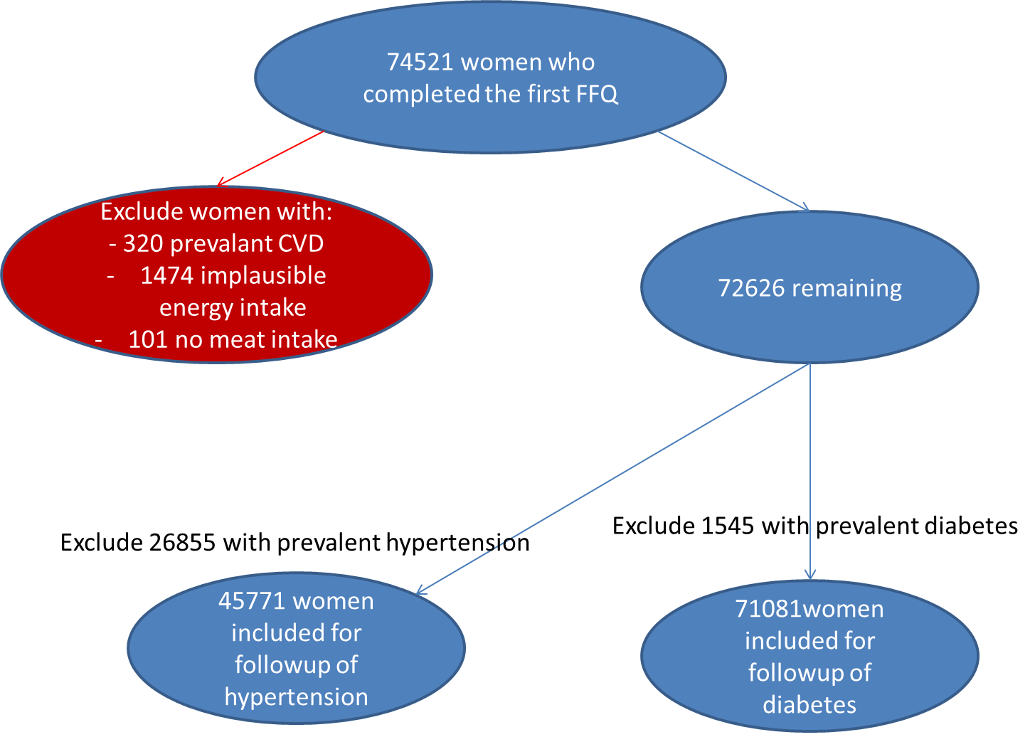
Supplementary figure 2 – Simplified directed acyclic graph showing modelling assumptions for the secondary analysis, with baseline at the return of the second FFQ
