Appendix 3
Subgroup analysis among cohort (n=7) and non-randomized trial (n = 1), and among cross-sectional (n=18) and case-control studies (n = 1)
Subgroup | Number of studies | RR (95% CI)ª  OR (95% CI)^{b} | I² | Test for subgroup difference
Cohort and non-randomized trial
Age group (years) |  |  |  | P = 0.49; I² = 0%
< 6 | 5 | 2.00 (1.27, 1.35) | 64%
6 to 19 | 3 | 1.58 (0.97, 2.57) | 77%
Country |  |  |  | P = 0.31; I² = 1.4%
Low-Middle income | 5 | 1.51 (1.25, 1.82) | 7%
High income | 3 | 2.49 (0.95, 6.48) | 88%
Year of publication |  |  |  | P = 0.90; I² = 0%
< 2010 | 3 | 1.83 (0.98, 3.41) | 84%
2010 to present | 5 | 1.74 (1.19, 2.54) | 54%
Sample size |  |  |  | P = 0.15; I² = 52.4%
< 500 | 2 | 3.97 (1.05; 15.00) | 70%
500 – 1,500 | 6 | 1.47 (1.17; 1.84) | 56%
Main confounders^{c} |  |  |  | P = 0.51; I² = 0%
No | 4 | 2.00 (1.11; 3.63) | 82%
Yes | 4 | 1.61 (1.21; 2.14) | 29%
Risk of bias assessement |  |  |  | P = 0.51; I² = 0%
Low | 4 | 1.61 (1.21; 2.14) | 29%
Moderate or high | 4 | 2.00 (1.11; 3.63) | 82%
Cross-sectional and case-control
Age group (years) |  |  |  | P = 0.000; I² = 95%
< 6 | 6 | 1.09 (1.00; 1.19) | 67%
6 to 19 | 13 | 1.86 (1.50; 2.31) | 89%
Country |  |  |  | P = 0.32; I² = 0%
Low-Middle income | 13 | 1.41 (1.25; 1.60) | 87%
High income | 6 | 1.70 (1.20; 2.43) | 91%
Year of publication |  |  |  | P = 0.15; I² = 52.4%
< 2010 | 5 | 1.88 (1.25; 2.83) | 88%
2010 to present | 14 | 1.38 (1.23; 1.55) | 87%
Sample size |  |  |  | P = 0.006; I² = 80%
< 500 | 6 | 1.81 (1.20; 2.73) | 75%
500 – 1,500 | 8 | 1.98 (1.35; 2.91) | 93%
>1,500 | 5 | 1.17 (1.06; 1.29) | 85%
Main confoundersª |  |  |  | P = 0.66; I² = 0%
No | 12 | 1.61 (1.28; 2.03) | 92%
Yes | 7 | 1.50 (1.24; 1.83) | 88%
Risk of bias assessement |  |  |  | P = 0.03; I² = 79.9%
Low | 8 | 1.26 (1.11; 1.43) | 89%
Moderate or high | 11 | 1.72 (1.35; 2.19) | 85%
Dental caries prevalence |  |  |  | P = 0.001; I² = 91.6%
<70% | 15 | 1.41 (1.26; 1.58) | 90%
>70% | 4 | 3.67 (2.16; 6.23) | 42%
ªLongitudinal studies. ^{b}Cross-sectional and case-control studies. ªThe main three confounders: SES/Family variables (e.g., income and education), Individual variables (e.g., brushing teeth and dental visit)

Sensitivity analysis among 7 cohort and 1 non-randomized trial according to sample size
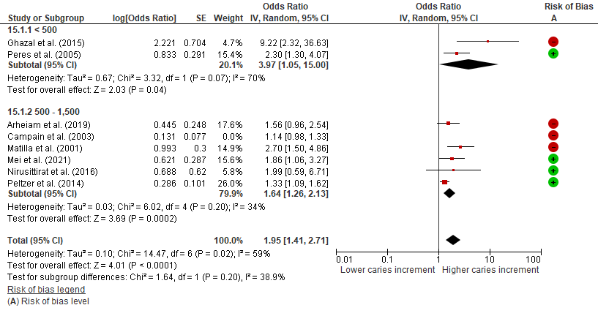
Findings: Heterogeneity among studies with sample size of 500 – 1,500 participants drop to 34% when Campain et al. (2003) is removed.

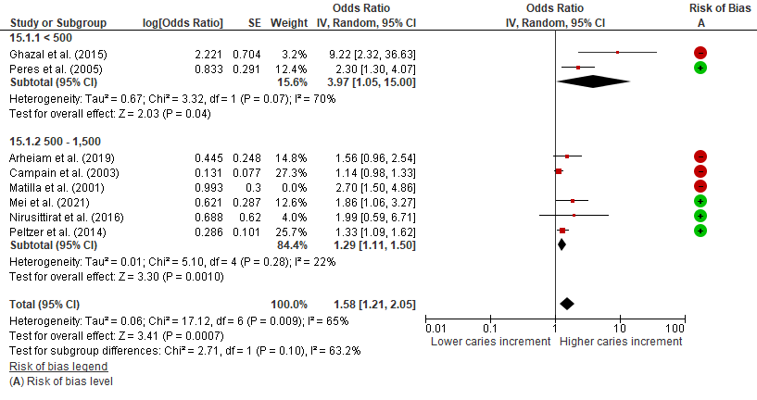
Findings: Heterogeneity among studies with sample size of 500 – 1,500 participants drop to 22% when Matilla et al. (2001) is removed.

Sensitivity analysis among 18 cross-sectional and 1 case-control studies according to year of publication
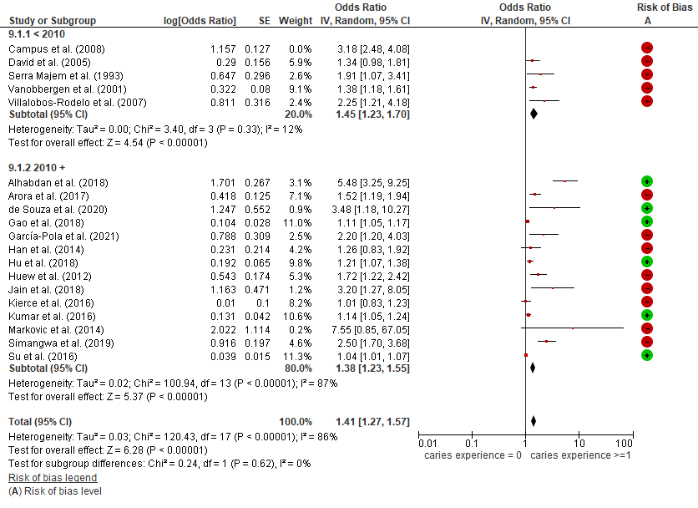
Findings: Heterogeneity among studies published before 2010 drop to 12% when Campus et al. (2008) is removed.

Sensitivity analysis among 18 cross-sectional and 1 case-control studies according to sample size
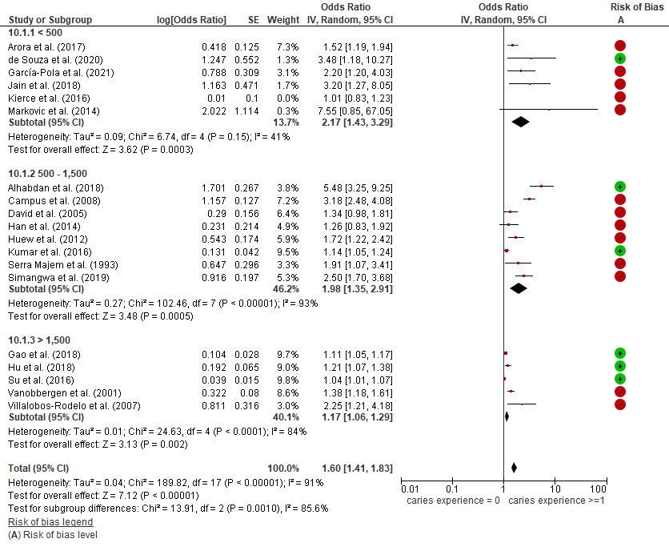
Findings: Heterogeneity among studies published with sample size of < 500 drop to 41% when Kierce et al. (2008) is removed.

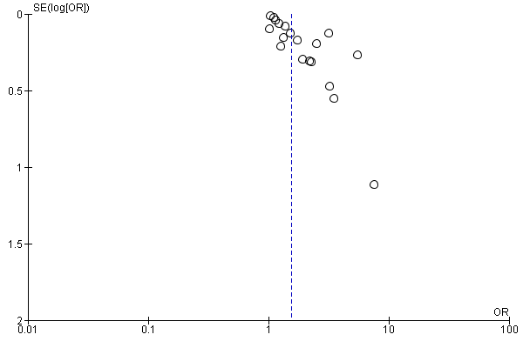
Funnel plot of cross-sectional and case-control studies (n = 19)
Harbord’s test for small-study effect p = 0.04

