Psychological distress and unhealthy dietary behaviours among adolescents aged 12-15 years in nine South-East Asian countries: a secondary analysis of the Global School-Based Health Survey data

Supplementary materials

Table S1: Variable definitions
Variables | Survey question | Response options and recording
Psychological distress variables
Anxiety | During the past 12 months, how often have you been so worried about something that you could not sleep at night? | No = “never” or “rarely” or “sometimes”  Yes = “most of the times” or “always”
Loneliness | During the past 12 months, how often have you felt lonely? | No = “never” or “rarely” or “sometimes”  Yes = “most of the times” or “always”
Suicide ideation | During the past 12 months, did you ever seriously consider attempting suicide? | No  Yes
Suicide planning | During the past 12 months, did you make a plan about how you would attempt suicide? | No  Yes
Suicide attempt | During the past 12 months, how many times did you actually attempt suicide? | No = 0 time  Yes = 1, 2 or 3, 4 or 5, 6 or more times
Psychological distress |  | No = Presence of less than two out of five psychological variables  Yes = Presence of two or more out of five psychological variables
Unhealthy dietary behaviours
Fruit consumption | During the past 30 days, how many times per day did you usually eat fruit, such as COUNTRY SPECIFIC EXAMPLES? | Inadequate = I did not eat fruit during the past 30 days or Less than one time per day  Adequate = 1 time per day, 2 times per day,  3 times per day, 4 times per day, or 5 or more times per day
Vegetable consumption | During the past 30 days, how many times per day did you usually eat fruit, such as COUNTRY SPECIFIC EXAMPLES? | Inadequate = I did not eat fruit during the past 30 days or Less than one time per day  Adequate = 1 time per day, 2 times per day,  3 times per day, 4 times per day, or 5 or more times per day
Soft drink consumption | During the past 30 days, how many times per day did you usually drink carbonated soft drinks, such as COUNTRY SPECIFIC EXAMPLES? (Do not include diet soft drinks.) | Daily = 1 time per day, 2 times per day,  3 times per day, 4 times per day, or  5 or more times per day  Less than daily = I did not drink carbonated soft drinks during the past 30 days or Less than 1 time per day
Fast food consumption | During the past 7 days, on how many days did you eat food from a fast food restaurant, such as COUNTRY SPECIFIC EXAMPLES? | Less than weekly = 0 days  Weekly = 1 day, 2 days, 3 days, 4 days, 5 days,  6 days, or 7 days
Covariates
Age | How old are you?
Sex | What is your sex?
Socioeconomic status (huger as proxy) | During the past 30 days, how often did you go hungry because there was not enough food in your home? | Average = “never” or “rarely” or “sometimes”  Below average = “most of the times” or “always”
Bullied | During the past 30 days, on how many days were you bullied? | No = 0 days  Yes = “1 or 2 days” or “3 to 5 days” or “6 to 9 days” or “10 to 19 days” or “20 to 29 days” or “All 30 days”
Parental support | During the past 30 days, how often did your parents or guardians understand your problems and worries? | No = “never” or “rarely” or “sometimes”  Yes = “most of the times” or “always”
Peer support | During the past 30 days, how often were most of the students in your school kind and helpful? | No = “never” or “rarely” or “sometimes”  Yes = “most of the times” or “always”
Close friend | How many close friends do you have? | No = 0  Yes = 1, 2, 3 or more
Smoking | During the past 30 days, on how many days did you smoke cigarettes? | No = “0 days”  Yes = “1 or 2 days” or “3 to 5 days” or ‘”6 to 9 days” or “10 to 19 days” or “20 to 29 days” or “All 30 days”
Physical activity | During the past 7 days, on how many days were you physically active for a total of at least 60 minutes per day? ADD UP ALL THE TIME YOU SPENT IN ANY KIND OF PHYSICAL ACTIVITY EACH DAY. | No = “0 days”  Yes = “1 day” or “2 days” or “3 days” or “4 days” or “5 days” or “6 days” or “7 days”
Overweight |  | Body mass index (BMI) is >+1SD from the median for age and sex, according to the WHO Growth Reference Data
More details about GSHS questionnaires can be found at: https://www.who.int/ncds/surveillance/gshs/methodology/en/

Table S2: Prevalence of individual psychological distress items among adolescents aged 12-15 years, pooled and by country
Country | Prevalence (95% CI)*
 | Boys | Girls | Total
Loneliness
Bangladesh | 11.1 (9.2-13.2) | 9.0 (7.7-10.5) | 10.3 (9.2-11.5)
Bhutan | 8.0 (6.6-9.6) | 14.0 (12.4-15.6) | 11.3 (10.2-12.4)
Indonesia | 4.5 (3.8-5.2) | 6.7 (6.0-7.4) | 5.6 (5.1-6.1)
Maldives | 10.5 (8.2-13.1) | 19.6 (17.2-22.3) | 15.2 (13.5-17.1)
Myanmar | 6.1 (4.7-7.7) | 9.8 (8.2-11.6) | 8.1 (6.9-9.3)
Nepal | 5.1 (4.2-6.2) | 5.3 (4.4-6.2) | 5.2 (4.5-5.9)
Sri Lanka | 6.6 (5.1-8.4) | 7.4 (6.0-9.0) | 7.0 (6.0-8.2)
Thailand | 9.2 (7.8-10.7) | 7.9 (6.8-9.2) | 8.5 (7.6-9.4)
Timor-Leste | 12.3 (9.8-15.2) | 10.0 (8.0-12.2) | 11.1 (9.5-12.8)
Pooled estimate | 8.0 (6.3-9.7) | 9.8 (7.7-11.9) | 9.1 (7.3-10.9)
Anxiety
Bangladesh | 3.3 (2.3-4.6) | 4.5 (3.5-5.6) | 3.8 (3.1-4.6)
Bhutan | 5.7 (4.5-7.0) | 7.8 (6.6-9.1) | 6.8 (5.9-7.7)
Indonesia | 4.1 (3.5-4.7) | 3.9 (3.3-4.5) | 4.0 (3.6-4.4)
Maldives | 10.1 (7.9-12.8) | 17.6 (15.3-20.2) | 14.0 (12.4-15.9)
Myanmar | 3.3 (2.3-4.7) | 3.7 (2.7-5.0) | 3.5 (2.8-4.4)
Nepal | 3.3 (2.5-4.1) | 3.4 (2.7-4.2) | 3.3 (2.8-3.9)
Sri Lanka | 3.4 (2.3-4.8) | 3.8 (2.8-5.0) | 3.6 (2.8-4.4)
Thailand | 6.1 (5.0-7.3) | 7.4 (6.3-8.6) | 6.8 (6.0-7.6)
Timor-Leste | 7.6 (5.6-10.0) | 7.8 (6.1-9.9) | 7.8 (6.4-9.3)
Pooled estimate | 4.9 (3.9-5.9) | 6.4 (4.8-8.1) | 5.8 (4.5-7.1)
Suicide ideation
Bangladesh | 4.2 (3.1-5.6) | 5.7 (4.7-7.0) | 4.8 (4.0-5.7)
Bhutan | 9.5 (8.0-11.2) | 11.7 (10.3-13.3) | 10.7 (9.7-11.9)
Indonesia | 3.4 (2.9-4.1) | 5.4 (4.7-6.1) | 4.4 (4.0-4.9)
Maldives | 10.1 (7.9-12.8) | 14.4 (12.2-16.8) | 12.3 (10.7-14.1)
Myanmar | 6.8 (5.3-8.5) | 9.6 (8.0-11.4) | 8.3 (7.2-9.5)
Nepal | 12.7 (11.3-14.3) | 12.2 (10.9-13.6) | 12.5 (11.5-13.5)
Sri Lanka | 9.4 (7.6-11.4) | 8.3 (6.8-10.0) | 8.9 (7.7-10.2)
Thailand | 10.2 (8.8-11.8) | 11.4 (10.0-12.8) | 10.8 (9.9-11.9)
Timor-Leste | 9.5 (7.2-12.1) | 7.4 (5.7-9.3) | 8.3 (6.9-9.8)
Pooled estimate | 8.4 (5.8-10.9) | 9.5 (7.3-11.7) | 9.0 (6.7-11.3)
Suicide planning
Bangladesh | 7.1 (5.6-8.8) | 7.1 (5.9-8.5) | 7.1 (6.1-8.1)
Bhutan | 11.9 (10.2-13.8) | 14.2 (12.6-15.9) | 13.2 (12.0-14.4)
Indonesia | 5.1 (4.5-5.9) | 5.5 (4.9-6.2) | 5.3 (4.9-5.8)
Maldives | 15.3 (12.5-18.3) | 19.9 (17.4-22.5) | 17.7 (15.9-19.7)
Myanmar | 4.5 (3.3-5.9) | 7.9 (6.5-9.6) | 6.3 (5.3-7.4)
Nepal | 13.1 (11.6-14.7) | 13.3 (11.9-14.7) | 13.2 (12.2-14.2)
Sri Lanka | 6.1 (4.6-7.8) | 6.3 (5.0-7.9) | 6.2 (5.2-7.3)
Thailand | 13.3 (11.8-15.1) | 12.5 (11.1-14.0) | 12.9 (11.9-14.0)
Timor-Leste | 11.4 (9.0-14.3) | 7.3 (5.6-9.2) | 9.2 (7.8-10.8)
Pooled estimate | 9.7 (7.0-12.3) | 10.4 (7.7-13.1) | 10.1 (7.5-12.7)
Suicide attempt
Bangladesh | 5.9 (4.5-7.5) | 5.7 (4.6-6.9) | 5.8 (5.0-6.8)
Bhutan | 10.8 (9.2-12.6) | 10.2 (8.8-11.6) | 10.5 (9.4-11.6)
Indonesia | 3.1 (2.6-3.7) | 3.2 (2.7-3.8) | 3.2 (2.8-3.6)
Maldives | 11.3 (8.9-14.0) | 10.0 (8.1-12.1) | 10.5 (9.1-12.2)
Myanmar | 5.7 (4.3-7.3) | 9.5 (7.9-11.4) | 7.8 (6.7-9.0)
Nepal | 8.7 (7.4-10.0) | 9.0 (7.9-10.2) | 8.8 (8.0-9.7)
Sri Lanka | 6.4 (4.9-8.2) | 6.2 (4.9-7.7) | 6.3 (5.3-7.4)
Thailand | 8.8 (7.5-10.3) | 10.5 (9.2-11.9) | 9.7 (8.8-10.7)
Timor-Leste | 9.0 (6.8-11.5) | 7.1 (5.5-9.1) | 7.9 (6.6-9.4)
Pooled estimate | 7.7 (5.5-9.8) | 7.9 (5.7-10.1) | 7.8 (5.6-10.0)
*Country-specific sampling weights were used to yield country representative estimates
Random-effect meta-analysis was used to calculate the pooled prevalence estimates

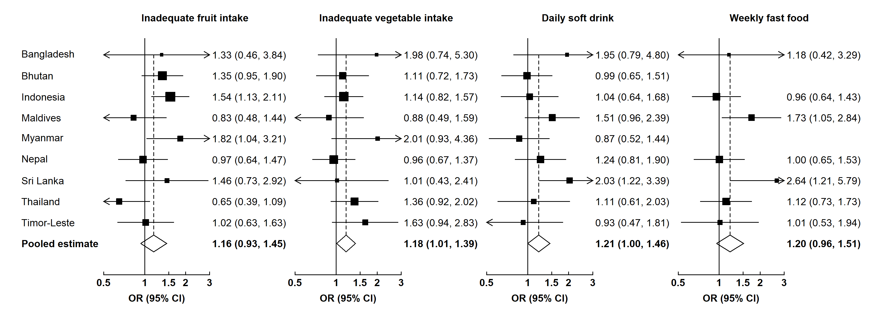
Figure S1: Associations between psychological distress and various unhealthy dietary behaviours among adolescent boys.
We used multivariable logistic regression models to estimate country-specific odds ratios (ORs) and then conducted a random-effect meta-analysis to pool the ORs. Regression models were adjusted for age, proxy for low socioeconomic status, peer support, parental support, bullying, having close friends, smoking, physical activity, and overweight.

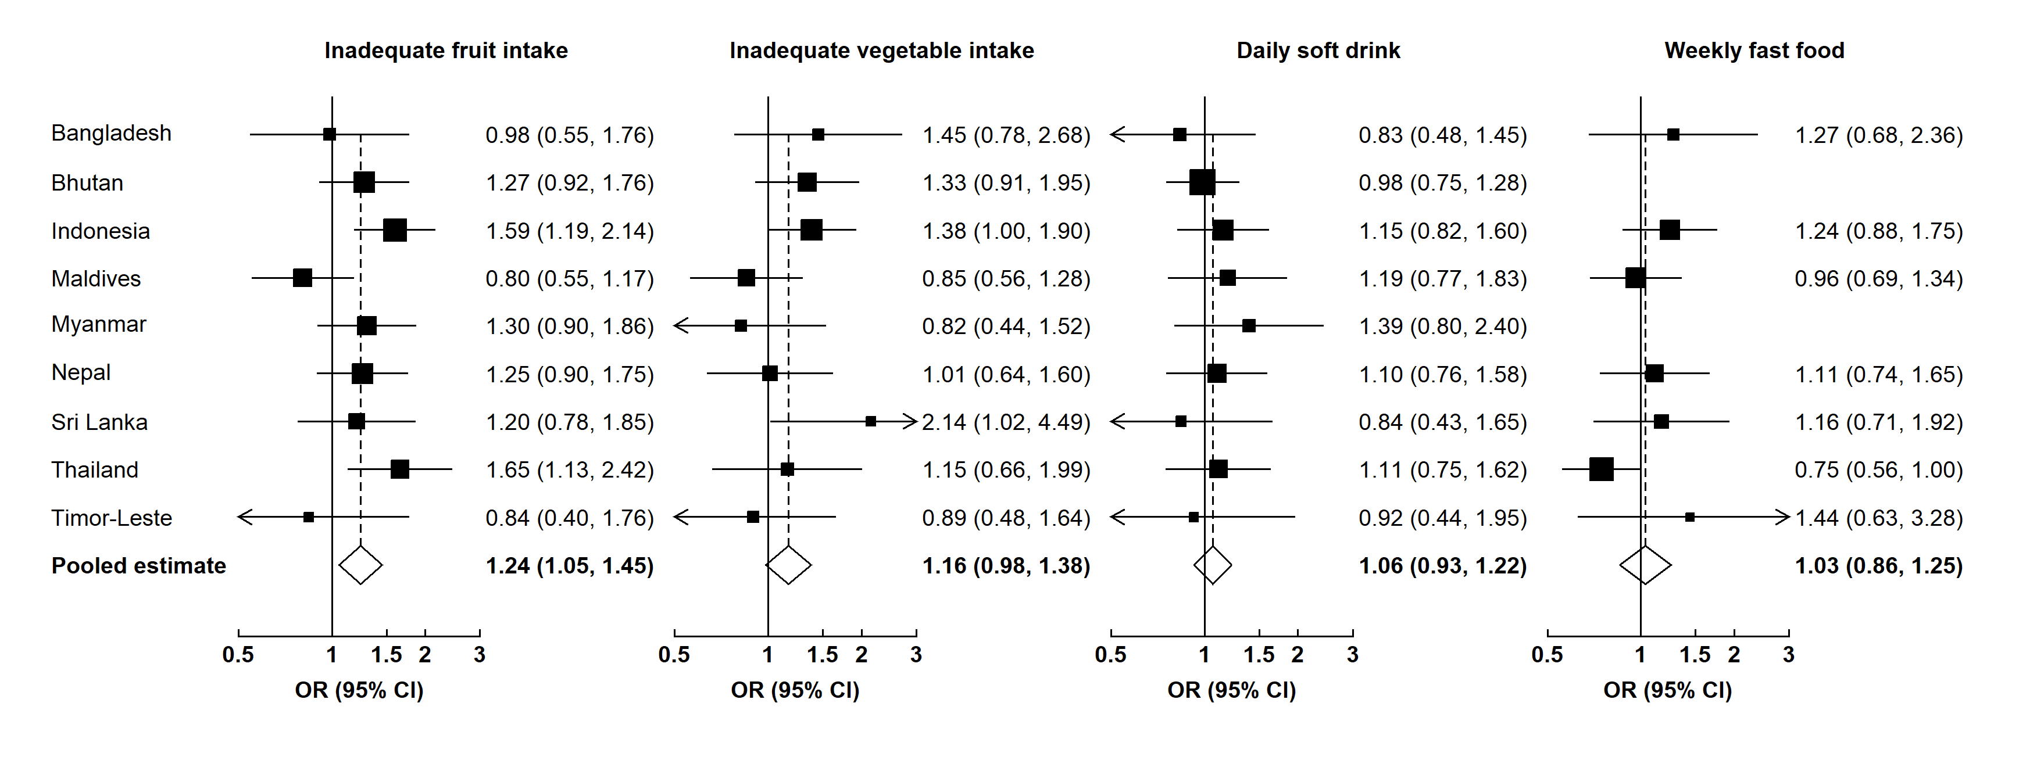
Figure S2: Associations between psychological distress and various unhealthy dietary behaviours among adolescent girls.
We used multivariable logistic regression models to estimate country-specific odds ratios (ORs) and then conducted a random-effect meta-analysis to pool the ORs. Regression models were adjusted for age, proxy for low socioeconomic status, peer support, parental support, bullying, having close friends, smoking, physical activity, and overweight.

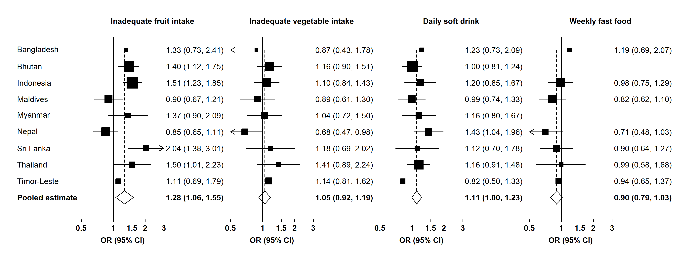
Figure S3: Associations between loneliness and various unhealthy dietary behaviours among adolescents.
We used multivariable logistic regression models to estimate country-specific odds ratios (ORs) and then conducted a random-effect meta-analysis to pool the ORs. Regression models were adjusted for age, proxy for low socioeconomic status, peer support, parental support, bullying, having close friends, smoking, physical activity, and overweight.

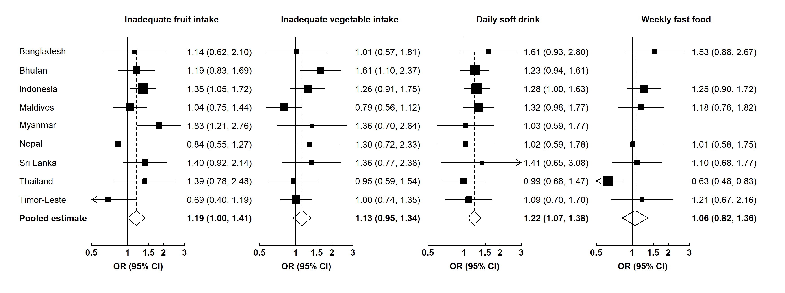
Figure S4: Associations between anxiety and various unhealthy dietary behaviours among adolescents.
We used multivariable logistic regression models to estimate country-specific odds ratios (ORs) and then conducted a random-effect meta-analysis to pool the ORs. Regression models were adjusted for age, proxy for low socioeconomic status, peer support, parental support, bullying, having close friends, smoking, physical activity, and overweight.

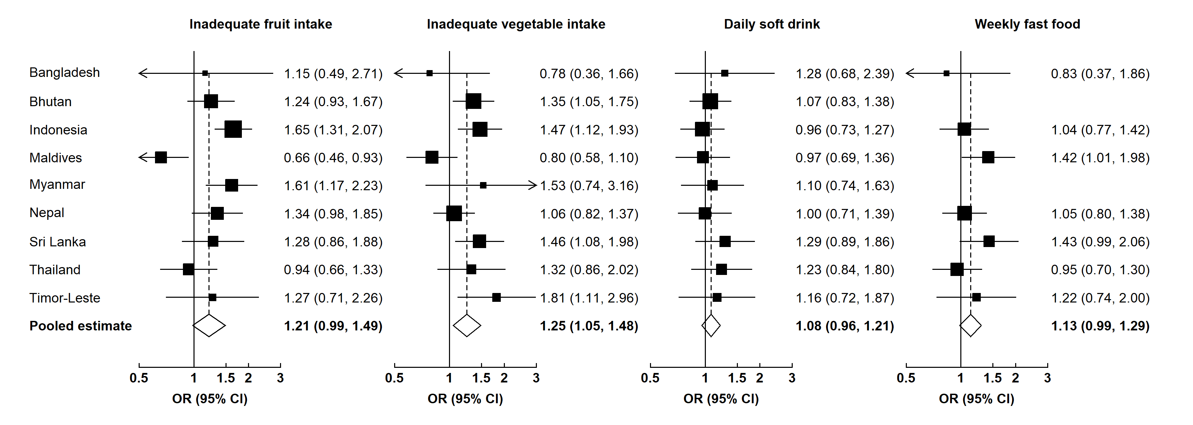
Figure S5: Associations between suicide ideation and various unhealthy dietary behaviours among adolescents.
We used multivariable logistic regression models to estimate country-specific odds ratios (ORs) and then conducted a random-effect meta-analysis to pool the ORs. Regression models were adjusted for age, proxy for low socioeconomic status, peer support, parental support, bullying, having close friends, smoking, physical activity, and overweight.

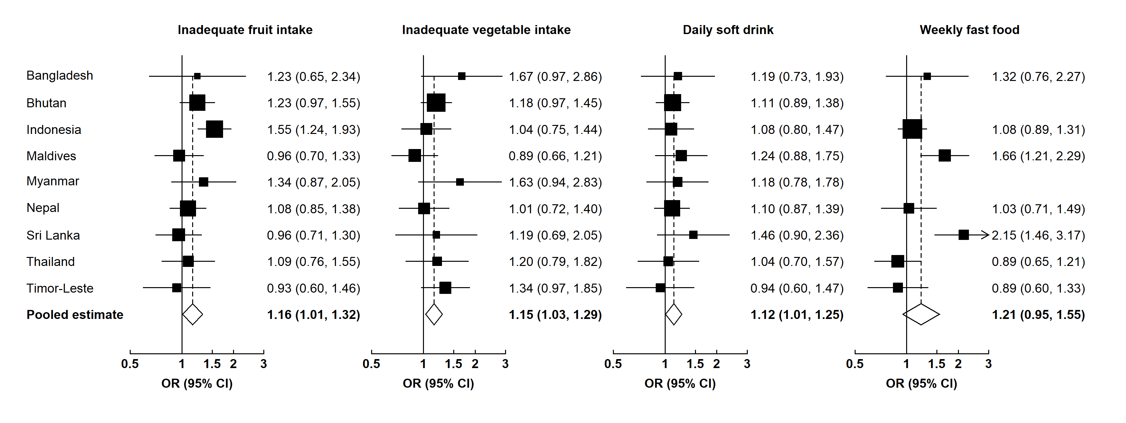
Figure S6: Associations between suicide planning and various unhealthy dietary behaviours among adolescents.
We used multivariable logistic regression models to estimate country-specific odds ratios (ORs) and then conducted a random-effect meta-analysis to pool the ORs. Regression models were adjusted for age, proxy for low socioeconomic status, peer support, parental support, bullying, having close friends, smoking, physical activity, and overweight.

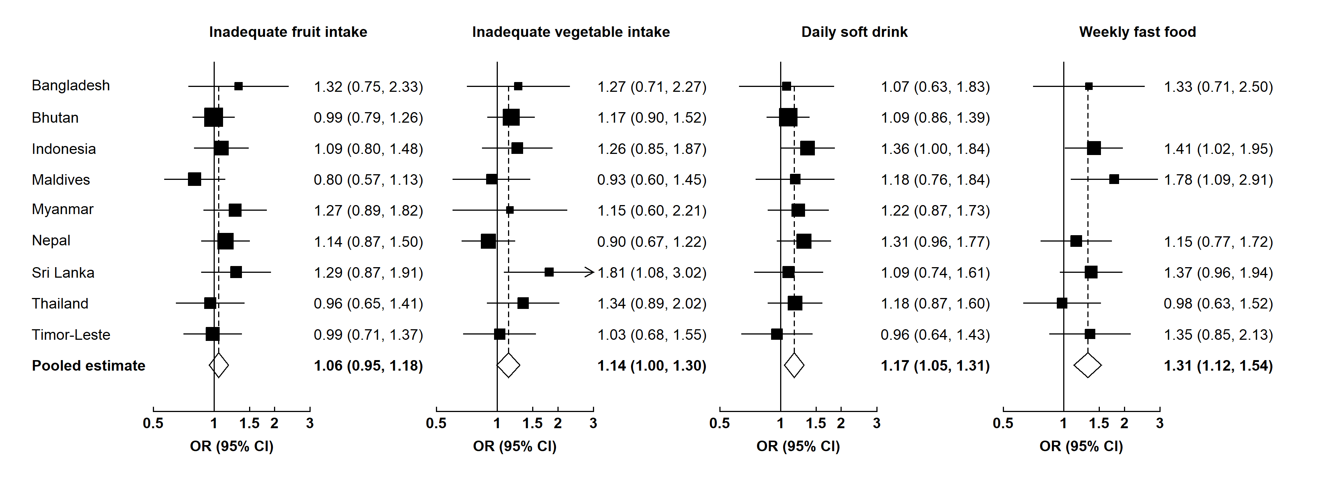
Figure S7: Associations between suicide attempt and various unhealthy dietary behaviours among adolescents.
We used multivariable logistic regression models to estimate country-specific odds ratios (ORs) and then conducted a random-effect meta-analysis to pool the ORs. Regression models were adjusted for age, proxy for low socioeconomic status, peer support, parental support, bullying, having close friends, smoking, physical activity, and overweight.

