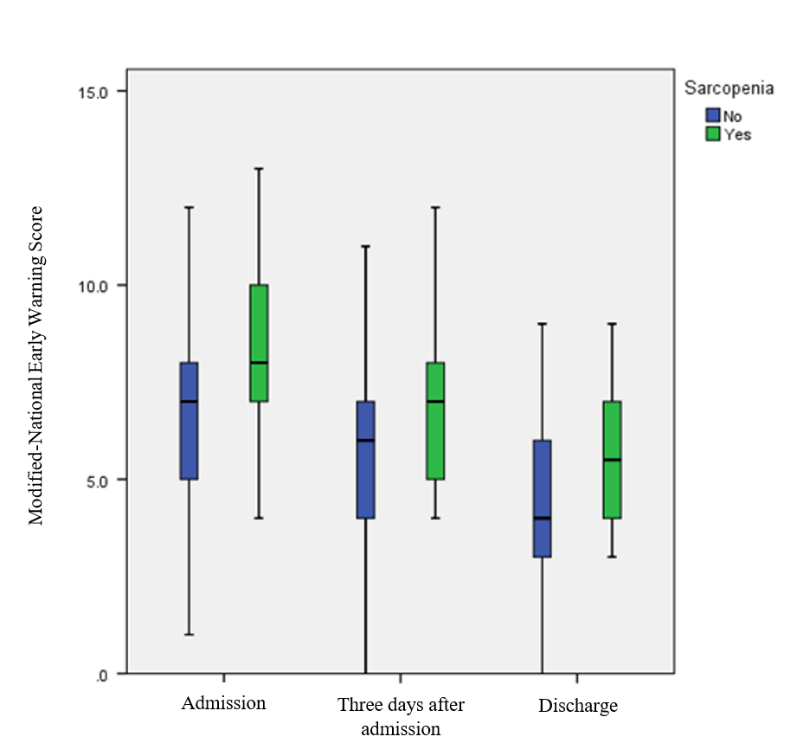
Supplementary Fig. 1. Mean and SD of modified-National Early Warning Scores (m-NEWS) at T1 to T3 follow-up times in both groups

