**Supplementary Material**

**Timing of gestational weight gain in association with birthweight outcomes: a prospective cohort study**

Lixia Lin, Xi Chen, Chunrong Zhong, Li Huang,Qian Li, Xu Zhang, Meng Wu, Huanzhuo Wang, Sen Yang, Xiyu Cao, Guoping Xiong, Guoqiang Sun, Xuefeng Yang, Liping Hao, Nianhong Yang

Supplementary Table S1. GWG recommendations on Chinese women.

|  |  |  |  |
| --- | --- | --- | --- |
| Pre-pregnancy weight status | Total GWG | GWG in the  first trimester | Weekly GWG in the  second and third trimesters |
| Underweight (BMI<18.5 kg/m2) | 11.0–16.0 kg | 0.0–2.0 kg | 0.46 (0.37–0.56) kg/wk |
| Normal-weight (BMI 18.5 to <24.0 kg/m2) | 8.0–14.0 kg | 0.0–2.0 kg | 0.37 (0.26–0.48) kg/wk |
| Overweight (BMI 24.0 to <28.0 kg/m2) | 7.0–11.0 kg | 0.0–2.0 kg | 0.30 (0.22–0.37) kg/wk |
| Obesity (BMI ≥28.0 kg/m2) | 5.0–9.0 kg | 0.0–2.0 kg | 0.22 (0.15–0.30) kg/wk |

BMI, body mass index; GWG, gestational weight gain.

Supplementary Table S2. Association of GWG in each gestational interval with birthweight according to pre-pregnancy BMI

(β and 95% confidence intervals)

|  |  |  |  |
| --- | --- | --- | --- |
|  | Pre-pregnancy BMI (kg/m2) | | |
|  | <18.5 (n 996) | 18.5 to <24.0 (n 3488) | ≥24.0 (n 565) |
| GWG | β (95% CI)* | β (95% CI)* | β (95% CI)* |
| The first 13 wk | 74.93 (3.79, 146.06) | 56.52 (25.02, 88.03) | 29.60 (-31.53, 90.74) |
| 14–18 wk | 122.96 (78.78, 167.14) | 79.01 (54.26, 103.75) | 113.43 (59.12, 167.74) |
| 19–23 wk | 119.42 (75.33, 163.50) | 85.51 (60.07, 110.96) | 28.47 (-33.85, 90.78) |
| 24–28 wk | 80.89 (36.74, 125.04) | 57.03 (31.44, 82.63) | 87.25 (24.75, 149.76) |
| 29–30 wk | 47.29 (10.24, 84.35) | 23.99 (2.04, 45.94) | 72.11 (15.93, 128.29) |
| 31–32 wk | -9.16 (-41.00, 22.69) | -2.65 (-20.84, 15.53) | -13.54 (-51.69, 24.61) |
| 33–34 wk | 13.82 (-16.03, 43.67) | 2.93 (-14.33, 20.20) | 8.00 (-32.71, 48.72) |
| 35–36 wk | 29.91 (-2.69, 62.51) | -6.39 (-21.63, 8.85) | -11.18 (-46.67, 24.31) |
| 37–38 wk | 2.65 (-20.77, 26.07) | 12.00 (-0.95, 24.96) | -19.83 (-52.84, 13.17) |
| 39–40 wk | 4.80 (-24.95, 34.56) | 10.54 (-6.33, 27.41) | 11.08 (-31.55, 53.72) |

BMI, body mass index; GWG, gestational weight gain.

* Values represent the change in birthweight (g) when GWG in the indicated gestational interval changed by 0.50 kg/wk.

All models were adjusted for maternal height, ethnicity, age, parity, average monthly income, current smoking at enrollment, alcohol intake before and in early pregnancy, cumulative GWG prior to the current interval, gestational age at delivery, and infant sex.

Supplementary Table S3. Association of GWG in each gestational interval with birthweight stratified by maternal vomiting in early pregnancy

(β and 95% confidence intervals)

|  |  |  |
| --- | --- | --- |
|  | No vomiting (n 1878) | Vomiting (n 3171) |
| GWG | β (95% CI)* | β (95% CI)* |
| The first 13 wk | 60.99 (14.94, 107.05) | 55.95 (23.97, 87.94) |
| 14–18 wk | 86.88 (52.99, 120.76) | 99.17 (74.29, 124.05) |
| 19–23 wk | 103.71 (68.84, 138.58) | 76.40 (50.48, 102.31) |
| 24–28 wk | 66.73 (33.08, 100.38) | 64.21 (37.48, 90.94) |
| 29–30 wk | 39.96 (10.01, 69.91) | 33.87 (11.05, 56.69) |
| 31–32 wk | 8.53 (-14.26, 31.31) | -9.13 (-27.60, 9.34) |
| 33–34 wk | 15.52 (-6.30, 37.33) | -1.20 (-19.64, 17.24) |
| 35–36 wk | -7.52 (-29.78, 14.73) | 3.94 (-11.78, 19.65) |
| 37–38 wk | 6.33 (-10.84, 23.50) | 6.26 (-7.72, 20.24) |
| 39–40 wk | 6.50 (-18.22, 31.22) | 7.67 (-9.67, 25.02) |

GWG, gestational weight gain.

* Values represent the change in birthweight (g) when GWG in the indicated gestational interval changed by 0.50 kg/wk.

All models were adjusted for maternal body mass index, height, ethnicity, age, parity, average monthly income, current smoking at enrollment, alcohol intake before and in early pregnancy, cumulative GWG prior to the current interval, gestational age at delivery, and infant sex.

Supplementary Table S4. Association of GWG in each gestational interval with birthweight among women without gestational diabetes mellitus and hypertensive disorders of pregnancy (n 3892)

(β and 95% confidence intervals)

|  |  |
| --- | --- |
| GWG | β (95% CI)* |
| The first 13 wk | 46.55 (17.32, 75.79) |
| 14–18 wk | 81.32 (58.99, 103.65) |
| 19–23 wk | 91.01 (68.79, 113.23) |
| 24–28 wk | 60.75 (37.66, 83.85) |
| 29–30 wk | 31.07 (10.34, 51.79) |
| 31–32 wk | 0.28 (-15.83, 16.39) |
| 33–34 wk | 8.31 (-7.05, 23.67) |
| 35–36 wk | -1.68 (-16.32, 12.96) |
| 37–38 wk | 6.90 (-5.02, 18.81) |
| 39–40 wk | 9.23 (-6.57, 25.03) |

GWG, gestational weight gain.

* Values represent the change in birthweight (g) when GWG in the indicated gestational interval changed by 0.50 kg/wk.

All models were adjusted for maternal body mass index, height, ethnicity, age, parity, average monthly income, current smoking at enrollment, alcohol intake before and in early pregnancy, cumulative GWG prior to the current interval, gestational age at delivery, and infant sex.

Supplementary Table S5. Associations of GWG between 14–23 weeks with the risk of SGA and LGA among women with adequate total GWG*

(Relative risks (RR) and 95% confidence intervals)

|  |  |  |  |  |  |  |  |
| --- | --- | --- | --- | --- | --- | --- | --- |
|  | SGA | | |  | LGA | | |
| GWG between 14–23 wk | Case (%) | RR (95% CI)† | RR (95% CI)‡ |  | Case (%) | RR (95% CI)† | RR (95% CI)‡ |
| Inadequate | 52 (11.6) | 1.95 (1.28, 2.97) | 1.80 (1.18, 2.74) |  | 20 (4.8) | 0.63 (0.37, 1.05) | 0.64 (0.39, 1.07) |
| Adequate | 32 (5.9) | Ref (1.00) | Ref (1.00) |  | 42 (7.7) | Ref (1.00) | Ref (1.00) |
| Excessive | 41 (5.9) | 1.00 (0.64, 1.56) | 1.01 (0.65, 1.57) |  | 71 (9.8) | 1.28 (0.89, 1.85) | 1.20 (0.83, 1.72) |

GWG, gestational weight gain; LGA, large-for-gestational-age; SGA, small-for-gestational-age.

* Total GWG and GWG between 14–23 weeks were categorized according to the National Academy of Medicine guidelines.

† Models were crude models.

‡ Models were adjusted for maternal pre-pregnancy body mass index, height, ethnicity, age, parity, average monthly income, current smoking at enrollment, and alcohol intake before and in early pregnancy.



Supplementary Fig. S1. Flowchart of the participants

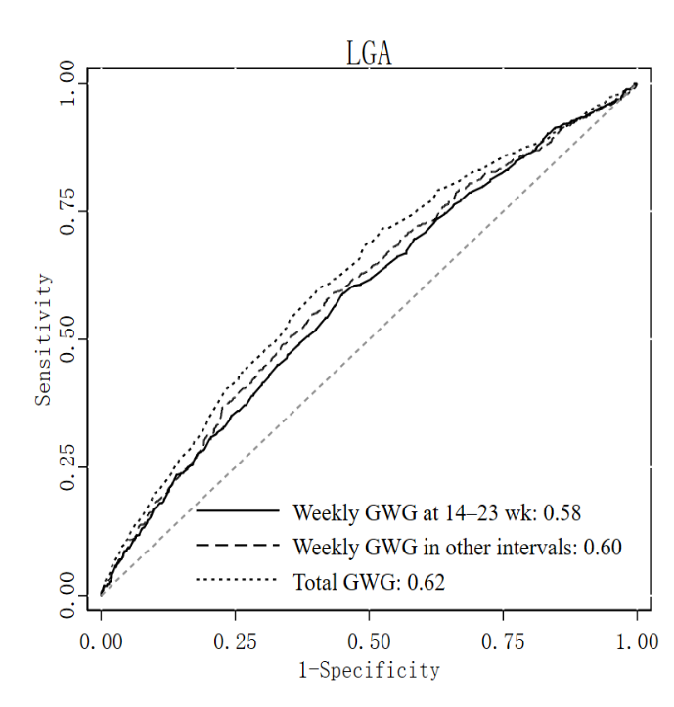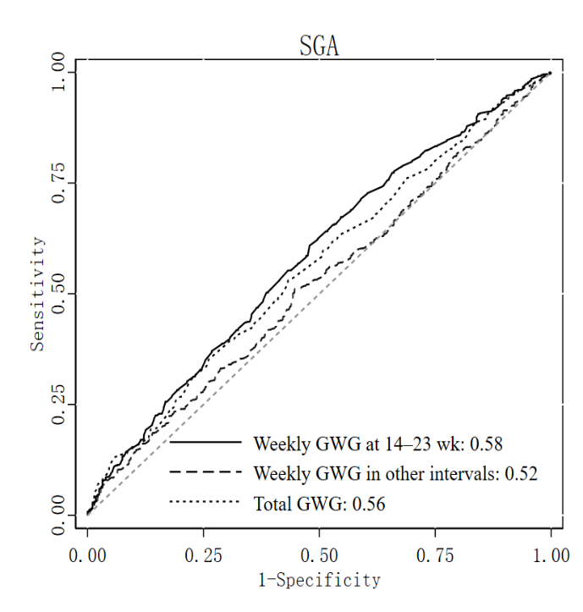

Supplementary Fig. S2. Receiver operator characteristic curves of GWG at 14–23 weeks, GWG in other intervals, and total GWG for SGA and LGA in all participants.

GWG, gestational weight gain; LGA, large-for-gestational-age; SGA, small-for-gestational-age.