Supplementary Table S1. Unadjusted odds ratios of sarcopenic obesity according to the quartiles of the anthropometric indices
 | Criterion 1 |  | P | Criterion 2 |  | P | Criterion 3 |  | P
Quartile group (range) | n (%) | OR (95% CI) |  | n (%) | OR (95% CI) |  | n (%) | OR (95% CI)
WWI
Men
1st (9.1–10.6) | 22 (8.5) | 1 (Reference) |  | 4 (1.6) | 1 (Reference) |  | 7 (2.7) | 1 (Reference)
2nd (10.6–11.0) | 45 (17.4) | 2.27 (1.32–3.90) | 0.003 | 15 (5.8) | 3.92 (1.28–11.96) | 0.017 | 19 (7.4) | 2.85 (1.18–6.90) | 0.020
3rd (11.0–11.4) | 63 (24.4) | 3.47 (2.06–5.84) | <0.001 | 32 (12.4) | 8.98 (3.13–25.79) | <0.001 | 37 (14.3) | 6.00 (2.62–13.74) | <0.001
4th (11.4–12.9) | 95 (36.8) | 6.25 (3.77–10.36) | <0.001 | 57 (22.1) | 17.99 (6.42–50.41) | <0.001 | 68 (26.4) | 12.83 (5.76–28.57) | <0.001
P for trend |  |  | <0.001 |  |  | <0.001 |  |  | <0.001
Women
1st (9.5–10.9) | 35 (14.1) | 1 (Reference) |  | 19 (7.6) | 1 (Reference) |  | 7 (2.7) | 1 (Reference)
2nd (10.6–11.5) | 34 (13.6) | 0.96 (0.58–1.60) | 0.883 | 11 (4.4) | 0.56 (0.26–1.20) | 0.134 | 19 (7.4) | 0.67 (0.36–1.25) | 0.204
3rd (11.5–11.9) | 37 (14.8) | 1.06 (0.64–1.75) | 0.813 | 17 (6.8) | 0.88 (0.45–1.74) | 0.720 | 37 (14.3) | 1.08 (0.61–1.90) | 0.785
4th (11.9–14.0) | 37 (14.8) | 1.06 (0.64–1.75) | 0.813 | 23 (9.2) | 1.23 (0.65–2.31) | 0.528 | 68 (26.4) | 1.21 (0.70–2.11) | 0.492
P for trend |  |  | - |  |  | - |  |  | -
P for interaction |  |  | <0.001 |  |  | <0.001 |  |  | <0.001
BMI
Men
1st (14.5–22.0) | 28 (10.9) | 1 (Reference) |  | 17 (6.6) | 1 (Reference) |  | 18 (7.0) | 1 (Reference)
2nd (22.0–23.9) | 74 (28.7) | 3.30 (2.05–5.32) | <0.001 | 31 (12.0) | 1.94 (1.04–3.59) | 0.036 | 39 (15.1) | 2.37 (1.32–4.27) | 0.004
3rd (23.9–25.7) | 76 (29.5) | 3.43 (2.13–5.52) | <0.001 | 32 (12.4) | 2.01 (1.08–3.72) | 0.027 | 41 (15.9) | 2.52 (1.41–4.52) | 0.002
4th (25.7–33.1) | 47 (18.2) | 1.83 (1.11–3.03) | 0.019 | 28 (10.9) | 1.73 (0.92–3.24) | 0.089 | 33 (12.8) | 1.96 (1.07–3.57) | 0.029
P for trend |  |  | 0.047 |  |  | 0.123 |  |  | 0.051
Women
1st (16.0–22.6) | 24 (9.6) | 1 (Reference) |  | 13 (5.2) | 1 (Reference) |  | 19 (7.6) | 1 (Reference)
2nd (22.6–24.4) | 52 (20.8) | 2.46 (1.46–4.14) | 0.001 | 21 (8.4) | 1.66 (0.81–3.40) | 0.163 | 33 (13.2) | 1.84 (1.02–3.33) | 0.044
3rd (24.4–26.2) | 48 (19.2) | 2.22 (1.31–3.75) | 0.003 | 24 (9.6) | 1.92 (0.95–3.86) | 0.068 | 36 (14.4) | 2.03 (1.13–3.64) | 0.018
4th (26.2–33.2) | 19 (7.6) | 0.77 (0.41–1.45) | 0.427 | 12 (4.8) | 0.92 (0.41–2.06) | 0.838 | 15 (6.0) | 0.78 (0.39–1.56) | 0.478
P for trend |  |  | 0.439 |  |  | - |  |  | 0.676
P for interaction |  |  | 0.197 |  |  | 0.564 |  |  | 0.206
WC
Men
1st (60.0–83.0) | 23 (8.9) | 1 (Reference) |  | 13 (5.0) | 1 (Reference) |  | 14 (5.4) | 1 (Reference)
2nd (83.1–88.5) | 57 (22.1) | 2.88 (1.72–4.85) | <0.001 | 21 (8.1) | 1.66 (0.81–3.40) | 0.163 | 25 (9.7) | 1.86 (0.94–3.67) | 0.073
3rd (88.6–93.9) | 75 (29.1) | 4.19 (2.53–6.94) | <0.001 | 35 (13.6) | 2.96 (1.53–5.73) | 0.001 | 43 (16.7) | 3.49 (1.86–6.55) | <0.001
4th (94.0–115.0) | 70 (27.1) | 3.82 (2.30–6.36) | <0.001 | 39 (15.1) | 3.37 (1.75–6.48) | <0.001 | 49 (19.0) | 4.11 (2.20–7.65) | <0.001
P for trend |  |  | <0.001 |  |  | <0.001 |  |  | <0.001
Women
1st (59.5–80.0) | 32 (12.9) | 1 (Reference) |  | 18 (7.2) | 1 (Reference) |  | 23 (9.2) | 1 (Reference)
2nd (80.1–86.0) | 42 (16.8) | 1.38 (0.84–2.27) | 0.203 | 17 (6.8) | 0.94 (0.48–1.88) | 0.871 | 25 (10.0) | 1.10 (0.61–2.00) | 0.751
3rd (86.1–91.5) | 40 (16.0) | 1.29 (0.78–2.13) | 0.318 | 20 (8.0) | 1.12 (0.58–2.16) | 0.746 | 31 (12.4) | 1.39 (0.79–2.46) | 0.257
4th (91.6–111.6) | 29 (11.6) | 0.91 (0.53–1.56) | 0.744 | 15 (6.0) | 0.84 (0.41–1.71) | 0.631 | 24 (9.6) | 1.07 (0.59–1.95) | 0.821
P for trend |  |  | - |  |  | - |  |  | -
P for interaction |  |  | 0.001 |  |  | 0.032 |  |  | 0.016
WHtR
Men
1st (0.35–0.51) | 25 (9.7) | 1 (Reference) |  | 9 (3.5) | 1 (Reference) |  | 11 (4.3) | 1 (Reference)
2nd (0.51–0.54) | 54 (20.9) | 2.47 (1.48–4.11) | 0.001 | 21 (8.1) | 2.45 (1.10–5.46) | 0.028 | 25 (9.7) | 2.41 (1.16–5.01) | 0.019
3rd (0.54–0.57) | 68 (26.4) | 3.34 (2.03–5.48) | <0.001 | 32 (12.4) | 3.92 (1.83–8.39) | <0.001 | 39 (15.1) | 4.00 (2.00–8.00) | <0.001
4th (0.57–0.72) | 78 (30.2) | 4.04 (2.47–6.60) | <0.001 | 46 (17.8) | 6.00 (2.87–12.55) | <0.001 | 56 (21.7) | 6.23 (3.18–12.20) | <0.001
P for trend |  |  | <0.001 |  |  | <0.001 |  |  | <0.001
Women
1st (0.41–0.53) | 29 (11.6) | 1 (Reference) |  | 16 (6.4) | 1 (Reference) |  | 22 (8.8) | 1 (Reference)
2nd (0.53–0.57) | 42 (16.8) | 1.53 (0.92–2.55) | 0.101 | 15 (6.0) | 0.93 (0.45–1.92) | 0.844 | 25 (10.0) | 1.15 (0.63–2.09) | 0.656
3rd (0.57–0.60) | 42 (16.8) | 1.53 (0.92–2.55) | 0.101 | 19 (7.6) | 1.20 (0.60–2.39) | 0.608 | 31 (12.4) | 1.46 (0.82–2.60) | 0.198
4th (0.60–0.76) | 30 (12.0) | 1.03 (0.60–1.78) | 0.903 | 20 (8.0) | 1.27 (0.64–2.51) | 0.498 | 25 (10.0) | 1.15 (0.63–2.09) | 0.656
P for trend |  |  | - |  |  | - |  |  | -
P for interaction |  |  | 0.002 |  |  | 0.024 |  |  | 0.002
WWI, weight-adjusted waist index; BMI, body mass index; WC, waist circumference; WHtR, waist-to-height ratio; OR, odds ratio; CI, confidence interval.
Criterion 1: high fat mass + low muscle mass; Criterion 2: high fat mass + low muscle mass + low muscle strength and/or slow gait speed; Criterion 3: high fat mass + low muscle mass + low muscle strength and/or low physical performance.
High fat mass: body fat percentage of ≥28.2% for men and ≥38.8% for women; low muscle mass: appendicular skeletal muscle mass/height² of <7.00 kg/m² for men and <5.40 kg/m² for women; low muscle strength: grip strength of <28 kg for men and <18 kg for women; slow gait speed: 4-m usual gait speed of <1.0 m/s; low physical performance: five-times sit-to-stand test score of ≥12s, 4-m usual gait speed of <1.0 m/s, and/or short physical performance battery score of ≤9.
P-values were obtained using a binary logistic regression model.

Supplementary Table S2. Odds ratios of sarcopenic obesity per standard deviation of anthropometric indices
 | Sarcopenic obesity
 | Criterion 1  n (%) |  | Criterion 2  n (%) |  | Criterion 3  n (%)
Men | 225 (21.8) |  | 108 (10.5) |  | 131 (12.7)
WWI, per 1 SD
Unadjusted OR (95% CI) | 2.00 (1.69–2.36) | <0.001 | 2.63 (2.10–3.30) | <0.001 | 2.60 (2.10–3.21) | <0.001
Age-adjusted OR (95% CI) | 1.90 (1.61–2.50) | <0.001 | 2.40 (1.89–3.03) | <0.001 | 2.39 (1.92–2.97) | <0.001
BMI, per 1 SD
Unadjusted OR (95% CI) | 1.14 (0.98–1.32) | 0.089 | 1.14 (0.93–1.39) | 0.213 | 1.16 (0.97–1.39) | 0.114
Age-adjusted OR (95% CI) | 1.18 (1.01–1.37) | 0.033 | 1.22 (0.99–1.50) | 0.060 | 1.24 (1.02–1.50) | 0.028
WC, per 1 SD
Unadjusted OR (95% CI) | 1.56 (1.33–1.82) | <0.001 | 1.63 (1.32–2.00) | <0.001 | 1.70 (1.41–2.07) | <0.001
Age-adjusted OR (95% CI) | 1.57 (1.34–1.83) | <0.001 | 1.66 (1.34–2.05) | <0.001 | 1.74 (1.43–2.12) | <0.001
WHtR, per 1 SD
Unadjusted OR (95% CI) | 1.62 (1.38–1.90) | <0.001 | 1.88 (1.52–2.32) | <0.001 | 1.89 (1.55–2.31) | <0.001
Adjusted OR (95% CI) | 1.60 (1.36–1.87) | <0.001 | 1.84 (1.48–2.30) | <0.001 | 1.86 (1.52–2.28) | <0.001
Women | 143 (14.3) |  | 70 (7.0) |  | 103 (10.3)
WWI, per 1 SD
Unadjusted OR (95% CI) | 0.96 (0.80–1.14) | 0.635 | 1.07 (0.84–1.37) | 0.565 | 1.07 (0.87–1.31) | 0.524
Age-adjusted OR (95% CI) | 0.96 (0.80–1.15) | 0.660 | 0.98 (0.77–1.26) | 0.879 | 1.02 (0.83–1.26) | 0.832
BMI, per 1 SD
Unadjusted OR (95% CI) | 0.95 (0.79–1.13) | 0.534 | 1.03 (0.81–1.31) | 0.826 | 0.99 (0.92–1.06) | 0.760
Age-adjusted OR (95% CI) | 0.95 (0.79–1.13) | 0.531 | 1.04 (0.82–1.32) | 0.767 | 0.97 (0.79–1.19) | 0.793
WC, per 1 SD
Unadjusted OR (95% CI) | 0.94 (0.78–1.12) | 0.468 | 0.99 (0.77–1.26) | 0.904 | 1.01 (0.83–1.24) | 0.905
Age-adjusted OR (95% CI) | 0.94 (0.78–1.12) | 0.476 | 0.96 (0.76–1.22) | 0.761 | 1.00 (0.82–1.23) | 0.999
WHtR, per 1 SD
Unadjusted OR (95% CI) | 0.95 (0.79–1.13) | 0.546 | 1.08 (0.84–1.37) | 0.558 | 1.03 (0.84–1.26) | 0.767
Age-adjusted OR (95% CI) | 0.95 (0.79–1.14) | 0.561 | 1.02 (0.72–1.45) | 0.872 | 1.00 (0.82–1.23) | 0.969
WWI, weight-adjusted waist index; BMI, body mass index; WC, waist circumference; WHtR, waist-to-height ratio; OR, odds ratio; SD, standard deviation; CI, confidence interval.
Criterion 1: high fat mass + low muscle mass; Criterion 2: high fat mass + low muscle mass + low muscle strength and/or slow gait speed; Criterion 3: high fat mass + low muscle mass + low muscle strength and/or low physical performance.
High fat mass: body fat percentage of ≥28.2% for men and ≥38.8% for women; low muscle mass: appendicular skeletal muscle mass/height² of <7.00 kg/m² for men and <5.40 kg/m² for women; low muscle strength: grip strength of <28 kg for men and <18 kg for women; slow gait speed: 4-m usual gait speed of <1.0 m/s; low physical performance: five-times sit-to-stand test score of ≥12s, 4-m usual gait speed of <1.0 m/s, and/or short physical performance battery score of ≤9.
P-values were obtained using a binary logistic regression model.

Supplementary Table S3. Odds ratios of obesity and sarcopenia per standard deviation of anthropometric indices
 | Obesity  (High fat mass) |  | Sarcopenia
 |  |  | Criterion 1 |  | Criterion 2 |  | Criterion 3
Men, n (%) | 413 (40.0) |  | 498 (48.3) |  | 219 (21.2) |  | 276 (26.7)
WWI, per 1 SD
Unadjusted OR (95% CI) | 2.35 (2.02–2.75) | <0.001 | 1.15 (1.02–1.30) | 0.027 | 1.56 (1.34–1.83) | <0.001 | 1.51 (1.30–1.74) | <0.001
Age-adjusted OR (95% CI) | 2.31 (1.98–2.70) | <0.001 | 1.08 (0.96–1.23) | 0.208 | 1.38 (1.17–1.63) | <0.001 | 1.35 (1.16–1.57) | <0.001
BMI, per 1 SD
Unadjusted OR (95% CI) | 3.70 (3.06–4.47) | <0.001 | 0.28 (0.23–0.33) | <0.001 | 0.52 (0.44–0.62) | <0.001 | 0.48 (0.41–0.56) | <0.001
Age-adjusted OR (95% CI) | 3.93 (3.24–4.77) | <0.001 | 0.27 (0.23–0.33) | <0.001 | 0.52 (0.44–0.62) | <0.001 | 0.47 (0.40–0.56) | <0.001
WC, per 1 SD
Unadjusted OR (95% CI) | 4.51 (3.66–5.56) | <0.001 | 0.55 (0.48–0.63) | <0.001 | 0.77 (0.66–0.89) | 0.001 | 0.75 (0.65–0.86) | <0.001
Age-adjusted OR (95% CI) | 4.63 (3.75–5.72) | <0.001 | 0.54 (0.47–0.62) | <0.001 | 0.75 (0.64–0.88) | <0.001 | 0.73 (0.63–0.85) | <0.001
WHtR, per 1 SD
Unadjusted OR (95% CI) | 4.61 (3.73–5.71) | <0.001 | 0.56 (0.49–0.65) | <0.001 | 0.87 (0.75–1.01) | 0.072 | 0.82 (0.71–0.94) | 0.006
Age-adjusted OR (95% CI) | 4.57 (3.70–5.65) | <0.001 | 0.54 (0.47–0.62) | <0.001 | 0.81 (0.69–0.95) | 0.010 | 0.77 (0.66–0.89) | <0.001
Women, n (%) | 400 (40.4) |  | 271 (27.1) |  | 127 (12.7) |  | 178 (17.8)
WWI, per 1 SD
Unadjusted OR (95% CI) | 1.29 (1.13–1.47) | <0.001 | 0.79 (0.69–0.92) | 0.002 | 1.00 (0.83–1.21) | 0.991 | 0.97 (0.82–1.14) | 0.677
Age-adjusted OR (95% CI) | 1.32 (1.15–1.51) | <0.001 | 0.78 (0.67–0.90) | 0.001 | 0.88 (0.73–1.07) | 0.199 | 0.89 (0.75–1.05) | 0.166
BMI, per 1 SD
Unadjusted OR (95% CI) | 4.65 (3.75–5.76) | <0.001 | 0.37 (0.31–0.44) | <0.001 | 0.46 (0.38–0.57) | <0.001 | 0.44 (0.36–0.53) | <0.001
Age-adjusted OR (95% CI) | 4.65 (3.75–5.76) | <0.001 | 0.37 (0.31–0.44) | <0.001 | 0.47 (0.38–0.59) | <0.001 | 0.45 (0.37–0.54) | <0.001
WC, per 1 SD
Unadjusted OR (95% CI) | 2.90 (2.45–3.44) | <0.001 | 0.50 (0.42–0.58) | <0.001 | 0.59 (0.49–0.72) | <0.001 | 0.61 (0.51–0.72) | <0.001
Age-adjusted OR (95% CI) | 2.94 (2.48–3.49) | <0.001 | 0.50 (0.42–0.58) | <0.001 | 0.58 (0.48–0.71) | <0.001 | 0.59 (0.50–0.71) | <0.001
WHtR, per 1 SD
Unadjusted OR (95% CI) | 2.60 (2.22–3.06) | <0.001 | 0.49 (0.42–0.57) | <0.001 | 0.64 (0.53–0.78) | <0.001 | 0.61 (0.52–0.73) | <0.001
Age-adjusted OR (95% CI) | 2.72 (2.30–3.21) | <0.001 | 0.48 (0.41–0.56) | <0.001 | 0.60 (0.49–0.73) | <0.001 | 0.58 (0.49–0.69) | <0.001
WWI, weight-adjusted waist index; BMI, body mass index; WC, waist circumference; WHtR, waist-to-height ratio; OR, odds ratio; SD, standard deviation; CI, confidence interval.
Sarcopenia criterion 1: low muscle mass; sarcopenia criterion 2: low muscle mass + low muscle strength and/or slow gait speed; sarcopenia criterion 3: low muscle mass + low muscle strength and/or low physical performance.
Obesity (high fat mass): body fat percentage of ≥28.2% for men and ≥38.8% for women; low muscle mass: appendicular skeletal muscle mass/height² of <7.00 kg/m² for men and <5.40 kg/m² for women; low muscle strength: grip strength of <28 kg for men and <18 kg for women; slow gait speed: 4-m usual gait speed of <1.0 m/s; low physical performance: five-times sit-to-stand test score of ≥12s, 4-m usual gait speed of <1.0 m/s, and/or short physical performance battery score of ≤9.
P-values were obtained using a binary logistic regression model.

Supplementary Table S4. Age-adjusted AUCs of the anthropometric indices for diagnosis of sarcopenic obesity
 | Criterion 1 | Criterion 2 | Criterion 3
Men, n (%) | 225 (21.8) | 108 (10.5) | 131 (12.7)
WWI
Age-adjusted AUC (95% CI) | 0.692 (0.653–0.731) | 0.799 (0.755–0.842) | 0.781 (0.738–0.824)
BMI
Age-adjusted AUC (95% CI) | 0.613 (0.571–0.656) | 0.723 (0.671–0.776) | 0.702 (0.654–0.751)
WC
Age-adjusted AUC (95% CI) | 0.656 (0.617–0.696) | 0.752 (0.704–0.801) | 0.740 (0.695–0.784)
WHtR
Age-adjusted AUC (95% CI) | 0.659 (0.619–0.698) | 0.764 (0.717–0.811) | 0.747 (0.703–0.792)
Women, n (%) | 143 (14.3) | 70 (7.0) | 103 (10.3)
WWI
Age-adjusted AUC (95% CI) | 0.503 (0.453–0.554) | 0.592 (0.520–0.665) | 0.550 (0.492–0.608)
BMI
Age-adjusted AUC (95% CI) | 0.515 (0.471–0.559) | 0.591 (0.517–0.664) | 0.554 (0.497–0.611)
WC
Age-adjusted AUC (95% CI) | 0.514 (0.466–0.562) | 0.595 (0.524–0.666) | 0.550 (0.492–0.608)
WHtR
Age-adjusted AUC (95% CI) | 0.509 (0.462–0.556) | 0.591 (0.518–0.664) | 0.550 (0.492–0.608)
AUC, area under the curve; WWI, weight-adjusted waist index; BMI, body mass index; WC, waist circumference; WHtR, waist-to-height ratio; CI, confidence interval.
Criterion 1: high fat mass + low muscle mass; Criterion 2: high fat mass + low muscle mass + low muscle strength and/or slow gait speed; Criterion 3: high fat mass + low muscle mass + low muscle strength and/or low physical performance.
High fat mass: body fat percentage of ≥28.2% for men and ≥38.8% for women; low muscle mass: appendicular skeletal muscle mass/height² of <7.00 kg/m² for men and <5.40 kg/m² for women; low muscle strength: grip strength of <28 kg for men and <18 kg for women; slow gait speed: 4-m usual gait speed of <1.0 m/s; low physical performance: five-times sit-to-stand test score of ≥12s, 4-m usual gait speed of <1.0 m/s, and/or short physical performance battery score of ≤9.

Supplementary Figure S1. Unadjusted ROC curves for sarcopenic obesity according to the anthropometric indices
Men | Women
(A) Criterion 1
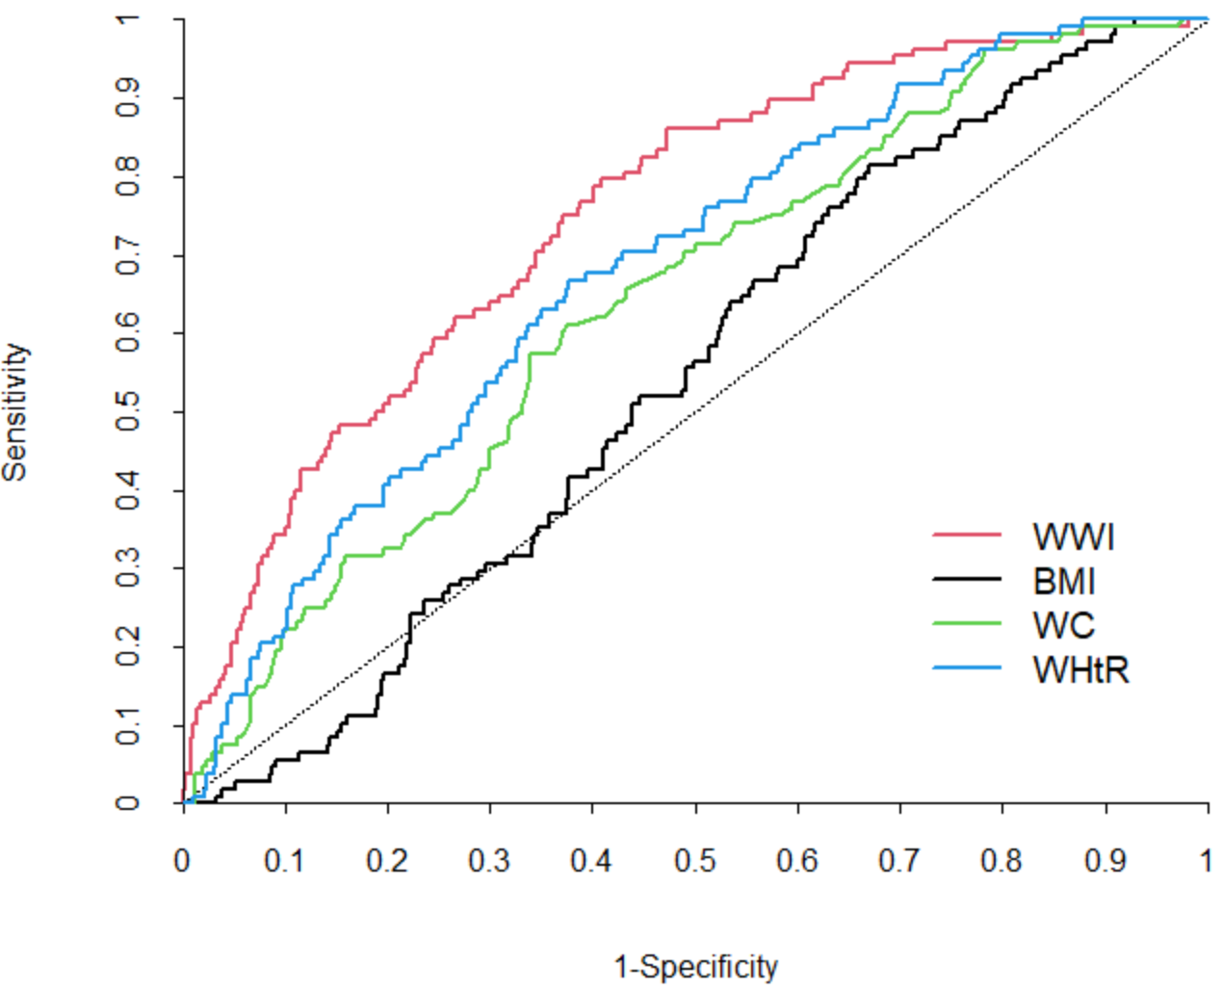 | 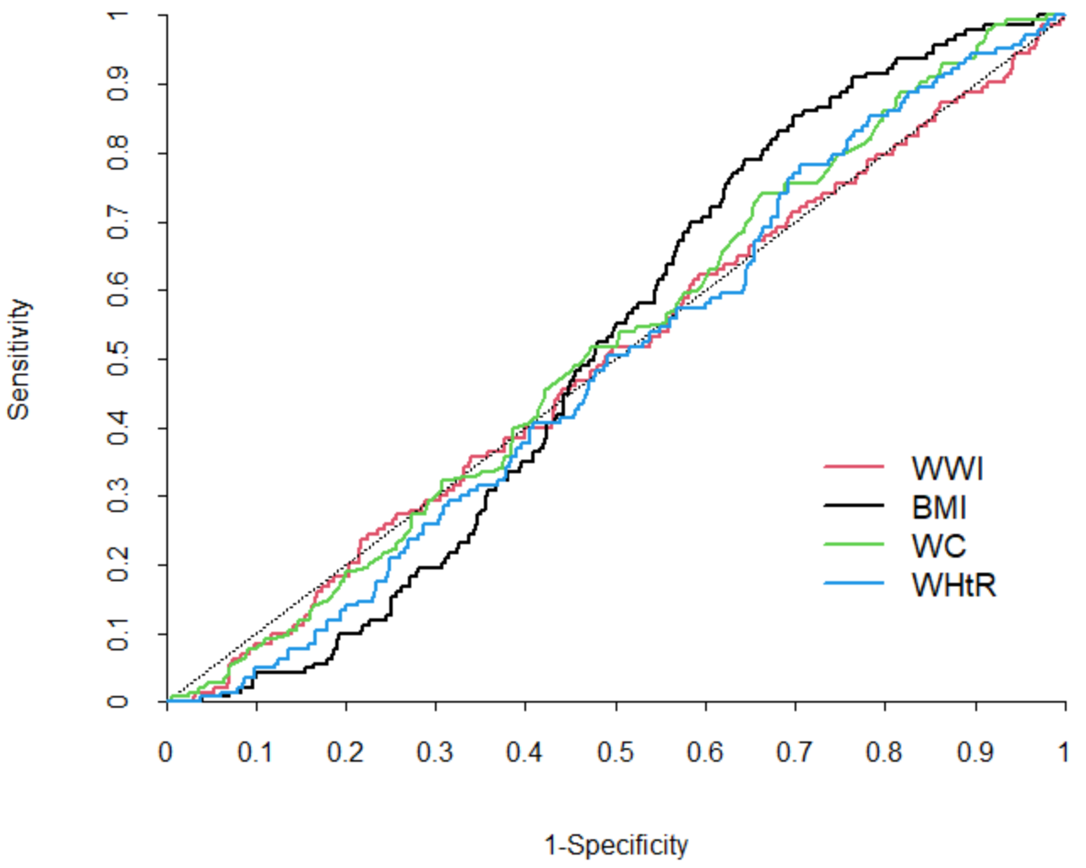
(B) Criterion 2
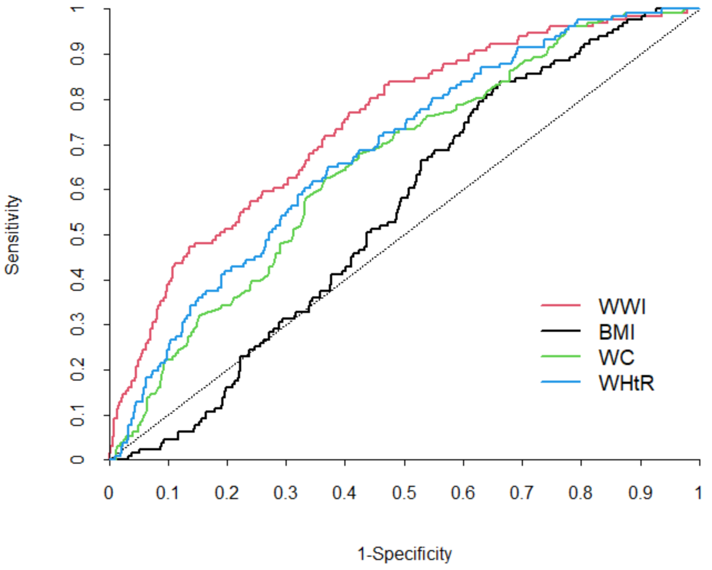 | 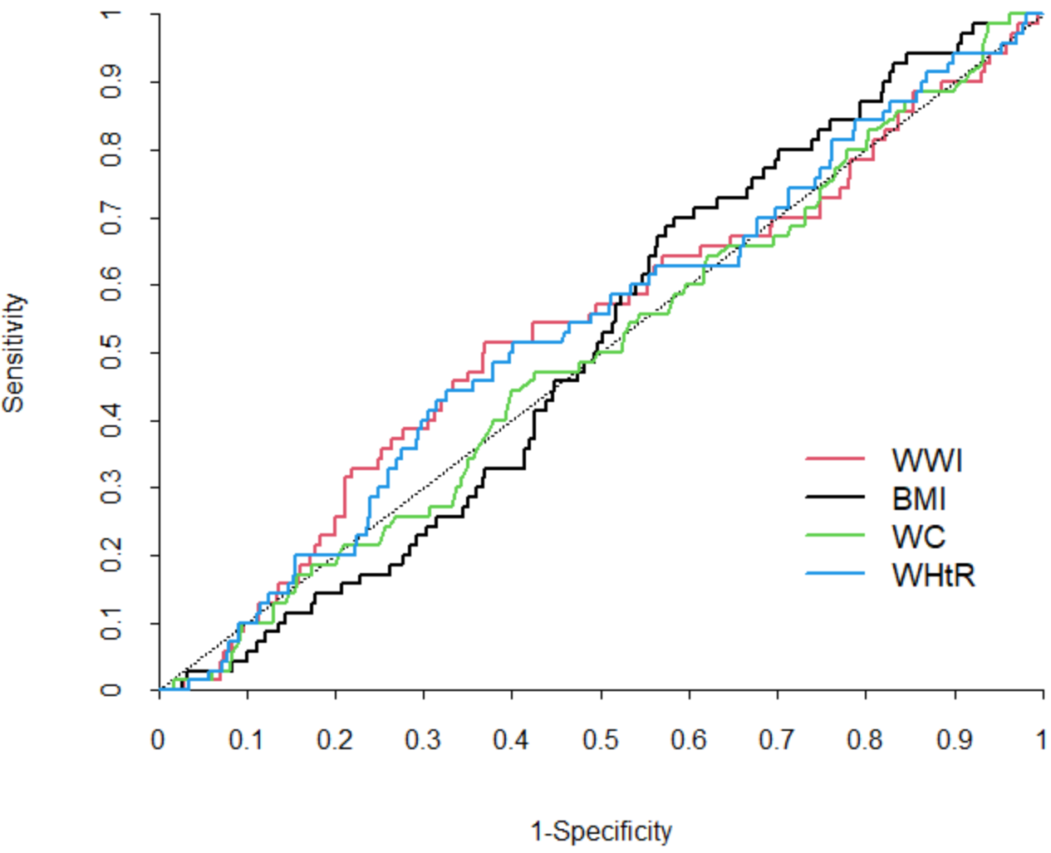
(C) Criterion 3
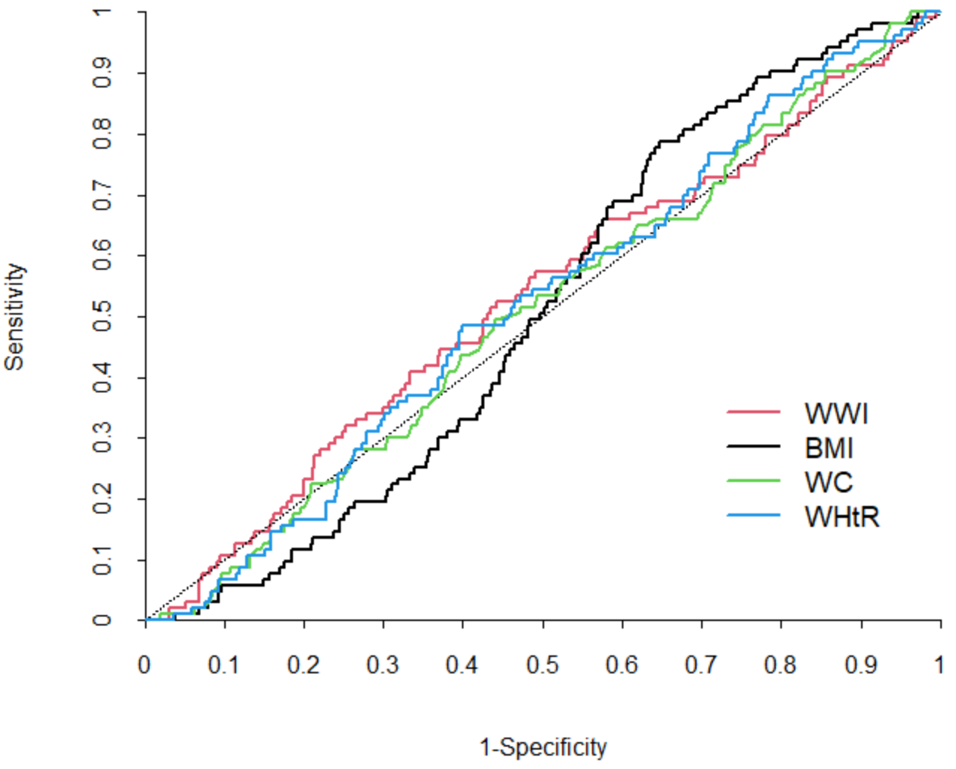
ROC, receiver operating characteristic; WWI, weight-adjusted waist index; BMI, body mass index; WC, waist circumference; WHtR, waist-to-height ratio.
Criterion 1: high fat mass + low muscle mass; Criterion 2: high fat mass + low muscle mass + low muscle strength and/or slow gait speed; Criterion 3: high fat mass + low muscle mass + low muscle strength and/or low physical performance.
High fat mass: body fat percentage of ≥28.2% for men and ≥38.8% for women; low muscle mass: appendicular skeletal muscle mass/height² of <7.00 kg/m² for men and <5.40 kg/m² for women; low muscle strength: grip strength of <28 kg for men and <18 kg for women; slow gait speed: 4-m usual gait speed of <1.0 m/s; low physical performance: five-times sit-to-stand test score of ≥12s, 4-m usual gait speed of <1.0 m/s, and/or short physical performance battery score of ≤9.

Supplementary Table S5. Unadjusted AUCs of the anthropometric indices for diagnosis of sarcopenic obesity
 | Criterion 1 | Criterion 2 | Criterion 3
Men, n (%) | 225 (21.8) | 108 (10.5) | 131 (12.7)
WWI
Unadjusted AUC (95% CI) | 0.683 (0.645–0.722) | 0.751 (0.706–0.797) | 0.743 (0.699–0.787)
BMI
Unadjusted AUC (95% CI) | 0.542 (0.505–0.579) | 0.542 (0.492–0.591) | 0.550 (0.505–0.595)
WC
Unadjusted AUC (95% CI) | 0.626 (0.588–0.663) | 0.639 (0.587–0.690) | 0.654 (0.608–0.701)
WHtR
Unadjusted AUC (95% CI) | 0.635 (0.597–0.673) | 0.679 (0.630–0.729) | 0.681 (0.636–0.727)
Women, n (%) | 143 (14.3) | 70 (7.0) | 103 (10.3)
WWI
Unadjusted AUC (95% CI) | 0.504 (0.454–0.555) | 0.533 (0.460–0.606) | 0.528 (0.468–0.587)
BMI
Unadjusted AUC (95% CI) | 0.516 (0.474–0.558) | 0.511 (0.451–0.571) | 0.507 (0.459–0.556)
WC
Unadjusted AUC (95% CI) | 0.516 (0.468–0.564) | 0.504 (0.435–0.572) | 0.508 (0.451–0.564)
WHtR
Unadjusted AUC (95% CI) | 0.509 (0.463–0.556) | 0.533 (0.463–0.603) | 0.518 (0.463–0.573)
AUC, area under the curve; WWI, weight-adjusted waist index; BMI, body mass index; WC, waist circumference; WHtR, waist-to-height ratio; CI, confidence interval.
Criterion 1: high fat mass + low muscle mass; Criterion 2: high fat mass + low muscle mass + low muscle strength and/or slow gait speed; Criterion 3: high fat mass + low muscle mass + low muscle strength and/or low physical performance.
High fat mass: body fat percentage of ≥28.2% for men and ≥38.8% for women; low muscle mass: appendicular skeletal muscle mass/height² of <7.00 kg/m² for men and <5.40 kg/m² for women; low muscle strength: grip strength of <28 kg for men and <18 kg for women; slow gait speed: 4-m usual gait speed of <1.0 m/s; low physical performance: five-times sit-to-stand test score of ≥12s, 4-m usual gait speed of <1.0 m/s, and/or short physical performance battery score of ≤9.

Supplementary Table S6. Optimal cut-off values for the anthropometric indices for the diagnosis of sarcopenic obesity in men according to Youden’s index
 | Criterion 1 | Criterion 2 | Criterion 3
Men, n (%) | 225 (21.8) | 108 (10.5) | 131 (12.7)
WWI
Optimal cut-off value | 10.95 | 10.96 | 10.96
Sensitivity (%) | 73.78 | 86.11 | 83.21
Specificity (%) | 53.53 | 52.71 | 53.27
BMI
Optimal cut-off value | 22.60 | – | 22.51
Sensitivity (%) | 81.78 | – | 83.97
Specificity (%) | 36.43 | – | 33.74
WC
Optimal cut-off value | 84.0 | 90.2 | 90.2
Sensitivity (%) | 88.44 | 61.11 | 62.60
Specificity (%) | 31.85 | 62.55 | 63.37
WHtR
Optimal cut-off value | 0.509 | 0.548 | 0.548
Sensitivity (%) | 88.89 | 66.67 | 64.89
Specificity (%) | 32.71 | 62.34 | 62.82
WWI, weight-adjusted waist index; BMI, body mass index; WC, waist circumference; WHtR, waist-to-height ratio.
Criterion 1: high fat mass + low muscle mass; Criterion 2: high fat mass + low muscle mass + low muscle strength and/or slow gait speed; Criterion 3: high fat mass + low muscle mass + low muscle strength and/or low physical performance.
High fat mass: body fat percentage of ≥28.2% for men and ≥38.8% for women; low muscle mass: appendicular skeletal muscle mass/height² of <7.00 kg/m² for men and <5.40 kg/m² for women; low muscle strength: grip strength of <28 kg for men and <18 kg for women; slow gait speed: 4-m usual gait speed of <1.0 m/s; low physical performance: five-times sit-to-stand test score of ≥12s, 4-m usual gait speed of <1.0 m/s, and/or short physical performance battery score of ≤9.

