Supplementary Material

Supplementary Figure 1. Energy intake (kcal/day) of each participant (n = 155) by study day, in each tertile of change in energy intake over time. (A) Tertile 1; (B) Tertile 2; (C) Tertile 3. Each line represents an individual participant. Participants in Tertile 1 were categorised as Reactive Reporters.
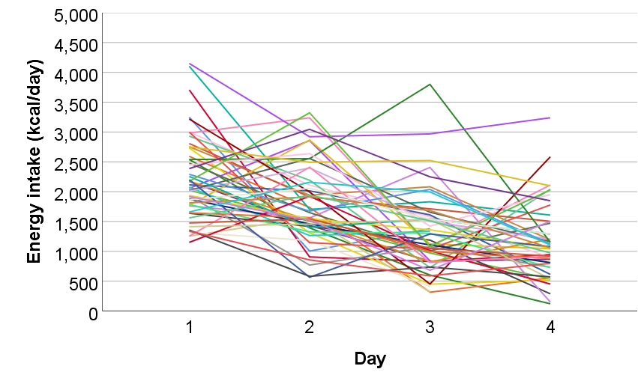 | 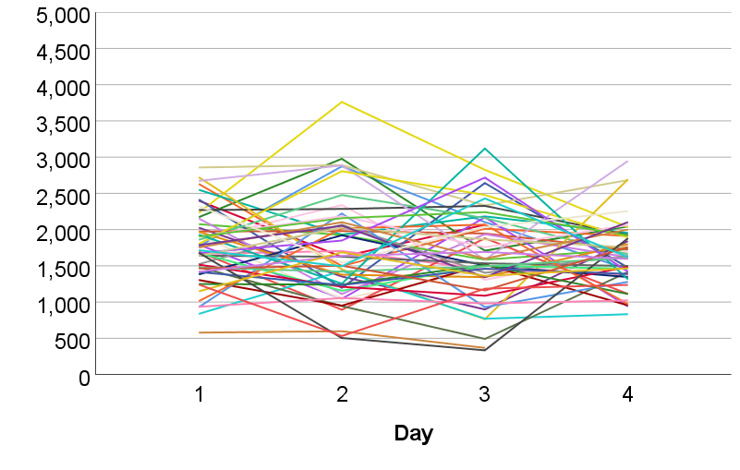 | 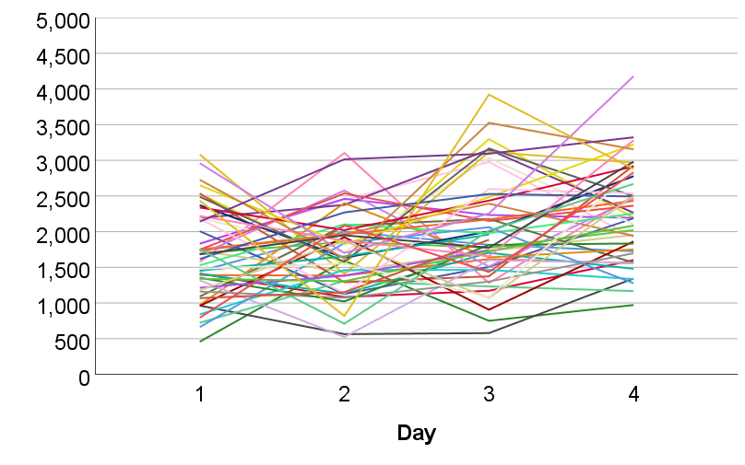
(A) | (B) | (C)

