Supplementary Material
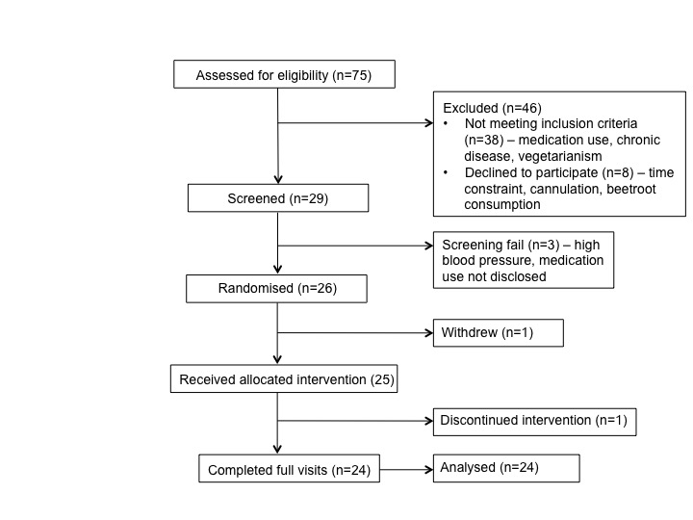
Figure S1: Flow chart of recruitment

Table S1: Changes in microvascular forearm blood flow measured by laser Doppler following post-occlusive reactive hyperaemia (PORH) after imputation of missing data points (see methods for details). 23 young and old participants were included in the analysis.
 | BR 100g |  |  | BR 200g |  |  | BR 300g |  |  | 1000mg KNO₃ |  |  | Time (T), p=0.70  Intervention (I), p=0.14  T*I, p=0.38
 |  |  |  |  |  |  | Minutes
 | 0 | 150 | 300 | 0 | 150 | 300 | 0 | 150 | 300 | 0 | 150 | 300
PORH | 3.62±4.76 | 3.14±4.76 | 3.32±1.07 | 3.38±4.08 | 3.40±3.33 | 3.54±4.69 | 2.88±3.19 | 2.79±4.11 | 3.18±4.11 | 3.24±3.60 | 3.46±5.27 | 3.18±5.06

Data presented as mean ± SD. BR = whole beetroot, KNO³ = potassium nitrate (positive control). Repeated measure-Anova was used to test the effects of Time, Intervention and their interaction (independent factors) on PROH (dependent variable). One participant had all PROH value missing.

Table S2: P values for model parameters for the repeated measure Anova testing whether randomisation sequence had a confounding effects on changes in systolic and diastolic blood pressure (BP)
Systolic BP | P
Time  Intervention  Sequence  Time*Sequence  Sequence*Intervention | <0.001  0.81  0.84  0.19  0.29
Diastolic BP | P
Time  Intervention  Sequence  Time*Sequence  Sequence*Intervention | <0.001  0.86  0.88  0.34  0.33

Table S3: Repeated-Measure Correlations (r_{rm}) testing the association between changes (∆) in diastolic blood pressure (DBP) with changes in nitrate (NO₃) and nitrite (NO₂) concentrations in young and old participants.
Young | ∆DBP _{300min - Bas} (mmHg) vs ∆NO_{3 Bas- 300min} (μmol/L) | r_{rm}(35) = -0.19, 95% CI [-0.495, 0.149], p = 0.251
 | ∆DBP _{300min - Bas} (mmHg) vs ∆NO_{2 Bas- 300min} (nmol/L) | r_{rm}(35) = -0.29, 95% CI [-0.567, 0.05], p = 0.084
Old | ∆DBP _{300min - Bas} (mmHg) vs ∆NO_{3 Bas- 300min} (μmol/L) | r_{rm}(35) = -0.24, 95% CI [-0.528, 0.105], p = 0.159
 | ∆DBP _{300min - Bas} (mmHg) vs ∆NO_{2 Bas- 300min} (nmol/L) | r_{rm}(35) = -0.32, 95% CI [-0.59, 0.016], p = 0.054
Bas, baseline. See methods for specific details on the analysis.

