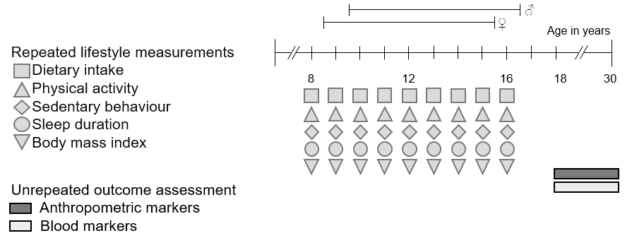
S1 Figure: Assessment time point of exposure and outcome within the DONALD study
Lifestyle factors were assessed – if available – repeatedly per individual. Anthropometric markers and blood markers were assessed once per individual. All available assessments of lifestyle factors prior to outcome assessment were used to construct the lifestyle score for each individual.

S1 Table: Participants reference fulfilment across categories of the lifestyle score (in %)
 | Lifestyle score categories (points)
 | 2-2.9 | 2-2.9 | 2-2.9 | 2-2.9 | P_{trend}²
Diet (recommended age-specific portions in ≥3 food groups/d)¹ | 3.3 | 3.0 | 11.5 | 69.2 | <0.0001
MVPA (≥ age-specific reference/d) | 3.3 | 4.0 | 21.9 | 61.5 | <0.0001
Sedentary behaviour (≤ age-specific reference/d) | 0 | 1.0 | 11.5 | 53.9 | <0.0001
Sleep duration (within age-specific reference/d) | 30.0 | 48.5 | 59.4 | 84.6 | 0.0004
BMI SDS (normal weight) | 16.7 | 63.4 | 85.4 | 92.3 | <0.0001
MVPA: moderate-to-vigorous physical activity, BMI: body mass index, SDS: standard deviation score. ¹Age-specific portion sizes were published elsewhere⁽¹⁾, ²P_{trend} was calculated using age- and sex-adjusted linear regression models.

S2 Table: Associations between adolescence lifestyle score and fatty liver indices in young adulthood using WHtR¹ in the adolescent lifestyle score instead of BMI SDS²
 |  | Basic model |  | Multivariable adjusted model
 | n | ß-estimate (95% CI) | p-Value | ß-estimate (95% CI) | p-Value
Overall
HSI | 240 | -6.7 (-9.4 to -4.0) | <0.0001 | -5.9 (-8.6 to -3.2) | <0.0001
FLI | 240 | -35.1 (-45.1 to -22.9) | <0.0001 | -32.4 (-42.9 to -20.0) | <0.0001
Men
HSI | 124 | -9.4 (-13.1 to -5.5) | <0.0001 | -8.7 (-12.5 to -4.7) | 0.0001
FLI | 124 | -46.6 (-58.0 to -32.1) | <0.0001 | -45.2 (-57.2 to -30.0) | <0.0001
Women
HSI | 116 | -2.9 (-6.5 to 0.9) | 0.13 | -2.1 (-5.7 to 1.7) | 0.27
FLI | 116 | -14.7 (-33.4 to 9.1) | 0.20 | -12.6 (-31.9 to 12.2) | 0.29
Associations were analysed using multiple linear regression. Values displayed in bold are significant at 0.05 significance level. Basic model: adjusted for age and sex (for all subjects only), Multivariable adjusted model: Basic model + additionally adjusted for maternal overweight. HSI: hepatic steatosis index, FLI: fatty liver index. WHtR: waist-to-height ratio. ¹Lifestyle score consists of the factors diet, moderate-to-vigorous physical activity, sedentary behaviour, sleep duration and WHtR. ²Log transformed ß values were back transformed.
S3 Table: Associations between modified version of the adolescence lifestyle score and fatty liver indices in young adulthood¹
 | Adolescent lifestyle score without diet |  | Adolescent lifestyle score without MVPA |  | Adolescent lifestyle score without sedentary behaviour |  | Adolescent lifestyle score without sleep duration |  | Adolescent lifestyle score without BMI SDS
 | ß (95% CI) | P-value | ß (95% CI) | P-value | ß (95% CI) | P-value | ß (95% CI) | P-value | ß (95% CI) | P-value
Overall
HSI | -6.0 (-9.0 to -3.0) | 0.0002 | -8.1 (-11.1 to -4.9) | <0.0001 | -6.9 (-9.8 to -4.0) | <0.0001 | -5.6 (-8.4 to -2.8) | 0.0002 | -2.8 (-5.4 to -0.2) | 0.0350
FLI | -37.7 (-48.8 to -24.2) | <0.0001 | -40.3 (-51.4 to -26.7) | <0.0001 | -38.0 (-48.8 to -24.9) | <0.0001 | -28.2 (-39.9 to -14.1) | 0.0003 | -17.6 (-30.0 to -3.0) | 0.0201
Men
HSI | -7.7 (-12.0 to -3.3) | 0.0010 | -10.8 (-15.2 to -6.3) | <0.0001 | -9.1 (-13.2 to -4.8) | 0.0001 | -7.5 (-11.5 to -3.4) | 0.0005 | -3.1 (-7.0 to 0.8) | 0.12
FLI | -49.9 (-61.5 to -34.8) | <0.0001 | -50.3 (-62.8 to -33.8) | <0.0001 | -45.8 (-58.4 to -29.3) | <0.0001 | -37.7 (-51.3 to -20.3) | 0.0002 | -20.2 (-35.7 to -1.1) | 0.0393
Women
HSI | -4.1 (-8.2 to 0.1) | 0.06 | -3.9 (-8.1 to 0.5) | 0.08 | -3.4 (-7.4 to 0.9) | 0.11 | -2.8 (-6.6 to 1.1) | 0.16 | -1.7 (-5.0 to 1.8) | 0.34
FLI | -20.7 (-40.7 to 6.1) | 0.12 | -21.6 (-41.9 to 5.7) | 0.11 | -23.3 (-42.3 to 1.9) | 0.07 | -11.5 (-31.9 to 15.1) | 0.36 | -8.4 (-28.5 to 17.3) | 0.48
Linear regression model was adjusted for age, sex (for all subjects only), maternal overweight and the omitted lifestyle factor (e.g. hours while sitting (h/d) or sleep duration (h/d)). Values displayed in bold are significant at 0.05 significance level. MVPA: moderate-to-vigorous physical activity, BMI: body mass index, SDS: standard deviation score, HSI: hepatic steatosis index, FLI: fatty liver index. ¹Log transformed ß values were back transformed.
S4 Table: Association between adolescent lifestyle score and fatty liver indices in young adulthood in different subsamples
Subsample | Risk factor | n | ß (95% CI) | P-value
≥2 assessments of each factor | Overall  HSI  FLI  Men  HSI  FLI  Women  HSI  FLI | 221  221  117  117  104  104 | -6.4 (-9.1 to -3.6)  -37.0 (-47.1 to -24.9)  -8.5 (-12.4 to -4.5)  -45.1 (-47.1 to -24.9)  -2.8 (-12.4 to 4.5)  -21.2 (-38.9 to 1.7) | <0.0001  <0.0001  0.0001  <0.0001  0.15  0.07
More correct than potentially underreported reported 3dWR | Overall  HSI  FLI  Men  HSI  FLI  Women  HSI  FLI | 217  217  107  107  110  110 | -5.4 (-8.1 to -2.6)  -29.2 (-40.9 to -15.1)  -7.1 (-11.0 to -2.9)  -37.9 (-51.8 to -20.1)  -2.9 (-6.6 to 1.1)  -13.5 (-33.9 to 13.2) | 0.0003  0.0002  0.0012  0.0003  0.15  0.29
Linear regression model was adjusted for age, sex (for all subjects only) and maternal overweight. Values displayed in bold are significant at 0.05 significance level. HSI: Hepatic steatoses index, FLI: Fatty liver index. ¹Log transformed ß values were back transformed.

1. Schnermann ME, Schulz CA, Herder C, et al. (2021) A lifestyle pattern during adolescence is associated with cardiovascular risk markers in young adults: results from the DONALD cohort study. J Nutr Sci;10:e92.

