Supplementary Tables
Supplementary Table 1 Intake of relevant food components in grams per day
 | Intake at baseline  N = 195 | Recommended intake
Vegetables | 126 [72 – 183] g/day | ≥ 200 g/day
Fruit | 139 [59 – 176] g/day | ≥ 200 g/day
Wholegrain products | 129 [87 – 189] g/day | ≥ 90 g/day
Legumes | 4.4 [0.0 – 17] g/day | ≥ 10 g/day
Nuts | 4.3 [1.4 – 16] g/day | ≥ 15 g/day
Dairy* | 169 [84 – 316] g/day | 300-450 g/day
Fish | 9.6 [5.8 – 15] g/day | ≥ 15 g/day
Red meat | 22 [7.2 – 43] g/day | ≤ 45 g/day
Processed meat | 25 [9.5 – 49] g/day | 0 g/day
Values expressed as median [IQR]. *Including milk, yoghurt and cheese products.
Supplementary Table 2 Factors associated with change in health-related quality of life over time
Variable * | β | 95% CI | P-value
Diet quality (total Eetscore) | 0.04 | 0.002; 0.07 | 0.04
Age (in years) | 0.09 | 0.01; 0.17 | 0.02
Female gender (vs. male) | – 2.79 | – 5.02; – 0.56 | 0.02
BMI (kg/m²) | – 0.43 | – 0.67; – 0.19 | < 0.001
Biologics as highest step-up | – 1.28 | – 3.51; 0.95 | 0.26
Clinically active disease (vs. clinical remission) | – 6.58 | – 5.85; – 5.32 | < 0.001
Bold values are significant. * Level of education was not associated with health-related quality of life in univariable analysis and therefore not included in the multivariable model.
Supplementary Figures
Supplementary Figure 1 Diet quality score of an individual participant as shown in the Eetscore tool
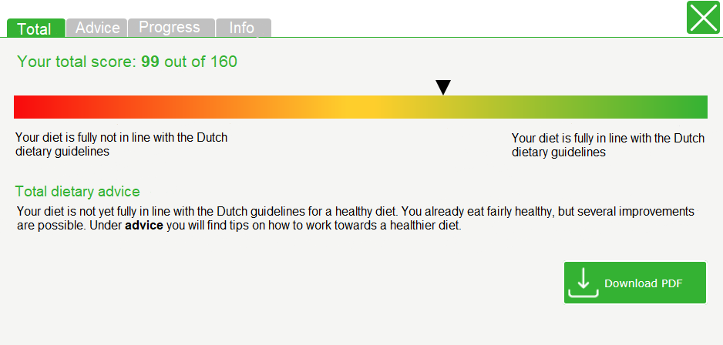
Supplementary Figure 2 Personalised dietary advice of an individual participant as shown in the Eetscore tool
