Participants in the baseline survey (n=215,251)

Not one of the five main racial and ethnic groups (n=5,265)
Five main racial and ethnic groups (n=92,949)
Participants in the 10-year follow-up survey (n=98,214)
Final analysis (n=56,263)
No previous heart disease or cancer (n=63,188)
Valid diet (n=87,021)

Implausible diet (n=5,298)
at either survey

Heat disease or cancer (n=23,833) at either survey

Missing BMI (n=5,058) or smoking (n=1,867) at follow-up

Supplementary Figure 1. Flow diagram summarizing inclusion and exclusion criteria

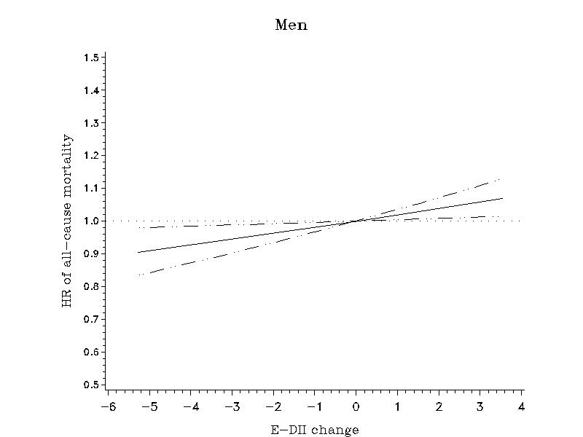 | 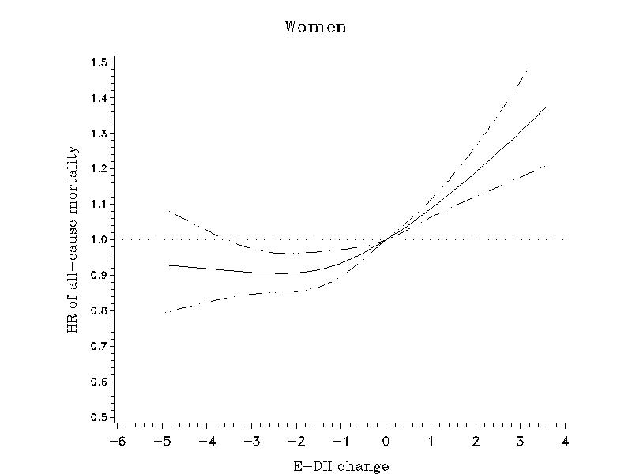
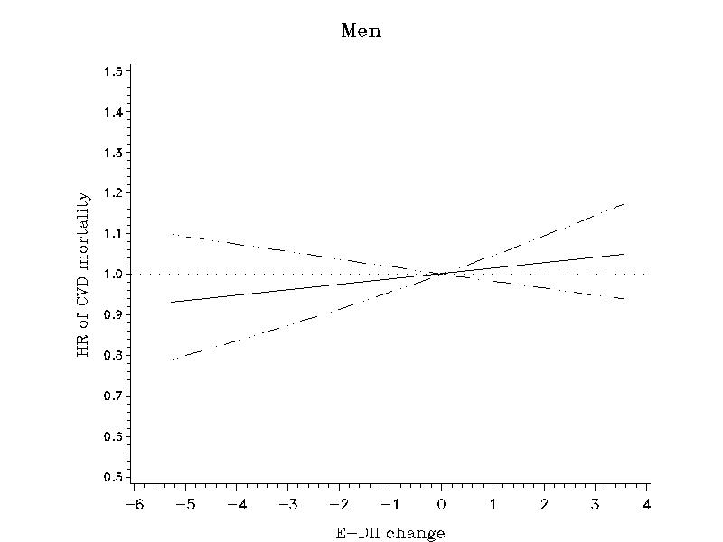 | 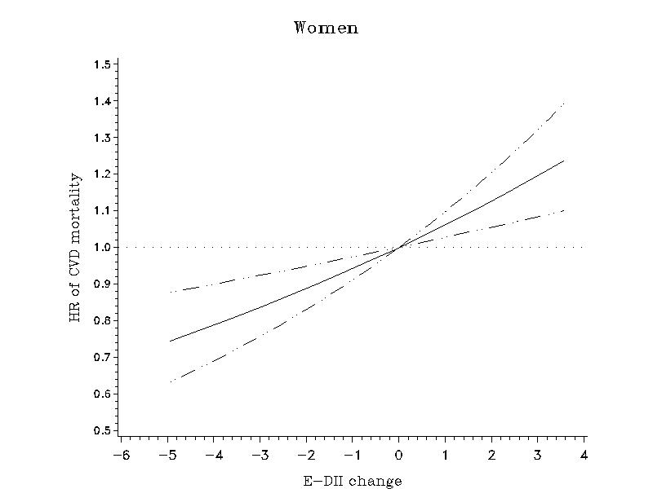
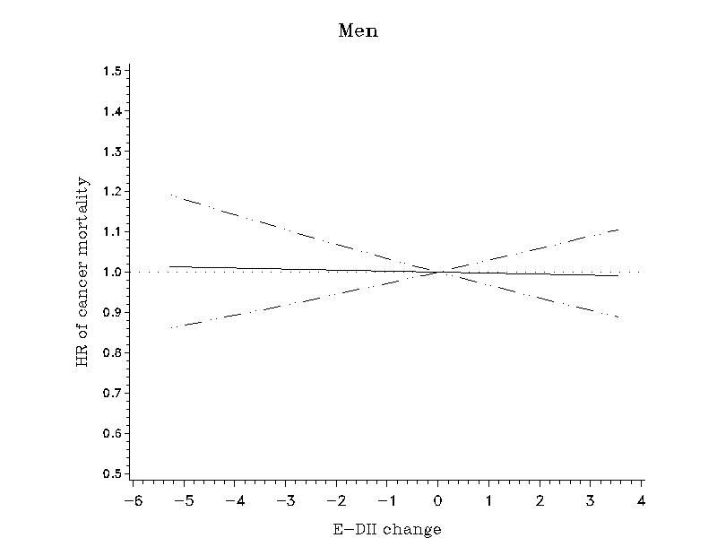 | 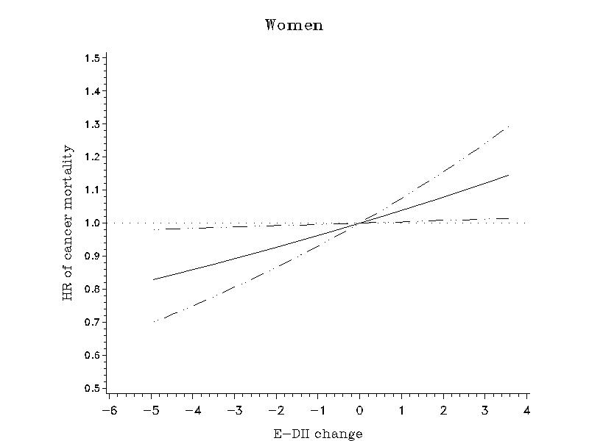
Supplementary Figure 2. Multivariate association between DII change and subsequent mortality in the Multiethnic Cohort Study. Association estimated by Cox regression based on restricted cubic splines. Dashed lines represent 95% CIs for adjusted estimates.

