Mela et al, “Dose-response efficacy of mulberry fruit extract for reducing post-prandial blood glucose and insulin responses: Randomized trial evidence in healthy adults”

Supplementary tables and figures (in order of reference in manuscript)

Table S1. Inclusion and exclusion criteria.
Subjects who met the following criteria could be included in the study:
- Willing and able to give consent to participate in the study in writing
- Age >20 and <50 yr
- Body Mass Index (BMI) ≥18 and ≤25 kg/m²
- Volunteer apparently healthy [No medical conditions which might affect study measurement, as judged by study physician or measured by questionnaire, and/or assessed by haematology, blood chemistry and urinalysis]
- Willing to comply to study protocol
- Agree to be informed by study physician about medically-relevant personal test results
- Willing to refrain from drinking alcohol the day of and one day before blood withdrawals
- Fasting blood glucose value >3.4 and <6.1 mmol/ litre (62-110 mg/dl)
- Haemoglobin level within normal reference range as judged by the research physician
- Literate

Subjects who met any of the following criteria were excluded from the study:
- Employee of Unilever, Hindustan Lever, or Lambda Therapeutics Research
- Smoking or consumption of tobacco in any form, and/or was smoking or consuming tobacco in any form within 6 months preceding the study and/or smoking or consuming tobacco in any form, during the study
- Participated in any other biomedical study within 3 months before screening visit day for this study and/or participating in any other biomedical study during the study period
- Alcohol intake > 120 ml/week
- On a medically prescribed/slimming diet
- Work in night shifts (between 23.00 and 6.00 hrs) in the week preceding or during the study
- Use of any medication including traditional medicines, vitamins or tonics which might interfere with study measurements, as judged by the PI and/or study physician?
- Engaging in intense exercise >10h/week (defined as exercise which induces sweating and causes sufficient breathlessness to limit conversation)
- Reported weight loss/gain >10% of body weight in the 6 months preceding screening
- Blood donation within 2 months prior to screening visit
- Evidence of drug abuse based on urine analysis
- Allergy to any food or cosmetics
- Pregnant or planning pregnancy during the study period
- Lactating or has been lactating within 6 weeks before pre-study investigation and/or during the study period

Table S2. Time and event schedule for volunteers.
Screening Visit 1
Age, identity and literacy proof
1st informed consent form (for screening)
Weight, height, physical examination and medical history
Alcohol breath and drug abuse test
Urine pregnancy test
Blood sampling (8 ml for fasting blood glucose and other screening tests)
Lunch

Screening Visit 2
Verification of identify
2nd informed consent form (for study participation)
Inclusion/exclusion criteria
Instructions for subsequent steps

Intervention Visits (Visits 3 to 6, 2 days each)

Day 1 (Check-in day)
Arrive on site ~18:00
Verification of identity
Health and compliance check
Alcohol breath test
Pregnancy test
Allocation to wards
Dinner with standardized meals* (20:00-21.00 hr)

Day 2 (Treatment day)
(Trial 1 only:) Baseline gastrointestinal symptoms questionnaire (-60 min)
(Trial 1 only:) Baseline breath hydrogen test (-20 minutes)
Fasting blood samples (2 samples at -15 min)
Test product intake (0 to +15 min)
Blood sampling (+15, 30, 45, 60, 90, 120, and 180 min)
(Trial 1 only:) Breath hydrogen test (+65, 125, 185, 245, 305, 365, and 425 min)
(Trial 1 only:) Gastrointestinal symptom questionnaire (+ 430 mins)
Instruction to subjects for wash out period and for next visit
Check-out from the facility
Check-out from the facility

Post-study
Follow up telephone call (~1 week after last study visit)

*Subjects were provided with a standardized dinner to consume between 20.00 and 21.00 on the evening preceding all four treatment days. The actual quantity of food consumed by each subject prior to their initial treatment visit was recorded, and on subsequent visits, the same quantity of this identical meal was served to the subject. Subjects were not permitted to take any other food or beverage, except water, after dinner, until the test meal was provided after baseline samples were taken in the morning of each treatment day.

Figure S1. Trial 1: Overview of subjects screened, randomized and entering the study.

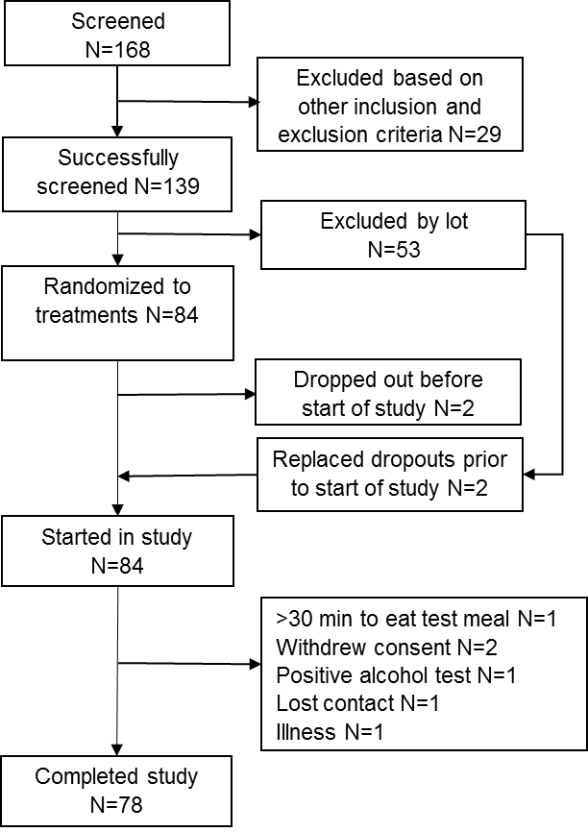

Figure S2. Trial 2: Overview of subjects screened, randomized and entering the study.

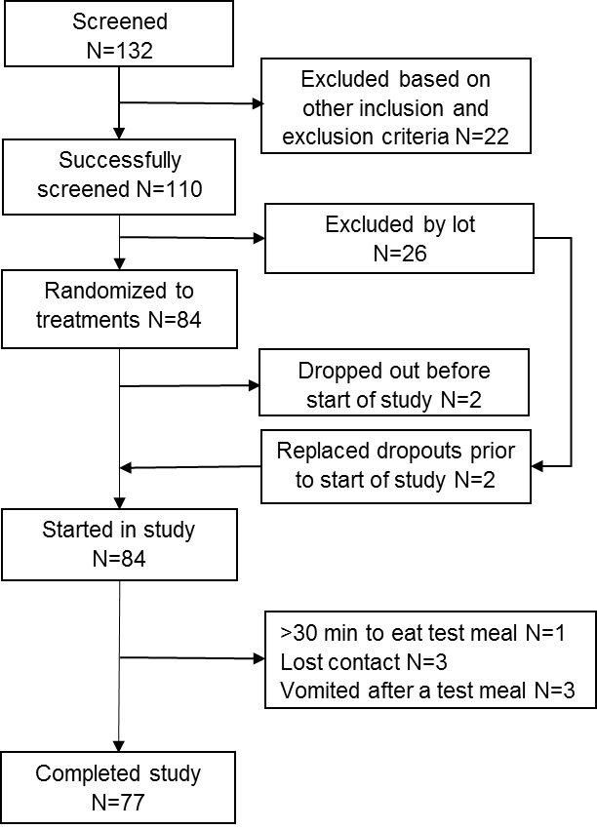

Table S3. Trial 1: Mean and standard deviation (SD) age, body weight and BMI of subjects receiving each study test product combination of rice porridge (RP) or boiled rice (BR) alone or with additions of mulberry fruit extract (MFE).
Intervention | N (Male) | Age |  | Weight (kg) |  | BMI, kg/m²
 |  | Mean | SD | Mean | SD | Mean | SD
BR alone | 47 (23) | 33.2 | 7.0 | 58.8 | 9.4 | 22.9 | 2.0
BR + 0.37 g MFE | 44 (23) | 33.8 | 6.9 | 58.6 | 7.9 | 22.9 | 2.0
BR + 0.75 g MFE | 46 (25) | 32.8 | 6.9 | 57.7 | 8.5 | 22.1 | 2.1
BR + 1.12 g MFE | 45 (24) | 33.1 | 6.8 | 58.6 | 8.7 | 22.5 | 2.3
BR + 1.50 g MFE | 47 (25) | 34.1 | 6.5 | 57.7 | 8.3 | 22.9 | 2.0
RP alone | 45 (22) | 32.7 | 5.9 | 57.7 | 9.3 | 22.8 | 2.2
RP + 1.5 g MFE | 44 (22) | 32.4 | 6.5 | 57.2 | 9.1 | 22.6 | 2.3

Table S4. Trial 1: Mean and standard deviation (SD) maximum post-prandial glucose concentration (Cmax, mmol/L, baseline adjusted) and time to reach maximum concentration (Tmax, min) following consumption of rice porridge (RP) or boiled rice (BR) alone or with additions of mulberry fruit extract (MFE).
Intervention | N | Baseline adjusted Cmax, mmol/L |  | Tmax, min
 |  | Mean | SD | Mean | SD
BR alone | 47 | 2.73 | 1.01 | 44.0 | 16.4
BR + 0.37 g MFE | 44 | 2.22 | 1.00 | 45.0 | 18.9
BR + 0.75 g MFE | 46 | 1.91 | 1.14 | 52.2 | 22.1
BR + 1.12 g MFE | 45 | 1.81 | 0.93 | 53.0 | 20.4
BR + 1.50 g MFE | 47 | 1.68 | 0.80 | 55.5 | 17.7
RP alone | 45 | 3.15 | 1.32 | 47.0 | 16.2
RP + 1.5 g MFE | 44 | 2.29 | 1.05 | 50.1 | 17.4

Table S5. Trial 1: Plasma glucose positive incremental area under the curve for 3 hours (+iAUC_{3hr}) following consumption of rice porridge (RP) or boiled rice (BR) alone or with additions of mulberry fruit extract (MFE).
Intervention | N | Glucose +iAUC_{3hr} adjusted for baseline, min.mmol/L |  | Percent difference from control |  | Adjusted p-value vs control
 |  | Mean | Lower, upper  95% CI | Mean | Lower, upper 95% CI
BR alone | 47 | 143.3 | 123.4, 166.6
BR + 0.37 g MFE | 44 | 111.9 | 96.0, 130.4 | -21.9 | -36.9, -3.4 | 0.043
BR + 0.75 g MFE | 46 | 115.7 | 99.5, 134.6 | -19.3 | -34.6, -0.3 | 0.093
BR + 1.12 g MFE | 45 | 110.9 | 95.3, 129.1 | -22.6 | -37.3, -4.5 | 0.030
BR + 1.50 g MFE | 47 | 111.5 | 96.0, 129.5 | -22.2 | -36.8, -4.3 | 0.032
RP alone | 45 | 168.9 | 145.2, 196.5
RP + 1.5 g MFE | 44 | 136.2 | 116.9, 158.7 | -19.4 | -31.5, -5.1 | 0.031

Table S6. Trial 1: Serum insulin total area under the curve for 3 hours (tAUC_{3hr}) following consumption of rice porridge (RP) or boiled rice (BR) alone or with additions of mulberry fruit extract (MFE).
Intervention | N | Insulin tAUC_{3hr} adjusted for baseline, min.mIU/L |  | Percent difference from control |  | Adjusted p-value vs control
 |  | Mean | Lower, upper 95% CI | Mean | Lower, upper 95% CI
BR alone | 47 | 5999 | 5551, 6483
BR + 0.37 g MFE | 44 | 5187 | 4793, 5615 | -13.5 | -21.9, -4.3 | 0.008
BR + 0.75 g MFE | 46 | 5061 | 4681, 5471 | -15.6 | -23.7, -6.8 | 0.001
BR + 1.12 g MFE | 45 | 4684 | 4330, 5066 | -21.9 | -29.4, -13.7 | <0.001
BR + 1.50 g MFE | 47 | 4731 | 4379, 5113 | -21.1 | -28.6, -12.9 | <0.001
RP alone | 45 | 8762 | 8100, 9477
RP + 1.5 g MFE | 44 | 6055 | 5595, 6553 | -30.9 | -36.1, -25.3 | <0.001

Figure S3. Mean unadjusted post-prandial glucose and insulin (PPG and PPI) responses per timepoint following the addition of different doses of mulberry fruit extract (MFE) to boiled rice (BR, trials 1 and 2) or rice porridge (RP, trial 1 only).

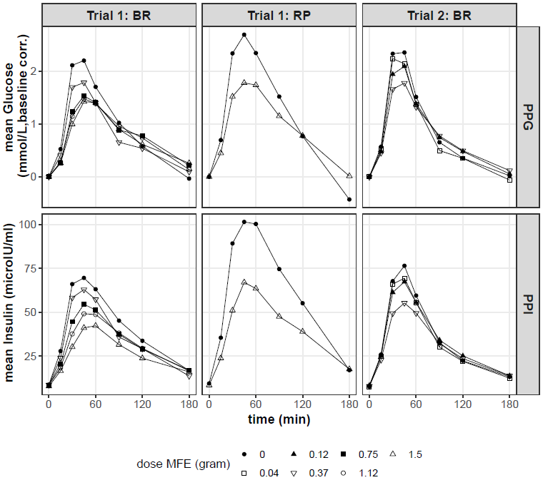

Figure S4. Mean and 95%CI percent change (i.e., reductions) relative to control in post-prandial glucose (positive incremental area under the curve, +iAUC) and insulin (total area under the curve, tAUC) over 2 hours following the addition of different doses of mulberry fruit extract (MFE) to boiled rice (BR, trials 1 and 2) or rice porridge (RP, trial 1 only).
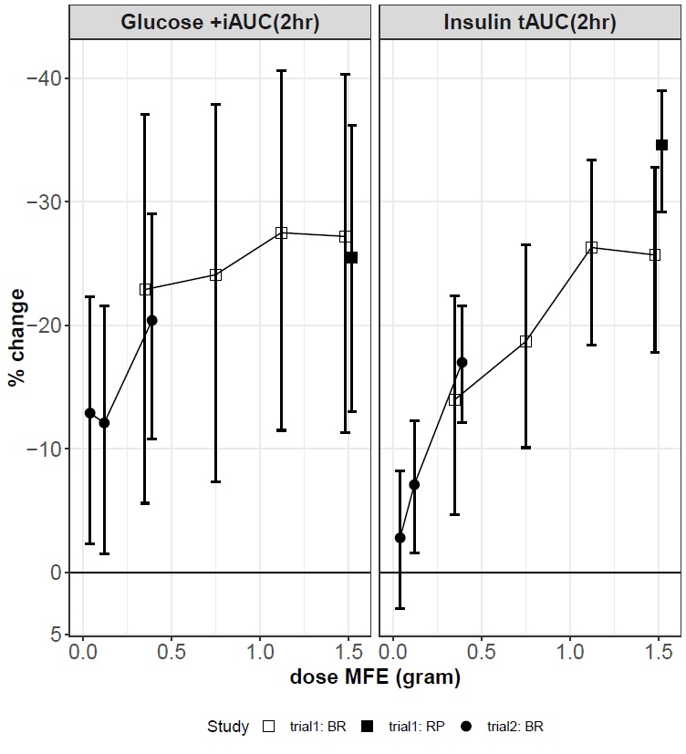

Table S7. Trial 1: Gastrointestinal complaints recorded in the 7 hour period following consumption of rice porridge (RP) or boiled rice (BR) alone or with additions of mulberry fruit extract (MFE).

Intervention |  | Percent of subjects reporting mild complaints*
 | N | Bloating | Flatulence | Nausea | Pain
BR alone | 47 | 1 | 0 | 1 | 0
BR + 0.37 g MFE | 44 | 1 | 3 | 3 | 0
BR + 0.75 g MFE | 46 | 0 | 0 | 0 | 0
BR + 1.12 g MFE | 44 | 1 | 0 | 0 | 0
BR + 1.50 g MFE | 46 | 1 | 0 | 0 | 0
RP alone | 45 | 0 | 0 | 1 | 1
RP + 1.5 g MFE | 44 | 2 | 2 | 1 | 0

*no moderate or severe complaints were reported

