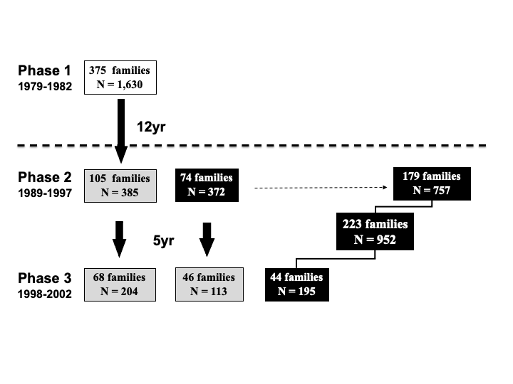
Supplementary Figure 1: The Quebec Family Study (QFS) design
QFS is an observational study with three phases of data collection (NCT03355729). The dotted line between Phase 1 and Phases 2 and 3 illustrates the modification in the sampling procedure that was introduced in Phase 2 to recruit families ascertained for obesity. The grey boxes represent the maximum number of subjects and families with longitudinal data: 498 subjects with data on two time points and 204 subjects with data on three time points. The black boxes represent the maximum number of families and subjects with cross-sectional data: a total of 952 subjects from 223 families. DNA samples are available on a maximum of 939 subjects.

