Supplementary tables

Table S1. Formulation and chemical composition of the experimental diets (4-mm pellet; fish weight ~200 g; October 2017 to January 2018).
 | Dietary EPA + DHA levels (%)
Formulation† | 1.0 | 1.3 | 1.6 | 3.5
Rapeseed oil, crude¹ | 21.6 | 20.1 | 18.6 | 8.7
Soya protein concentrate | 22.8 | 25.4 | 26.4 | -
Wheat¹ | 13.1 | 11.3 | 11.3 | -
Fish oil² | 2.3 | 4.8 | 6.3 | 9.5
Wheat gluten³ | 12.1 | 9.6 | 9.1 | -
Fish meal² | 15.0 | 15.0 | 15.0 | 41.5
Maize gluten⁴ | 5 | 5 | 5 | -
Pea protein⁵ | 4 | 5 | 5 | -
Monocalcium phosphate | 1.5 | 1.5 | 1.4 | -
Vitamin and mineral premix⁶ | 0.8 | 0.8 | 0.8 | 1.8
Amino acids⁷ | 2.0 | 2.0 | 1.8 | 0.6
Lucatin Pink CWD, 10% | 0.06 | 0.06 | 0.06 | -
Lucatin Pink CWD, 20% | - | - | - | 0.001
Water change | -0.8 | -0.7 | -0.7 | -0.2
Chemical composition
Moisture (%) | 6 | 6 | 6 | 6
Energy, crude (MJ/kg) | 23.1 | 23.2 | 23.3 | 23.6
Protein, crude (%) | 42.9 | 43.2 | 43.0 | 45.2
Fat, crude (%) | 27.9 | 28.3 | 28.3 | 27.7
Ash (%) | 6.2 | 6.4 | 6.3 | 8.4
†g/100 g feed
¹Denmark; ²Peru/Denmark; ³EU; ⁴Ukraine; ⁵China; ⁶Sweden; ⁷Germany/Korea/China

Table S2. Formulation and chemical composition of the experimental diets (6-mm pellet; fish weight ~500 g; January 2018 to April 2018).

 | Dietary EPA + DHA levels (%)
Formulation† | 1.0 | 1.3 | 1.6 | 3.5
Rapeseed oil, crude¹ | 24.1 | 22.1 | 20.7 | 15.6
Soya protein concentrate | 30 | 30 | 30 | 30
Wheat¹ | 11.3 | 11.3 | 11.3 | 11.3
Fish oil² | 3.4 | 5.4 | 6.8 | 11.8
Wheat gluten³ | 8.9 | 9.6 | 9.6 | 5.8
Fish meal² | 11 | 10 | 10 | 10
Maize gluten⁴ | 5 | 5 | 5 | 5
Pea protein⁵ | - | - | - | 5
Sunflower expeller | 3.0 | 3.0 | 3.1 | 2.6
Monocalcium phosphate | 1.3 | 1.4 | 1.4 | 1.4
Vitamin and mineral premix⁶ | 0.9 | 0.9 | 0.9 | 0.9
Amino acids⁷ | 1.6 | 1.7 | 1.7 | 1.4
Lucatin Pink CWD, 10% | 0.06 | 0.06 | 0.06 | 0.06
Water change | -0.47 | -0.43 | -0.44 | -0.58
Chemical composition
Moisture (%) | 6 | 6 | 6 | 6
Energy, crude (MJ/kg) | 24.5 | 24.5 | 24.5 | 24.5
Protein, crude (%) | 39.5 | 39.5 | 39.4 | 39.5
Fat, crude (%) | 30.4 | 30.4 | 30.4 | 30.4
Ash (%) | 5.8 | 5.8 | 5.7 | 5.7
†g/100 g feed
¹Denmark; ²Peru/Denmark; ³EU; ⁴Ukraine; ⁵China; ⁶Sweden; ⁷Germany/Korea/China

Table S3. Formulation and chemical composition of the experimental diets (9-mm pellet; fish weight ~1,000 g; April 2018 to August 2018).

 | Dietary EPA + DHA levels (%)
Formulation† | 1.0 | 1.3 | 1.6 | 3.5
Rapeseed oil, crude¹ | 25.9 | 24.3 | 22.8 | 14.9
Soya protein concentrate | 11.4 | 11.4 | 11.4 | 9.8
Guar meal² | 20 | 20 | 20 | 20
Wheat¹ | 10.8 | 10.8 | 10.8 | 11.5
Fish oil³ | 4.3 | 5.8 | 7.3 | 15
Wheat gluten⁴ | 2.2 | 2.2 | 2.2 | 2.8
Fish meal³ | 5 | 5 | 5 | 5
Maize gluten⁵ | 5 | 5 | 5 | 5
Vitamin and mineral premix⁶ | 2.9 | 2.9 | 2.9 | 2.9
Amino acids⁷ | 1.3 | 1.3 | 1.3 | 1.4
Lucatin Pink CWD, 10% | 0.06 | 0.06 | 0.06 | 0.06
Water change | 0.5 | 0.5 | 0.5 | 0.5
Chemical composition
Moisture (%) | 6 | 6 | 6 | 6
Energy, crude (MJ/kg) | 25.3 | 25.3 | 25.3 | 25.3
Protein, crude (%) | 36.2 | 36.2 | 36.2 | 36.2
Fat, crude (%) | 34.7 | 34.7 | 34.7 | 34.6
Ash (%) | 5.5 | 5.5 | 5.5 | 5.5
†g/100g feed
¹Denmark; ²India; ³Peru/Denmark; ⁴EU; ⁵Ukraine; ⁶Sweden; ⁷Germany/Korea/China

Table S4. Formulation and chemical composition of the experimental diets (9-mm pellet; fish weight ~2,500 g; August 2018 to September 2018).

 | Dietary EPA + DHA levels (%)
Formulation† | 1.0 | 1.3 | 1.6 | 3.5
Rapeseed oil, crude¹ | 30.6 | 29.1 | 27.8 | 19.6
Soya protein concentrate | 11.0 | 8.4 | 8.4 | 3.1
Guar meal | 17.6 | 20.0 | 20.0 | 20.0
Wheat¹ | 10.9 | 10.8 | 10.8 | 13.8
Fish oil² | 3.8 | 5.1 | 6.4 | 14.2
Wheat gluten³ | 6.9 | 7.0 | 6.9 | 9.4
Fish meal² | 5 | 5 | 5 | 5
Maize gluten⁴ | 5 | 5 | 5 | 5
Pea protein⁵ | 5 | 5 | 5 | 6
Monocalcium phosphate | 1.3 | 1.3 | 1.3 | 1.3
Vitamin and mineral premix⁶ | 1.7 | 1.7 | 1.7 | 1.7
Amino acids⁷ | 1.0 | 1.1 | 1.1 | 1.3
Lucatin Pink CWD, 20% | 0.03 | 0.03 | 0.03 | 0.03
Water change | 0.5 | 0.6 | 0.6 | 0.6
Chemical composition
Moisture (%) | 6 | 6 | 6 | 6
Energy, crude (MJ/kg) | 26.1 | 26.1 | 26.1 | 26.0
Protein, crude (%) | 33.5 | 33.6 | 33.6 | 33.5
Fat, crude (%) | 38.2 | 38.2 | 38.2 | 37.7
Ash (%) | 4.5 | 4.5 | 4.5 | 4.3
†g/100 g feed
¹Denmark; ²Peru/Denmark; ³EU; ⁴Ukraine; ⁵China; ⁶Sweden; ⁷Germany/Korea/China

Melanin adipose tissue
 |  | Score 1 |  | Clear white fat
 |  | Score 2 |  | Whitish, few dark spots
 |  | Score 3 |  | Pale grey, many dark spots
Melanin Heart
 |  | Score 1 |  | No fat deposits with melanin
 |  | Score 2 |  | Fat deposits with melanin
Heart shape
 |  | Score 1 |  | Normal, deep red, pear-shaped, little fat deposit stands on its point.
 |  | Score 2 |  | Slight pink, focal fat deposits.
 |  | Score 3 |  | Multifocal fat deposits, loss of shape.
 |  | Score 4 |  | Rounded, multiple fat deposits, small, does not hold shape
Stomach inflammation
 |  | Score 1 |  | Normal, pale,
 |  | Score 2 |  | Slight pink, focal patches
 |  | Score 3 |  | Multifocal patches
 |  | Score 4 |  | Dark red, diffuse patches
Table S5. Welfare indicator scoring system developed by Biomar AS, Norway.

Table S6. Total lipid content and fatty acid composition (% of total) in the livers of Atlantic salmon fed different experimental diets. Data are shown as mean ± SEM (n = 3 cages).
 | 1.0% EPA + DHA | 1.3% EPA + DHA | 1.6% EPA + DHA | 3.5% EPA + DHA | P-value (ANOVA)
Total fat | 10.5 ± 0.80^{ab} | 12.4 ± 1.86ª | 10.1 ± 0.57^{ab} | 6.0 ± 0.45^{b} | 0.0164
14:0 | 0.7 ± 0.01ª | 0.8 ± 0.02^{ab} | 0.9 ± 0.02^{b} | 1.4 ± 0.05^{c} | <0.0001
16:0 | 5.9 ± 0.17ª | 5.6 ± 0.54ª | 5.8 ± 0.08ª | 9.9 ± 0.28^{b} | <0.0001
18:0 | 3.5 ± 0.08^{ab} | 3.6 ± 0.13^{ab} | 3.4 ± 0.12ª | 4.5 ± 0.44^{b} | 0.0345
Σ SFA¹ | 10.7 ± 0.26ª | 10.6 ± 0.76ª | 10.7 ± 0.19ª | 16.7 ± 0.72^{b} | <0.0001
16:1 n-7 | 1.1 ± 0.21ª | 1.1 ± 0.06ª | 1.4 ± 0.10^{ab} | 1.9 ± 0.10^{b} | 0.0084
18:1 n-9 | 44.2 ± 0.77ª | 45.0 ± 1.49ª | 42.5 ± 0.89ª | 26.3 ± 0.61^{b} | <0.0001
18:1 n-7 | 3.0 ± 0.02ª | 3.1 ± 0.05^{ab} | 3.2 ± 0.04^{b} | 3.1 ± 0.05^{ab} | 0.0430
20:1 n-9 | 4.4 ± 0.02 | 4.8 ± 0.16 | 4.5 ± 0.13 | 4.2 ± 0.12 | 0.0681
22:1 n-7 | 0.8 ± 0.05 | 0.8 ± 0.06 | 0.8 ± 0.03 | 0.9 ± 0.02 | 0.1413
22:1 n-11 | 0.1 ± 0.00ª | 0.1 ± 0.01ª | 0.2 ± 0.01ª | 0.6 ± 0.07^{b} | <0.0001
Σ MUFA² | 55.1 ± 0.69ª | 56.3 ± 1.52ª | 53.7 ± 1.05ª | 38.9 ± 0.89^{b} | <0.0001
18:2 n-6 | 14.0 ± 0.38ª | 13.8 ± 0.27ª | 13.3 ± 0.15ª | 8.4 ± 0.15^{b} | <0.0001
20:2 n-6 | 2.3 ± 0.05ª | 2.5 ± 0.05ª | 2.5 ± 0.05ª | 2.1 ± 0.04^{b} | 0.0009
20:3 n-6 | 1.0 ± 0.00ª | 0.8 ± 0.06^{b} | 0.6 ± 0.01^{b} | 0.3 ± 0.02^{c} | <0.0001
20:4 n-6 | 0.9 ± 0.21^{ab} | 0.6 ± 0.10ª | 0.8 ± 0.05^{ab} | 1.4 ± 0.16^{b} | 0.0211
18:3 n-3 | 4.3 ± 0.07ª | 4.4 ± 0.27ª | 4.6 ± 0.10ª | 2.7 ± 0.07^{b} | <0.0001
20:3 n-3 | 0.6 ± 0.03 | 0.8 ± 0.06 | 0.7 ± 0.14 | 0.6 ± 0.01 | 0.5055
20:5 n-3 | 3.1 ± 0.24ª | 2.8 ± 0.36ª | 3.5 ± 0.21ª | 7.4 ± 0.36^{b} | <0.0001
22:5 n-3 | 0.9 ± 0.06ª | 0.8 ± 0.12ª | 1.0 ± 0.09ª | 2.5 ± 0.09^{b} | <0.0001
22:6 n-3 | 6.0 ± 0.50ª | 5.2 ± 0.71ª | 7.0 ± 0.63ª | 16.1 ± 0.52^{b} | <0.0001
EPA + DHA | 9.0 ± 0.74ª | 8.0 ± 1.07ª | 10.4 ± 0.84ª | 23.5 ± 0.88^{b} | <0.0001
Σ PUFA³ | 33.2 ± 0.41ª | 32.2 ± 0.78ª | 34.5 ± 1.07ª | 42.3 ± 0.83^{b} | <0.0001
Σ n-3 | 15.1 ± 0.79ª | 14.3 ± 0.88ª | 17.1 ± 0.98ª | 29.9 ± 0.94^{b} | <0.0001
Σ n-6 | 18.1 ± 0.37ª | 17.9 ± 0.16ª | 17.4 ± 0.16ª | 12.5 ± 0.11^{b} | <0.0001
^{a,b,c,d} Mean values within a row with unlike superscript letters were significantly different (P < 0.05; one-way ANOVA followed by Tukey’s honest significant difference test).
¹Includes 15:0, 17:0, 20:0, 22:0, 24:0.
²Includes 14:1 n–5, 16:1 n-5, 16:1 n-9, 17:1 n-7, 18:1 n-11, 20:1 n -7, 20:1 n-11, 22:1 n-9, 24:1 n-9.
³Includes 16:2 n-3, 16:2 n-6, 16:3 n-4, 18:3 n-6, 18:4 n-3, 20:4 n-3.
MUFA, monounsaturated fatty acid; PUFA, polyunsaturated fatty acid; SFA, saturated fatty acid.

Table S7. Total lipid content and fatty acid composition (% of total) in the skin of Atlantic salmon fed different experimental diets. Data are shown as mean ± SEM (n = 3 cages).

 | 1.0% EPA + DHA | 1.3% EPA + DHA | 1.6% EPA + DHA | 3.5% EPA + DHA | P-value (ANOVA)
Total fat | 17.3 ± 1.82 | 14.4 ± 1.10 | 17.3 ± 1.78 | 18.1 ± 1.29 | 0.4001
14:0 | 1.0 ± 0.00ª | 1.2 ± 0.01^{b} | 1.4 ± 0.02^{c} | 2.5 ± 0.03^{d} | <0.0001
16:0 | 8.2 ± 0.20ª | 8.5 ± 0.05^{ab} | 8.7 ± 0.09^{b} | 10.6 ± 0.03^{c} | <0.0001
18:0 | 2.8 ± 0.07 | 2.8 ± 0.22 | 2.7 ± 0.17 | 3.1 ± 0.19 | 0.5604
Σ SFA¹ | 12.5 ± 0.21ª | 13.5 ± 0.31ª | 13.7 ± 0.37ª | 17.2 ± 0.19^{b} | <0.0001
16:1 n-7 | 1.2 ± 0.07ª | 1.3 ± 0.07^{ab} | 1.6 ± 0.04^{b} | 2.9 ± 0.08^{c} | <0.0001
18:1 n-9 | 46.7 ± 0.20ª | 44.4 ± 0.27^{b} | 43.7 ± 0.33^{b} | 35.5 ± 0.13^{c} | <0.0001
18:1 n-7 | 3.0 ± 0.02 | 2.8 ± 0.12 | 3.0 ± 0.02 | 3.1 ± 0.01 | 0.0860
20:1 n-9 | 2.3 ± 0.06 | 2.3 ± 0.05 | 2.3 ± 0.05 | 2.3 ± 0.01 | 0.9632
22:1 n-7 | 0.6 ± 0.02ª | 0.7 ± 0.05^{ab} | 0.7 ± 0.01^{ab} | 0.8 ± 0.01^{b} | 0.0288
Σ MUFA² | 55.9 ± 0.12ª | 53.5 ± 0.41^{b} | 53.4 ± 0.44^{b} | 47.4 ± 0.24^{c} | <0.0001
18:2 n-6 | 17.0 ± 0.06ª | 16.3 ± 0.08^{b} | 16.0 ± 0.15^{b} | 13.6 ± 0.09^{c} | <0.0001
20:2 n-6 | 1.2 ± 0.07^{ab} | 1.2 ± 0.04ª | 1.2 ± 0.02^{ab} | 1.0 ± 0.02^{b} | 0.0406
20:3 n-6 | 0.5 ± 0.01ª | 0.4 ± 0.02^{b} | 0.4 ± 0.01^{b} | 0.2 ± 0.00^{c} | <0.0001
20:4 n-6 | 0.3 ± 0.01ª | 0.3 ± 0.08ª | 0.4 ± 0.02^{ab} | 0.6 ± 0.01^{b} | 0.0207
18:3 n-3 | 6.6 ± 0.02ª | 6.4 ± 0.05^{b} | 6.3 ± 0.05^{b} | 5.3 ± 0.02^{c} | <0.0001
20:3 n-3 | 0.4 ± 0.03 | 0.5 ± 0.01 | 0.5 ± 0.04 | 0.4 ± 0.01 | 0.2663
20:5 n-3 | 1.7 ± 0.06ª | 2.2 ± 0.02^{b} | 2.5 ± 0.06^{c} | 4.7 ± 0.08^{d} | <0.0001
22:5 n-3 | 0.6 ± 0.02ª | 0.7 ± 0.04ª | 0.9 ± 0.01^{b} | 1.9 ± 0.04^{c} | <0.0001
22:6 n-3 | 2.0 ± 0.08ª | 2.8 ± 0.27^{b} | 3.0 ± 0.12^{b} | 5.2 ± 0.15^{c} | <0.0001
EPA+DHA | 3.7 ± 0.14ª | 5.0 ± 0.28^{b} | 5.4 ± 0.16^{b} | 10.0 ± 0.23^{c} | <0.0001
Σ PUFA³ | 31.0 ± 0.15ª | 31.5 ± 0.30^{ab} | 32.1 ± 0.11^{b} | 33.8 ± 0.27^{c} | <0.0001
Σ n-3 | 11.7 ± 0.14ª | 12.8 ± 0.19^{b} | 13.4 ± 0.16^{b} | 18.0 ± 0.20^{c} | <0.0001
Σ n-6 | 19.4 ± 0.01ª | 18.7 ± 0.20^{b} | 18.4 ± 0.15^{b} | 15.6 ± 0.15^{c} | <0.0001
^{a,b,c,d} Mean values within a row with unlike superscript letters were significantly different (P < 0.05; one-way ANOVA followed by Tukey’s honest significant difference test).
¹Includes 15:0, 17:0, 20:0, 22:0, 24:0.
²Includes 14:1 n-5, 16:1 n-5, 16:1 n-9, 17:1 n-7, 18:1 n-11, 20:1 -7, 20:1 n-11, 22:1 n-9, 24:1 n-9.
³Includes 16:2 n-3, 16:2 n-6, 16:3 n-4, 18:3 n-6, 18:4 n-3, 20:4 n-3.
MUFA, monounsaturated fatty acid; PUFA, polyunsaturated fatty acid; SFA, saturated fatty acid.

Table S8. Total lipid content and fatty acid composition (% of total) in the fillet of Atlantic salmon fed the different experimental diets. Data are shown as mean ± SEM (n = 3 cages).

 | 1.0% EPA + DHA | 1.3% EPA + DHA | 1.6% EPA + DHA | 3.5% EPA + DHA | P-value (ANOVA)
Total fat | 20.4 ± 0.41 | 20.9 ± 1.25 | 20.4 ± 0.72 | 19.9 ± 0.26 | 0.8534
14:0 | 0.9 ± 0.01ª | 1.1 ± 0.01^{b} | 1.4 ± 0.01^{c} | 2.4 ± 0.01^{d} | <0.0001
16:0 | 7.9 ± 0.10ª | 8.3 ± 0.03^{b} | 8.8 ± 0.08^{c} | 10.8 ± 0.09^{d} | <0.0001
18:0 | 2.3 ± 0.02 | 2.4 ± 0.02 | 2.5 ± 0.01 | 2.6 ± 0.17 | 0.2285
Σ SFA¹ | 12.2 ± 0.13ª | 12.8 ± 0.02^{ab} | 13.5 ± 0.13^{b} | 16.9 ± 0.32^{c} | <0.0001
16:1 n-7 | 1.1 ± 0.02ª | 1.3 ± 0.02^{b} | 1.6 ± 0.03^{c} | 3.0 ± 0.01^{d} | <0.0001
18:1 n-9 | 47.3 ± 0.15ª | 45.9 ± 0.10^{b} | 44.3 ± 0.09^{c} | 35.9 ± 0.10^{d} | <0.0001
18:1 n-7 | 2.8 ± 0.11ª | 2.9 ± 0.02^{ab} | 2.9 ± 0.01^{ab} | 3.1 ± 0.00^{b} | 0.0280
20:1 n-9 | 2.3 ± 0.01 | 2.4 ± 0.03 | 2.3 ± 0.03 | 2.3 ± 0.01 | 0.4017
22:1 n-7 | 0.6 ± 0.02ª | 0.6 ± 0.00ª | 0.7 ± 0.00ª | 0.8 ± 0.02^{b} | <0.0001
22:1 n-11 | 0.3 ± 0.00ª | 0.3 ± 0.02^{b} | 0.4 ± 0.00^{c} | 0.8 ± 0.01^{d} | <0.0001
Σ MUFA² | 56.0 ± 0.21ª | 55.1 ± 0.10^{b} | 53.8 ± 0.04^{c} | 48.0 ± 0.06^{d} | <0.0001
18:2 n-6 | 17.4 ± 0.07ª | 17.1 ± 0.05^{b} | 16.4 ± 0.04^{c} | 13.8 ± 0.04^{d} | <0.0001
20:2 n-6 | 1.1 ± 0.01ª | 1.2 ± 0.02ª | 1.1 ± 0.04ª | 1.0 ± 0.02^{b} | 0.0015
20:3 n-6 | 0.5 ± 0.01 | 0.4 ± 0.01 | 0.4 ± 0.01 | 0.3 ± 0.08 | 0.0703
20:4 n-6 | 0.2 ± 0.00ª | 0.2 ± 0.01^{b} | 0.2 ± 0.00^{c} | 0.4 ± 0.00^{d} | <0.0001
18:3 n-3 | 6.8 ± 0.03ª | 6.7 ± 0.05^{ab} | 6.6 ± 0.05^{b} | 5.4 ± 0.01^{c} | <0.0001
20:3 n-3 | 0.4 ± 0.01^{ab} | 0.4 ± 0.01^{ab} | 0.5 ± 0.02ª | 0.4 ± 0.01^{b} | 0.0487
20:5 n-3 | 1.5 ± 0.02ª | 1.8 ± 0.02^{b} | 2.2 ± 0.01^{c} | 4.3 ± 0.04^{d} | <0.0001
22:5 n-3 | 0.6 ± 0.01ª | 0.6 ± 0.11ª | 0.9 ± 0.01^{b} | 1.9 ± 0.03^{c} | <0.0001
22:6 n-3 | 2.0 ± 0.02ª | 2.3 ± 0.10^{b} | 2.8 ± 0.02^{c} | 5.2 ± 0.03^{d} | <0.0001
EPA + DHA | 3.5 ± 0.03ª | 4.1 ± 0.08^{b} | 5.0 ± 0.01^{c} | 9.5 ± 0.06^{d} | <0.0001
Σ PUFA³ | 31.3 ± 0.08ª | 31.4 ± 0.11ª | 31.9 ± 0.10^{b} | 33.7 ± 0.07^{c} | <0.0001
Σ n-3 | 11.6 ± 0.03ª | 12.2 ± 0.09^{b} | 13.3 ± 0.07^{c} | 17.6 ± 0.08^{d} | <0.0001
Σ n-6 | 19.6 ± 0.07ª | 19.2 ± 0.05^{b} | 18.6 ± 0.05^{c} | 15.8 ± 0.06^{d} | <0.0001
^{a,b,c,d} Mean values within a row with unlike superscript letters were significantly different (P < 0.05; one-way ANOVA followed by Tukey’s honest significant difference test).
¹Includes 15:0, 17:0, 20:0, 22:0, 24:0.
²Includes 14:1 n-5, 16:1 n-5, 16:1 n-9, 17:1 n-7, 18:1 n-11, 20:1 n-7, 20:1 n-11, 22:1 n-9, 24:1 n-9.
³Includes 16:2 n-3, 16:2 n-6, 16:3 n-4, 18:3 n-6, 18:4 n-3, 20:4 n-3.
MUFA, monounsaturated fatty acid; PUFA, polyunsaturated fatty acid; SFA, saturated fatty acid.

Table S9. Total lipid content and fatty acid composition (% of total) in the middle intestine of Atlantic salmon fed different experimental diets. Data are shown as mean ± SEM (n = 3 cages).

 | 1.0% EPA + DHA | 1.3% EPA + DHA | 1.6% EPA + DHA | 3.5% EPA + DHA | P-value (ANOVA)
Total fat | 5.9 ± 0.95 | 5.0 ± 0.25 | 5.1 ± 0.38 | 4.9 ± 0.74 | 0.6707
14:0 | 0.8 ± 0.01ª | 0.9 ± 0.03ª | 1.1 ± 0.05ª | 1.6 ± 0.10^{b} | <0.0001
16:0 | 9.6 ± 0.38ª | 10.8 ± 0.24^{ab} | 11.4 ± 0.37^{ab} | 13.0 ± 0.98^{b} | 0.0183
18:0 | 3.7 ± 0.25 | 4.4 ± 0.19 | 4.6 ± 0.21 | 4.9 ± 0.45 | 0.1105
Σ SFA¹ | 15.3 ± 0.70ª | 17.4 ± 0.37^{ab} | 18.5 ± 0.56^{ab} | 20.8 ± 1.60^{b} | 0.0191
16:1 n-7 | 0.9 ± 0.02ª | 0.9 ± 0.03ª | 1.2 ± 0.08ª | 1.7 ± 0.08^{b} | <0.0001
18:1 n-9 | 39.6 ± 1.20ª | 35.4 ± 0.78^{ab} | 33.0 ± 1.25^{ab} | 27.8 ± 3.05^{b} | 0.0106
18:1 n-7 | 2.6 ± 0.02ª | 2.6 ± 0.02ª | 2.6 ± 0.04ª | 2.8 ± 0.02^{b} | 0.0026
20:1 n-9 | 2.2 ± 0.07 | 2.2 ± 0.01 | 2.2 ± 0.07 | 2.4 ± 0.06 | 0.0893
22:1 n-7 | 0.7 ± 0.04 | 0.7 ± 0.02 | 0.6 ± 0.12 | 0.6 ± 0.02 | 0.3161
22:1 n-11 | 0.3 ± 0.01ª | 0.3 ± 0.01ª | 0.3 ± 0.03ª | 0.7 ± 0.02^{b} | <0.0001
Σ MUFA² | 47.8 ± 1.19ª | 43.6 ± 0.87^{ab} | 41.2 ± 1.43^{ab} | 37.8 ± 3.13^{b} | 0.0291
18:2 n-6 | 15.7 ± 0.55ª | 14.0 ± 0.33^{ab} | 12.8 ± 0.44^{bc} | 11.0 ± 0.98^{c} | 0.0042
20:2 n-6 | 1.3 ± 0.04 | 1.5 ± 0.04 | 1.5 ± 0.07 | 1.3 ± 0.08 | 0.0511
20:3 n-6 | 0.7 ± 0.28 | 1.0 ± 0.07 | 0.9 ± 0.03 | 0.5 ± 0.07 | 0.1694
20:4 n-6 | 0.8 ± 0.10 | 1.0 ± 0.08 | 1.2 ± 0.07 | 1.5 ± 0.21 | 0.0268
18:3 n-3 | 5.5 ± 0.28ª | 4.8 ± 0.14^{ab} | 4.4 ± 0.20^{ab} | 3.6 ± 0.48^{b} | 0.0112
20:3 n-3 | 0.4 ± 0.02^{ab} | 0.4 ± 0.01ª | 0.4 ± 0.01ª | 0.3 ± 0.01^{b} | 0.0051
20:5 n-3 | 3.2 ± 0.22ª | 4.1 ± 0.13ª | 4.4 ± 0.18^{ab} | 6.1 ± 0.71^{b} | 0.0046
22:5 n-3 | 1.1 ± 0.09ª | 1.6 ± 0.12^{ab} | 1.7 ± 0.06^{ab} | 2.1 ± 0.26^{b} | 0.0144
22:6 n-3 | 6.4 ± 0.78ª | 9.1 ± 0.50^{ab} | 10.2 ± 0.63^{ab} | 13.0 ± 1.80^{b} | 0.0151
EPA + DHA | 9.6 ± 1.00ª | 13.2 ± 0.62^{ab} | 14.6 ± 0.80^{ab} | 19.1 ± 2.51^{b} | 0.0109
Σ PUFA³ | 35.9 ± 0.22ª | 38.3 ± 0.55^{ab} | 38.2 ± 0.57^{ab} | 40.4 ± 1.55^{b} | 0.0422
Σ n-3 | 16.9 ± 0.77ª | 20.2 ± 0.61^{ab} | 21.4 ± 0.62^{ab} | 25.5 ± 2.30^{b} | 0.0099
Σ n-6 | 18.9 ± 0.71ª | 17.9 ± 0.18ª | 16.6 ± 0.39^{ab} | 14.6 ± 0.83^{b} | 0.0046
^{a,b,c,d} Mean values within a row with unlike superscript letters were significantly different (P < 0.05; one-way ANOVA followed by Tukey’s honest significant difference test).
¹Includes 15:0, 17:0, 20:0, 22:0, 24:0.
²Includes 14:1 n-5, 16:1 n-5, 16:1 n-9, 17:1 n-7, 18:1 n-11, 20:1 n-7, 20:1 n-11, 22:1 n-9, 24:1 n-9.
³Includes 16:2 n-3, 16:2 n-6, 16:3 n-4, 18:3 n-6, 18:4 n-3, 20:4 n-3.
MUFA, monounsaturated fatty acid; PUFA, polyunsaturated fatty acid; SFA, saturated fatty acid.

Table S10. Total lipid content and fatty acid composition (% of total) in the distal intestine of Atlantic salmon fed different experimental diets. Data are shown as mean ± SEM (n = 3 cages).

 | 1.0% EPA + DHA | 1.3% EPA + DHA | 1.6% EPA + DHA | 3.5% EPA + DHA | P-value (ANOVA)
Total fat | 3.9 ± 0.54 | 2.7 ± 0.22 | 3.8 ± 0.20 | 5.7 ± 1.25 | 0.0938
14:0 | 0.7 ± 0.03ª | 0.8 ± 0.06^{ab} | 1.0 ± 0.01^{b} | 2.1 ± 0.10^{c} | <0.0001
16:0 | 10.8 ± 0.34 | 12.0 ± 0.83 | 11.4 ± 0.42 | 11.8 ± 0.49 | 0.4529
18:0 | 4.4 ± 0.24 | 5.1 ± 0.45 | 4.3 ± 0.15 | 3.9 ± 0.25 | 0.1051
Σ SFA¹ | 17.1 ± 0.53 | 19.1 ± 1.28 | 17.9 ± 0.49 | 19.0 ± 0.64 | 0.3073
16:1 n-7 | 0.7 ± 0.04ª | 0.8 ± 0.10ª | 1.0 ± 0.04ª | 2.3 ± 0.17^{b} | <0.0001
18:1 n-9 | 32.8 ± 1.49 | 28.1 ± 3.03 | 31.3 ± 1.20 | 29.2 ± 1.65 | 0.3870
18:1 n-7 | 2.6 ± 0.02ª | 2.5 ± 0.09ª | 2.7 ± 0.02ª | 3.0 ± 0.04^{b} | 0.0011
20:1 n-9 | 3.0 ± 0.11^{ab} | 3.2 ± 0.12ª | 3.0 ± 0.06^{ab} | 2.7 ± 0.08^{b} | 0.0229
22:1 n-7 | 0.8 ± 0.01 | 0.6 ± 0.10 | 0.7 ± 0.01 | 0.7 ± 0.02 | 0.1520
22:1 n-11 | 0.2 ± 0.02ª | 0.2 ± 0.05ª | 0.3 ± 0.04ª | 0.8 ± 0.06^{b} | <0.0001
Σ MUFA² | 41.8 ± 1.61 | 37.3 ± 3.00 | 40.9 ± 1.26 | 40.8 ± 1.69 | 0.4517
18:2 n-6 | 12.3 ± 0.45 | 10.3 ± 1.20 | 11.2 ± 0.47 | 10.8 ± 0.71 | 0.3733
20:2 n-6 | 2.3 ± 0.14ª | 2.6 ± 0.20ª | 2.1 ± 0.07^{ab} | 1.5 ± 0.17^{b} | 0.0092
20:3 n-6 | 1.1 ± 0.04ª | 1.0 ± 0.12^{ab} | 0.7 ± 0.03^{b} | 0.3 ± 0.01^{c} | <0.0001
20:4 n-6 | 1.3 ± 0.13 | 1.5 ± 0.18 | 1.3 ± 0.10 | 1.1 ± 0.14 | 0.3322
18:3 n-3 | 4.4 ± 0.19 | 3.7 ± 0.45 | 4.2 ± 0.19 | 4.1 ± 0.30 | 0.4934
20:3 n-3 | 0.6 ± 0.02ª | 0.6 ± 0.02ª | 0.6 ± 0.01ª | 0.5 ± 0.04^{b} | 0.0072
20:5 n-3 | 4.7 ± 0.32 | 5.7 ± 0.69 | 5.1 ± 0.23 | 5.7 ± 0.22 | 0.2939
22:5 n-3 | 2.1 ± 0.11 | 2.7 ± 0.32 | 2.4 ± 0.10 | 2.7 ± 0.24 | 0.2799
22:6 n-3 | 10.4 ± 0.96 | 13.8 ± 1.87 | 11.9 ± 0.81 | 11.5 ± 1.48 | 0.3971
EPA + DHA | 15.1 ± 1.26 | 19.5 ± 2.56 | 17.0 ± 1.05 | 17.1 ± 1.68 | 0.4039
Σ PUFA³ | 40.0 ± 1.03 | 42.7 ± 1.78 | 40.3 ± 0.68 | 39.1 ± 1.12 | 0.2560
Σ n-3 | 22.4 ± 1.24 | 26.8 ± 2.43 | 24.5 ± 0.95 | 24.8 ± 1.57 | 0.3649
Σ n-6 | 17.2 ± 0.29ª | 15.5 ± 0.68^{ab} | 15.6 ± 0.27^{ab} | 14.1 ± 0.52^{b} | 0.0112
^{a,b,c} Mean values within a row with unlike superscript letters were significantly different (P < 0.05; one-way ANOVA followed by Tukey’s honest significant difference test).
¹Includes 15:0, 17:0, 20:0, 22:0, 24:0.
²Includes 14:1 n-5, 16:1 n-5, 16:1 n-9, 17:1 n-7, 18:1 n-11, 20:1 n-7, 20:1 n-11, 22:1 n-9, 24:1 n-9.
³Includes 16:2 n-3, 16:2 n-6, 16:3 n-4, 18:3 n-6, 18:4 n-3, 20:4 n-3.
MUFA, monounsaturated fatty acid; PUFA, polyunsaturated fatty acid; SFA, saturated fatty acid.

Table S11. Visual evaluation of external and internal welfare indicators. External and internal welfare indexes are also included.

 |  | Dietary EPA+DHA levels (%)
 |  | 1 |  |  |  | 1.3 |  |  |  | 1.6 |  |  |  | 3.5
 |  | Mean | SEM |  | Mean |  | SEM |  | Mean |  | SEM |  | Mean |  | SEM | P-value (ANOVA)
External indicators
External welfare index |  | 2.20 | 0.50 |  | 1.49 |  | 0.12 |  | 1.61 |  | 0.19 |  | 1.48 |  | 0.11 | NS
Eyes |  | 0.46 | 0.07 |  | 0.64 |  | 0.14 |  | 0.47 |  | 0.08 |  | 0.33 |  | 0.07 | NS
Skin |  | 0.64 | 0.06 |  | 0.69 |  | 0.10 |  | 0.52 |  | 0.08 |  | 0.85 |  | 0.28 | NS
Snout |  | 1.22 | 0.02 |  | 1.37 |  | 0.05 |  | 1.12 |  | 0.05 |  | 1.17 |  | 0.07 | NS
Dorsal fin |  | 1.36 | 0.15 |  | 1.04 |  | 0.12 |  | 1.02 |  | 0.16 |  | 0.82 |  | 0.08 | NS
Caudal fin |  | 1.16 | 0.25 |  | 1.13 |  | 0.04 |  | 1.04 |  | 0.04 |  | 0.98 |  | 0.08 | NS
Pectoral fin |  | 0.93 | 0.31 |  | 1.22 |  | 0.10 |  | 1.00 |  | 0.24 |  | 0.69 |  | 0.12 | NS
Internal indicators
Internal welfare index |  | 4,59ª | 0,07 |  | 4,45ª |  | 0,15 |  | 3,72^{c} |  | 0,09 |  | 2,68^{d} |  | 0,14 | <0.0001
Melanin adipose tissue |  | 1.23 | 0.13 |  | 1.25 |  | 0.02 |  | 1.11 |  | 0.08 |  | 1.01 |  | 0.01 | NS
Melanin heart |  | 1.11ª | 0.04 |  | 1.00^{b} |  | 0.00 |  | 1.00^{b} |  | 0.00 |  | 1.00^{b} |  | 0.00 | 0.018
Heart shape |  | 1.50 | 0.10 |  | 1.44 |  | 0.14 |  | 1.36 |  | 0.12 |  | 1.38 |  | 0.14 | NS
Stomach inflammation |  | 1.02 | 0.02 |  | 1.00 |  | 0.00 |  | 1.00 |  | 0.00 |  | 1.03 |  | 0.03 | NS
Intestine inflammation |  | 1.26 | 0.07 |  | 1.20 |  | 0.05 |  | 1.13 |  | 0.07 |  | 1.03 |  | 0.03 | NS
Liver fat |  | 1.89ª | 0.05 |  | 1.98ª |  | 0.32 |  | 1.62^{ab} |  | 0.11 |  | 0.65^{b} |  | 0.31 | 0.013
Data are shown as mean ± SEM (n = 3 cages). Different letters within each row indicate significant differences between values determined using a one-way ANOVA followed by Tukey's post hoc test.

Supplementary figures

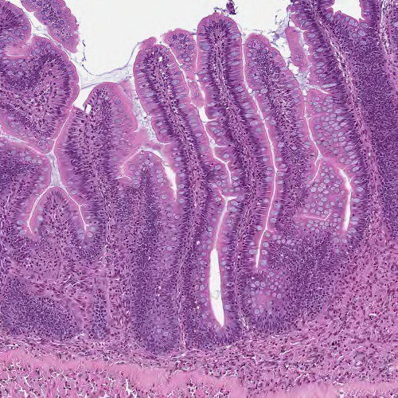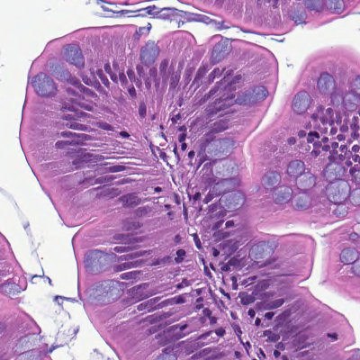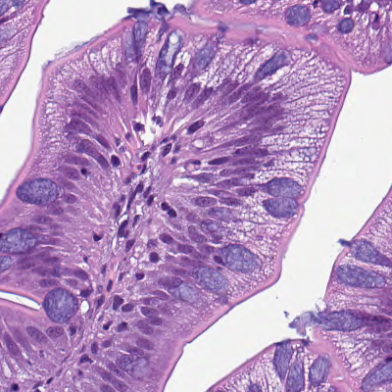
C
B
A

Figure S1. Middle intestine. (A) Normal folding of middle intestine mucosa, (B) detail of mucosal lining with non-vacuolized cytoplasm of enterocytes, and (C) detail of middle intestine mucosa with signs of excess vacuolization of enterocytes.

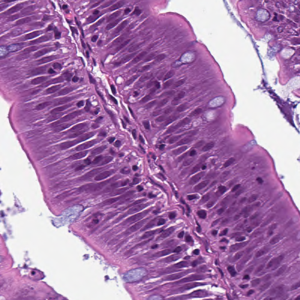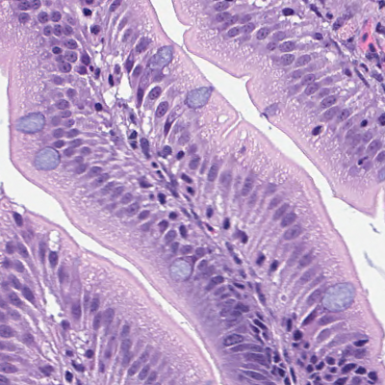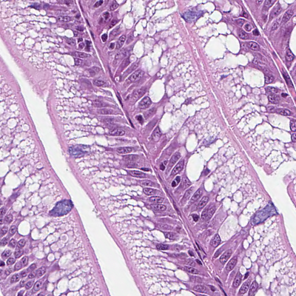
C
B
A

Figure S2. Detail of distal intestine mucosa. (A) Section of intestinal fold with supranuclear cytoplasm of enterocytes devoid of vacuolization, (B) intestinal mucosa with foamy cytoplasm, and (C) normal vacuolization of distal intestinal enterocytes.

n | Fish with fusions (%) | Average size of fusion (mm) | Fish with cross-stitch lesions (%)
5 | 16 | 9 | 4
22 | 18 | 4 | 5
24 | 21 | 4 | 0
24 | 17 | 4 | 4

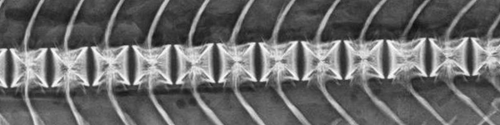
A
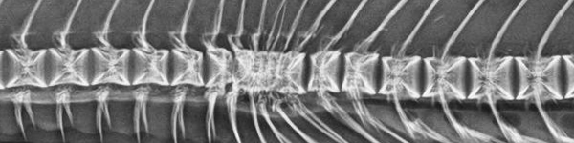
B
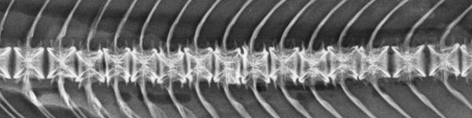
C

Figure S3. Detail of vertebral lesions (radiography). (A) Section of normal vertebral column, (B) fusion affecting a total of 11 vertebrae (circled), and (C) section of vertebral column with cross-stitch vertebrae (dotted line).

