Supplementary material

Table 1. Dietary intake and exercise at baseline and study end
 | Cherry  N=25 | Placebo  N=25 | ANOVA
 |  |  |  | Treatment | Time | Interaction
METs (min/week)
Baseline | 2462 ± 2038 | 1953 ± 1527 |  | 0.267 | 0.959 | 0.961
3 months | 2464 ± 2336 | 1978 ± 1217
Sitting time (h)
Baseline | 6.6 ± 3.1 | 6.7 ± 3.0 |  | 0.856 | 0.852 | 0.486
3 months | 6.7 ± 2.8 | 6.3 ± 3.0
Energy (Kcal)
Baseline | 1921 ± 340 | 1896 ± 430 |  | 0.997 | 0.212 | 0.673
3 months | 1977 ± 439 | 1987 ± 420
Carbohydrates (%)
Baseline | 43.8 ± 6.1 | 41.7 ± 4.9 |  | 0.587 | <0.001 | 0.297
3 months | 47.6 ± 9.0ª | 47.3 ± 8.3ª
Fat (%)
Baseline | 35.8 ± 5.9 | 36.7 ± 4.9 |  | 0.689 | 0.019 | 0.648
3 months | 33.3 ± 6.5 | 33.0 ± 7.3ª
Protein (%)
Baseline | 16.7 ± 3.2 | 19.9 ± 3.5* |  | 0.176 | 0.007 | 0.001
3 months | 16.8 ± 4.4 | 16.1 ± 3.5ª
Mean ± SD
ªSignificantly different from baseline (P <0.05): * significantly different between groups (P <0.05)

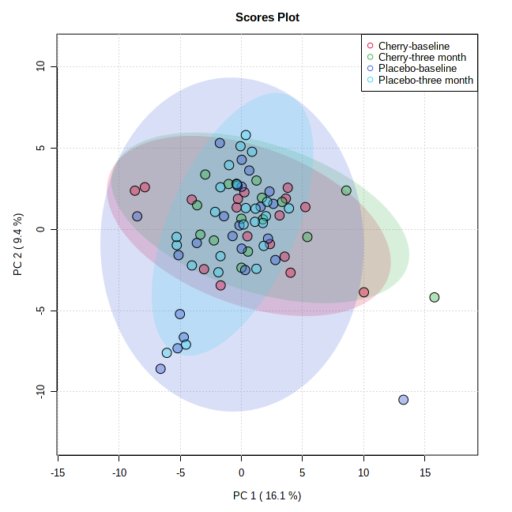
Figure 1. Principal component analysis (PCA) of all groups before and after supplementation

Figure 2. The pre-task adjusted oxygenated (HbO₂; top panel; n = 44), deoxygenated (hHb; middle panel; n = 42) and total- haemoglobin (THb; bottom panel; n = 41) concentrations for each task repetition pre-supplementation (left) and post-supplementation (right). Rep = repetition

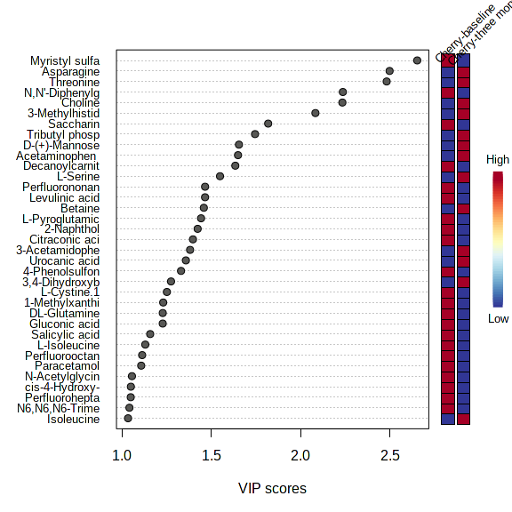Figure 3. Heat map of metabolites that were discriminatory between baseline and 3-month supplementation with Montmorency tart cherries (Variable Importance in Projection (VIP) factor >1).

