Supplementary Materials:
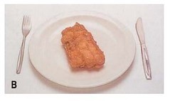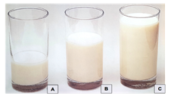
Example: Fried fish in batter Example A: Milk with tea or coffee
Example B: Milk with breakfast cereals
Example C: Milk in latte, cappuccino,
hot chocolate or just on own
Supplementary Figure 1. Example of photos provided within the Food Frequency Questionnaire (FFQ) to demonstrate medium portions of commonly consumed foods (46).

