Table S1. Formulation and proximate composition of the experimental diets
Ingredients  (g/kg) | Diets
 | HF | HF/L-LC | HF/H-LC
White fish mealª | 360 | 360 | 360
Wheat glutenª | 150 | 150 | 150
Soy protein concentrateª | 110 | 110 | 110
Fish oilª | 135 | 135 | 135
Soybean lecithinª | 15 | 15 | 15
Tapioca starchª | 190 | 190 | 190
Vitamin premix^{b} | 4 | 4 | 4
Vitamin C phosphateª | 1 | 1 | 1
Mineral premix^{b} | 5 | 5 | 5
Monocalcium phosphateª | 9 | 9 | 9
Ethoxyquin | 1 | 1 | 1
Celluloseª | 19.2 | 18 | 16.8
Choline chloride^{c} | 0.8 | 0.8 | 0.8
L-carnitine^{c} | 0 | 1.2 | 2.4
Total | 1000 | 1000 | 1000
Proximate composition (%)
Crude protein | 42.74 | 42.61 | 42.69
Crude lipid | 17.66 | 17.54 | 17.81
ªAll of these ingredients were supplied by Guangdong Yuehai Feeds Group, China.
^{b}The two premix were purchased from Great Seven Biotechnology Co., Ltd., China.
Vitamin premix (mg or g kg-1diet): vitamin D, 5 mg; vitamin K, 10 mg; vitaminB12, 10 mg; vitamin B6, 20 mg; folic acid, 20 mg; vitamin B1, 25 mg; vitamin A,32 mg; vitamin B2, 45 mg; pantothenic acid, 60 mg; biotin, 60 mg; niacin acid,200 mg; a-tocopherol, 240 mg; inositol, 800 mg; ascorbic acid, 2,000 mg; microcrystalline cellulose, 16.47 g.
Mineral premix (mg or g kg-1diet): CuSO4.5H2O, 10 mg; Na2SeO3 (1%), 25 mg; ZnSO4.H2O, 50 mg; CoCl2.6H2O (1%), 50 mg; MnSO4.H2O, 60 mg; FeSO4.H2O,80 mg; Ca(IO3)2, 180 mg; MgSO4.7H2O, 1,200 mg; zeolite, 18.35 g.
^{c}Choline chloride (99%) and L-carnitine (99%) were bought from Shanghai Aladdin Bio-Chem Technology Co.LTD, China.

Table S2 The primers used in the experiment

Target genes |  | Forward (5'–3') | Reverse (5'–3') | GenBank NO.
pgc1α |  | CTGCTCAGTATGGCAACGA | GGTCACTGGCATTGGTCAC | KM593914
pparα |  | GTCAAGCAGATCCACGAAGCC | TGGTCTTTCCAGTGAGTATGAGCC | KF998577
cpt1 |  | GCTGAGCCTGGTGAAGATGTTC | TCCATTTGGTTGAATTGTTTACTGTCC | JX434612
nrf1 |  | GTGCCGTCTCAAACTGTGG | GTGCCAACCTGGATGAGC | KM593916
aco |  | AGTGCCCAGATGATCTTGAAGC | CTGCCAGAGGTAACCATTTCCT | JX456348
abcd4 |  | GGAGGAAGACGCTAACCGAG | CTTACACAACCTCTCCGCGT | XM_010745354.3
hsd17b4 |  | GCTGAAAGAGGTGCTTCGGT | GCCTCCCTTCGCTCTTATCTC | XM_010733193.3
ehhadh |  | CTGAAGCCGTACCTCGAACA | CCTCCAACGCTCCATCTACC | XM_019270582.2
scp2 |  | GACGGGAAAGTTGAACGCAC | GCCTTGCCTGGTGTGATTTG | XM_010753092.3
acaa1 |  | AACGTCGCAGAGAGATTCGG | ACCTCACGCTCTTTACCGTC | XM_027283707.1
pex5 |  | CAGTCGGAGGAGAAGTTGTGG | GTCCACTGACACCTCTGTGTT | XM_010747785.3
pex7 |  | TTGTTGGCGTCCTGTTCGTA | ACGGTGCCCTTCCTCATTAC | XM_027279527.1
mff |  | CAACGATTCCGCACTTGCAC | GCTTTGCTCGCTCCTTGTTC | XM_010751973.3
pex11α |  | CGGCACAGAATGCAAGGAAC | GTCTTGGAACCGCACCATCT | XM_027272650
pex11β |  | CTGCGATAACGTCCTGTGGG | CTTGGAGGCTCTGTAACGCT | XM_027287520
pex11γ |  | GCTGAGTGAAAGGATGTGTAGG | GTCTACATGCTTCTCCGCTGT | XM_010742664
srebp1 |  | TCTCCTTGCAGTCTGAGCCAAC | TCAGCCCTTGGATATGAGCCT | KP342262
fas |  | CAGCCACAGTGAGGTCATCC | TGAGGACATTGAGCCAGACAC | JX456351
scd1 |  | AAAGGACGCAAGCTGGAACT | CTGGGACGAAGTACGACACC | KP202156
dgat2 |  | TTCGGTGCTTTCTGCAACTTCG | AAGGATGGGGAAGCGGAAGT | KJ563922
β-actin |  | CTACGAGGGTTATGCCCTGCC | TGAAGGAGTAACCGCGCTCTGT | GU584189
Mitochondrial DNA
D-loop | CTGAGGTTGGTGGAGTGC |  | GGGTTGCTCCCACTTATGT | EU339149
cyt b | GCCTCTACTATGGCTCCTATCTT |  | AGGCACTGCTGACAAGAGGT | EU339149
16S rRNA | TATGAATGGCAAGACGAGG |  | TAGGACAGGGCTCAGTTAGTT | EU339149
Nuclear DNA
nβ-actin | CCCAACTTGAGCCTAACAT |  | TACCTCCAGACAGCACGG | GQ168793

Peroxisome proliferator-activated receptor γ coactivator 1α (pgc1α), Peroxisome proliferator activated receptorα (pparα), Carnitine palmitoyltransferase 1 (cpt1); nuclear respiratory factor 1 (nrf1); Acyl-CoA oxidase (aco); ATP binding cassette subfamily D member 4 (abcd4); hydroxysteroid 17-beta dehydrogenase 4 (hsd17b4); enoyl-CoA hydratase and 3-hydroxyacyl CoA dehydrogenase (ehhadh); sterol carrier protein 2 (scp2); acetyl-CoA acyltransferase 1 (acaa1); peroxisomal biogenesis factor 5 (pex5); peroxisomal biogenesis factor 7 (pex7); mitochondrial fission factor (mff); peroxisomal biogenesis factor 11 alpha (pex11a); peroxisomal biogenesis factor 11 beta (pex11β); peroxisomal biogenesis factor 11 gamma (pex11γ); Sterol-regulatory element binding protein 1(srebp1); Fatty acid synthase (fas); Stearoyl-CoA desaturase I (scd1); acyl-CoA: diacylglycerol acyltransferase 2 (dgat2); cytochrome b (cyt b); 16S ribosomal RNA (16S rRNA);Nuclear β-actin DNA (nβ-actin).

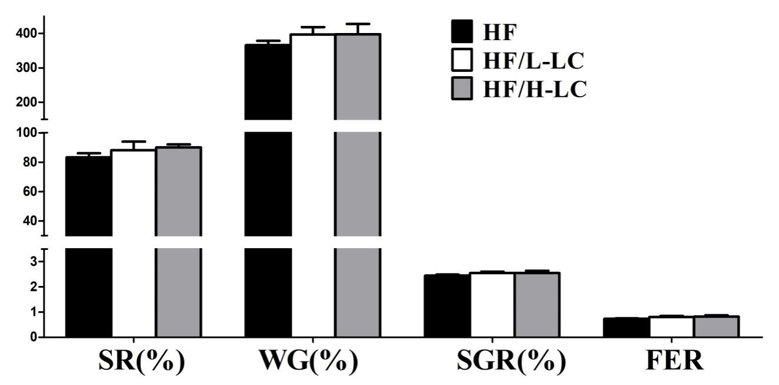
Figure S1 Effect of dietary L-carnitine (LC) on the survival, growth performance and feed utilization of large yellow croaker. Data are expressed as the means±SEM (n=3). Survival rate (SR), Weight gain (WG), specific growth rate (SGR) and feed efficiency ratio (FER).

