Supplementary Material
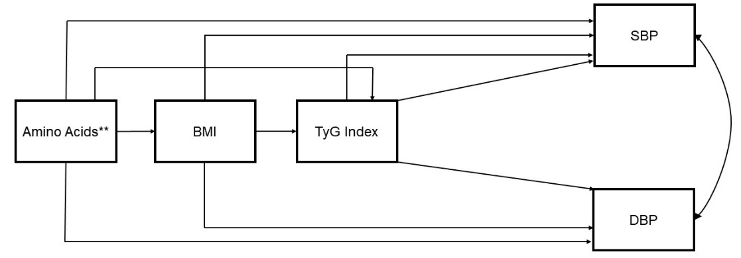
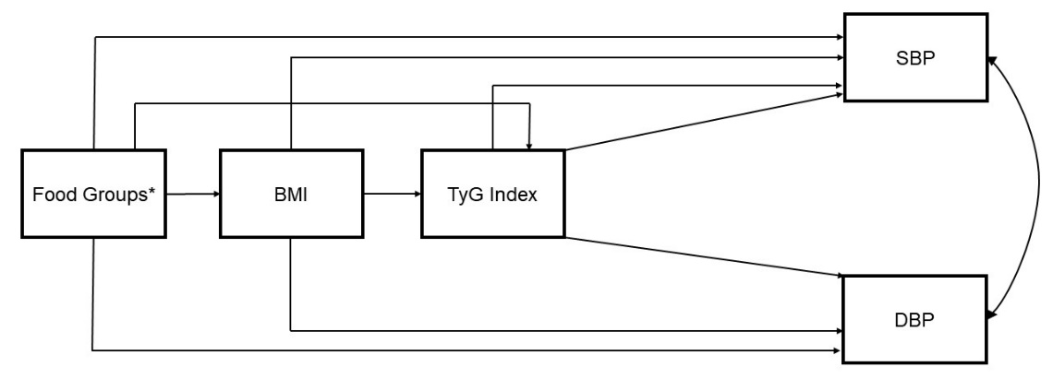
22
1

The construction of theoretical models was in accordance with the scientific literature on these relationships, directed acyclic graph during this process were not used.
* Each food groups separately: vegetables, nuts and seeds, dairy products, legumes, fruits, eggs, meats and fish.
** Each amino acid separately: arginine, glutamic acid, cysteine, glycine, histidine, isoleucine, leucine, tyrosine and valine.
BMI: body mass index; DBP: diastolic blood pressure; SBP: systolic blood pressure; TyG: triglycerides/blood glucose index.
Supplementary Figure 1: Theoretical models built according to scientific literature.

Supplementary Table 1: Correlation matrix of the variables included in the final model.
 | BMI  (kg/m²) | TyG index | SBP  (mmHg) | DBP  (mmHg) | Histidine  (g/day) | Legumes  (g/day) | Fruits (g/day) | Vegetables  (g/day)
Age (years) | -0.07** | -0.06* | 0.05* | -0.02 | -0.01 | 0.01 | 0.04 | -0.03
BMI  (kg/m²) |  | 0.22** | 0.16** | 0.18** | -0.5* | -0.07** | -0.02 | 0.06*
TyG index |  |  | 0.06* | 0.09** | -0.01 | 0.007 | -0.5* | -0.02
SBP  (mmHg) |  |  |  | 0.58** | -0.10** | -0.02 | -0.04 | -0.03
DBP  (mmHg) |  |  |  |  | -0.04 | -0.01 | -0.06* | -0.02
Histidine  (g/day) |  |  |  |  |  | 0.28** | 0.07** | 0.15**
Legumes  (g/day) |  |  |  |  |  |  | -0.02 | 0.10**
Fruits (g/day) |  |  |  |  |  |  |  | 0.16**
p values according Spearman’s Correlation.

Supplementary Table 2: Goodness of fit values and R2 values (variance explained) for each of the models (including the models for each amino acid).
Models | RMSEA | SRMR | CFI | TLI | R²
Arginine | 1.000 | 1.000 | 0.000 | 0.000 | SBP = 0.040  DBP = 0.044  BMI = 0.048  TyG Index = 0.138
Glutamic Acid | 1.000 | 1.000 | 0.000 | 0.000 | SBP = 0.040  DBP = 0.044  BMI = 0.048  TyG Index = 0.137
Cysteine | 1.000 | 1.000 | 0.000 | 0.000 | SBP = 0.042  DBP = 0.043  BMI = 0.048  TyG Index = 0.136
Glycine | 1.000 | 1.000 | 0.000 | 0.000 | SBP = 0.040  DBP = 0.044  BMI = 0.048  TyG Index = 0.138
Histidine | 1.000 | 1.000 | 0.000 | 0.000 | SBP = 0.042  DBP = 0.043  BMI = 0.048  TyG Index = 0.136
Leucine | 1.000 | 1.000 | 0.000 | 0.000 | SBP = 0.040  DBP = 0.044  BMI = 0.048  TyG Index = 0.138
Tyrosine | 1.000 | 1.000 | 0.000 | 0.000 | SBP = 0.043  DBP = 0.043  BMI = 0.048  TyG Index = 0.136
Isoleucine | 1.000 | 1.000 | 0.000 | 0.000 | SBP = 0.042  DBP = 0.043  BMI = 0.048  TyG Index = 0.136
Valine | 1.000 | 1.000 | 0.000 | 0.000 | SBP = 0.040  DBP = 0.044  BMI = 0.048  TyG Index = 0.138
Vegetables | 1.000 | 1.000 | 0.000 | 0.000 | SBP = 0.041  DBP = 0.043  BMI = 0.051  TyG Index = 0.137
Nuts and seeds | 1.000 | 1.000 | 0.000 | 0.000 | SBP = 0.041  DBP = 0.046  BMI = 0.048  TyG Index = 0.136
Dairy products | NO CONVERGENCE
Legumes | 1.000 | 1.000 | 0.000 | 0.000 | SBP = 0.040  DBP = 0.043  BMI = 0.051  TyG Index = 0.136
Fruits | NO CONVERGENCE
Eggs | 1.000 | 1.000 | 0.000 | 0.000 | SBP = 0.040  DBP = 0.043  BMI = 0.052  TyG Index = 0.136
Meats | 1.000 | 1.000 | 0.000 | 0.000 | SBP = 0.042  DBP = 0.044  BMI = 0.051  TyG Index = 0.138
Fish | 1.000 | 1.000 | 0.000 | 0.000 | SBP = 0.041  DBP = 0.043  BMI = 0.049  TyG Index = 0.136
RMSEA: Root Mean Square Error of Approximation; SRMR: Standardized Root Mean Square Residual; TLI: Tucker-Lewis Index and CFI: Comparative Fit Index.

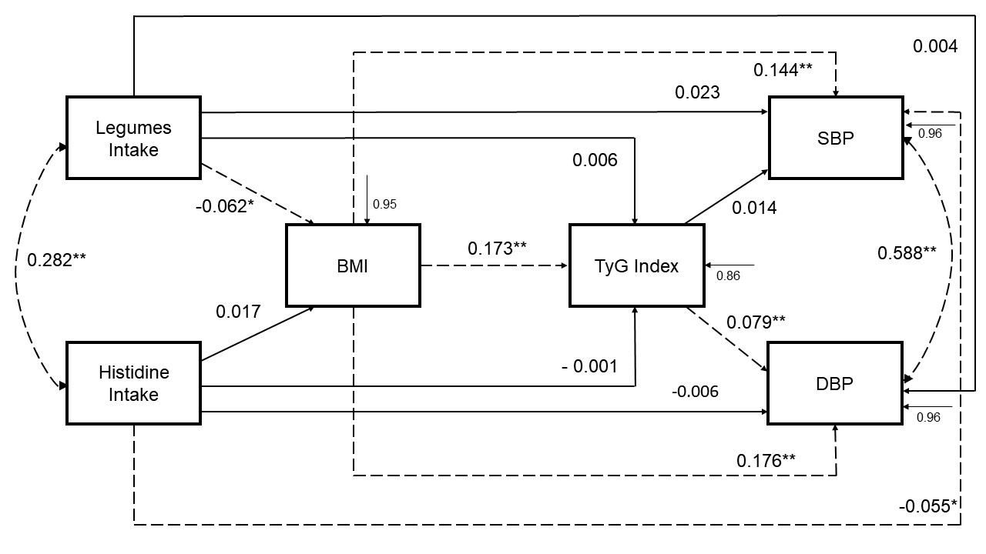
Dashed lines indicate paths with statistical significance. *p<0.05; **p<0.001. RMSEA/SRMR < 0.001; CFI/TLI = 1.000. R² BMI = 0.052; R²; TyG index = 0.136; R² SBP = 0,044 and R² DBP = 0.045. The model was adjusted for sex (categorical variable: male or female), age (continuous variable), physical activity (categorical variable: sedentary lifestyle or physical activity practice), smoking (categorical variable: non-smoking or smokers), use of antihypertensive and hypoglycemic agents (categorical variable: no or yes) and fruits intake (continuous variable). BMI: body mass index; DBP: diastolic blood pressure; SBP: systolic blood pressure TyG: triglycerides/blood glucose index. Legumes intake, histidine intake, BMI, TyG index, SBP and DBP: continuous values.
Supplementary Figure 2: Path model of relationships between food intake, cardiometabolic risk factors, and blood pressure, constructed based on the baseline data from the BALANCE Program Trial (n= 2,247).

Supplementary Table 3: Direct, indirect, and total coefficients of the mediation relationships of the path model, using baseline data from the BALANCE Program Trial (n=2,247).
Relationship | Mediators | Effects | Standardized coefficient | Standard error | p value
Legume intake → SBP |  | Direct | 0.023 | 0.022 | 0.304
 | BMI | Indirect | -0.009 | 0.003 | 0.010
 | TyG |  | 0.000 | 0.0.00 | 0.785
 | BMI → TyG |  | 0.000 | 0.000 | 0.527
 |  | Total | 0.014 | 0.022 | 0.538
Histidine intake → SBP |  | Direct | -0.055 | 0.023 | 0.016
 | BMI | Indirect | 0.003 | 0.003 | 0.400
 | TyG |  | 0.000 | 0.000 | 0.970
 | BMI → TyG |  | 0.000 | 0.000 | 0.614
 |  | Total | -0.052 | 0.023 | 0.022
Legume intake → DBP |  | Direct | 0.004 | 0.022 | 0.840
 | BMI | Indirect | -0.011 | 0.004 | 0.019
 | TyG |  | 0.000 | 0.002 | 0.769
 | BMI → TyG |  | -0.001 | 0.000 | 0.036
 |  | Total | -0.007 | 0.022 | 0.750
Histidine intake → DBP |  | Direct | -0.006 | 0.022 | 0.776
 | BMI | Indirect | 0.003 | 0.004 | 0.398
 | TyG |  | 0.000 | 0.002 | 0.970
 | BMI → TyG |  | 0.000 | 0.000 | 0.420
 |  | Total | -0.003 | 0.022 | 0.897
BMI → SBP | TyG | Direct | 0.144 | 0.022 | <0.001
 |  | Indirect | 0.002 | 0.004 | 0.5137
 |  | Total | 0.146 | 0.022 | <0.001
BMI → DBP | TyG | Direct | 0.176 | 0.023 | <0.001
 |  | Indirect | 0.014 | 0.004 | 0.002
 |  | Total | 0.190 | 0.023 | <0.001
p-values in bold have statistical significance (p <0.05). BMI: body mass index; DBP: diastolic blood pressure; SBP: systolic blood pressure TyG: triglycerides/blood glucose index.

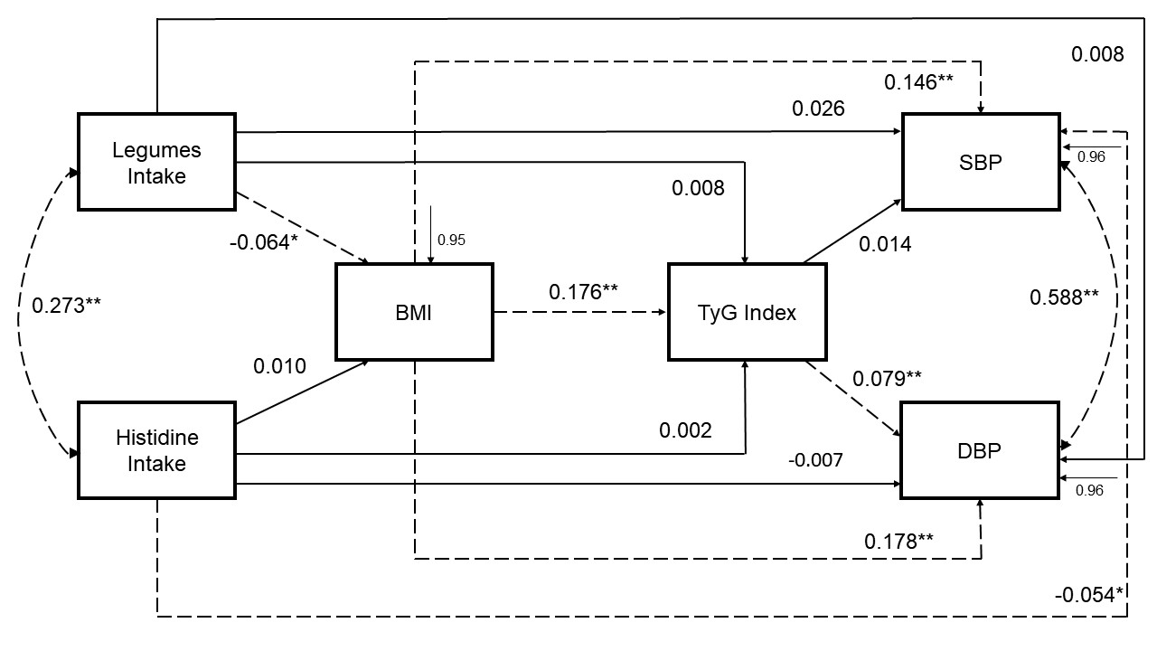
Dashed lines indicate paths with statistical significance. *p<0.05; **p<0.001. RMSEA/SRMR < 0.001; CFI/TLI = 1.000. R² BMI = 0.055; R² TyG index = 0.137; R² SBP and DBP = 0.044. The model was adjusted for sex (categorical variable: male or female), age (continuous variable), physical activity (categorical variable: sedentary lifestyle or physical activity practice), smoking (categorical variable: non-smoking or smokers), use of antihypertensive and hypoglycemic agents (categorical variable: no or yes) and vegetables intake (continuous variable). BMI: body mass index; DBP: diastolic blood pressure; SBP: systolic blood pressure TyG: triglycerides/blood glucose index. Legumes intake, histidine intake, BMI, TyG index, SBP and DBP: continuous values.
Supplementary Figure 3: Path model of relationships between food intake, cardiometabolic risk factors, and blood pressure, constructed based on the baseline data from the BALANCE Program Trial (n= 2,247).

Supplementary Table 4: Direct, indirect, and total coefficients of the mediation relationships of the path model, using baseline data from the BALANCE Program Trial (n=2,247).
Relationship | Mediators | Effects | Standardized coefficient | Standard error | p value
Legume intake → SBP |  | Direct | 0.026 | 0.022 | 0.241
 | BMI | Indirect | -0.009 | 0.003 | 0.008
 | TyG |  | 0.000 | 0.0.00 | 0.36
 | BMI → TyG |  | 0.000 | 0.000 | 0.545
 |  | Total | 0.016 | 0.022 | 0.457
Histidine intake → SBP |  | Direct | -0.054 | 0.023 | 0.018
 | BMI | Indirect | 0.002 | 0.003 | 0.630
 | TyG |  | 0.000 | 0.000 | 0.918
 | BMI → TyG |  | 0.000 | 0.000 | 0.709
 |  | Total | -0.052 | 0.023 | 0.022
Legume intake → DBP |  | Direct | 0.008 | 0.022 | 0.705
 | BMI | Indirect | -0.011 | 0.004 | 0.008
 | TyG |  | 0.001 | 0.002 | 0.697
 | BMI → TyG |  | -0.001 | 0.000 | 0.034
 |  | Total | -0.004 | 0.022 | 0.872
Histidine intake → DBP |  | Direct | -0.007 | 0.022 | 0.762
 | BMI | Indirect | 0.002 | 0.004 | 0.630
 | TyG |  | 0.000 | 0.002 | 0.915
 | BMI → TyG |  | 0.000 | 0.000 | 0.637
 |  | Total | -0.004 | 0.022 | 0.841
BMI → SBP | TyG | Direct | 0.146 | 0.022 | <0.001
 |  | Indirect | 0.003 | 0.004 | 0.536
 |  | Total | 0.178 | 0.023 | <0.001
BMI → DBP | TyG | Direct | 0.177 | 0.023 | <0.001
 |  | Indirect | 0.014 | 0.004 | 0.002
 |  | Total | 0.192 | 0.023 | <0.001
p-values in bold have statistical significance (p <0.05). BMI: body mass index; DBP: diastolic blood pressure; SBP: systolic blood pressure TyG: triglycerides/blood glucose index.

MPlus software codes for each final model.
Model 1
TITLE: MODELO ESTRUTURAL TRANSVERSAL

DATA: FILE IS banco.inp;
!LISTWISE=ON;

VARIABLE:
Names are ncen npac g1g2x sexo idade idct escol af2 clas4
has dm dlp dac4 dap5 hisdac antcag anthas hipgli estat fumo2
peso estm estcm imc imcct pc pcct rce pad pas medpa hasct
ct ctct tg tgct gli glict dmct hdl hdlct ldl tyg tghdl
kcal cho fibra ptn lip chodis ig chosol choliq chotot1
prsoli choint choout choto2 prinou iqc trip treo isol leu lis
met cis fenil tiro val arg his ala acasp acglu glici
prol ser cerint cer prodoc prepa prosal padoc horta
acuca oleage suco latic legu tempe fruta ovo bbal caf
pasal oleos capro peixe dieli caver ave kcal2 cho2
fibra2 ptn2 lip2 chodi2 ig2 choso2 choli2 choin2 choou2
iqc2 trip2 treo2 isol2 leu2 lis2 met2 cis2 fenil2 tiro2
val2 arg2 his2 ala2 acasp2 acglu2 glici2 prol2 ser2
cerin2 cere2 prodo2 prepa2 prosa2 padoc2 horta2 acuca2
oleag2 suco2 latic2 legum2 tempe2 fruta2 ovo2 bbal2
caf2 pasal2 oleo2 capro2 peixe2 dieli2 caver2 ave2
kcal3 cho3 fibra3 ptn3 lip3 chodi3 ig3 choso3 choli3
choin3 choou3 iqc3 trip3 treo3 isol3 leu3 lis3 met3
cis3 fenil3 tiro3 val3 arg3 his3 ala3 acasp3 acglu3
glici3 prol3 ser3 cerin3 cere3 prodo3 prepa3 prosa3
padoc3 horta3 acuca3 oleag3 suco3 latic3
legum3 temp3 fruta3 ovo3 bbal3 caf3 pasal3 oleo3 capro3
peixe3 dieli3 caver3 ave3 kcal4 cho4 fibra4 ptn4
lip4 chodi4 ig4 choso4 choli4 choin4 choou4 iqc4
trip4 treo4 isol4 leu4 lis4 met4 cis4 fenil4
tiro4 val4 arg4 his4 ala4 acasp4 acglu4 glici4 prol4
ser4 cein4 cere4 prodo4 prepa4 prosa4 padoc4 horta4
acuca4 oleag4 suco4 lati4 legum4 temp4 fruta4
ovo4 bbal4 caf4 pasal4 oleo4 capro4
peixe4 dieli4 caver4 ave4;

USEVARIABLES ARE his legu pas pad imc tyg sexo idade af2
fumo2 anthas hipgli;

!CATEGORICAL ARE dmct;

MISSING ARE ALL (-9999);

ANALYSIS:
!TYPE=BASIC
!PARAMETERIZATION=THETA;
ESTIMATOR=MLR;

MODEL:
!ess BY arg3 met3 trip3;
!bcaa BY leu2 isol2 val2;
!hcy BY met2 cis2 ser2;
!predm BY isol2 tiro2 fenil2;
!aacar BY cis2 acglu2 his2 glici2;

!leu with ig;

legu with his;
pas with pad;

pas ON legu his imc tyg sexo idade af2 fumo2 anthas hipgli;
pad ON legu his imc tyg sexo idade af2 fumo2 anthas hipgli;
!dmct ON ig leu imc tyg sexo idade af2 fumo2;
tyg ON legu his imc sexo idade af2 fumo2 anthas hipgli;
imc ON legu his sexo idade af2 fumo2 anthas hipgli;
legu ON sexo idade af2 fumo2 anthas hipgli;
his ON sexo idade af2 fumo2 anthas hipgli;

MODEL INDIRECT:
!dmct IND leu;
!dmct IND ig;
pas IND his;
pas IND legu;
pas IND imc;
!dmct IND imc;
pad IND legu;
pad IND his;
pad IND imc;

OUTPUT: STDYX;
Model 2
TITLE: MODELO ESTRUTURAL TRANSVERSAL

DATA: FILE IS banco.inp;
!LISTWISE=ON;

VARIABLE:
Names are ncen npac g1g2x sexo idade idct escol af2 clas4
has dm dlp dac4 dap5 hisdac antcag anthas hipgli estat fumo2
peso estm estcm imc imcct pc pcct rce pad pas medpa hasct
ct ctct tg tgct gli glict dmct hdl hdlct ldl tyg tghdl
kcal cho fibra ptn lip chodis ig chosol choliq chotot1
prsoli choint choout choto2 prinou iqc trip treo isol leu lis
met cis fenil tiro val arg his ala acasp acglu glici
prol ser cerint cer prodoc prepa prosal padoc horta
acuca oleage suco latic legu tempe fruta ovo bbal caf
pasal oleos capro peixe dieli caver ave kcal2 cho2
fibra2 ptn2 lip2 chodi2 ig2 choso2 choli2 choin2 choou2
iqc2 trip2 treo2 isol2 leu2 lis2 met2 cis2 fenil2 tiro2
val2 arg2 his2 ala2 acasp2 acglu2 glici2 prol2 ser2
cerin2 cere2 prodo2 prepa2 prosa2 padoc2 horta2 acuca2
oleag2 suco2 latic2 legum2 tempe2 fruta2 ovo2 bbal2
caf2 pasal2 oleo2 capro2 peixe2 dieli2 caver2 ave2
kcal3 cho3 fibra3 ptn3 lip3 chodi3 ig3 choso3 choli3
choin3 choou3 iqc3 trip3 treo3 isol3 leu3 lis3 met3
cis3 fenil3 tiro3 val3 arg3 his3 ala3 acasp3 acglu3
glici3 prol3 ser3 cerin3 cere3 prodo3 prepa3 prosa3
padoc3 horta3 acuca3 oleag3 suco3 latic3
legum3 temp3 fruta3 ovo3 bbal3 caf3 pasal3 oleo3 capro3
peixe3 dieli3 caver3 ave3 kcal4 cho4 fibra4 ptn4
lip4 chodi4 ig4 choso4 choli4 choin4 choou4 iqc4
trip4 treo4 isol4 leu4 lis4 met4 cis4 fenil4
tiro4 val4 arg4 his4 ala4 acasp4 acglu4 glici4 prol4
ser4 cein4 cere4 prodo4 prepa4 prosa4 padoc4 horta4
acuca4 oleag4 suco4 lati4 legum4 temp4 fruta4
ovo4 bbal4 caf4 pasal4 oleo4 capro4
peixe4 dieli4 caver4 ave4;

USEVARIABLES ARE his legu pas pad imc tyg sexo idade af2
fumo2 anthas hipgli fruta;

!CATEGORICAL ARE dmct;

MISSING ARE ALL (-9999);
ANALYSIS:
!TYPE=BASIC
!PARAMETERIZATION=THETA;
ESTIMATOR=MLR;

MODEL:
!ess BY arg3 met3 trip3;
!bcaa BY leu2 isol2 val2;
!hcy BY met2 cis2 ser2;
!predm BY isol2 tiro2 fenil2;
!aacar BY cis2 acglu2 his2 glici2;

!leu with ig;

legu with his;
pas with pad;

pas ON legu his imc tyg sexo idade af2 fumo2 anthas hipgli fruta;
pad ON legu his imc tyg sexo idade af2 fumo2 anthas hipgli fruta;
!dmct ON ig leu imc tyg sexo idade af2 fumo2;
tyg ON legu his imc sexo idade af2 fumo2 anthas hipgli fruta;
imc ON legu his sexo idade af2 fumo2 anthas hipgli fruta;
legu ON sexo idade af2 fumo2 anthas hipgli fruta;
his ON sexo idade af2 fumo2 anthas hipgli fruta;

MODEL INDIRECT:
!dmct IND leu;
!dmct IND ig;
pas IND his;
pas IND legu;
pas IND imc;
!dmct IND imc;
pad IND legu;
pad IND his;
pad IND imc;

OUTPUT: STDYX;
Model 3
TITLE: MODELO ESTRUTURAL TRANSVERSAL

DATA: FILE IS banco.inp;
!LISTWISE=ON;

VARIABLE:
Names are ncen npac g1g2x sexo idade idct escol af2 clas4
has dm dlp dac4 dap5 hisdac antcag anthas hipgli estat fumo2
peso estm estcm imc imcct pc pcct rce pad pas medpa hasct
ct ctct tg tgct gli glict dmct hdl hdlct ldl tyg tghdl
kcal cho fibra ptn lip chodis ig chosol choliq chotot1
prsoli choint choout choto2 prinou iqc trip treo isol leu lis
met cis fenil tiro val arg his ala acasp acglu glici
prol ser cerint cer prodoc prepa prosal padoc horta
acuca oleage suco latic legu tempe fruta ovo bbal caf
pasal oleos capro peixe dieli caver ave kcal2 cho2
fibra2 ptn2 lip2 chodi2 ig2 choso2 choli2 choin2 choou2
iqc2 trip2 treo2 isol2 leu2 lis2 met2 cis2 fenil2 tiro2
val2 arg2 his2 ala2 acasp2 acglu2 glici2 prol2 ser2
cerin2 cere2 prodo2 prepa2 prosa2 padoc2 horta2 acuca2
oleag2 suco2 latic2 legum2 tempe2 fruta2 ovo2 bbal2
caf2 pasal2 oleo2 capro2 peixe2 dieli2 caver2 ave2
kcal3 cho3 fibra3 ptn3 lip3 chodi3 ig3 choso3 choli3
choin3 choou3 iqc3 trip3 treo3 isol3 leu3 lis3 met3
cis3 fenil3 tiro3 val3 arg3 his3 ala3 acasp3 acglu3
glici3 prol3 ser3 cerin3 cere3 prodo3 prepa3 prosa3
padoc3 horta3 acuca3 oleag3 suco3 latic3
legum3 temp3 fruta3 ovo3 bbal3 caf3 pasal3 oleo3 capro3
peixe3 dieli3 caver3 ave3 kcal4 cho4 fibra4 ptn4
lip4 chodi4 ig4 choso4 choli4 choin4 choou4 iqc4
trip4 treo4 isol4 leu4 lis4 met4 cis4 fenil4
tiro4 val4 arg4 his4 ala4 acasp4 acglu4 glici4 prol4
ser4 cein4 cere4 prodo4 prepa4 prosa4 padoc4 horta4
acuca4 oleag4 suco4 lati4 legum4 temp4 fruta4
ovo4 bbal4 caf4 pasal4 oleo4 capro4
peixe4 dieli4 caver4 ave4;

USEVARIABLES ARE his legu pas pad imc tyg sexo idade af2
fumo2 anthas hipgli horta;

!CATEGORICAL ARE dmct;

MISSING ARE ALL (-9999);

ANALYSIS:
!TYPE=BASIC
!PARAMETERIZATION=THETA;
ESTIMATOR=MLR;

MODEL:
!ess BY arg3 met3 trip3;
!bcaa BY leu2 isol2 val2;
!hcy BY met2 cis2 ser2;
!predm BY isol2 tiro2 fenil2;
!aacar BY cis2 acglu2 his2 glici2;

!leu with ig;

legu with his;
pas with pad;

pas ON legu his imc tyg sexo idade af2 fumo2 anthas hipgli horta;
pad ON legu his imc tyg sexo idade af2 fumo2 anthas hipgli horta;
!dmct ON ig leu imc tyg sexo idade af2 fumo2;
tyg ON legu his imc sexo idade af2 fumo2 anthas hipgli horta;
imc ON legu his sexo idade af2 fumo2 anthas hipgli horta;
legu ON sexo idade af2 fumo2 anthas hipgli horta;
his ON sexo idade af2 fumo2 anthas hipgli horta;

MODEL INDIRECT:
!dmct IND leu;
!dmct IND ig;
pas IND his;
pas IND legu;
pas IND imc;
!dmct IND imc;
pad IND legu;
pad IND his;
pad IND imc;

OUTPUT: STDYX;

