**Supplemental Figure 1**

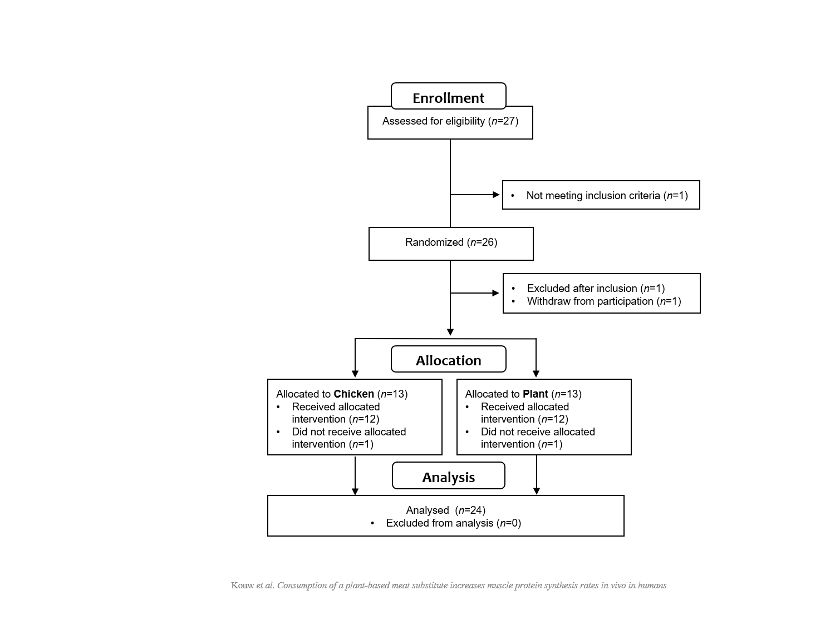

**Supplemental Figure 2**



**Supplemental Figure 3**



**Supplemental Figure 4**



**FIGURE LEGENDS**

**Supplemental Figure 1.** Flow diagram of participants’ enrollment procedure according to the CONSORT (Consolidated Standards of Reporting Trials). Plant: 40 g protein in the form of a baked lysine-enriched wheat and chickpea protein product, Chicken: 40 g protein in the form of baked chicken breast filet.

**Supplemental Figure 2.** Mean (±SD) plasma alanine, arginine, asparagine, aspartic acid, beta-alanine, cystine, glutamic acid, glycine and histidine, concentrations in 24 healthy, young males following the ingestion of 40 g protein of either a lysine-enriched wheat and chickpea protein product (Plant; *n*=12) or chicken breast filet (Chicken; *n*=12). Data were analysed by repeated measures (time x treatment) ANOVA. Bonferroni post-hoc test was used to locate differences over time. *Indicates a significant difference between treatments, *P*<0.05.

**Supplemental Figure 3**.Mean (±SD) plasma isoleucine, ornithine, phenylalanine, proline, serine, threonine, tryptophan, tyrosine, and valine concentrations in 24 healthy, young males following the ingestion of 40 g protein of either a lysine-enriched wheat and chickpea protein product (Plant; *n*=12) or chicken breast filet (Chicken; *n*=12). Data were analysed by repeated measures (time x treatment) ANOVA. Bonferroni post-hoc test was used to locate differences over time. *Indicates a significant difference between treatments, *P*<0.05.

**Supplemental Figure 4**.Mean (±SD) plasma L-[ring-13C6]-phenylalanine enrichments in 24 healthy, young males following the ingestion of 40 g protein of either a lysine-enriched wheat and chickpea protein product (Plant; *n*=12) or chicken breast filet (Chicken; *n*=12). Data were analysed by repeated measures (time x treatment) ANOVA. Bonferroni post-hoc test was used to locate differences over time. Basal period: time x treatment interaction, *P*=0.309, main time effect, *P*=0.01, main group effect, *P*=0.700, Postprandial period: time x treatment interaction, *P*=0.323, main time effect, *P*<0.001, main group effect, *P*=0.449. No significant differences were observed between treatment groups.