Appendix II – Supplementary figures
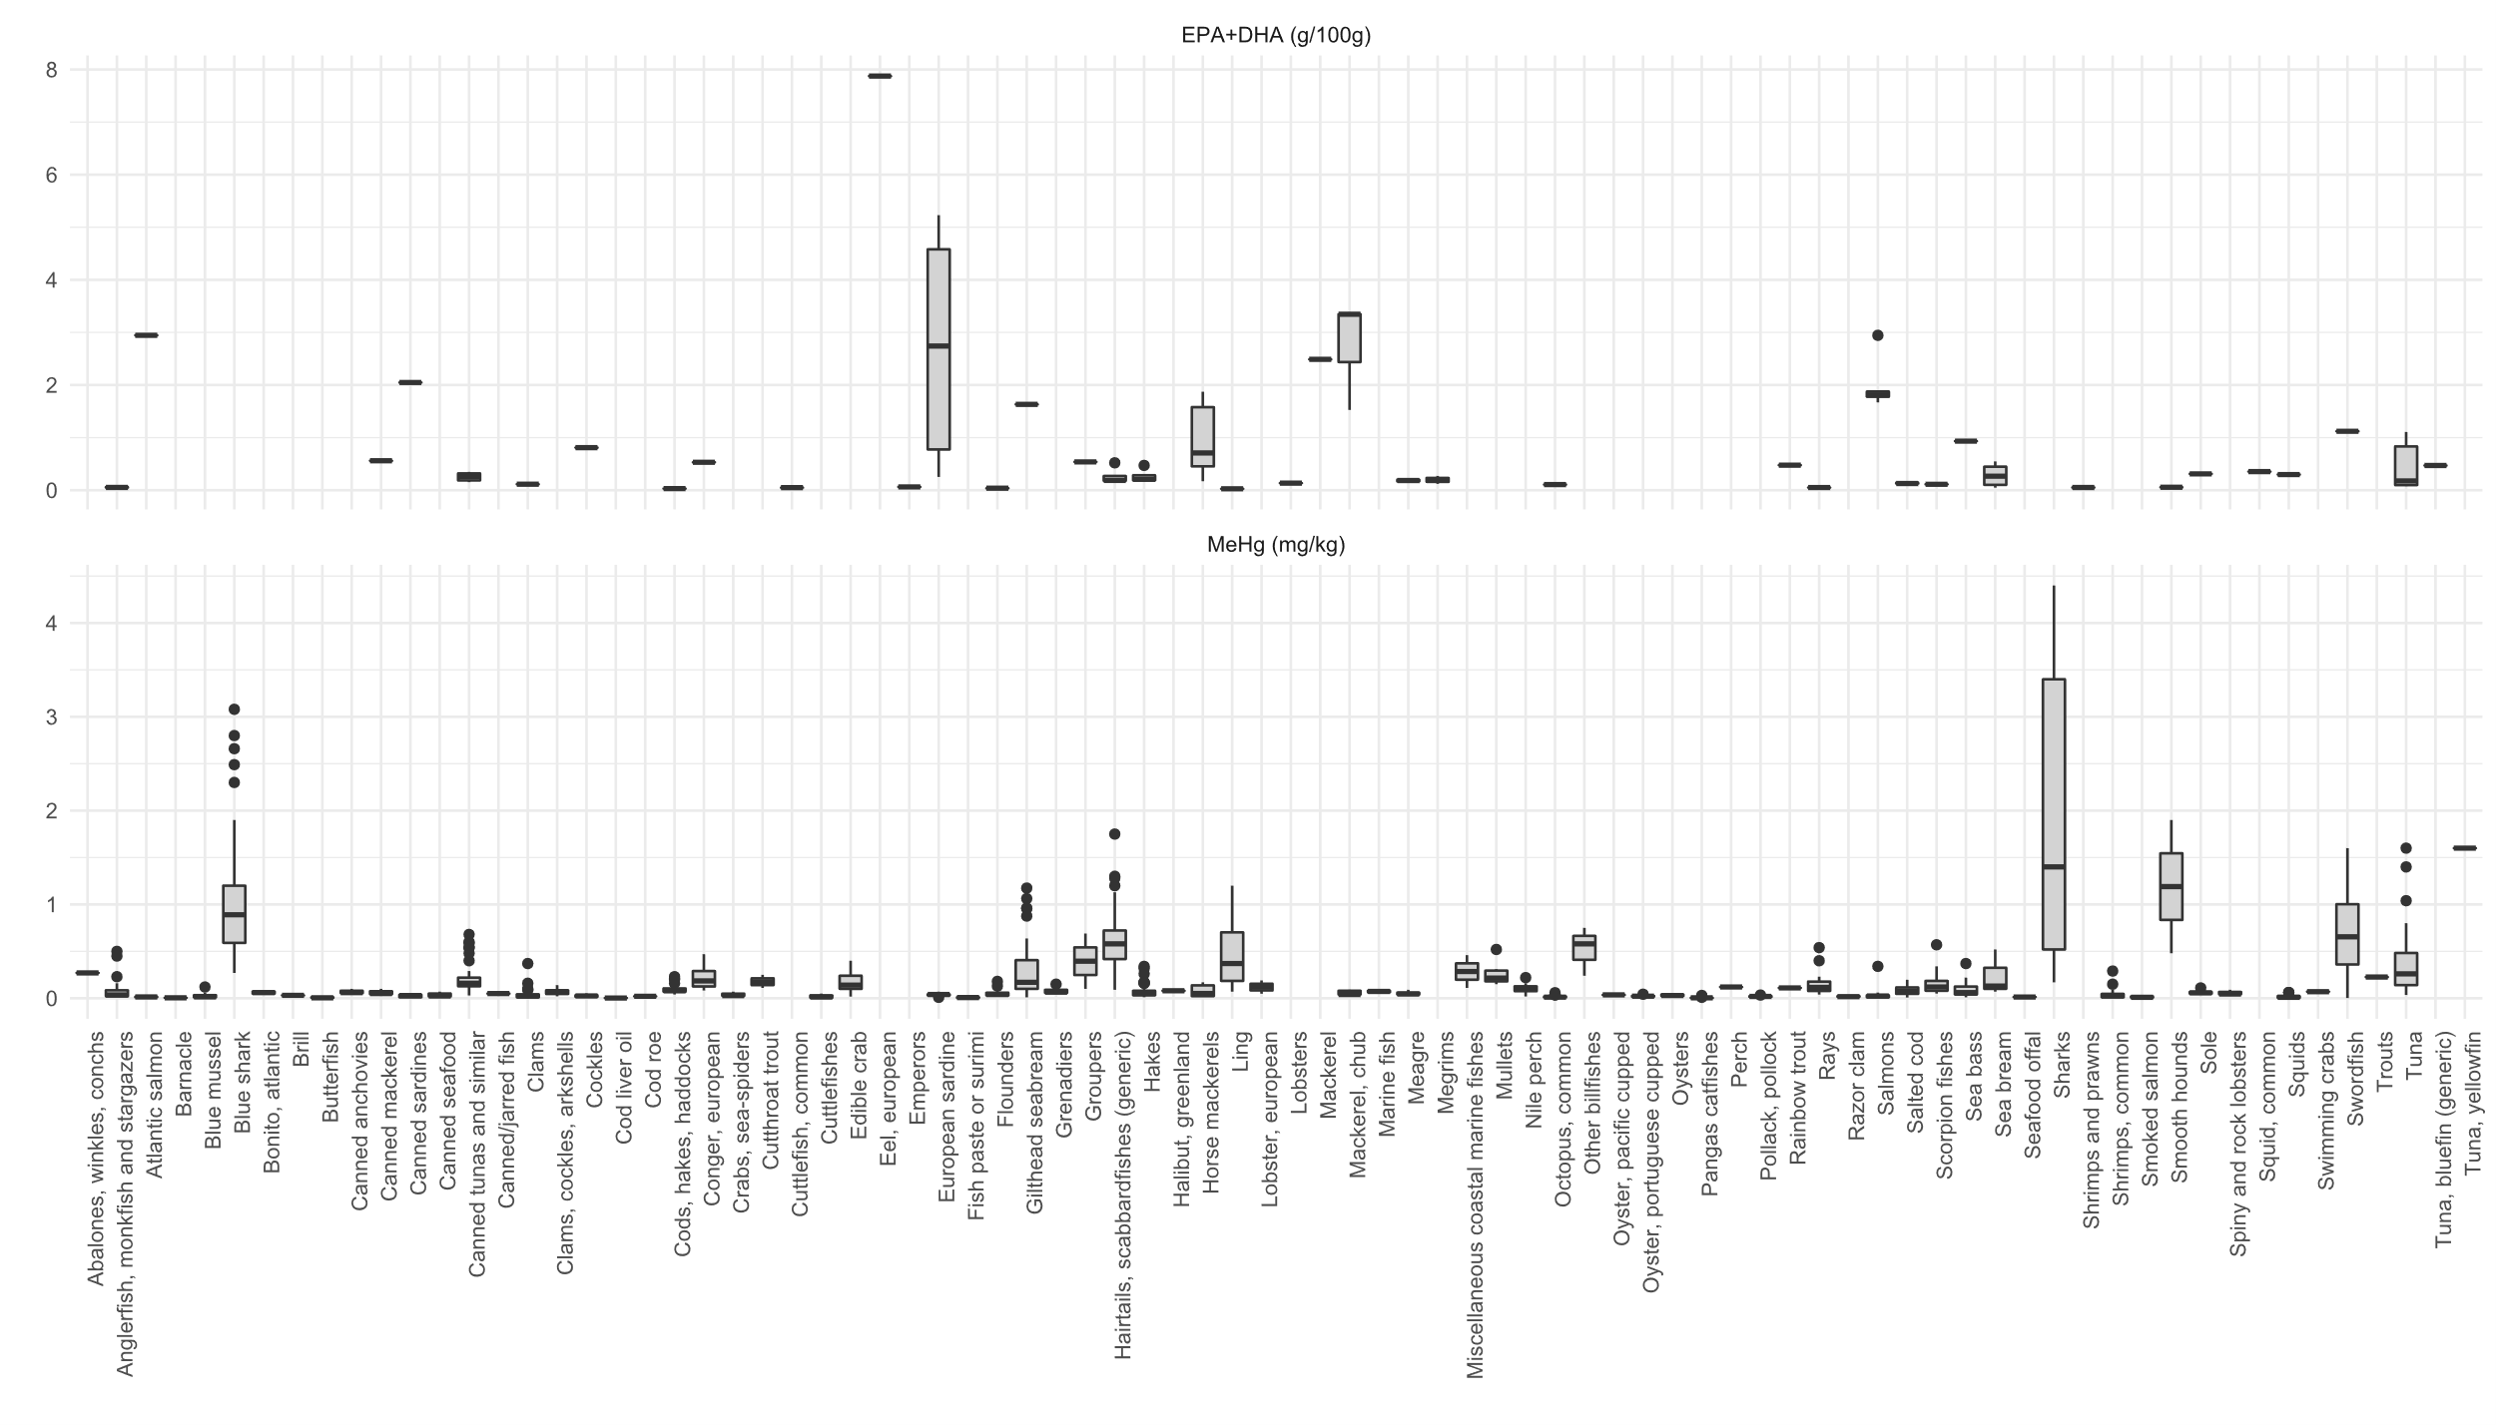
Figure S1. Distribution of EPA+DHA (g/100g) and MeHg (mg/kg) concentrations in the samples of fish and other seafood species captured in Portuguese waters and/or marketed in Portugal, by FoodEx2 category.

