Association between fat-soluble vitamins and self-reported health status: a cross-sectional analysis of the MARK-AGE cohort – Supplementary material

Caroline S. Stokes^{1,2,}*, Daniela Weber^{1,3}, Stefan Wagenpfeil⁴, Wolfgang Stuetz⁵, María Moreno-Villanueva^{6,7}, Martijn E. T. Dollé⁸, Eugène Jansen⁸, Efstathios S. Gonos⁹, Jürgen Bernhardt¹⁰, Beatrix Grubeck-Loebenstein¹¹, Simone Fiegl¹², Ewa Sikora¹³, Olivier Toussaint¹⁴§, Florence Debacq-Chainiaux¹⁴, Miriam Capri^{15,16}, Antti Hervonen¹⁷, P. Eline Slagboom¹⁸, Nicolle Breusing¹⁹, Jan Frank⁵, Alexander Bürkle⁶, Claudio Franceschi²⁰, Tilman Grune^{1,3,21,22,23,24}

¹ Department of Molecular Toxicology, German Institute of Human Nutrition, 14558 Potsdam-Rehbrücke, Germany
² Food and Health Research Group, Faculty of Life Sciences, Humboldt-Universität zu Berlin, 14195 Berlin, Germany
³ NutriAct-Competence Cluster Nutrition Research Berlin-Potsdam, Nuthetal 14458, Germany
⁴ Institute of Medical Biometry, Epidemiology and Medical Informatics, Saarland University, Homburg, Germany
⁵ Department of Food Biofunctionality, Institute of Nutritional Sciences (140), University of Hohenheim, 70599 Stuttgart, Germany
⁶ Molecular Toxicology Group, Department of Biology, University of Konstanz, 78457 Konstanz, Germany
⁷ Human Performance Research Centre, Department of Sport Science, University of Konstanz, 78457 Konstanz, Germany
⁸ Centre for Health Protection, National Institute for Public Health and the Environment, PO Box 1, 3720 BA Bilthoven, The Netherlands
⁹ National Hellenic Research Foundation, Institute of Biology, Medicinal Chemistry and Biotechnology, Athens, Greece
¹⁰ BioTeSys GmbH, Schelztorstr. 54-56, 73728 Esslingen, Germany
¹¹ Research Institute for Biomedical Aging Research, University of Innsbruck, Rennweg, 10, 6020 Innsbruck, Austria
¹² UMIT TIROL – Private University for Health Sciences, Medical Informatics and Technology, 6060 Hall in Tyrol, Austria
¹³ Laboratory of the Molecular Bases of Ageing, Nencki Institute of Experimental Biology, Polish Academy of Sciences, 3 Pasteur street, 02-093 Warsaw, Poland
¹⁴ URBC-NARILIS, University of Namur, Rue de Bruxelles, 61, Namur, Belgium
¹⁵ Department of Experimental, Diagnostic and Specialty Medicine, Alma Mater Studiorum, University of Bologna, Bologna, Italy.
¹⁶ Interdepartmental Center - Alma Mater Research Institute on Global Challenges and Climate Change - University of Bologna, Bologna, Italy
¹⁷ Medical School, University of Tampere, 33014 Tampere, Finland
¹⁸ Section of Molecular Epidemiology, Leiden University Medical Centre, Leiden, The Netherlands
¹⁹ Department of Applied Nutritional Science/Dietetics, Institute of Nutritional Medicine, University of Hohenheim, Stuttgart 70599, Germany
²⁰ Department of Experimental Pathology, University of Bologna, Bologna, Italy
²¹ German Center for Diabetes Research (DZD), 85764 München-Neuherberg, Germany
²² German Center for Cardiovascular Research (DZHK), Partner Site Berlin, 13347 Berlin, Germany
²³ University of Potsdam, Institute of Nutritional Science, Nuthetal, Germany
²⁴ University of Vienna, Department of Physiological Chemistry, Faculty of Chemistry, 1090 Vienna, Austria
§ deceased

*Correspondence: Prof. Dr. Caroline Stokes,
Department of Molecular Toxicology, Nutrients and Health Research Group
German Institute of Human Nutrition, 14558 Potsdam-Rehbrücke, Germany
Phone: +49 151 535 83778; Email: caroline.stokes@dife.de

Analytical Methods
Given the larger variation in age range for the RASIG group (35–75 years) compared to the GO and SGO groups (mainly 55–75 years), subgroup analyses stratified by age with participants ≥55 years only were carried out to compare health status (depicted in the flow chart below).

Flow Chart: Flow Chart depicting the main analyses for the overall cohort in addition to the subgroup analysis based on a cut-off of 55 years of age

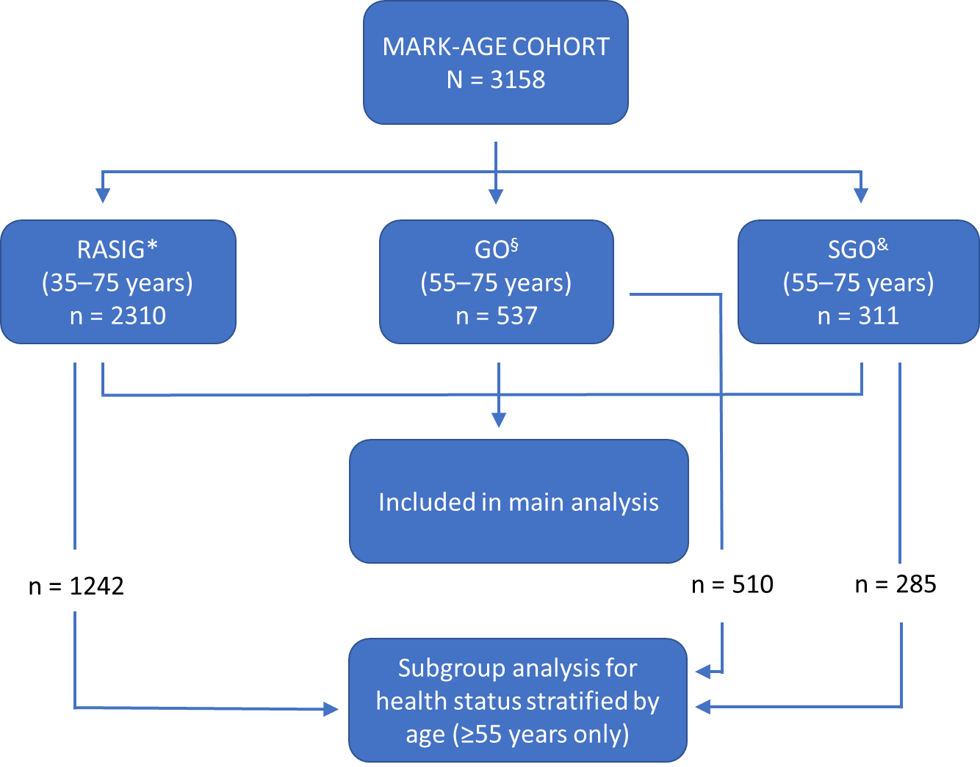

*RASIG group (age-stratified individuals from the general population)
§GO group (Genetics of Healthy Aging GEHA offspring)
&SGO group (spouses from the recruited GO participants)

Supplementary Table 1: Self-rated health status based on study group

 | RASIG | GO | SGO
Health Status | (n=2310) | (n=537) | (n=311)
Excellent | 267 (11.6%) | 76 (14.2%) | 26 (8.4%)
Very good | 880 (38.1%) | 152 (28.3%) | 80 (25.7%)
Good | 897 (38.8%) | 236 (43.9%) | 159 (51.1%)
Fair/poor | 266 (11.5%) | 73 (13.6%) | 46 (14.8)
≥ 55 years old | RASIG | GO | SGO
Health Status | (n=1242) | (n=510) | (n=285)
Excellent | 107 (8.6) | 75 (14.7) | 23 (8.1)
Very good | 418 (33.7) | 143 (28.0) | 70 (24.6)
Good | 519 (41.8) | 221 (43.3) | 146 (51.2)
Fair/poor | 198 (15.9) | 71 (13.9) | 46 (16.1)

The groups of study participants: RASIG (73.1%); GO (17.1%); SGO (9.8%) differed significantly based on the categories of self-rated health status (χ2(4)=41.49, P<0.001). The association was considered small (Cramer's V=0.081). The GO group had the highest percentage of participants rating health status as excellent (14.2%) and the SGO had the highest percentage for self-reported fair/poor health status (14.8%). Given, that the RASIG group included participants from the age of 35 years, a subgroup comparison between the three groups only including participants ≥55 years confirmed the above findings (χ2(4)=28.53, P<0.001; Cramer’s V=0.84).

Supplementary Table 2: Self-rated health status according to country

 | Austria | Belgium | Finland | Germany | Greece | Italy | Netherlands | Poland
Health Status | (n=399) | (n=379) | (n=294) | (n=357) | (n=425) | (n=563) | (n=215) | (n=526)
Excellent | 81 (20.3%) | 60 (15.8%) | 42 (14.3%) | 45 (12.6%) | 56 (13.2%) | 44 (7.8%) | 38 (17.7%) | 3 (0.6%)
Very good | 205 (51.4%) | 147 (38.8%) | 109 (37.1%) | 153 (42.9%) | 160 (37.6%) | 178 (31.6%) | 67 (31.2%) | 93 (17.7%)
Good | 107 (26.8%) | 133 (35.1%) | 97 (33.0%) | 139 (38.9%) | 144 (33.9%) | 285 (50.6%) | 98 (45.6%) | 289 (54.9%)
Fair/poor | 6 (1.5%) | 39 (10.3) | 46 (15.6%) | 20 (5.6%) | 65 (15.3) | 56 (9.9) | 12 (5.6%) | 141 (26.8%)
≥ 55 years old | Austria | Belgium | Finland | Germany | Greece | Italy | Netherlands | Poland
Health Status | (n=200) | (n=273) | (n=258) | (n=198) | (n=218) | (n=349) | (n=212) | (n=329)
Excellent | 30 (15.0) | 43 (15.8) | 33 (12.6) | 23 (11.6) | 19 (8.7) | 19 (5.4) | 37 (17.5) | 1 (0.3)
Very good | 101 (50.5) | 92 (33.7) | 93 (36.0) | 85 (42.9) | 65 (29.8) | 91 (26.1) | 67 (31.6) | 37 (11.2)
Good | 65 (32.5) | 104 (38.1) | 88 (34.1) | 79 (39.9) | 83 (38.1) | 191 (54.7) | 96 (45.3) | 180 (54.7)
Fair/poor | 4 (2.0) | 34 (12.5) | 44 (17.1) | 11 (5.6) | 51 (23.4) | 48 (13.8) | 12 (5.7) | 111 (33.7)

The highest percentage of participants reporting fair/poor health status was from Poland (26.8% in all ages; 33.7% in those ≥55 years), with the lowest reported from Austria with 1.5% (2% in ≥55 years). Health status category was statistically significantly associated with country (χ2(21)=421.58, P<0.001) with a moderate to small association (Cramer's V=0.21). Similar results were obtained when stratifying the cohort according to age for those 55 years and older (χ2(21)=313.41, P<0.001; Cramer's V=0.23).

Supplementary Table 3: Univariate binary logistic regression analysis

For binary logistic regression the dependent variable, health status categories were dichotomised as follows: excellent/very good/good versus fair/poor. The univariate analysis assessed vitamin D, retinol and α-tocopherol as well as the following confounders: sex, age group, education, marital status, BMI, smoking and alcohol consumption status, supplement use, number of current comorbidities, number of medications, hospital visits during the preceding 12 months, season of blood sampling, vitamin D status, quartiles for retinol and α-tocopherol, country of residence and study group.

The following variables contained missing values (ordered as presented in table): BMI (n=1), Hospitalisation status (n=6), 25-hydroxyvitamin D (n=140), α-tocopherol (n=136), retinol (n=136).
 | OR (95% CI) | P
Sex: Male | 0.916 (0.740, 1.135) | 0.42
Age group: 35-44 | Reference | < 0.001
Age group 45-54 | 2.222 (1.294, 3.815) | 0.004
Age group 55-64 | 4.185 (2.563, 6.834) | < 0.001
Age group 65-75 | 5.005 (3.073, 8.150) | < 0.001
Education: University degree | Reference | < 0.001
Finished school | 1.753 (1.359, 2.260) | < 0.001
Elementary unfinished | 5.232 (2.386, 11.473) | < 0.001
Married | Reference | 0.006
Never | 0.878 (0.602, 1.281) | 0.49
Divorced | 1.386 (1.025, 1.874) | 0.034
Widow | 1.768 (1.191, 2.623) | 0.005
BMI (kg/m2) | 1.106 (1.083, 1.130) | < 0.001
Supplements: yes | 0.856 (0.689, 1.063) | 0.16
Alcohol consumption: yes | 0.455 (0.352, 0.589) | < 0.001
Smoker: no | Reference | < 0.001
Smoker: current | 1.894 (1.437, 2.497) | < 0.001
Smoker: previous | 1.253 (0.980, 1.601) | 0.07
Meds (0) | Reference | < 0.001
Meds (1-2) | 1.923 (1.400, 2.639) | < 0.001
Meds (3-4) | 5.713 (4.137, 7.889) | < 0.001
Meds (5+) | 11.166 (7.999, 15.589) | < 0.001
Comorbidities (0-1) | Reference | < 0.001
Comorbidities (2-3) | 1.994 (1.320, 3.012) | < 0.001
Comorbidities (4+) | 10.062 (6.992, 14.481) | < 0.001
Hospitalised past 12 mo: yes | 2.193 (1.658, 2.901) | < 0.001
Summer | Reference | < 0.001
Spring | 1.577 (1.120, 2.220) | 0.009
Winter | 1.993 (1.408, 2.820) | < 0.001
Autumn | 2.320 (1.633, 3.294) | < 0.001
Optimal vitamin D | Reference | < 0.001
Insufficient vitamin D | 1.604 (0.953, 2.700) | 0.075
Vitamin D deficiency | 2.636 (1.596, 4.354) | < 0.001
Severe vitamin D deficiency | 4.153 (2.419, 7.130) | < 0.001
α-Tocopherol quartiles (µmol) >33.37 | Reference | 0.38
28.22-33.37 | 1.012 (0.733, 1.399) | 0.941
23.85-28.21 | 1.183 (0.864, 1.620) | 0.294
<23.85 | 1.256 (0.921, 1.713) | 0.150
Retinol quartile (µmol) (>2.02) | Reference | 0.017
1.73-2.02 | 0.917 (0.661, 1.272) | 0.604
1.45-1.72 | 1.019 (0.743, 1.398) | 0.91
<1.45 | 1.438 (1.063, 1.945) | 0.02
Germany | Reference | < 0.001
Finland | 3.125 (1.803, 5.417) | < 0.001
Belgium | 1.933 (1.104, 3.383) | 0.021
Netherlands | 0.996 (0.477, 2.981) | 0.99
Poland | 6.171 (3.778, 10.079) | < 0.001
Greece | 3.042 (1.804, 5.131) | < 0.001
Austria | 0.257 (0.102, 0.648) | 0.004
Italy | 1.861 (1.097, 3.158) | 0.02
Study group: RASIG | Reference | 0.14
GO | 1.209 (0.916, 1.596) | 0.18
SGO | 1.334 (0.951, 1.870) | 0.09

Supplementary Table 4: Univariate ordinal logistic regression analysis

Ordinal logistic regression was performed to determine the effect of the three fat-soluble vitamins on the four groups of SRH (excellent, very good, good, fair/good) as the dependent variable taking into account possible confounders. The following predictor variables were assessed in a univariate analysis: sex, age group, education, marital status, BMI, smoking and alcohol consumption status, supplement use, number of current comorbidities, number of medications, hospital visits during the preceding 12 months, season of blood sampling, vitamin D status, quartiles for retinol and α-tocopherol, country of residence and study group.

The following variables contained missing values (ordered as presented in table): BMI (n=1), Hospitalisation status (n=6), 25-hydroxyvitamin D (n=140), α-tocopherol (n=136), retinol (n=136).
 |  | OR (95% CI) | P
Sex: Male |  | 0.834 (0.734, 0.949) | 0.006
Age group: 35-44 |  | Reference | < 0.001
Age group 45-54 |  | 1.153 (0.981, 1.354) | 0.08
Age group 55-64 |  | 1.686 (1.401, 2.029) | < 0.001
Age group 65-75 |  | 2.749 (2.247, 3.364) | < 0.001
Education: University degree |  | Reference | < 0.001
Finished school |  | 2.222 (1.145, 4.313) | 0.02
Elementary unfinished |  | 3.386 (1.735, 6.608) | < 0.001
Married |  | Reference | 0.004
Never |  | 1.578 (1.194, 2.087) | 0.001
Divorced |  | 1.636 (1.172, 2.284) | 0.004
Widow |  | 1.306 (0.945, 1.805) | 0.11
BMI (kg/m2) |  | 0.911 (0.897, 0.924) | < 0.001
Supplements: yes |  | 0.980 (0.859, 1.119) | 0.76
Alcohol consumption: yes |  | 0.496 (0.412, 0.597) | < 0.001
Smoker: no |  | Reference | < 0.001
Smoker: previous |  | 1.325 (1.093, 1.608) | 0.004
Smoker: current |  | 1.834 (1.527, 2.202) | < 0.001
Meds (0) |  | Reference | < 0.001
Meds (1-2) |  | 1.898 (1.435, 2.512) | < 0.001
Meds (3-4) |  | 4.962 (3.854, 6.389) | < 0.001
Meds (5+) |  | 8.492 (6.618, 10.897) | < 0.001
Comorbidities (0-1) |  | Reference | < 0.001
Comorbidities (2-3) |  | 3.487 (2.954, 4.116) | < 0.001
Comorbidities (4+) |  | 6.330 (5.319, 7.533) | < 0.001
Hospitalised past 12 mo: yes |  | 1.806 (1.470, 2.219) | < 0.001
Summer |  | Reference | < 0.001
Spring |  | 1.194 (0.987, 1.446) | 0.07
Winter |  | 1.406 (1.173, 1.684) | < 0.001
Autumn |  | 1.553 (1.275, 1.892) | < 0.001
Optimal vitamin D |  | Reference | < 0.001
Insufficient vitamin D |  | 1.404 (1.131, 1.744) | 0.002
Vitamin D deficiency |  | 1.864 (1.494, 2.327) | < 0.001
Severe vitamin D deficiency |  | 2.903 (2.192, 3.844) | < 0.001
α-Tocopherol quartiles (µmol) >33.37 |  | Reference | 0.48
28.22-33.37 |  | 0.927 (0.770, 1.116) | 0.42
23.85-28.21 |  | 1.074 (0.892, 1.292) | 0.45
<23.85 |  | 1.022 (0.849, 1.230) | 0.82
Retinol quartile (µmol) (>2.02) |  | Reference | < 0.001
1.73-2.02 |  | 1.381 (1.147, 1.664) | 0.001
1.45-1.72 |  | 1.498 (1.240, 1.809) | < 0.001
<1.45 |  | 1.426 (1.183, 1.719) | < 0.001
Germany |  | Reference | < 0.001
Finland |  | 1.286 (0.966, 1.711) | 0.09
Belgium |  | 0.721 (0.554, 0.937) | 0.014
Netherlands |  | 2.387 (1.802, 3.162) | < 0.001
Poland |  | 0.971 (0.737, 1.280) | 0.83
Greece |  | 0.257 (0.196, 0.337) | < 0.001
Austria |  | 1.183 (0.854, 1.638) | 0.31
Italy |  | 1.242 (0.937, 1.647) | 0.13
Study group: RASIG |  | Reference | < 0.001
GO |  | 1.381 (1.066, 1.789) | 0.014
SGO |  | 1.663 (1.335, 2.072) | < 0.001

