Supplementary Material
Title: Evaluation of paper-based and web-based food frequency questionnaires for 7-year-old children in Singapore.
Journal: British Journal of Nutrition
Authors: Jun S Lai, Jason Loh, Jia Ying Toh, Ray Sugianto, Marjorelee T Colega, Kok Hian Tan, Fabian Yap, Yap Seng Chong, Keith M. Godfrey, Mary FF Chong
*Correspondence to: Mary FF Chong. Saw Swee Hock School of Public Health, National University of Singapore and National University Health System, Tahir Foundation Building, 12 Science Drive 2, #09-01Q Singapore 117549. Ph: (65) 65164969. Fax: (65) 67791489. Email: ephmcff@nus.edu.sg
Supplementary Methods
Detailed description of GUSTO Year-7 paper-FFQ
The GUSTO Year-7 paper-FFQ is a quantitative FFQ that assesses food intake of 7-year-old children over the past 1 month through parent-report. It contains 120 items divided into the following categories: breads, spreads, cereals, rice and rice dishes, rice porridge, noodles and pasta, soups, vegetables and legumes, fruits, poultry and meat, fish and seafood, eggs, desserts, savory and sweet snacks, confectionaries, pizza and burger, milk and dairy products, and beverages. This paper-FFQ was modified from the validated Year-5 FFQ ⁽¹⁾ as follows: 1) adding commonly consumed food items (e.g. mixture of white and unpolished rice, and okra and eggplant) and cooking methods (e.g. cooked in curry gravy); 2) splitting existing food items into more defined types (e.g. noodles were split into rice and wheat noodles); and 3) collapsing existing less consumed food items (e.g. “Milo” and “Horlicks” were collapsed into malt beverages).
Detailed description of GUSTO Year-7 web FFQ photography
Generic food pictures were purchased from websites (https://www.shutterstock.com/ or https://www.dreamstime.com/) which offered royalty-free stock images. Portion size photographs were taken in-house and in collaboration with Temasek Polytechnic, Singapore.
Foods were purchased from local supermarkets and food centers. All portion sizes were weighed using a food scale or measured with standard household measuring utensils ⁽²⁾. Food was placed in the middle and towards the bottom of a standard plate commonly used in local food centers (9-inch diameter), with a dessertspoon positioned beside the plate to provide perspective ^{(2, 3)}. The plate of food and the spoon was shot at the same angle and distance from the camera with the same lighting each time.
References
- Sugianto R, Chan MJ, Wong SF et al. (2020) Evaluation of a quantitative food frequency questionnaire for 5-year-old children in an Asian population. J Acad Nutr Diet 120, 437-444.
- Forster H, Fallaize R, Gallagher C et al. (2014) Online dietary intake estimation: the Food4Me food frequency questionnaire. J Med Internet Res 16, e150.
- Beasley JM, Davis A, Riley WT (2009) Evaluation of a web-based, pictorial diet history questionnaire. Public Health Nutr 12, 651-659.

Supplementary Table 1: Description of food groups and their percentages of consumption for evaluation of paper-based and web-based food frequency questionnaires in the Growing Up in Singapore Towards healthy Outcomes cohort (n=92).
Foods/food groups | Items | % of participants with no consumption
 |  | Paper-FFQ | Web-FFQ | 3-day DR
Breads | white bread, wholemeal/multigrain bread, buns (sweet or savoury fillings), ethnic bread (fried or steamed) | 1.1 | 4.3 | 12.0
Spreads | butter, margarine, peanut butter, kaya, nutella, jam, honey, mayonnaise | 6.5 | 14.1 | 43.5
Oats and breakfast cereals | oats/high fibre cereals, refined cereals (e.g. corn flakes, Koko Krunch®, Honey stars®) | 18.5 | 25.0 | 80.1
Other types of cereals | semolina, uppuma, millet | 86.8 | 93.4 | 95.6
Rice | plain rice (white, unpolished, mixture of white and unpolished) | 0.0 | 8.7 | 0.1
Flavored rice dishes | e.g. fried rice, chicken rice, nasi lemak, nasi briyani | 3.3 | 31.5 | 43.5
Porridge | plain and flavoured porridge | 32.6 | 37.0 | 82.6
Noodles and pasta | rice and wheat noodles (in soup, stir-fried/dry, with gravy), instant noodles, pasta | 1.1 | 1.1 | 15.2
Soup | cream and clear soups | 18.5 | 29.3 | 40.2
Cruciferous and dark-green vegetables | cabbage, broccoli, cauliflower, dark-green leafy, green peas and beans | 23.9 | 22.8 | 30.4
Other vegetables | tomatoes, peppers, carrots, pumpkin, corn, potatoes (boiled), mushrooms, okra and eggplant, stalk vegetables, gourds | 7.6 | 8.7 | 32.7
Legumes, nuts, soybean products | lentils, dhal, chickpeas, nuts, bean curd, soymilk | 8.7 | 18.5 | 53.3
Fruits | all types excluding dried fruits and fruit juices | 0.0 | 2.2 | 33.3
Dried Fruits |  | 61.3 | 74.5 | 94.6
Poultry and meat | poultry, pork, beef (stir-fried, pan-fried, braised, steamed, boiled, roasted, grilled, deep fried, cooked in curry with coconut milk/cream) | 4.3 | 6.5 | 23.9
Processed meat | dried/preserved meat, meatballs, nuggets | 4.3 | 6.5 | 52.2
Fish, seafood, and products | all types of fish and seafood, canned fish, fish and seafood products | 7.6 | 12.0 | 32.9
Eggs | fried, scrambled, boiled, poached, steamed, omelette | 3.3 | 6.5 | 27.2
Desserts and sweet snacks | dessert soups, sweet ethnic snacks (e.g. kueh, gulab jamun), cake, pastry, cream-filled biscuits/cookies, plain biscuits/crackers, ice cream, chocolates, jellies/puddings, sweets | 0.0 | 0.0 | 19.6
Fast food and fried snacks | pizza, burger, fried potatoes (e.g. fries), fried dough snacks, fried dim sum, fried salty snacks (e.g. crisps, corn chips, prawn crackers) | 0.0 | 0.0 | 32.7
Local steamed snacks | steamed bun with sweet or savoury fillings, steamed dim sum | 32.1 | 35.8 | 83.2
Milk | full-cream, low-fat, formula, powdered | 9.8 | 13.0 | 29.3
Dairy products (excluding milk) | dairy-based drinks (milk shake, lassi), cultured drinks, yoghurt, cheese, malt beverages (e.g. Horlicks®, Milo®, Ovaltine®) | 2.2 | 3.3 | 25.0
Sweet drinks | fruit juices, sweetened commercial beverages | 21.7 | 23.9 | 51.1
Non-sweet drinks | coffee, tea, low calorie drinks | 41.3 | 69.6 | 80.5
FFQ, food frequency questionnaire, DR, diet records

- Paper-FFQ and 3-day DR
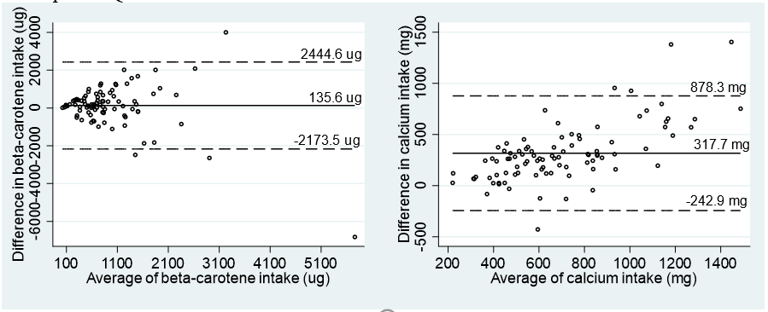

B. Web-FFQ and 3-day DR
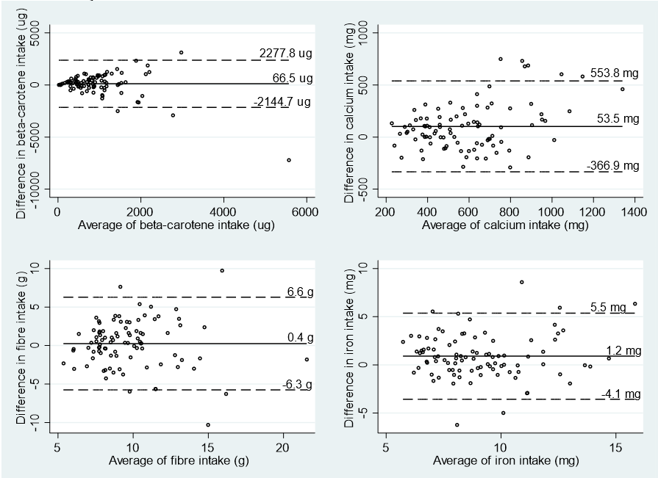
Supplementary Figure 1: Bland–Altman plots comparing average daily β-carotene and calcium intakes between paper-food frequency questionnaire (FFQ) and 3-day diet records (DR) (A), and comparing average daily β-carotene, calcium, fibre and iron intakes between web-FFQ and 3-day DR (B). The x-axis represents the average daily intakes of paper-or web-FFQ and DR, and the y-axis represents the difference in average daily intakes between paper- or web-FFQ and DR. The solid line represents the mean difference and the dash lines represent the limits of agreements (±2SD).
- Paper-FFQ and 3-day DR
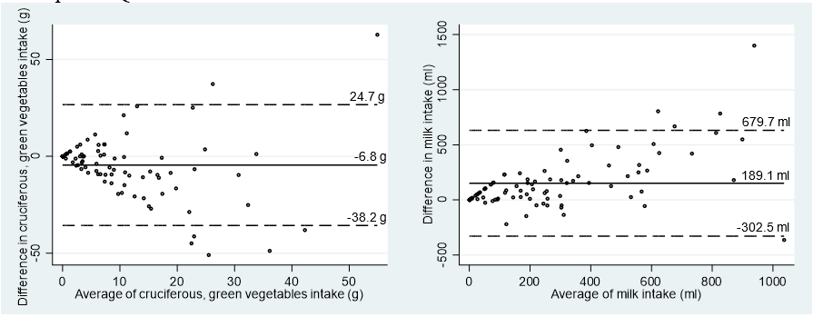

B. Web-FFQ and 3-day DR
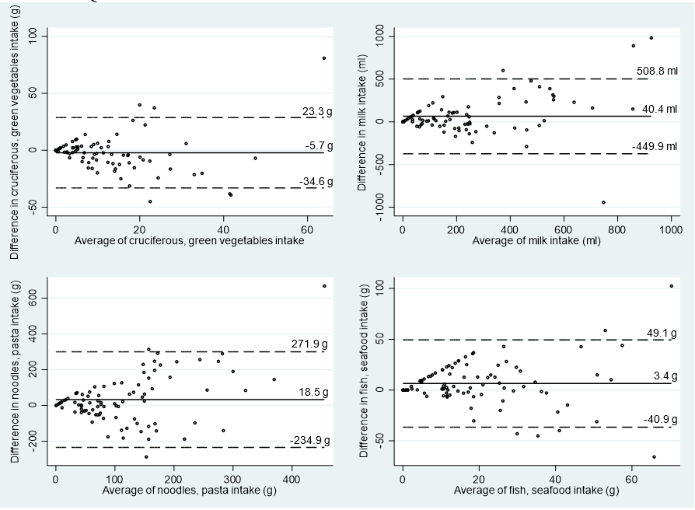

Supplementary Figure 2: Bland–Altman plots comparing average daily intakes of cruciferous and dark green vegetables, and milk between paper-food frequency questionnaire (FFQ) and 3-day diet records (DR) (A), and comparing average daily intakes of cruciferous and dark green vegetables, milk, noodles and pasta, and fish and seafood between web-FFQ and 3-day DR (B). The x-axis represents the average daily intakes of paper- or web-FFQ and 3-day DR, and the y-axis represents the difference in average daily intakes between paper-or web-FFQ and 3-day DR. The solid line represents the mean difference and the dash lines represent the limits of agreements (±2SD).

