Table S1: Search strategy, original MeSH terms and alternative terms

PubMed | SCOPUS | Google Scholar
(“Vitamin D Deficiency” [MeSH]) AND Bangladesh [MeSH] AND pregnant women [MeSH]  (“Vitamin D” [MeSH]) AND Bangladesh [MeSH] AND pregnant women [MeSH]  (“Vitamin D” [MeSH]) AND Bangladesh [MeSH] AND Prevalence [MeSH] AND pregnant women [MeSH]  (“Vitamin D Deficiency” [MeSH]) AND India [MeSH] AND pregnant women [MeSH]  (“Vitamin D” [MeSH]) AND India [MeSH] AND pregnant women [MeSH]  (“Vitamin D” [MeSH]) AND India [MeSH] AND Prevalence [MeSH] AND pregnant women [MeSH]  (“Vitamin D Deficiency” [MeSH]) AND Pakistan [MeSH] AND pregnant women [MeSH]  (“Vitamin D” [MeSH]) AND Pakistan [MeSH] AND pregnant women [MeSH] | (INDEXTERMS (“Vitamin D Deficiency”) AND INDEXTERMS(BANGLADESH) AND INDEXTERMS (Pregnant women)) OR (INDEXTERMS (“Vitamin D”) AND INDEXTERMS(BANGLADESH) AND INDEXTERMS (Pregnant women)) OR (TITLE-ABS-KEY(“Prevalence”) AND (TITLE-ABS-KEY (“Vitamin D”) AND TITLE-ABS-KEY(BANGLADESH) AND TITLE-ABS-KEY (Pregnant women))  (INDEXTERMS (“Vitamin D Deficiency”) AND INDEXTERMS(INDIA) AND INDEXTERMS (Pregnant women)) OR (INDEXTERMS (“Vitamin D”) AND INDEXTERMS(INDIA) AND INDEXTERMS (Pregnant women) OR (TITLE-ABS-KEY(“Prevalence”) AND (TITLE-ABS-KEY (“Vitamin D”) AND TITLE-ABS-KEY(INDIA) AND TITLE-ABS-KEY (Pregnant women))  (INDEXTERMS (“Vitamin D Deficiency”) AND INDEXTERMS(PAKISTAN) AND INDEXTERMS (Pregnant women)) OR (INDEXTERMS (“Vitamin D”) AND INDEXTERMS(PAKISTAN)  INDEXTERMS (Pregnant women)) OR (TITLE-ABS-KEY(“Prevalence”) AND (TITLE-ABS-KEY (“Vitamin D”) AND TITLE-ABS-KEY(PAKISTAN) AND TITLE-ABS-KEY (Pregnant women)) | ((“Vitamin D”) OR (“Vitamin D3”)) AND ((prevalence) OR (deficiency)) AND (Bangladesh) AND (Pregnant women)  ((“Vitamin D”) OR (“Vitamin D3”)) AND ((prevalence) OR (deficiency)) AND (India) AND (Pregnant women)  ((“Vitamin D”) OR (“Vitamin D3”)) AND ((prevalence) OR (deficiency)) AND (Pakistan) AND (Pregnant women)  ((“Vitamin D”) OR (“Vitamin D3”)) AND ((prevalence) OR (deficiency)) AND (Sri Lanka) AND (Pregnant women)  ((“Vitamin D”) OR (“Vitamin D3”)) AND ((prevalence) OR (deficiency)) AND (Afghanistan) AND (Pregnant women)
PubMed | SCOPUS | Google Scholar
(“Vitamin D” [MeSH]) AND Pakistan [MeSH] AND Prevalence [MeSH] AND pregnant women [MeSH]  (“Vitamin D Deficiency” [MeSH]) AND Nepal [MeSH] AND pregnant women [MeSH]  (“Vitamin D” [MeSH]) AND Nepal [MeSH] AND pregnant women [MeSH]  (“Vitamin D” [MeSH]) AND Nepal [MeSH] AND Prevalence [MeSH] AND pregnant women [MeSH]  (“Vitamin D Deficiency” [MeSH]) AND Sri Lanka [MeSH] AND pregnant women [MeSH]  (“Vitamin D” [MeSH]) AND Sri Lanka [MeSH] AND pregnant women [MeSH]  (“Vitamin D” [MeSH]) AND Sri Lanka [MeSH] AND Prevalence [MeSH] AND pregnant women [MeSH]  (“Vitamin D Deficiency” [MeSH]) AND Maldives [MeSH] AND pregnant women [MeSH]  (“Vitamin D” [MeSH]) AND Maldives [MeSH] AND pregnant women [MeSH] | (INDEXTERMS (“Vitamin D Deficiency”) AND INDEXTERMS(NEPAL) AND INDEXTERMS (Pregnant women)) OR (INDEXTERMS (“Vitamin D”) AND INDEXTERMS(NEPAL) AND INDEXTERMS (Pregnant women)) OR (TITLE-ABS-KEY(“Prevalence”) AND (TITLE-ABS-KEY (“Vitamin D”) AND TITLE-ABS-KEY(NEPAL) AND TITLE-ABS-KEY (Pregnant women))  (INDEXTERMS (“Vitamin D Deficiency”) AND INDEXTERMS(BHUTAN) AND INDEXTERMS (Pregnant women)) OR (INDEXTERMS (“Vitamin D”)  INDEXTERMS(BHUTAN) AND INDEXTERMS (Pregnant women)) OR (TITLE-ABS-KEY(“Prevalence”) AND (TITLE-ABS-KEY (“Vitamin D”) AND TITLE-ABS-KEY(BHUTAN) AND TITLE-ABS-KEY (Pregnant women))  (INDEXTERMS (“Vitamin D Deficiency”) AND INDEXTERMS(BHUTAN) AND INDEXTERMS (Pregnant women)) OR (INDEXTERMS (“Vitamin D”) AND INDEXTERMS(BHUTAN) AND INDEXTERMS (Pregnant women)) OR (TITLE-ABS-KEY(“Prevalence”) AND (TITLE-ABS-KEY (“Vitamin D”) AND TITLE-ABS-KEY(BHUTAN) AND TITLE-ABS-KEY (Pregnant women))  (INDEXTERMS (“Vitamin D Deficiency”) AND INDEXTERMS  (SRI LANKA) AND INDEXTERMS (Pregnant women)) OR (INDEXTERMS (“Vitamin D”) AND INDEXTERMS (SRI LANKA) | ((“Vitamin D”) OR (“Vitamin D3”)) AND ((prevalence) OR (deficiency)) AND (Nepal) AND (Pregnant women)  ((“Vitamin D”) OR (“Vitamin D3”)) AND ((prevalence) OR (deficiency)) AND (Nepal) AND (Pregnant women)  ((“Vitamin D”) OR (“Vitamin D3”)) AND ((prevalence) OR (deficiency)) AND (Bhutan) AND (Pregnant women)  ((“Vitamin D”) OR (“Vitamin D3”)) AND ((prevalence) OR (deficiency)) AND (Maldives) AND (Pregnant women)  ((“Vitamin D”) OR (“Vitamin D3”)) AND ((prevalence) OR (deficiency)) AND (Maldives) AND (Pregnant women)  ((“Vitamin D”) OR (“Vitamin D3”)) AND ((prevalence) OR (deficiency)) AND (South Asia) AND (Pregnant women)
PubMed | SCOPUS
(“Vitamin D” [MeSH]) AND Maldives [MeSH] AND Prevalence [MeSH] AND pregnant women [MeSH]  (“Vitamin D Deficiency” [MeSH]) AND Bhutan [MeSH] AND pregnant women [MeSH]  (“Vitamin D” [MeSH]) AND Bhutan [MeSH] AND pregnant women [MeSH]  (“Vitamin D” [MeSH]) AND Bhutan [MeSH] AND Prevalence [MeSH] AND pregnant women [MeSH]  (“Vitamin D Deficiency” [MeSH]) AND Afghanistan [MeSH] AND pregnant women [MeSH]  (“Vitamin D” [MeSH]) AND Afghanistan [MeSH] AND pregnant women [MeSH]  (“Vitamin D” [MeSH]) AND Afghanistan [MeSH] AND Prevalence [MeSH] AND pregnant women [MeSH]  (“Vitamin D Deficiency” [MeSH]) AND South Asia [MeSH] AND pregnant women [MeSH]  (“Vitamin D” [MeSH]) AND South Asia [MeSH] AND pregnant women [MeSH]  (“Vitamin D” [MeSH]) AND South Asia [MeSH] AND Prevalence [MeSH] AND pregnant women [MeSH] | AND INDEXTERMS (Pregnant women)) OR (TITLE-ABS-KEY(“Prevalence”) AND (TITLE-ABS-KEY (“Vitamin D”) AND (TITLE-ABS-KEY (SRI LANKA) AND TITLE-ABS-KEY (Pregnant women))  (INDEXTERMS (“Vitamin D Deficiency”) AND INDEXTERMS(MALDIVES) AND INDEXTERMS (Pregnant women)) OR (INDEXTERMS (“Vitamin D”) AND INDEXTERMS(MALDIVES)  INDEXTERMS (Pregnant women)) OR (TITLE-ABS-KEY(“Prevalence”) AND (TITLE-ABS-KEY (“Vitamin D”) AND TITLE-ABS-KEY(MALDIVES) AND TITLE-ABS-KEY (Pregnant women))  (INDEXTERMS (“Vitamin D Deficiency”) AND INDEXTERMS(AFGHANISTAN) AND INDEXTERMS (Pregnant women)) OR (INDEXTERMS (“Vitamin D”) AND INDEXTERMS(AFGHANISTAN) AND  INDEXTERMS (Pregnant women)) OR (TITLE-ABS-KEY(“Prevalence”) (TITLE-ABS-KEY (“Vitamin D”) AND AND TITLE-ABS-KEY(AFGHANISTAN) AND TITLE-ABS-KEY (Pregnant women))  (INDEXTERMS (“Vitamin D Deficiency”) AND INDEXTERMS (SOUTH ASIA) AND INDEXTERMS (Pregnant women)) OR (INDEXTERMS (“Vitamin D”) AND  INDEXTERMS (SOUTH ASIA) AND INDEXTERMS (Pregnant women)) OR (TITLE-ABS-KEY(“Prevalence”) (TITLE-ABS-KEY (“Vitamin D”) AND TITLE-ABS-KEY (SOUTH ASIA) AND TITLE-ABS-KEY (Pregnant women))
Table S2: Quality assessment of selected studies (Q1, Q2, Q3……Q10 denotes ten parameters described by Hoy et al for-quality assessment)
Authors | Q1 | Q2 | Q3 | Q4 | Q5 | Q6 | Q7 | Q8 | Q9 | Q10 | Total score | Quality
Sahu et al ³¹ | 0 | 1 | 1 | 0 | 0 | 0 | 0 | 0 | 0 | 0 | 2 | Low
Sachan et al ³² | 1 | 1 | 1 | 0 | 0 | 0 | 0 | 0 | 1 | 0 | 4 | Moderate
Ajmani et al ³³ | 1 | 1 | 1 | 0 | 0 | 0 | 0 | 0 | 1 | 0 | 4 | Moderate
Sheetal et al ³⁴ | 1 | 1 | 1 | 0 | 0 | 0 | 0 | 0 | 1 | 1 | 5 | Moderate
Sudhanshu et al ³⁵ | 1 | 1 | 1 | 0 | 0 | 0 | 0 | 0 | 1 | 0 | 4 | Moderate
Taru et al ³⁶ | 0 | 1 | 1 | 0 | 0 | 0 | 1 | 0 | 1 | 1 | 5 | Moderate
Krishnaveni et al ³⁷ | 1 | 1 | 1 | 0 | 0 | 0 | 0 | 0 | 1 | 0 | 4 | Moderate
Singla et al ³⁸ | 1 | 1 | 1 | 0 | 0 | 0 | 0 | 0 | 1 | 0 | 4 | Moderate
Sahu et al ³⁹ | 1 | 0 | 0 | 0 | 0 | 0 | 0 | 0 | 1 | 0 | 2 | Low
Sharma et al ⁴⁰ | 1 | 1 | 1 | 0 | 0 | 0 | 0 | 0 | 1 | 0 | 4 | Moderate
Nagendra et al ⁴¹ | 1 | 1 | 1 | 0 | 0 | 0 | 0 | 0 | 1 | 0 | 4 | Moderate
Marwaha et al ⁴² | 1 | 0 | 0 | 0 | 0 | 0 | 0 | 0 | 0 | 0 | 1 | Low
Ullah et al ⁴³ | 0 | 1 | 1 | 0 | 0 | 0 | 0 | 0 | 1 | 1 | 4 | Moderate
Schulze et al ⁴⁴ | 0 | 0 | 0 | 0 | 0 | 0 | 0 | 0 | 1 | 0 | 1 | Low
Roth et al ⁴⁵ | 1 | 1 | 0 | 0 | 0 | 0 | 0 | 0 | 1 | 1 | 4 | Moderate
Roth et al ⁴⁶ | 1 | 1 | 1 | 0 | 0 | 0 | 1 | 0 | 1 | 1 | 6 | Moderate
Anwar et al ⁴⁷ | 0 | 0 | 0 | 0 | 0 | 0 | 0 | 0 | 1 | 0 | 1 | Low
Khan et al ⁴⁸ | 1 | 0 | 0 | 0 | 0 | 0 | 0 | 0 | 1 | 0 | 2 | Low
Karim et al ⁴⁹ | 1 | 1 | 1 | 0 | 0 | 0 | 1 | 0 | 1 | 0 | 5 | Moderate
Jiang et al ⁵⁰ | 0 | 0 | 0 | 0 | 0 | 0 | 0 | 0 | 1 | 1 | 2 | Low

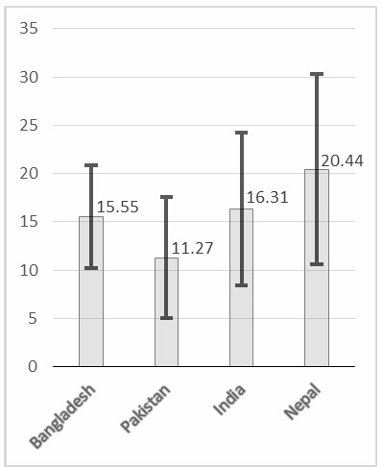

Figure S1: Weighted mean level of serum vitamin D (ng/mL) among South Asian pregnant women (on the Y-axis). X-axis represent the name of the South Asian countries. Error bars represent the weighted standard deviations.

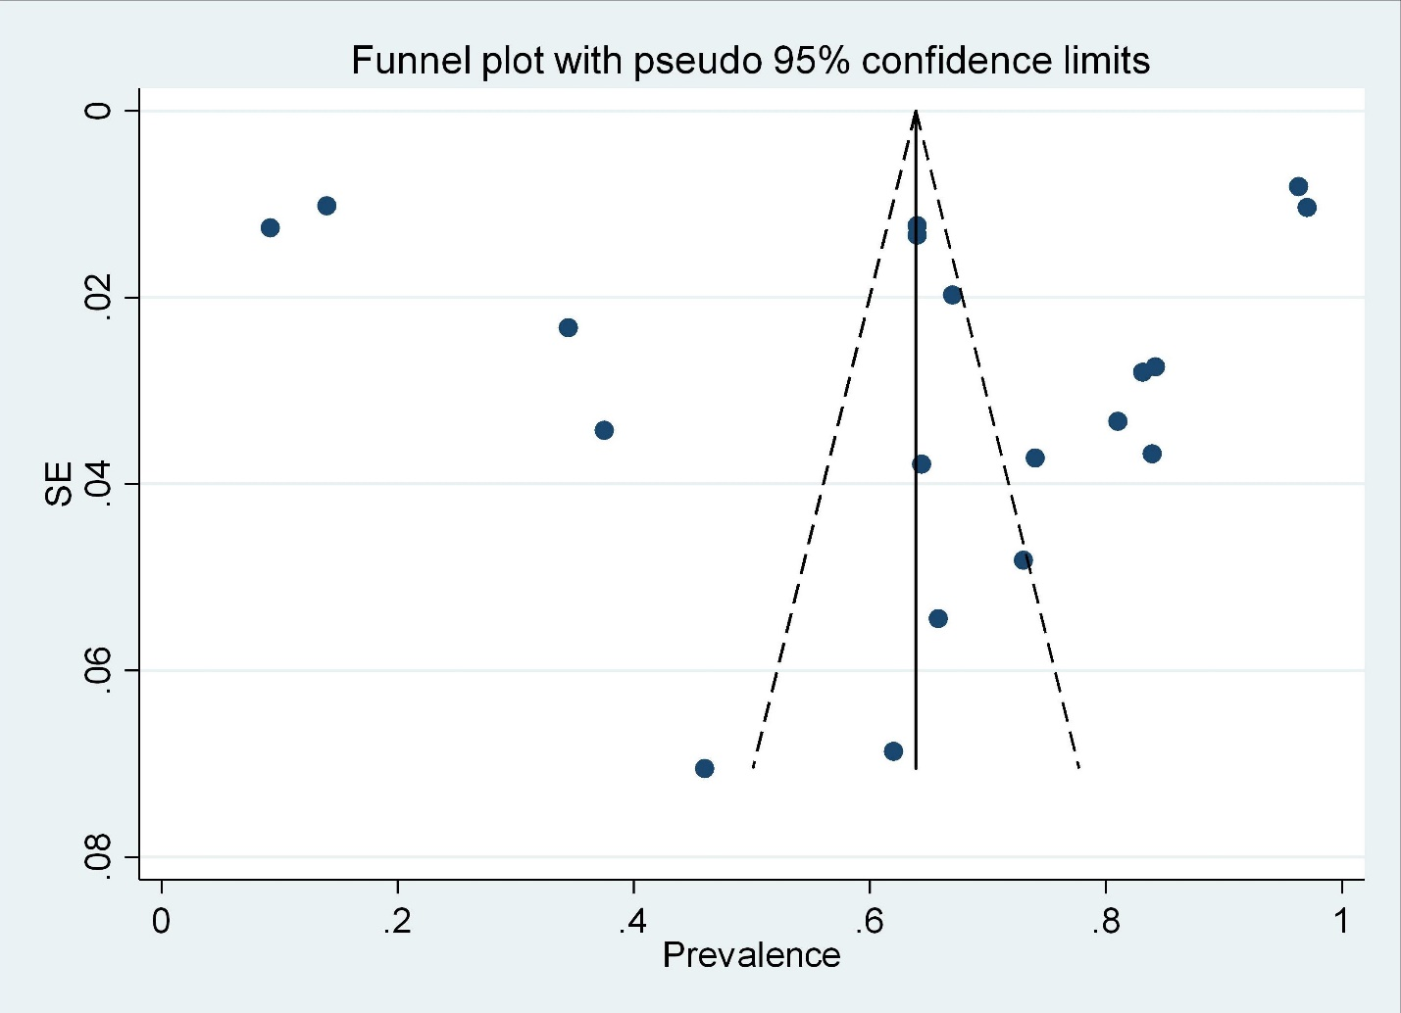
Figure S2: Funnel plot for the publication bias of the selected studies.
Each dots of the funnel plot represent a single study. Y-axis represent the standard error of the effect estimates, and the X-axis shows the result (prevalence) for individual study.

