Supplementary file 5 (a): The impact of leaving out one study from the milk meta-analysis and combing the remainders [Arafa: the JACC Study]
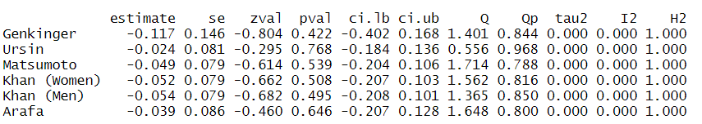

Supplementary file 5 (b): The impact of leaving out one study from the yogurt meta-analysis and combing the remainders [Arafa: the JACC Study]
