

**Supplementary file 4 (a): Forest plot for the association between milk intake and the risk of pancreatic cancer [This Study: the JACC Study]**

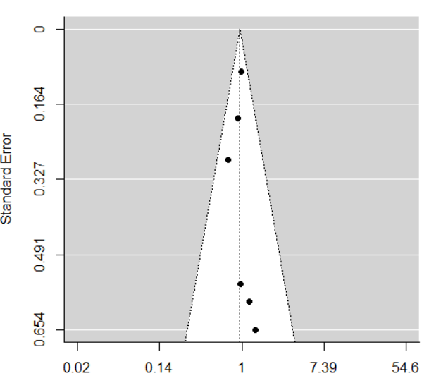

**Supplementary file 4 (b): Funnel plot for the studies that investigated the association between milk intake and the risk of pancreatic cancer**



**Supplementary file 4 (c): Forest plot for the association between cheese intake and the risk of pancreatic cancer [This Study: the JACC Study]**



**Supplementary file 4 (d): Forest plot for the association between yogurt intake and the risk of pancreatic cancer [This Study: the JACC Study]**

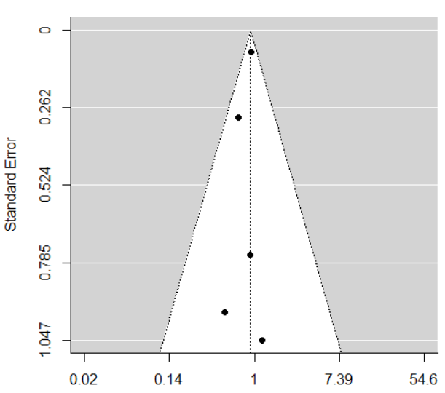

**Supplementary file 4 (e): Funnel plot for the studies that investigated the association between yogurt intake and the risk of pancreatic cancer**