Supplementary material 4. Previous clinical manifestations (present before starting the cow’s milk elimination diet) in the elimination diet group.
(Frequency expressed as percentage, n = 144)

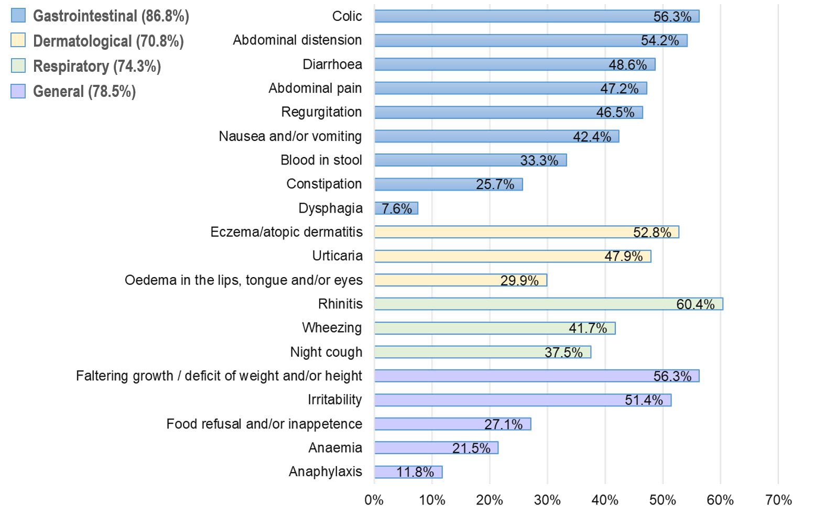

Median number of clinical manifestations = 8.0 (25th and 75th percentiles: 6.0 and 10.0).

