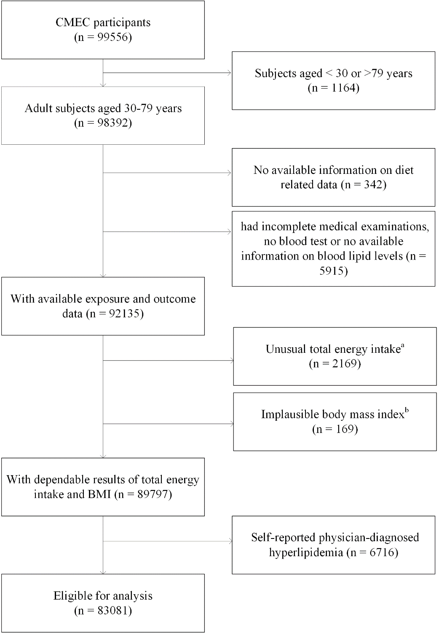
Figure S1. Flow diagram of study participation.
a. Total energy intake, macronutrients and fatty acids were calculated using modified food exchange list and representative food values from China Food Composition Tables. Unusual total energy intake was defined as < 600 or > 3500 kcal/day for female, < 800 or > 4200 kcal/day for male.
b. Implausible BMI was defined as < 14 or > 45 kg/m².
Table S1. Scoring criteria for the DASH score in the CMEC study.
Component | Foods | Scoring criteria | Q1,  g/day | Q5,  g/day
Fruit | All fresh fruit | Q1=1 point  Q2=2 points  Q3=3 points  Q4=4 points  Q5=5 points | 6.4 | 359.9
Vegetable | All fresh vegetables except tubers and legumes |  | 92.7 | 635.0
Legumes | Soybeans, black beans, tofu, soybean milk, dried beans, dried bean curd |  | 0.0 | 39.0
Dairy Product | Fresh milk, yogurt, cheese, milk tea |  | 0.0 | 220.5
Whole Grains | Oats, sorghum, dried corn, highland barely |  | 0.0 | 88.6
Red & processed meat | Beef, mutton, pork and their products | Reverse score:  Q1=5 points  Q2=4 points  Q3=3 points  Q4=2 points  Q5=1 point | 9.7 | 248.8
Sodium * | Sodium in salt and preserved vegetables ^{b} |  | 3.0 | 15.9
Abbreviation: DASH for Dietary Approaches to Stop Hypertension; Q for quintiles.
* Since preserved vegetables are an important source of sodium intake, we further converted the preserved vegetables into an equivalent amount of salt to be added to sodium intake.

Table S2. Scoring criteria for the AMED score in the CMEC study.
Component | Foods | Scoring criteria | Q1,  g/day | Q5,  g/day
Vegetables | All fresh vegetables except tubers and legumes | Q1=1 point  Q2=2 points  Q3=3 points  Q4=4 points  Q5=5 points | 92.7 | 635.0
Legumes | Soybeans, black beans, tofu, soybean milk, dried beans, dried bean curd |  | 0.0 | 39.0
Fruit | All fresh fruits |  | 6.4 | 359.9
Whole grains | Oats, sorghum, dried corn, highland barely |  | 0.0 | 88.6
Fish | Fish and all kinds of seafood products |  | 0.0 | 50.0
MUFA: SFA * | From all kinds of foods and fats |  | 0.2 | 0.3
Red & processed meats | Beef, mutton, pork and their products | Reverse score:  Q1=5 points  Q2=4 points  Q3=3 points  Q4=2 points  Q5=1 point | 9.7 | 248.8
Ethanol † | All alcoholic beverages | moderate alcohol intake criteria ^{c} | - | -
Abbreviation: AMED for alternative Mediterranean diet; Q for quintiles; MUFA: SFA for monounsaturated/saturated fat ratio.
* Due to there is no values of fatty acids for food groups in the China food exchange list, we made an exchange value table according to the common consumed food items in each food group in Southwest China and the 2018 China food composition tables.
† According to the encouragement of moderate alcohol intake, the alcohol consumptions were categorized into five groups: (10,30], (0,10] or (30,40], 0 or (40,45], (45,50], and >50 grams per day for men; (5,15], (0,5] or (15,25], 0 or (25,30], (30,35], and >35 grams per day for women, and then we assigned descending scores of 1-5 to corresponding individuals.
Text S1. The process of constructing directed acyclic graphs (DAG)
The DAG was built based on the protocol of “Evidence Synthesis for Constructing Directed Acyclic Graphs” (ESC-DAGs), which combined evidence synthesis strategies and causal inference principles.⁽¹⁾ First, we determined a pool of potential confounders according to systematic literature review. Second, we assumed a saturated DAG by drawing directed or undirected edges between all variables, i.e., assuming that there was causal association between each pair of exposure, outcome and confounding factors. Third, each edge in the saturated DAG was assessed using several causal criteria (including temporality, validity, and theoretical support) and determined as retained, reversed, bi-directional or deleted. Fourth, a simplified DAG was constructed, thereby a series of conditional independences were generated according to the constructed DAG. Lastly, we continuously did the independence test and modified the DAG if the conditional independence did not agree with our data, until all the implied conditional independences were satisfied and the final DAG was reached. The final DAG can be found in Figure S2. According to the final DAG and back door criteria, the minimal sufficient set of confounders includes sex (male or female), age (years), marital status (married/cohabiting or not), education attainment (no formal school, primary school, middle and high school, college/university or higher), household income (<12,000, 12,000-19,999, 20,000-59,999, 60,000-99,999, 100,000-199,999, or >200,000 (CNY)/year), profession (agriculture, manufacturing, service, unemployed or other), regular smoking (never, former, or current), physical activity (MET-h/day), total energy intake ( kcal/day), BMI (<24, 24~28, or ≥28 kg/m²), regular intake of sweetened beverages (never, former, or current), insomnia symptoms (presence or absence), depressive symptoms (presence or absence), anxiety symptoms (presence or absence), menopause status for women (premenopausal, perimenopausal, or postmenopausal), and family history (yes or no). In addition, we adjusted for regional level confounders (includes urbanicity and ethnicity that is also equivalent to the study sites or locations) and dieted-related variables that was not included in the dietary pattern analysis (i.e., regular intake of dietary supplements, regular intake of spicy food, regular intake of pepper food).
References
1. Ferguson KD, McCann M, Katikireddi SV et al. (2020) Evidence synthesis for constructing directed acyclic graphs (ESC-DAGs): a novel and systematic method for building directed acyclic graphs. International journal of epidemiology 49, 322-329.
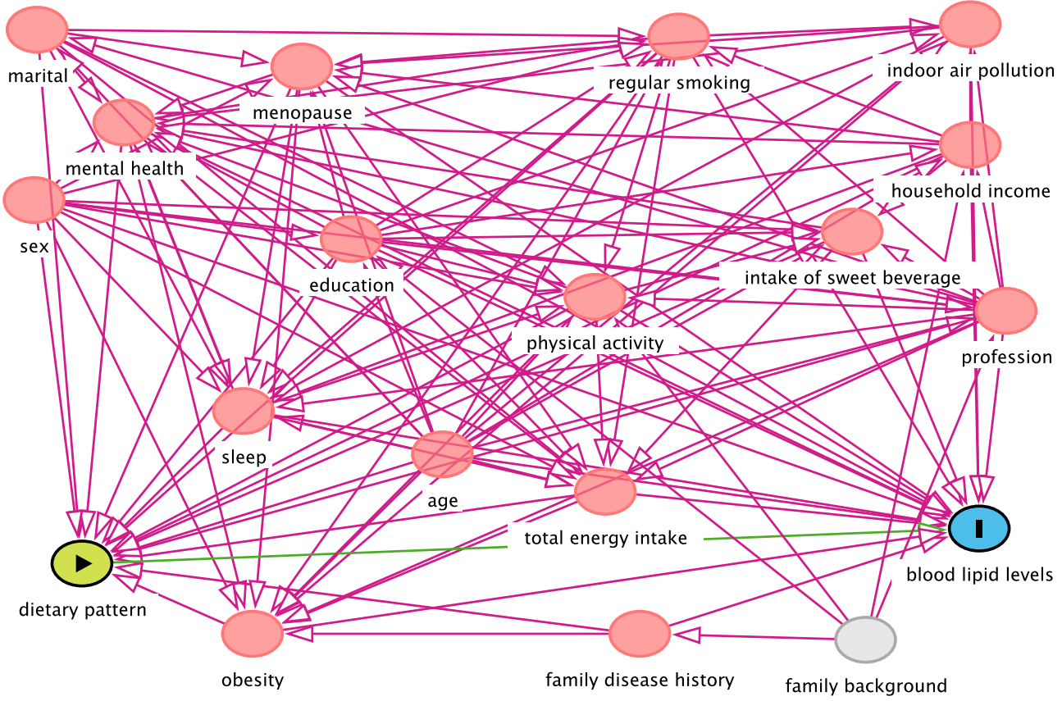
Figure S2. The final constructed DAG.
Text S2. Single component analysis
To investigate the relative importance of the individual components of DASH and AMED in generating the associations between diet and blood lipids, we ran a single component analysis proposed by Trichopoulou ⁽¹⁾. We assessed the contribution of each of the seven or eight components of DASH and AMED scores on blood lipids by dropping one component at a time from the total score, and then estimating the associations of the subtracted total scores (25% score range increment) with blood lipids by adjusting for the same confounders in the main analysis as well as the corresponding subtracted component. Then the relative importance of specific component can be calculated as reduction in apparent effect between the original total score and the subtracted total scores. Due to the score range would shorten after dropping one component, we multiplied the estimated coefficients of the linear regression by 25/29 for DASH and 29/33 for AMED to assure comparability.
References
1. Trichopoulou A, Bamia C, Trichopoulos D (2009) Anatomy of health effects of Mediterranean diet: Greek EPIC prospective cohort study. Bmj 338, b2337.

Table S3. Baseline characteristics in the CMEC study according to the regions. *
Characteristic | Sichuan Basin  n = 38,672 | Yunnan-Kweichow Plateau  n = 36,970 | Qinghai-Tibet Plateau  n = 7,439 | P †
Age (yr) | 50.7±11.9 | 52.5±10.8 | 48.2±11.2 | <0.001
Female sex (%) | 21226 (54.9) | 24863 (67.3) | 4634 (62.3) | <0.001
Urban residence (%) | 27838 (72.0) | 0 (0.0) | 738 (9.9) | <0.001
Ethnic group (%)
Han | 38672 (100.0) | 9677 (26.2) | 0 (0.0) | <0.001
Bouyei | 0 (0.0) | 5226 (14.1) | 0 (0.0)
Dong | 0 (0.0) | 6223 (16.8) | 0 (0.0)
Miao | 0 (0.0) | 4715 (12.8) | 0 (0.0)
Bai | 0 (0.0) | 5585 (15.1) | 0 (0.0)
Yi | 0 (0.0) | 5544 (15.0) | 0 (0.0)
Tibetan | 0 (0.0) | 0 (0.0) | 7439 (100.0)
Married or cohabiting (%) | 34531 (89.3) | 32907 (89.0) | 6553 (88.1) | 0.009
Highest education completed(%)
No formal school | 4068 (10.5) | 13159 (35.6) | 4826 (64.9) | <0.001
Primary school | 8368 (21.6) | 10983 (29.7) | 1867 (25.1)
Middle and high school | 19434 (50.3) | 10838 (29.3) | 568 (7.6)
College or university | 6802 (17.6) | 1989 (5.4) | 178 (2.4)
Household income (Yuan/year) (%)
<12,000 | 3935 (10.2) | 9039 (24.5) | 1393 (18.7) | <0.001
12,000-19,999 | 4765 (12.3) | 8187 (22.2) | 2330 (31.3)
20,000-59,999 | 13863 (35.9) | 13646 (37.0) | 2862 (38.5)
60,000-99,999 | 8024 (20.8) | 3504 (9.5) | 494 (6.6)
100,000-199,999 | 6309 (16.3) | 2180 (5.9) | 271 (3.6)
>200,000 | 1722 (4.5) | 371 (1.0) | 89 (1.2)
Occupation (%) ‡
Primary industry practitioner | 5528 (14.3) | 20990 (56.8) | 3131 (42.1) | <0.001
Secondary industry practitioner | 3892 (10.1) | 2054 (5.6) | 151 (2.0)
Tertiary industry practitioner | 17598 (45.5) | 10406 (28.2) | 2589 (34.8)
Unemployed or other | 11618 (30.1) | 3494 (9.5) | 1567 (21.1)
Regular smoking (%)
Never | 27410 (70.9) | 28886 (78.1) | 6343 (85.3) | <0.001
Previous | 2428 (6.3) | 1212 (3.3) | 289 (3.9)
Current | 8834 (22.8) | 6872 (18.6) | 807 (10.8)
Total physical activity (MET hours/day) § | 23.0±15.8 | 31.3±19.8 | 21.9±17.6 | <0.001
BMI (%, kg/m²)
＜24 | 18662 (48.3) | 21679 (58.7) | 2414 (32.5) | <0.001
24 to ＜28 | 15057 (38.9) | 11707 (31.7) | 3215 (43.2)
24 to ＜28 | 4953 (12.8) | 3584 (9.7) | 1810 (24.3)
Dietary supplement (%) | 6599 (17.1) | 6482 (17.5) | 236 (3.2) | <0.001
Regular beverage intake (%)
Never | 37044 (95.8) | 35794 (96.8) | 4425 (59.5) | <0.001
Previous | 232 (0.6) | 72 (0.2) | 48 (0.6)
Current | 1396 (3.6) | 1104 (3.0) | 2966 (39.9)
Regular spicy food intake (%) | 30817 (79.7) | 31087 (84.1) | 3463 (46.6) | <0.001
Regular pepper food intake (%) | 29253 (75.6) | 23786 (64.3) | 3177 (42.7) | <0.001
Insomnia Symptoms (%) | 17958 (46.4) | 15288 (41.4) | 3040 (40.9) | <0.001
Depressive symptoms (%) | 1508 (3.9) | 2504 (6.8) | 95 (1.3) | <0.001
Anxiety symptoms (%) | 1522 (3.9) | 3229 (8.8) | 93 (1.3) | <0.001
Menopause (%)
Pre-menopause | 10485 (49.4) | 10326 (41.5) | 2691 (58.1) | <0.001
Peri-menopause | 1519 (7.2) | 1723 (6.9) | 288 (6.2)
Post-menopause | 9222 (43.4) | 12814 (51.5) | 1655 (35.7)
Family history (%) || | 16763 (43.3) | 9979 (27.0) | 1388 (18.7) | <0.001
AMED score (median [IQR]) | 26.0 [23.0, 29.0] | 24.0 [21.0, 27.0] | 22.0 [19.0, 24.0] | <0.001
DASH score (median [IQR]) | 22.0 [18.0, 25.0] | 19.0 [16.0, 22.0] | 20.0 [18.0, 23.0] | <0.001
Total cholesterol (median [IQR]) | 4.86 [4.29, 5.50] | 4.97 [4.39, 5.65] | 4.66 [4.08, 5.32] | <0.001
LDL cholesterol (median [IQR]) | 2.82 [2.34, 3.34] | 2.91 [2.37, 3.51] | 2.92 [2.43, 3.45] | <0.001
HDL cholesterol (median [IQR]) | 1.41 [1.18, 1.68] | 1.50 [1.27, 1.77] | 1.29 [1.11, 1.49] | <0.001
Triglyceride (median [IQR]) | 1.24 [0.89, 1.79] | 1.40 [1.00, 2.05] | 0.94 [0.71, 1.29] | <0.001
Total cholesterol /HDL cholesterol (median [IQR]) | 3.43 [2.83, 4.17] | 3.29 [2.74, 3.96] | 3.55 [3.04, 4.25] | <0.001
Abbreviation: AMED for alternative Mediterranean diet; DASH for Dietary Approaches to Stop Hypertension; MET for metabolic equivalent; BMI for body mass index; IQR for interquartile range.
* Data are presented as the mean ± SD, n (%) or median [IQR].
† For the heterogeneity test between groups, normal data were analyzed by one-way ANOVA, non-normal data were analyzed by Kruskal-Wallis Rank Sum Test, and classified data were analyzed by Chi-square test.
‡ Primary industry practitioner is defined as farming, forestry, animal husbandry and fishery laborer. Secondary industry practitioner refers to workers in the processing and manufacturing industry. Tertiary industry practitioner refers to workers in industries other than primary and secondary industries.
§ Physical activity in metabolic equivalent task hours/day.
|| Family history refer to the self-reported hypertension, diabetes or cardiovascular disease from at least one first-degree relative (biological parents, sibling) in the baseline survey.

Figure S3. Stratified analysis of estimated associations between DASH and AMED with blood lipids according to regions, by comparing the highest with the lowest quintiles.

Figure S4. Estimated associations by further excluding the self-reported CVD. *
* The self-reported physician diagnosed CVD include coronary heart disease, stroke.

Figure S5. Estimated associations by further excluding the self-reported cardiometabolic disease, hepatic and gastrointestinal diseases. *
* The self-reported physician diagnosed cardiometabolic disease include hypertension, diabetes, coronary heart disease, and stroke. The self-reported physician diagnosed hepatic and gastrointestinal diseases include chronic hepatitis, hepatic cirrhosis, gastrointestinal ulcers, gastroenteritis, cholecystitis and gallstones.

Figure S6. Estimated associations based on the complete case analysis.

Figure S7. Estimated associations without excluding self-reported hyperlipidemia.

Figure S8. Estimated associations using quantile regression corresponding to median.

Figure S9. Estimated associations between DASH and blood lipids without adjusting for regular intake of sweetened beverages.

Table S4. Associations of the DASH and AMED scores with blood lipids in the non- and high-risk groups. *
Blood  lipids | Nondiabetes  n=75026 | Diabetes  n=8055 | P † | Nonhypertension  n=57056 | Hypertension  n=26025 | P †
DASH
TC | -0.0621 (-0.0843~-0.0399) | -0.1154 (-0.1935~-0.0374) | 0.099 | -0.0388 (-0.0638~-0.0138) | -0.1119 (-0.1531~-0.0707) | 0.001**
LDL-C | 0.0153 (-0.0031~0.0336) | -0.0314 (-0.0933~0.0304) | 0.078 | 0.0229 (0.0020~0.0437) | -0.0090 (-0.0422~0.0242) | 0.055
HDL-C | -0.0384 (-0.0470~-0.0298) | -0.0440 (-0.0694~-0.0187) | 0.341 | -0.0334 (-0.0432~-0.0236) | -0.0458 (-0.0606~-0.0310) | 0.086
TG | -0.0540 (-0.0859~-0.0221) | -0.0994 (-0.2515~0.0526) | 0.283 | -0.0437 (-0.0792~-0.0082) | -0.0779 (-0.1466~-0.0093) | 0.193
TC/HDL-C | 0.0302 (0.0044~0.0561) | 0.0342 (-0.0617~0.1301) | 0.531 | 0.0389 (0.0093~0.0685) | 0.0133 (-0.0347~0.0612) | 0.187
AMED
TC | -0.0791 (-0.1017~-0.0564) | -0.0856 (-0.1645~-0.0067) | 0.438 | -0.0483 (-0.0738~-0.0229) | -0.1394 (-0.1811~-0.0977) | ＜0.001***
LDL-C | -0.0274 (-0.0461~-0.0087) | -0.0422 (-0.1047~0.0204) | 0.328 | -0.0054 (-0.0266~0.0158) | -0.0755 (-0.1091~-0.0419) | ＜0.001***
HDL-C | -0.0291 (-0.0379~-0.0204) | -0.0234 (-0.0490~0.0022) | 0.660 | -0.0259 (-0.0359~-0.0159) | -0.0295 (-0.0446~-0.0145) | 0.348
TG | 0.0241 (-0.0084~0.0567) | 0.0178 (-0.1360~0.1715) | 0.469 | 0.0228 (-0.0134~0.0589) | 0.0170 (-0.0525~0.0866) | 0.442
TC/HDL-C | 0.0115 (-0.0148~0.0378) | 0.0137 (-0.0833~0.1107) | 0.517 | 0.0245 (-0.0056~0.0546) | -0.0231 (-0.0717~0.0255) | 0.051
Abbreviations: DASH, Dietary Approaches to Stop Hypertension; AMED: alternative Mediterranean diet; CI, confidence interval.; TC: Total cholesterol; LDL-C: Low-density lipoprotein cholesterol; HDL-C: High-density lipoprotein cholesterol; TG: Triglyceride.
* The high-risk population in this study was participants with diabetes or hypertension, including self-reported outcomes or newly confirmed outcomes by our physical examination and biochemical tests. In the baseline survey, information about self-reported physician-diagnosed common chronic diseases (e.g., diabetes and hypertension) was collected in a separate section of the questionnaire. For newly confirmed outcomes, diabetes was defined as fasting plasma glucose ≥ 7.0 mmol/L or HbA1c ≥ 6.5%, according to the American Diabetes Association criteria (2019); hypertension was defined as a mean systolic blood pressure (SBP) ≥ 140 mmHg or diastolic blood pressure (DBP) ≥ 90 mmHg, according to the International Society of Hypertension criteria (2020). Data are presented as coefficients (95% CIs).
† We implemented a 2-sample test based on the point estimate and standard error (SE) within each subgroup (i.e., nondiabetes vs diabetes, nonhypertension vs hypertension) to assess the difference between subgroups. Boldface indicates statistical significance (*p<0.05, **p<0.01, *** p<0.001).

Discussion of association between the DASH and AMED scores and blood lipids in high-risk groups.
Our findings imply a more favorable effect on TC, LDL-C and TG in high-risk groups. Diabetes or hypertension is associated with a cluster of interrelated lipid abnormalities, and they are all partially overlapping risk factors for CVD.^{(1; 2; 3; 4)} Our study also shows that participants with hypertension or diabetes had higher TC, LDL-C and TG levels, which is similar to other studies.^{(3; 4)} There are complex biological mechanisms between blood glucose or blood pressure and blood lipids. Some studies have shown that diabetes increases the production and secretion of intestinal and hepatic TG-rich lipoproteins.⁽⁵⁾ Several potential mechanisms may explain the relationship between hypertension and hypercholesterolemia, such as oxidative stress and endothelial dysfunction.⁽⁶⁾ Given this, some measures that lower blood glucose or blood pressure also improve blood lipids.^{(4; 6)} The stronger negative association between healthy dietary patterns and lipids in the high-risk group may be because both the DASH and Mediterranean diets also have an excellent significant effect on lowering blood glucose or blood pressure in this population^{(7; 8; 9; 10)}, which further affects blood lipid levels. Therefore, compared with non-high-risk groups, a healthy diet should be more actively encouraged in high-risk groups to better manage blood lipids and reduce the risk of serious cardiovascular events.
References
1. Laaksonen DE, Niskanen L, Nyyssönen K et al. (2008) Dyslipidaemia as a predictor of hypertension in middle-aged men. European heart journal 29, 2561-2568.
2. Osuji CU, Omejua EG, Onwubuya EI et al. (2012) Serum lipid profile of newly diagnosed hypertensive patients in nnewi, South-East Nigeria. International journal of hypertension 2012, 710486.
3. Krauss RM (2004) Lipids and lipoproteins in patients with type 2 diabetes. Diabetes care 27, 1496-1504.
4. Lazarte J, Hegele RA (2020) Dyslipidemia Management in Adults With Diabetes. Can J Diabetes 44, 53-60.
5. Stahel P, Xiao C, Lewis GF (2018) Control of intestinal lipoprotein secretion by dietary carbohydrates. Curr Opin Lipidol 29, 24-29.
6. Ivanovic B, Tadic M (2015) Hypercholesterolemia and Hypertension: Two Sides of the Same Coin. American journal of cardiovascular drugs : drugs, devices, and other interventions 15, 403-414.
7. Campbell AP (2017) DASH Eating Plan: An Eating Pattern for Diabetes Management. Diabetes spectrum : a publication of the American Diabetes Association 30, 76-81.
8. Kastorini CM, Milionis HJ, Esposito K et al. (2011) The effect of Mediterranean diet on metabolic syndrome and its components: a meta-analysis of 50 studies and 534,906 individuals. J Am Coll Cardiol 57, 1299-1313.
9. Chiu S, Bergeron N, Williams PT et al. (2016) Comparison of the DASH (Dietary Approaches to Stop Hypertension) diet and a higher-fat DASH diet on blood pressure and lipids and lipoproteins: a randomized controlled trial. The American journal of clinical nutrition 103, 341-347.
10. Anand SS, Hawkes C, de Souza RJ et al. (2015) Food Consumption and its Impact on Cardiovascular Disease: Importance of Solutions Focused on the Globalized Food System: A Report From the Workshop Convened by the World Heart Federation. J Am Coll Cardiol 66, 1590-1614.

