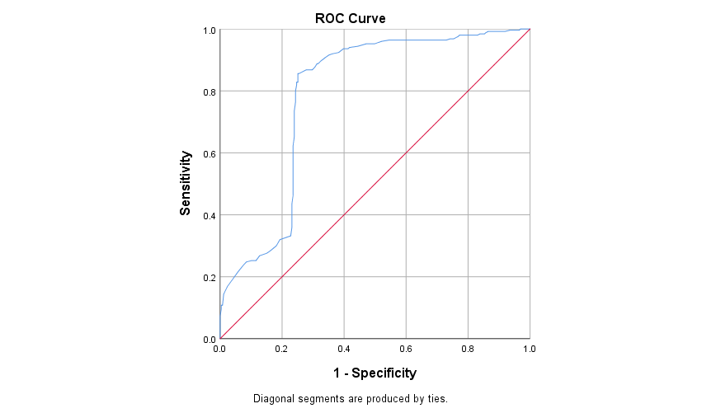
Supplementary Figure 1: Receiver operating characteristic (ROC) curve for prediction of obesity from birth weight.

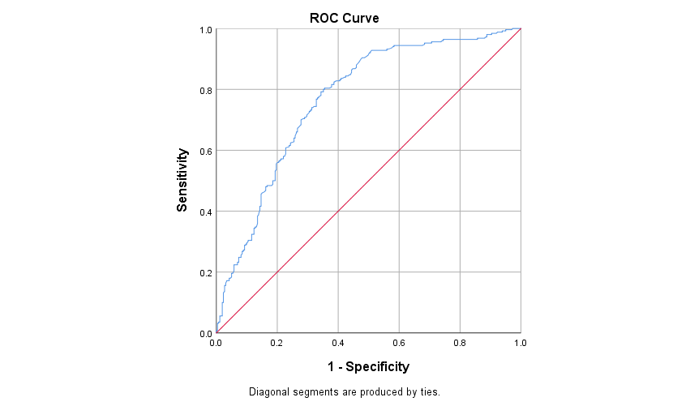

Supplementary Figure 2: Receiver operating characteristic (ROC) curve for prediction of obesity from maternal body mass index (BMI).

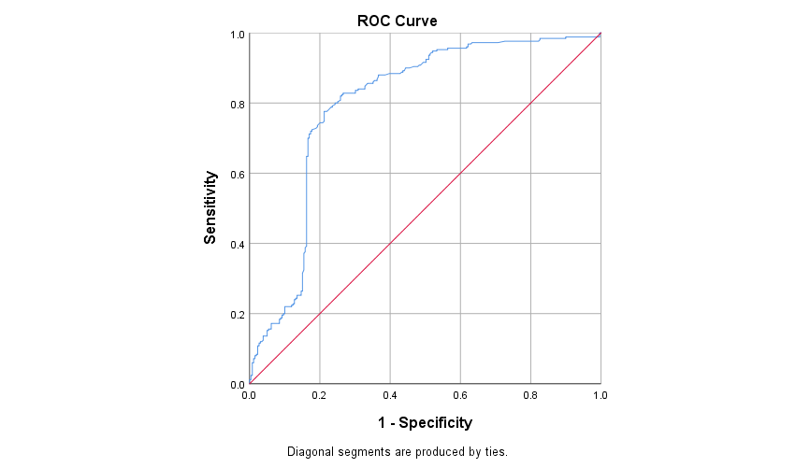

Supplementary Figure 3: Receiver operating characteristic (ROC) curve for prediction of obesity from paternal body mass index (BMI).

Legend: The ROC analysis showed that maternal BMI, paternal BMI and birth weight had high specificity and sensitivity in predicting the risk of childhood obesity.

