Supplementary Data
Supplementary Table 1: Factor-loading matrix for the 3 nutrient patterns identified among subjects
Nutrients | First Nutrient Pattern | Second Nutrient Pattern | Third Nutrient Pattern
Protein | ---- | ---- | 0.569
Carbohydrate | 0.756 | ---- | ---
Total sugars | 0.695 | ---- | ---
Dietary fiber | --- | 0.912 | ----
Total fat | 0.658 | 0.302 | 0.296
Saturated fatty acids | 0.869 | ---- | ---
Monounsaturated fatty acids | ---- | 0.569 | ---
Polyunsaturated fatty acids | ----- | 0.869 | ---
Cholesterol | 0.436 | ---- | 0.639
Vitamin E | 0.536 | 0.318 | ---
Vitamin A | 0.425 | 0.309 | ---
Thiamin (Vitamin B1) | --- | 0.326 | 0.298
Riboflavin (Vitamin B2) | --- | 0.468 | 0.326
Niacin | --- | 0.395 | 0.269
Vitamin B6 | --- | 0.296 | ---
Total folate | --- | 0.469 | ---
Vitamin B12 | --- | 0.536 | 0.342
Vitamin C | ---- | 0.429 | ---
Vitamin K | 0.369 | 0.369 | ---
Calcium | ---- | 0.458 | ---
Phosphorus | ---- | 0.462 | ---
Magnesium | ----- | 0.526 | ----
Iron | ----- | 0.365 | 0.326
Zinc | ---- | 0.758 | ---
Copper | ----- | 0.625 | ---
Sodium | ---- | 0.326 | 0.469
Potassium | ---- | 0.458 | ---
Selenium | ---- | 0.395 | ---
Alcohol | ---- | ----- | 0.369
Absolute values ≤0.25 were excluded from the table for simplicity.

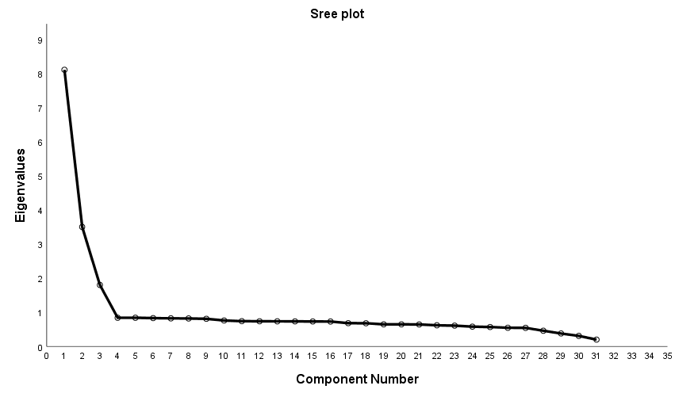

Supplementary Figure 1. Scree plot of eigenvalues resulting from principle component analysis.

