|  |  |  |  |  |  |  |  |  |  |
| --- | --- | --- | --- | --- | --- | --- | --- | --- | --- |
| Study | Representativeness of the exposed cohort | Selection of the unexposed cohort | Ascertainment of exposure | Demonstration that outcome of interest at start of study | Comparability of cohorts on the basis of the design or analysis | Outcome assessment | Follow-up  long enough for the outcomes to occur | Adequacy of follow-up of cohorts | Total quality scores |
| Yochum,1999 | - | - | ☆ | ☆ | ☆☆ | ☆ | ☆ | ☆ | ☆☆☆☆☆☆☆ |
| Knekt,2002 | - | - | ☆ | ☆ | ☆☆ | ☆ | ☆ | ☆ | ☆☆☆☆☆☆☆ |
| Hertog,1996 | - | - | ☆ | ☆ | ☆☆ | ☆ | ☆ | ☆ | ☆☆☆☆☆☆☆ |
| Lin,2006 | - | - | ☆ | ☆ | ☆☆ | ☆ | ☆ | ☆ | ☆☆☆☆☆☆☆ |
| Rimm,1996 | - | - | ☆ | ☆ | ☆☆ | ☆ | ☆ | ☆ | ☆☆☆☆☆☆☆ |
| Cassidy,2013 | - | ☆ | ☆ | ☆ | ☆☆ | ☆ | ☆☆ | ☆ | ☆☆☆☆☆☆☆☆☆ |
| Marniemi,2005 | - | - | ☆ | - | ☆☆ | ☆ | ☆ | ☆ | ☆☆☆☆☆☆ |
| Hirvonen,2000 | - | - | ☆ | ☆ | ☆☆ | ☆☆ | ☆ | ☆ | ☆☆☆☆☆☆☆☆ |
| Goetz,2016 | - | - | ☆ | ☆ | ☆☆ | ☆☆ | ☆ | ☆ | ☆☆☆☆☆☆☆☆ |
| Jacques,2015 | - | - | ☆ | ☆ | ☆☆ | ☆ | ☆ | ☆ | ☆☆☆☆☆☆☆ |
| Cassidy,2016 | - | - | ☆ | ☆ | ☆☆ | ☆☆ | ☆ | ☆ | ☆☆☆☆☆☆☆☆ |
| Mink,2007 | - | - | ☆ | ☆ | ☆☆ | ☆☆ | ☆ | ☆ | ☆☆☆☆☆☆☆☆ |
| Adriouch,2018 | - | - | ☆ | ☆ | ☆☆ | ☆☆ | ☆ | ☆ | ☆☆☆☆☆☆☆☆ |
| Ivey2013 | - | - | ☆ | ☆ | ☆☆ | ☆☆ | ☆ | ☆ | ☆☆☆☆☆☆☆☆ |
| Schouw,2004 | - | - | ☆ | ☆ | ☆☆ | ☆☆ | ☆ | ☆ | ☆☆☆☆☆☆☆☆ |
| Kokubo,2007 | - | - | ☆ | ☆ | ☆☆ | ☆☆ | ☆ | ☆ | ☆☆☆☆☆☆☆☆ |
| Dalgaard,2019 | - | - | ☆ | ☆ | ☆☆ | ☆☆ | ☆ | ☆ | ☆☆☆☆☆☆☆☆ |
| Ma,2020 | - | - | ☆ | ☆ | ☆☆ | ☆☆ | ☆ | ☆ | ☆☆☆☆☆☆☆☆ |
| Vogiatzoglou,  2015 | - | - | ☆ | ☆ | ☆☆ | ☆☆ | ☆ | ☆ | ☆☆☆☆☆☆☆☆ |

**Supplementary Table 1.** Quality assessment of each included study according to Newcastle-Ottawa Scale



**Supplementary Fig 1.** Dose-response analysis for the curvilinear association between intakes of anthocyanins and CHD risk.



**Supplementary Fig 2.** Dose-response analysis for the curvilinear association between intakes of proanthocyanidins and CHD risk.



**Supplementary Fig 3.** Dose-response analysis for the curvilinear association between intakes of flavonols and CHD risk.



**Supplementary Fig 4.** Dose-response analysis for the curvilinear association between intakes of flavones and CHD risk.



**Supplementary Fig 5.** Dose-response analysis for the curvilinear association between intakes of isoflavones and CHD risk.

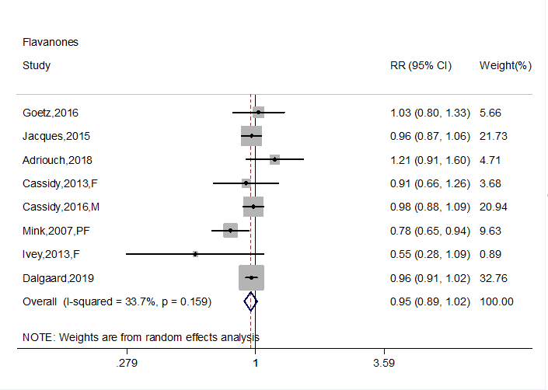

**Supplementary Fig 6**. Forest plot to quantify the association between flavanones intake and CHD



**Supplementary Fig 7**. Forest plot to quantify the association between flavan-3-ols intake and CHD

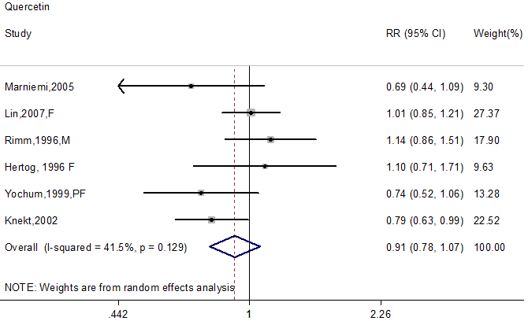

**Supplementary Fig 8.** Forest plot to quantify the association between quercetin intake and CHD risk.

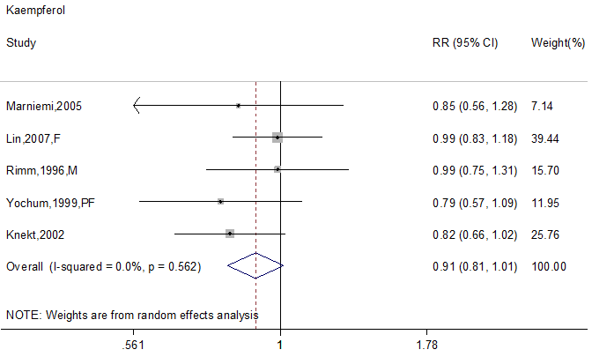

**Supplementary Fig 9.** Forest plot to quantify the association between kaempferol intake and CHD risk.

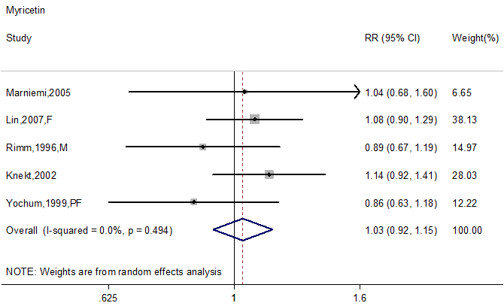

**Supplementary Fig 10.** Forest plot to quantify the association between myricetin intake and CHD risk.

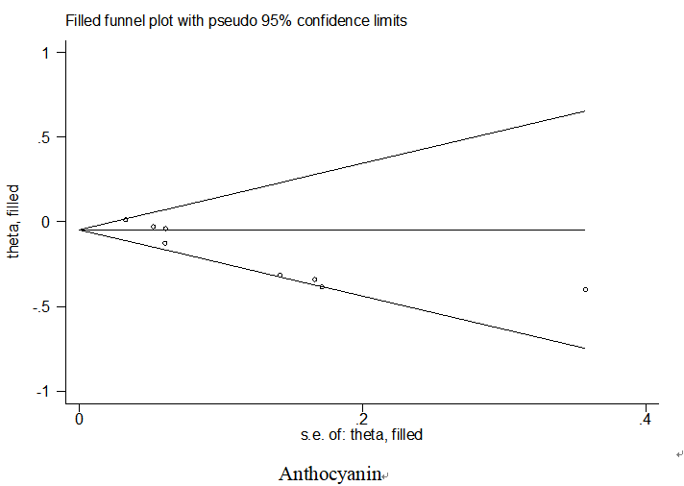

**Supplementary Fig 11.** Filled funnel plots for anthocyanin. The square represents theoretically missing studies. The funnel plots were achieved using trim and fill method.



**Supplementary Fig 12.** Sensitivity analysis with respect to flavonols intake.



**Supplementary Fig 13.** Sensitivity analysis with respect to flavones intake.



**Supplementary Fig 14.** Sensitivity analysis with respect to flavanones intake.



**Supplementary Fig 15.** Sensitivity analysis with respect to flavan-3-ols intake.



**Supplementary Fig 16.** Sensitivity analysis with respect to isoflavones intake.



**Supplementary Fig 17.** Sensitivity analysis with respect to anthocyanins intake.



**Supplementary Fig 18.** Sensitivity analysis with respect to proanthocyanidins

intake.



**Supplementary Fig 19.** Sensitivity analysis with respect to quercetin intake.



**Supplementary Fig 20.** Sensitivity analysis with respect to kaempferol intake.



**Supplementary Fig 21.** Sensitivity analysis with respect to myricetin intake.