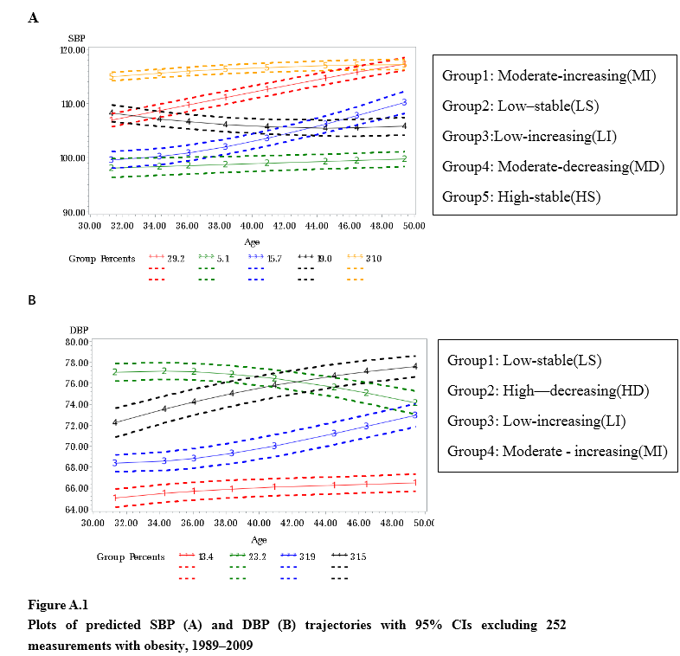
Table B.1 Modifiable factors for SBP trajectory groups: Multivariable analyses.
Modifiable factorsª |  | β value | χ² value | P value | Odds ratio | 95%(CI)
PA(vs. Q1^{b})
Q2 | MI^{c} (vs. LS) | -0.13 | 0.09 | 0.77 | 0.87 | 0.36 | 2.15
 | LI (vs. LS) | -0.12 | 0.07 | 0.80 | 0.89 | 0.35 | 2.24
 | MD (vs. LS) | 0.16 | 0.12 | 0.73 | 1.18 | 0.47 | 2.95
 | HS (vs. LS) | -0.06 | 0.02 | 0.90 | 0.94 | 0.38 | 2.37
Q3 | MI (vs. LS) | -0.64 | 2.45 | 0.12 | 0.53 | 0.23 | 1.18
 | LI (vs. LS) | -0.50 | 1.38 | 0.24 | 0.61 | 0.27 | 1.40
 | MD (vs. LS) | -0.05 | 0.02 | 0.90 | 0.95 | 0.42 | 2.16
 | HS (vs. LS) | -0.54 | 1.59 | 0.21 | 0.59 | 0.26 | 1.35
Q4 | MI (vs. LS) | -1.04 | 6.93 | 0.01 | 0.35 | 0.16 | 0.77
 | LI (vs. LS) | -0.90 | 4.85 | 0.03 | 0.41 | 0.18 | 0.91
 | MD (vs. LS) | -0.68 | 2.81 | 0.09 | 0.51 | 0.23 | 1.12
 | HS (vs. LS) | -0.98 | 5.66 | 0.02 | 0.38 | 0.17 | 0.84
WC
 | MI (vs. LS) | 0.06 | 9.08 | <0.01 | 1.06 | 1.02 | 1.10
 | LI (vs. LS) | 0.04 | 3.92 | 0.05 | 1.04 | 1.00 | 1.08
 | MD (vs. LS) | 0.05 | 5.94 | 0.01 | 1.05 | 1.01 | 1.09
 | HS (vs. LS) | 0.09 | 21.56 | <0.01 | 1.09 | 1.05 | 1.13

Table B.2 Modifiable factors for DBP trajectory groups: Multivariable analyses
Modifiable factorsª |  | β value | χ² value | P value | Odds ratio | 95%(CI)
PA(vs. Q1^{b})
Q2 | HD^{d}(vs. LS) | -0.16 | 0.38 | 0.54 | 0.85 | 0.51 | 1.43
 | LI(vs. LS) | -0.13 | 0.31 | 0.58 | 0.88 | 0.55 | 1.39
 | MI(vs.LS) | -0.26 | 1.17 | 0.28 | 0.77 | 0.48 | 1.24
Q3 | HD(vs. LS) | -0.12 | 0.19 | 0.66 | 0.89 | 0.52 | 1.51
 | LI(vs. LS) | -0.11 | 0.20 | 0.65 | 0.90 | 0.57 | 1.42
 | MI(vs.LS) | -0.38 | 2.43 | 0.12 | 0.68 | 0.42 | 1.10
Q4 | HD(vs. LS) | -0.67 | 6.16 | 0.01 | 0.51 | 0.30 | 0.87
 | LI(vs. LS) | -0.52 | 5.32 | 0.02 | 0.59 | 0.38 | 0.92
 | MI(vs.LS) | -0.52 | 4.72 | 0.03 | 0.60 | 0.37 | 0.95
BMI
 | HD(vs. LS) | 0.07 | 2.11 | 0.15 | 1.07 | 0.98 | 1.17
 | LI(vs. LS) | 0.08 | 3.74 | 0.05 | 1.08 | 1.00 | 1.16
 | MI(vs.LS) | 0.11 | 7.12 | 0.01 | 1.12 | 1.03 | 1.21
Vegetable consumption, g per day (vs. < 300 g)
300～500g | HD(vs. LS) | -0.43 | 4.91 | 0.03 | 0.65 | 0.45 | 0.95
 | LI(vs. LS) | -0.39 | 5.86 | 0.02 | 0.68 | 0.49 | 0.93
 | MI(vs.LS) | -0.34 | 3.86 | 0.05 | 0.71 | 0.51 | 1.00
≥500g | HD(vs. LS) | -0.40 | 3.21 | 0.07 | 0.67 | 0.43 | 1.04
 | LI(vs. LS) | -0.26 | 1.94 | 0.16 | 0.77 | 0.54 | 1.11
 | MI(vs.LS) | -0.43 | 4.45 | 0.04 | 0.65 | 0.44 | 0.97
WC
 | HD(vs. LS) | 0.06 | 15.46 | <0.01 | 1.06 | 1.03 | 1.09
 | LI(vs. LS) | 0.02 | 3.85 | 0.05 | 1.03 | 1.00 | 1.05
 | MI(vs.LS) | 0.04 | 10.58 | <0.01 | 1.04 | 1.02 | 1.07
Salt consumption, g per day (vs. < 6 g)
6～12 | HD(vs. LS) | 0.78 | 7.68 | 0.01 | 2.18 | 1.26 | 3.77
 | LI(vs. LS) | 0.31 | 1.78 | 0.18 | 1.36 | 0.86 | 2.16
 | MI(vs.LS) | 0.46 | 3.42 | 0.06 | 1.58 | 0.97 | 2.57
12～18 | HD(vs. LS) | 0.19 | 0.46 | 0.50 | 1.21 | 0.70 | 2.09
 | LI(vs. LS) | 0.03 | 0.01 | 0.91 | 1.03 | 0.66 | 1.60
 | MI(vs.LS) | 0.15 | 0.36 | 0.55 | 1.16 | 0.72 | 1.86
≥18 | HD(vs. LS) | 0.30 | 1.53 | 0.22 | 1.35 | 0.84 | 2.19
 | LI(vs. LS) | 0.12 | 0.40 | 0.53 | 1.13 | 0.77 | 1.66
 | MI(vs.LS) | 0.09 | 0.18 | 0.67 | 1.10 | 0.72 | 1.66
Abbreviations: Body Mass Index(BMI), diastolic blood pressure (DBP), High-stable(HS), High-increasing(HI), Low-increasing(LI), Low–stable(LS), Moderate-increasing(MI), Moderate-decreasing(MD), Moderate–stable(MS), physical activity(PA), systolic blood pressure (SBP), waist circumference (WC);
ªModel includes age; gender; urban or rural status; north or south region; education; working; alcohol consumption; cigarette smoking; tea drinking; PA; fruit, vegetable, and salt consumption; BMI; and WC. Only modifiable factors with statistically significant P values are listed in the table.
^{b}Q1–Q4 are classified according to the quartile of PA. Those less than the lower quartile are classified as Q1, those between the lower quartile and the median are classified as Q2, those between the median and the upper quartile are classified as Q3, and those greater than the upper quartile are classified as Q4.
^{c}MI, LS, LI, MD and HS refer to the SBP trajectory groups.
^{d}LS, HD, LI and MI refer to the DBP trajectory groups.

Table B.3 Adjusted HRs and 95% CIs for risk of HTN in 2011–2018 according to SBP and DBP trajectory groups in 1989–2009
Trajectories | Model 1ª  HR (95% CI) | Model 2^{b}  HR (95% CI) | Model 3^{c}  HR (95% CI)
SBP trajectories
MI (vs. LS) | 1.94(1.14,3.31) | 1.85(1.08,3.17) | 1.61(0.94,2.78)
LI (vs. LS) | 1.37(0.80,2.37) | 1.33(0.77,2.31) | 1.14(0.65,1.99)
MD (vs. LS) | 1.45(0.85,2.46) | 1.40(0.82,2.38) | 1.28(0.75,2.19)
HS (vs. LS) | 2.47(1.43,4.26) | 2.39(1.38,4.14) | 2.01(1.15,3.50)
DBP trajectories
HD(vs. LS) | 1.80(1.33,2.43) | 1.79(1.32,2.42) | 1.67(1.22,2.30)
LI(vs. LS) | 1.31(1.00,1.71) | 1.31(1.00,1.71) | 1.16(0.88,1.53)
MI(vs.LS) | 1.59(1.19,2.13) | 1.55(1.16,2.07) | 1.40(1.04,1.90)
ªModel 1 was adjusted by age, gender, urban or rural status, north or south, and blood pressure in 2009
^{b}Model 2 was further adjusted by alcohol consumption, cigarette smoking, physical activity and salt consumption
^{c}Model 3 was further adjusted by body mass index, waist circumference, TC, TG, LDL-C and diabetes status

