Supplemental files

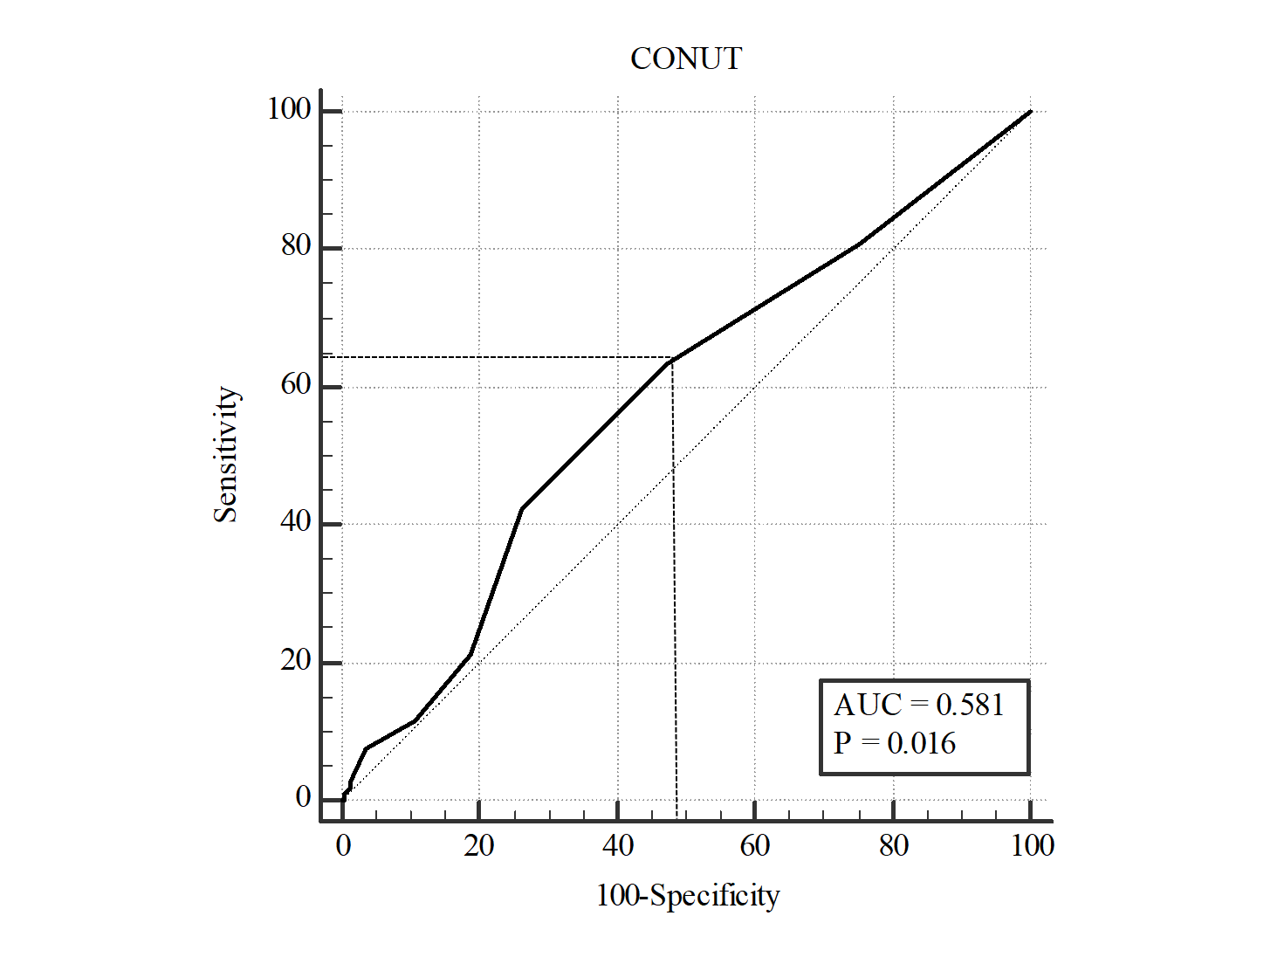

**Figure S1.** **Receiver operating characteristics (ROC) curves analysis for the cut-off value of the CONUT scores.**

roc图

**Figure S2. ROC curve analysis on comparing the CONUT with NRS in predicting a poor outcome classified by mRS**

Table S1: Assessment of undernutrition degree by CONUT

|  |  |  |  |  |
| --- | --- | --- | --- | --- |
|  | Undernutrition Degree | | | |
| Parameter | Normal | Light | Moderate | Severe |
| Serum albumin(g/dl) | 3.5 – 4.5 | 3.0 – 3.49 | 2.5 – 2.9 | ＜2.5 |
| Score | 0 | 2 | 4 | 6 |
| Total lymphocytes/ml | ＞1600 | 1200 - 1599 | 800 - 1199 | ＜800 |
| Score | 0 | 1 | 2 | 3 |
| Cholesterol(mg/dl) | ＞180 | 140-180 | 100-139 | ＜100 |
| Score | 0 | 1 | 2 | 3 |
| Screening Total Score | 0-1 | 2-4 | 5-8 | 9-12 |

Table S2: The detail scales in Nutritional Risk Screening (NRS-2002)

|  |  |  |  |  |  |
| --- | --- | --- | --- | --- | --- |
| **Pre-Screening** | | | | | |
| 1 | Is BMI ＜20.5? | | | Yes | No |
| 2 | Has the patient lost weight within the last 3 months? | | |  |  |
| 3 | Has the patient had a reduced dietary intake in the last week? | | |  |  |
| 4 | Is the patient severely ill? | | |  |  |
| **Yes:** If the answer is ‘Yes’ to any question, the screening in Table 2 is performed.  **No:** If the answer is ‘No’ to all questions, the patient is re-screened at weekly intervals. | | | | | |
| **Final Screening** | | | | | |
| **Score** | | 1. **Impaired nutritional status** | 1. **Severity of disease** | | |
| 0 – absent | | Normal nutritional status | Normal nutritional requirements | | |
| 1 – mild | | Weight loss >5% in 3 months or  food intake <50%–75% of normal requirement in the preceding week | Hip fracture  Chronic diseases  (cirrhosis, COPD,  hemodialysis, diabetes,  oncology, and so on) | | |
| 2 – moderate | | Weight loss >5% in 2 months or BMI 18.5–20.5 kg/m2 + impaired general condition or food intake 25%–50% of normal requirement in the preceding week | Major abdominal surgery, stroke, severe pneumonia, hematologic malignancy | | |
| 3 – severe | | Weight loss >5% in 1 month or  BMI <18.5 kg/m2+ impaired general condition or food intake 0%–25% of normal requirement in the preceding week | Head injury  Bone marrow transplant  ICU patient (APACHE＞10) | | |
| **Age** | | | | | |
| <70 years: 0 point;≥70 years: 1 point | | | | | |
| **TOTAL** = **(A)** + **(B)** + **Age** | | | | | |
| **Score ≥3:** the patient is nutritionally at-risk and a nutritional care plan is initiated  **Score ＜3:** weekly rescreening of the patient. If the patient e.g. is scheduled for a major operation, a preventive nutritional care plan is considered to avoid the associated risk status. | | | | | |

**Table S3:** **Subgroup Analyses for the CONUT Score in predicting the 3-month poor functional outcomes in the AHS patients**

|  |  |  |  |  |
| --- | --- | --- | --- | --- |
| Subgroups | Poor functional prognosis outcomes | | | |
| Crude OR (95% CI) | P-value | Adjusted OR (95% CI) | P-value |
| Gender |  |  |  |  |
| Male (n=219) | 1.89 (1.06-3.39) | 0.032* | 2.70 (1.28-5.68) | 0.009* |
| Female (n=109) | 2.02 (0.88-4.66) | 0.098 | 1.96 (0.68-5.64) | 0.211 |
| Age |  |  |  |  |
| ≤65 (n=209) | 2.10(1.15-3.83) | 0.015* | 2.71(1.28-5.74) | 0.009* |
| >65 (n=119) | 1.67(0.76-3.69) | 0.202 | 1.81(0.64-5.07) | 0.262 |
| Hypertension |  |  |  |  |
| Yes (n=289) | 1.73(1.03-2.89) | 0.038* | 2.12(1.11-4.04) | 0.023* |
| No (n=59) | 3.22(0.85-12.26) | 0.086 | / | |
| BMI |  |  |  |  |
| ≤18.5 (n=13) | 1.33(0.09-20.11) | 0.835 | / | |
| >18.5 (n=259) | 2.09(1.21-3.61) | 0.008* | 2.46(1.35-4.48) | 0.003* |
| Hyperlipidemia |  |  |  |  |
| Yes (n=153) | 2.69(1.32-5.48) | 0.006* | 3.45(1.43-8.31) | 0.006* |
| No (n=175) | 1.45(0.76-2.77) | 0.265 | 1.70(0.73-3.95) | 0.218 |
| Barthel Index |  |  |  |  |
| ≤60 (n=266) | 1.98(1.17-3.35) | 0.011* | 2.14(1.10-4.16) | 0.024* |
| >60 (n=62) | 1.54(0.48-4.96) | 0.467 | 1.37(0.28-6.77) | 0.696 |
| NIHSS score |  |  |  |  |
| ≥8 (n=95) | 1.96(0.84-4.58) | 0.119 | 1.93(0.60-6.13) | 0.268 |
| <8 (n=193) | 2.47(1.29-4.73) | 0.007* | 2.98(1.42-6.23) | 0.004* |

Abbreviations: *CONUT,* Controlling Nutritional Status*; AHS,* acute hemorrhagic stroke*; BMI,* body mass index *NIHSS,* National Institute of Health stroke scale;/, no statistical data.

Poor prognosis outcome was defined as the mRS value of 3-6.

OR with 95% CI for the incident 3-month poor functional outcome was estimated by using a crude logistic model and a multivariate model with full adjustments for age, gender, BMI, hypertension, hyperlipidemia, NIHSS score, and Batherl Index.