Supplementary Tables
Table S1. Concentrate components and nutrient levels of the basal diet (dry matter basis, %)
Ingredients | Formula of concentrate |  | Nutrients | TMR nutrient levels
 | EG | LG |  | EG | LG
Corn | 53.00 | 50.00 | Dry matter | 92.35 | 90.96
Soybean meal | 9.70 | 22.50 | Crude protein | 9.60 | 10.00
Rapeseed meal | 12.00 | 7.00 | Ether extract | 3.51 | 4.52
Wheat bran | 15.70 | 11.50 | Ash | 11.19 | 8.85
Limestone | 1.00 | 1.00 | Neutral detergent fiber | 49.19 | 34.15
CaHPO₄ | 0.60 | 0.60 | Acid detergent fiber | 29.98 | 24.86
NaHCO₃ | 1.30 | 1.30 | Metabolizable energy ²⁾ | 1.93 | 2.15
NaCl | 0.80 | 0.40 | Calcium | 0.54 | 0.56
Vitamin E | 0.40 | 0.10 | Phosphorus | 0.37 | 0.26
Soybean oil | 0.30 | 0.40
Premix¹⁾ | 5.00 | 5.00
De-mold agent | 0.20 | 0.20
Total | 100.00 | 100.00
TMR, total mixed ration; EG, early gestation; LG, late gestation.
¹⁾Premix provide for per kilogram TMR: VA 30000 IU, VD 10000 IU, VE 100mg, Fe 90 mg, Cu 12.5 mg, Mn 50 mg, Zn 80 mg, Se 0.3 mg, I 0.8 mg, Co 0.5 mg.
²⁾ Metabolizable energy value was calculated according to the NRC, unit: Mcal / kg
Table S2. Primers sequence for qRT-PCR verify test
Items | Genes name | Primers sequence (Forward, 5' to 3') | Primers sequence (Reverse, 5' to 3')
TW | IGF1 | GTCACATCCTCCTCGCATCTCTTC | CCTGTCTCCGCACACGAACTG
 | PRKAG2 | TCCGCTTCTTCTCTCGCTCCAG | GTCGCTCAGGCTCTTGCTTGTAG
 | PRKAG3 | GCCTCTACTCCCGCTTTGATGTG | TCCTCCGCCTCAGTGCTTCTC
 | PCK1 | GAGGGTGTCCGTGGTTGTCTTTG | TGAGTAGTTGAGGCCGTCTGAGAG
 | SDS | GCCTCTTGTGCGGAGTGGTTC | GCCTTGGTGGAAGCGTGGAAG
 | SDSL | CCTGGATGATGAGCGAACACTGG | GCACACGATGACCACGACTGAG
TR | CCNE2 | TGATGGTGCTTGCAGTGAAGAGG | TAGCCAGGAGATGACCGTTACAGG
 | CCNA2 | ACCACAGCACGCACAACAGTC | AGTGTCTCTGGTGGGTTGAGGAG
 | CDC20 | GCAGACCTTCACCCAGCATCAAG | CCGCCAGTTGCCAGGACATTG
 | BUB1 | TGGAGATGTCGCAGGGGAACC | TGCTGAGGGACGGCTGGAAG
 | POLD1 | GTGAAGACATCGGTGCGGAAGG | GTCCAACACTTGTCGCCGTAGG
 | POLD2 | TGCTGCTGGTGTCTGGTCTGG | CACTGCACTGCTCTCCTTCATCC
 | GAPDH | CGGCACAGTCAAGGCAGAGAAC | CACGTACTCAGCACCAGCATCAC
TW, Twin lambs; TR, Triplet lambs; IGF1, Insulin Growth Factor 1; PRKAG2, Protein Kinase AMP-Activated Non-Catalytic Subunit Gamma 2; PRKAG3, Protein Kinase AMP-Activated Non-Catalytic Subunit Gamma 3; PCK1, Phosphoenolpyruvate Carboxykinase 1; SDS, Serine Dehydratase; SDSL, Serine Dehydratase Like; CCNE2, Cyclin E2; CCNA2, Cyclin A2; CDC20, Cell Division Cycle 20; BUB1, BUB1 Mitotic Checkpoint Serine/Threonine Kinase; POLD1, DNA Polymerase Delta 1, Catalytic Subunit; POLD2, DNA Polymerase Delta 2, Catalytic Subunit; GAPDH, Glyceraldehyde-3-Phosphate Dehydrogenase.
Table S3. Quality contronl of the raw and clean data
Sample | Raw Reads | Raw Bases | Clean Reads | Clean Bases | Error Rate | Q20 | Q30 | GC Content
TW_C_1_1 | 20487438 | 3.07G | 20130449 | 3.02G | 0.03% | 97.58% | 93.44% | 50.68%
TW_C_1_2 | 20487438 | 3.07G | 20130449 | 3.02G | 0.03% | 97.41% | 92.96% | 50.67%
TW_C_2_1 | 21408492 | 3.21G | 20976019 | 3.15G | 0.03% | 97.60% | 93.46% | 51.00%
TW_C_2_2 | 21408492 | 3.21G | 20976019 | 3.15G | 0.03% | 97.17% | 92.43% | 50.98%
TW_C_3_1 | 21260504 | 3.18G | 20812826 | 3.12G | 0.03% | 97.63% | 93.53% | 50.67%
TW_C_3_2 | 21260504 | 3.18G | 20812826 | 3.12G | 0.03% | 97.29% | 92.66% | 50.65%
TW_C_4_1 | 20913821 | 3.13G | 20347837 | 3.05G | 0.03% | 97.09% | 92.31% | 47.64%
TW_C_4_2 | 20913821 | 3.2G | 20943947 | 3.14G | 0.03% | 97.60% | 93.45% | 50.30%
TW_C_5_1 | 21336140 | 3.2G | 20943947 | 3.14G | 0.03% | 97.60% | 93.45% | 50.30%
TW_C_5_2 | 21336140 | 3.2G | 20943947 | 3.14G | 0.03% | 96.57% | 91.10% | 50.28%
TW_C_6_1 | 25775156 | 3.86G | 25253560 | 3.79G | 0.03% | 97.60% | 93.49% | 50.90%
TW_C_6_2 | 25775156 | 3.86G | 25253560 | 3.79G | 0.03% | 97.33% | 92.73% | 50.89%
TR_C_1_1 | 20478627 | 3.07G | 20048546 | 3.01G | 0.03% | 97.63% | 93.53% | 50.81%
TR_C_1_2 | 20478627 | 3.07G | 20048546 | 3.01G | 0.03% | 97.33% | 92.75% | 50.79%
TR_C_2_1 | 23606122 | 3.54G | 23127806 | 3.47G | 0.03% | 97.66% | 93.53% | 50.80%
TR_C_2_2 | 23606122 | 3.54G | 23127806 | 3.47G | 0.03% | 97.57% | 93.23% | 50.80%
TR_C_3_1 | 19731762 | 2.95G | 19456890 | 2.92G | 0.03% | 97.67% | 93.56% | 50.51%
TR_C_3_2 | 19731762 | 2.95G | 19456890 | 2.92G | 0.03% | 97.03% | 92.01% | 50.50%
TR_C_4_1 | 21645839 | 3.24G | 21249971 | 3.19G | 0.03% | 97.70% | 93.59% | 50.98%
TR_C_4_2 | 21645839 | 3.24G | 21249971 | 3.19G | 0.03% | 97.54% | 93.11% | 50.97%
TR_C_5_1 | 27596270 | 4.13G | 27200817 | 4.08G | 0.03% | 97.55% | 93.40% | 51.17%
TR_C_5_2 | 27596270 | 4.13G | 27200817 | 4.08G | 0.03% | 97.06% | 92.24% | 51.16%
TR_C_6_1 | 21906865 | 3.28G | 21479593 | 3.22G | 0.03% | 97.59% | 93.45% | 51.29%
TR_C_6_2 | 21906865 | 3.28G | 21479593 | 3.22G | 0.03% | 97.39% | 92.89% | 51.28%
TW_F16_1_1 | 21761460 | 3.26G | 21389835 | 3.21G | 0.03% | 97.72% | 93.60% | 50.53%
TW_F16_1_2 | 21761460 | 3.26G | 21389835 | 3.21G | 0.03% | 97.25% | 92.46% | 50.52%
TW_F16_2_1 | 20995832 | 3.14G | 20641977 | 3.1G | 0.03% | 97.58% | 93.38% | 50.55%
TW_F16_2_2 | 20995832 | 3.14G | 20641977 | 3.1G | 0.03% | 97.46% | 93.00% | 50.55%
TW_F16_3_1 | 21335097 | 3.2G | 20792643 | 3.12G | 0.03% | 97.75% | 93.69% | 50.69%
TW_F16_3_2 | 21335097 | 3.2G | 20792643 | 3.12G | 0.03% | 97.86% | 93.83% | 50.70%
TW_F16_4_1 | 20841157 | 3.12G | 20401608 | 3.06G | 0.03% | 97.65% | 93.47% | 50.99%
TW_F16_4_2 | 20841157 | 3.12G | 20401608 | 3.06G | 0.03% | 97.59% | 93.23% | 50.97%
TW_F16_5_1 | 22114610 | 3.31G | 21590822 | 3.24G | 0.03% | 97.66% | 93.57% | 50.66%
TW_F16_5_2 | 22114610 | 3.31G | 21590822 | 3.24G | 0.03% | 97.58% | 93.24% | 50.65%
TW_F16_6_1 | 21381500 | 3.2G | 20849209 | 3.13G | 0.03% | 97.64% | 93.56% | 51.31%
TW_F16_6_2 | 21381500 | 3.2G | 20849209 | 3.13G | 0.03% | 97.30% | 92.72% | 51.30%
TW_F32_1_1 | 22834346 | 3.42G | 22350783 | 3.35G | 0.03% | 97.69% | 93.57% | 51.12%
TW_F32_1_2 | 22834346 | 3.42G | 22350783 | 3.35G | 0.03% | 97.66% | 93.39% | 51.11%
TW_F32_2_1 | 21297730 | 3.19G | 20883809 | 3.13G | 0.03% | 97.69% | 93.59% | 51.19%
TW_F32_2_2 | 21297730 | 3.19G | 20883809 | 3.13G | 0.03% | 97.49% | 93.06% | 51.18%
TW_F32_3_1 | 22259102 | 3.33G | 21836089 | 3.28G | 0.03% | 97.70% | 93.64% | 51.22%
TW_F32_3_2 | 22259102 | 3.33G | 21836089 | 3.28G | 0.03% | 97.54% | 93.14% | 51.21%
TW_F32_4_1 | 20052612 | 3G | 19646476 | 2.95G | 0.03% | 97.66% | 93.51% | 50.78%
TW_F32_4_2 | 20052612 | 3G | 19646476 | 2.95G | 0.03% | 97.41% | 92.86% | 50.77%
TW_F32_5_1 | 21629413 | 3.24G | 21147784 | 3.17G | 0.03% | 97.63% | 93.47% | 50.67%
TW_F32_5_2 | 21629413 | 3.24G | 21147784 | 3.17G | 0.03% | 97.41% | 92.86% | 50.65%
TW_F32_6_1 | 24754210 | 3.71G | 24244607 | 3.64G | 0.03% | 97.58% | 93.38% | 50.40%
TW_F32_6_2 | 24754210 | 3.71G | 24244607 | 3.64G | 0.03% | 97.38% | 92.83% | 50.38%
TR_F16_1_1 | 25852753 | 3.87G | 25395813 | 3.81G | 0.03% | 97.54% | 93.34% | 51.51%
TR_F16_1_2 | 25852753 | 3.87G | 25395813 | 3.81G | 0.03% | 97.54% | 93.22% | 51.52%
TR_F16_2_1 | 21094517 | 3.16G | 20671782 | 3.1G | 0.03% | 97.63% | 93.55% | 51.18%
TR_F16_2_2 | 21094517 | 3.16G | 20671782 | 3.1G | 0.03% | 97.23% | 92.58% | 51.17%
TR_F16_3_1 | 24065134 | 3.6G | 23636959 | 3.55G | 0.03% | 97.60% | 93.52% | 51.46%
TR_F16_3_2 | 24065134 | 3.6G | 23636959 | 3.55G | 0.03% | 97.13% | 92.41% | 51.44%
TR_F16_4_1 | 22834416 | 3.42G | 22430132 | 3.36G | 0.03% | 97.66% | 93.57% | 50.78%
TR_F16_4_2 | 22834416 | 3.42G | 22430132 | 3.36G | 0.03% | 97.40% | 92.92% | 50.78%
TR_F16_5_1 | 21142551 | 3.17G | 20767025 | 3.12G | 0.03% | 97.63% | 93.55% | 50.85%
TR_F16_5_2 | 21142551 | 3.17G | 20767025 | 3.12G | 0.03% | 97.35% | 92.80% | 50.84%
TR_F16_6_1 | 23483148 | 3.52G | 23084691 | 3.46G | 0.03% | 97.61% | 93.50% | 50.85%
TR_F16_6_2 | 23483148 | 3.52G | 23084691 | 3.46G | 0.03% | 97.06% | 92.21% | 50.84%
TR_F32_1_1 | 21286242 | 3.19G | 20959733 | 3.14G | 0.03% | 97.69% | 93.67% | 50.73%
TR_F32_1_2 | 21286242 | 3.19G | 20959733 | 3.14G | 0.03% | 97.50% | 93.13% | 50.72%
TR_F32_2_1 | 25682961 | 3.85G | 25322381 | 3.8G | 0.03% | 97.60% | 93.50% | 50.50%
TR_F32_2_2 | 25682961 | 3.85G | 25322381 | 3.8G | 0.03% | 97.28% | 92.67% | 50.50%
TR_F32_3_1 | 23980401 | 3.59G | 23641549 | 3.55G | 0.03% | 97.58% | 93.48% | 51.66%
TR_F32_3_2 | 23980401 | 3.59G | 23641549 | 3.55G | 0.03% | 97.37% | 92.91% | 51.64%
TR_F32_4_1 | 23145904 | 3.47G | 22689295 | 3.4G | 0.03% | 97.70% | 93.63% | 50.65%
TR_F32_4_2 | 23145904 | 3.47G | 22689295 | 3.4G | 0.03% | 97.69% | 93.49% | 50.65%
TR_F32_5_1 | 23594742 | 3.53G | 23247237 | 3.49G | 0.03% | 97.62% | 93.51% | 50.69%
TR_F32_5_2 | 23594742 | 3.53G | 23247237 | 3.49G | 0.03% | 97.27% | 92.63% | 50.66%
TR_F32_6_1 | 21227110 | 3.18G | 20931509 | 3.14G | 0.03% | 97.54% | 93.38% | 51.05%
TR_F32_6_2 | 21227110 | 3.18G | 20931509 | 3.14G | 0.03% | 97.26% | 92.61% | 51.08%

Table S4. the results of clean data mapped to reference genome
Sample name | Total reads | Total mapped | Multiple mapped | Uniquely mapped
TW_C_1 | 40260898 | 35250770 (87.56%) | 2535496 (6.3%) | 32715274 (81.26%)
TW_C_2 | 41952038 | 36675470 (87.42%) | 2622190 (6.25%) | 34053280 (81.17%)
TW_C_3 | 41625652 | 36583276 (87.89%) | 2801740 (6.73%) | 33781536 (81.16%)
TW_C_4* | 40695674 | 35566344 (87.4%) | 12043828 (29.59%) | 23522516 (57.8%)
TW_C_5 | 41887894 | 36692762 (87.6%) | 3416054 (8.16%) | 33276708 (79.44%)
TW_C_6 | 50507120 | 42683988 (84.51%) | 3156022 (6.25%) | 39527966 (78.26%)
TR_C_1 | 40097092 | 35379746 (88.24%) | 2631644 (6.56%) | 32748102 (81.67%)
TR_C_2 | 46255612 | 40561044 (87.69%) | 2972828 (6.43%) | 37588216 (81.26%)
TR_C_3 | 38913780 | 33898546 (87.11%) | 2501224 (6.43%) | 31397322 (80.68%)
TR_C_4 | 42499942 | 37358176 (87.9%) | 2794344 (6.57%) | 34563832 (81.33%)
TR_C_5 | 54401634 | 47041566 (86.47%) | 3537882 (6.5%) | 43503684 (79.97%)
TR_C_6 | 42959186 | 37218086 (86.64%) | 2606258 (6.07%) | 34611828 (80.57%)
TW_F16_1 | 42779670 | 37011026 (86.52%) | 2655400 (6.21%) | 34355626 (80.31%)
TW_F16_2 | 41283954 | 35328970 (85.58%) | 3008984 (7.29%) | 32319986 (78.29%)
TW_F16_3 | 41585286 | 35916678 (86.37%) | 2836276 (6.82%) | 33080402 (79.55%)
TW_F16_4 | 40803216 | 35316342 (86.55%) | 2704336 (6.63%) | 32612006 (79.93%)
TW_F16_5 | 43181644 | 36888354 (85.43%) | 2820150 (6.53%) | 34068204 (78.9%)
TW_F16_6 | 41698418 | 35936014 (86.18%) | 2514736 (6.03%) | 33421278 (80.15%)
TW_F32_1 | 44701566 | 38583226 (86.31%) | 2772164 (6.2%) | 35811062 (80.11%)
TW_F32_2 | 41767618 | 36354372 (87.04%) | 2656962 (6.36%) | 33697410 (80.68%)
TW_F32_3 | 43672178 | 37985828 (86.98%) | 2720128 (6.23%) | 35265700 (80.75%)
TW_F32_4 | 39292952 | 34556956 (87.95%) | 2670932 (6.8%) | 31886024 (81.15%)
TW_F32_5 | 42295568 | 36417536 (86.1%) | 2779332 (6.57%) | 33638204 (79.53%)
TW_F32_6 | 48489214 | 42472708 (87.59%) | 3572320 (7.37%) | 38900388 (80.22%)
TR_F16_1 | 50791626 | 43487994 (85.62%) | 2678992 (5.27%) | 40809002 (80.35%)
TR_F16_2 | 41343564 | 35888146 (86.8%) | 2729222 (6.6%) | 33158924 (80.2%)
TR_F16_3 | 47273918 | 40637496 (85.96%) | 2707184 (5.73%) | 37930312 (80.24%)
TR_F16_4 | 44860264 | 39292564 (87.59%) | 3079932 (6.87%) | 36212632 (80.72%)
TR_F16_5 | 41534050 | 35481160 (85.43%) | 2688518 (6.47%) | 32792642 (78.95%)
TR_F16_6 | 46169382 | 39302190 (85.13%) | 2741336 (5.94%) | 36560854 (79.19%)
TR_F32_1 | 41919466 | 36875108 (87.97%) | 2626062 (6.26%) | 34249046 (81.7%)
TR_F32_2 | 50644762 | 43627098 (86.14%) | 3234712 (6.39%) | 40392386 (79.76%)
TR_F32_3 | 47283098 | 41556902 (87.89%) | 3016206 (6.38%) | 38540696 (81.51%)
TR_F32_4 | 45378590 | 39212498 (86.41%) | 3068082 (6.76%) | 36144416 (79.65%)
TR_F32_5 | 46494474 | 40332508 (86.75%) | 3240076 (6.97%) | 37092432 (79.78%)
TR_F32_6 | 41863018 | 35814540 (85.55%) | 2823428 (6.74%) | 32991112 (78.81%)
*TW_C_4 was removed in the following analysis because of it low quality (the significant higher multiple mapped percentage and lower uniquely mapped percentage than other samples).
Table S5. Candidate DEGs affected by litter size
Gene name | Log₂(Fold change) | P value | Comparison groups
CCNB2 (cyclin B2) | 1.09 | 0.0437 | TR-C vs TW-C
CCNE2 (cyclin E2) | 1.25 | 0.0215 | TR-C vs TW-C
CDC6 (cell division cycle 6) | 2.53 | 0.0465 | TR-C vs TW-C
CDC20 (cell division cycle 20) | 3.60 | 0.0232 | TR-C vs TW-C
CCNA2 (cyclin A2) | 2.73 | 0.0077 | TR-C vs TW-C
E2F2 (E2F transcription factor 2) | 1.64 | 0.0082 | TR-C vs TW-C
MCM4 (minichromosome maintenance complex component 4) | 1.65 | 0.0296 | TR-C vs TW-C
BUB1 (BUB1 mitotic checkpoint serine/threonine kinase) | 2.62 | 0.0169 | TR-C vs TW-C
TTK (TTK protein kinase) | 2.31 | 0.0037 | TR-C vs TW-C
POLE (DNA polymerase epsilon, catalytic subunit) | 1.46 | 0.0214 | TR-C vs TW-C
TK1 (thymidine kinase 1) | 1.86 | 0.0293 | TR-C vs TW-C
TXNRD3 (thioredoxin reductase 3) | 0.71 | 0.0482 | TR-C vs TW-C
RRM2 (ribonucleotide reductase regulatory subunit M2) | 3.10 | 0.0078 | TR-C vs TW-C
DCK (deoxycytidine kinase) | 1.16 | 0.0322 | TR-C vs TW-C
DNA2 (DNA replication helicase/nuclease 2) | -0.86 | 0.0340 | TR-F32 vs TW-F32
MCM3 (minichromosome maintenance complex component 3) | -0.75 | 0.0290 | TR-F32 vs TW-F32
MCM6 (minichromosome maintenance complex component 6) | -0.77 | 0.0257 | TR-F32 vs TW-F32
POLD2 (DNA polymerase delta 2, accessory subunit) | -0.80 | 0.0260 | TR-F32 vs TW-F32
SMAD3 (SMAD family member 3) | -0.73 | 0.0457 | TR-F32 vs TW-F32
CHEK1 (checkpoint kinase 1) | -0.74 | 0.0436 | TR-F32 vs TW-F32

Table S6. Candidate DEGs affected by dietary FA supplementation in twin born lambs
Gene name | Log2(Fold change) | P value | Comparison groups
IGF1 (insulin like growth factor 1) | 0.86 | 0.0058 | TW-F16 vs TW-C
GADD45B (growth arrest and DNA damage inducible beta) | 1.34 | 0.0495 | TW-F16 vs TW-C
THBS1 (thrombospondin 1) | 2.25 | 0.0095 | TW-F16 vs TW-C
IGFBP3 (insulin like growth factor binding protein 3) | -0.75 | 0.0091 | TW-F16 vs TW-C
CCNG1 (cyclin G1) | -0.66 | 0.0234 | TW-F16 vs TW-C
SLC7A9 (solute carrier family 7 member 9) | -0.97 | 0.0083 | TW-F16 vs TW-C
SLC16A10 (solute carrier family 16 member 10) | -0.71 | 0.0238 | TW-F16 vs TW-C
LMNB1 (lamin B1) | 0.74 | 0.0132 | TW-F32 vs TW-C
TUBA3E (tubulin alpha 3e) | 1.43 | 0.0097 | TW-F32 vs TW-C
TUBA1C (tubulin alpha 1c) | 0.85 | 0.0226 | TW-F32 vs TW-C
TUBA8 (tubulin alpha 8) | 0.64 | 0.0350 | TW-F32 vs TW-C
PRKAG2 (protein kinase AMP-activated non-catalytic subunit gamma 2) | -0.61 | 0.0172 | TW-F32 vs TW-C
PRKAG3 (protein kinase AMP-activated non-catalytic subunit gamma 3) | -1.52 | 0.0344 | TW-F32 vs TW-C
INSR (insulin receptor) | -0.56 | 0.0221 | TW-F32 vs TW-C
G6PC (glucose-6-phosphatase catalytic subunit) | -1.46 | 0.0018 | TW-F32 vs TW-C
PCK1 (phosphoenolpyruvate carboxykinase 1) | -0.85 | 0.0219 | TW-F16 vs TW-C
 | -0.83 | 0.0389 | TW-F32 vs TW-C
CTH (cystathionine gamma-lyase) | -1.35 | 0.0083 | TW-F32 vs TW-F16
SARDH (sarcosine dehydrogenase) | -0.52 | 0.0444 | TW-F32 vs TW-F16
GLDC (glycine decarboxylase) | -0.81 | 0.0318 | TW-F32 vs TW-F16
GNMT (glycine N-methyltransferase) | -1.37 | 0.0011 | TW-F32 vs TW-F16
SDS (serine dehydratase) | 1.30 | 0.0354 | TW-F16 vs TW-C
 | -2.19 | 0.0006 | TW-F32 vs TW-F16
SDSL (serine dehydratase like) | -1.43 | 0.0105 | TW-F32 vs TW-C
 | -1.13 | 0.0081 | TW-F32 vs TW-F16

Table S7. Candidate DEGs affected by dietary FA supplementation in triplet born lambs
Gene name | Log2(Fold change) | P value | Comparison groups
HSD17B2 (hydroxysteroid 17-beta dehydrogenase 2) | -1.79 | 0.0171 | TR-F16 vs TR-C
HSD17B6 (hydroxysteroid 17-beta dehydrogenase 6) | -1.90 | 0.0197 | TR-F16 vs TR-C
AKR1D1 (aldo-keto reductase family 1 member D1) | -0.77 | 0.0123 | TR-F16 vs TR-C
CYP1A2 (cytochrome P450 family 1 subfamily A member 2) | -4.91 | 0.0008 | TR-F16 vs TR-C
CYP1A1 (cytochrome P4501A1) | -4.94 | 0.0002 | TR-F16 vs TR-C
UGT2A3 (UDP glucuronosyltransferase family 2 member A3) | -1.19 | 0.0002 | TR-F16 vs TR-C
CCNB2 (cyclin B2) | -1.07 | 0.0279 | TR-F16 vs TR-C
CDK1 (cyclin dependent kinase 1) | -2.18 | 0.0190 | TR-F16 vs TR-C
CDKN2C (cyclin dependent kinase inhibitor 2C) | -1.85 | 0.0402 | TR-F16 vs TR-C
CDC20 (cell division cycle 20) | -2.75 | 0.0492 | TR-F16 vs TR-C
CDC6 (cell division cycle 6) | -2.17 | 0.0493 | TR-F32vs TR-C
MCM4 (minichromosome maintenance complex component 4) | -1.60 | 0.0195 | TR-F32vs TR-C
MCM5 (minichromosome maintenance complex component 5) | -1.60 | 0.0411 | TR-F32vs TR-C
POLD1 (DNA polymerase delta 1, catalytic subunit) | -0.87 | 0.0402 | TR-F32vs TR-C
POLD2 (DNA polymerase delta 2, accessory subunit) | -1.02 | 0.0140 | TR-F32vs TR-C
TYMS (thymidylate synthetase) | -1.56 | 0.0197 | TR-F32vs TR-C
TK1 (thymidine kinase 1) | -2.02 | 0.0118 | TR-F32vs TR-C
DCK (deoxycytidine kinase) | -1.20 | 0.0164 | TR-F32vs TR-C
CCNA2 (cyclin A2) | -2.73 | 0.0052 | TR-F16 vs TR-C
 | -1.64 | 0.0491 | TR-F32vs TR-C
CCNE2 (cyclin E2) | -1.24 | 0.0159 | TR-F16 vs TR-C
 | -1.11 | 0.0282 | TR-F32vs TR-C
TTK (TTK protein kinase) | -2.84 | 0.0004 | TR-F16 vs TR-C
 | -1.44 | 0.0406 | TR-F32vs TR-C
BUB1 (BUB1 mitotic checkpoint serine/threonine kinase) | -3.01 | 0.0051 | TR-F16 vs TR-C
 | -1.85 | 0.0426 | TR-F32vs TR-C
PKMYT1 (protein kinase, membrane associated tyrosine/threonine 1) | -1.17 | 0.0366 | TR-F16 vs TR-C
 | -1.19 | 0.0468 | TR-F32vs TR-C

Table S8. Person correlation between the hepatic gene expression and biochemical indexes in twin lambs
Items | IGF1 | PRKAG2 | PRKAG3 | PCK1 | SDS | SDSL | Folate | Met | Hcy | SAH | SAM | DNMT | SAM/SAH
IGF1 | 1 | -.538* | .298 | -.239 | .450 | .073 | .706** | .628** | -.258 | -.472 | .462 | .386 | .464
PRKAG2 |  | 1 | -.420 | .487* | -.445 | .538* | -.717** | -.746** | .398 | .424 | -.700** | -.639** | -.659**
PRKAG3 |  |  | 1 | -.338 | .665** | -.254 | .709** | .164 | -.295 | -.275 | .288 | .680** | .428
PCK1 |  |  |  | 1 | -.415 | .114 | -.423 | -.404 | -.033 | -.078 | -.569* | -.539* | -.398
SDS |  |  |  |  | 1 | -.139 | .603* | .501* | -.336 | -.240 | .335 | .459 | .415
SDSL |  |  |  |  |  | 1 | -.323 | -.469 | .578* | .408 | -.438 | -.481 | -.483*
Folate |  |  |  |  |  |  | 1 | .653** | -.486* | -.582* | .693** | .859** | .728**
Met |  |  |  |  |  |  |  | 1 | -.358 | -.597* | .758** | .496* | .799**
Hcy |  |  |  |  |  |  |  |  | 1 | .492* | -.335 | -.617** | -.357
SAH |  |  |  |  |  |  |  |  |  | 1 | -.533* | -.489* | -.796**
SAM |  |  |  |  |  |  |  |  |  |  | 1 | .715** | .805**
DNMT |  |  |  |  |  |  |  |  |  |  |  | 1 | .695**
SAM/SAH |  |  |  |  |  |  |  |  |  |  |  | . | 1
“*” means P < 0.05. “**” means P <0.01.
Table S9. Person correlation between the hepatic gene expression and biochemical indexes in triplet lambs
Items | CCNE2 | CCNA2 | CDC20 | BUB1 | POLD1 | POLD2 | Folate | Met | Hcy | SAH | SAM | DNMT | SAM/SAH
CCNE2 | 1 | .722** | .387 | .422 | .773** | .632** | -.556* | -.472* | .653** | .520* | -.743** | -.719** | -.713**
CCNA2 |  | 1 | .663** | .583* | .740** | .754** | -.748** | -.585* | .639** | .538* | -.576* | -.712** | -.669**
CDC20 |  |  | 1 | .398 | .331 | .538* | -.576* | -.169 | .324 | .284 | -.308 | -.366 | -.383
BUB1 |  |  |  | 1 | .548* | .774** | -.342 | -.579* | .371 | .223 | -.694** | -.471* | -.486*
POLD1 |  |  |  |  | 1 | .722** | -.637** | -.538* | .712** | .455 | -.601** | -.774** | -.619**
POLD2 |  |  |  |  |  | 1 | -.608** | -.698** | .597** | .443 | -.833** | -.767** | -.706**
Folate |  |  |  |  |  |  | 1 | .549* | -.541* | -.691** | .385 | .544* | .671**
Met |  |  |  |  |  |  |  | 1 | -.288 | -.531* | .614** | .391 | .609**
Hcy |  |  |  |  |  |  |  |  | 1 | .506* | -.443 | -.552* | -.646**
SAH |  |  |  |  |  |  |  |  |  | 1 | -.465 | -.439 | -.893**
SAM |  |  |  |  |  |  |  |  |  |  | 1 | .779** | .773**
DNMT |  |  |  |  |  |  |  |  |  |  |  | 1 | .693**
SAM/SAH |  |  |  |  |  |  |  |  |  |  |  |  | 1
“*” means P < 0.05. “**” means P <0.01.
Supplementary Figures

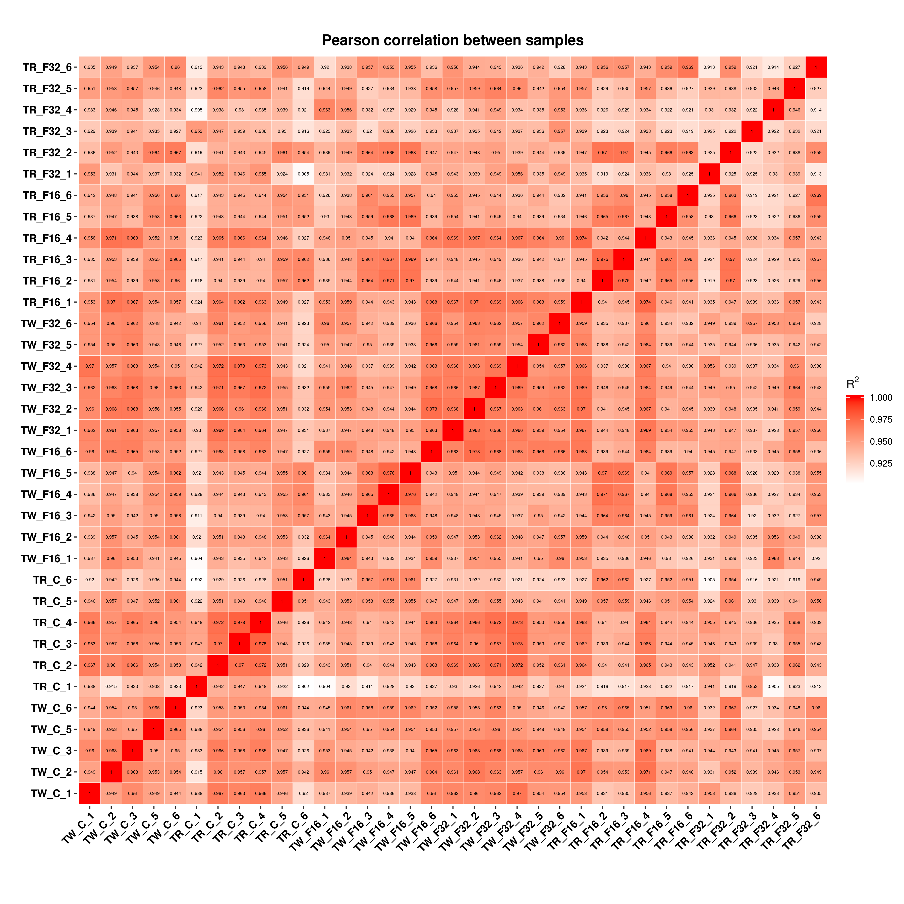

Fig. S1. Person correlation of transcript expression between samples. TW_C and TR_C indicate twin born and triplet born fed control diet, respectively. TW_F16 and TR_F16 mean twin- and triplet-born lambs from ewes fed control diet with 16 mg/(kg·DM) FA supplementation, respectively. TW_F32 and TR_F32 mean twin- and triplet-born lambs from ewes fed control diet with 32 mg/(kg·DM) FA supplementation, respectively.
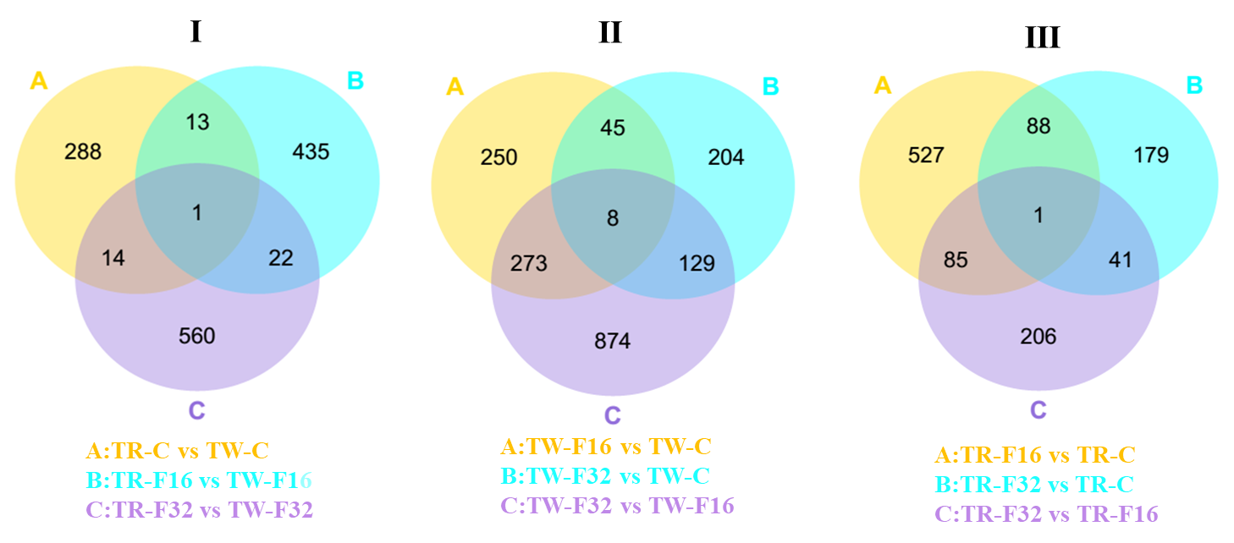
Fig. S2. Venn diagram analysis of DEGs among different comparisons. TW-C, TW-F16 and TW-F32 indicate newborn twin lambs from ewes fed control diet supplemented with 0, 16 and 32 mg/(kg·DM) FA, respectively. TR-C, TR-F16 and TR-F32 indicate newborn triplet lambs from ewes fed with 0, 16 and 32 mg/(kg·DM) FA supplemented in control diet, respectively.

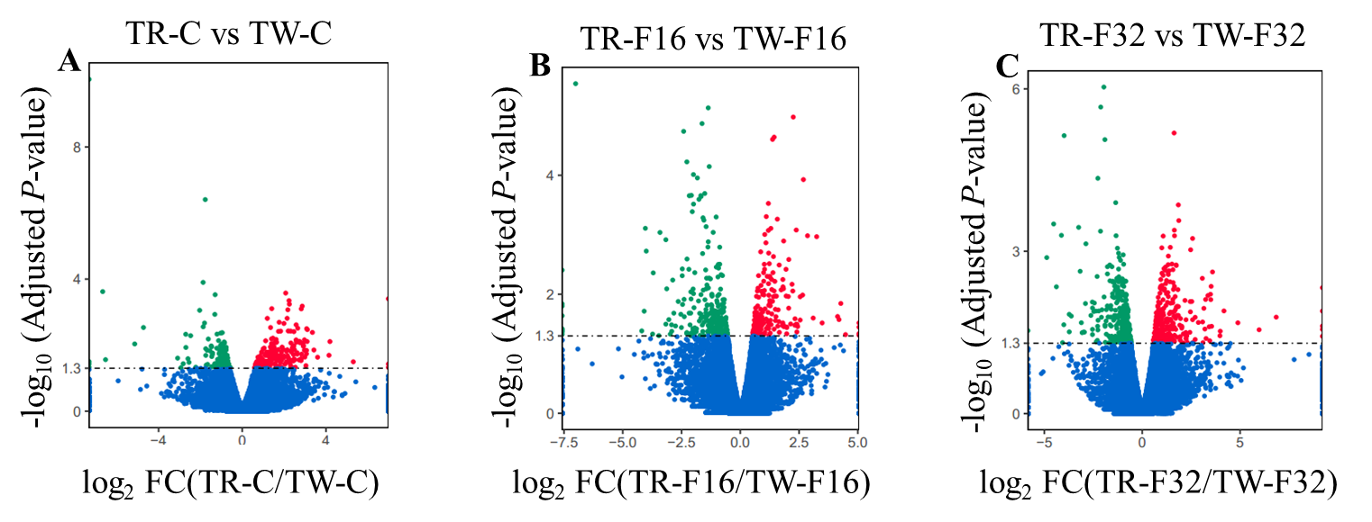
Fig. S3. Liver genes expression profile affected by litter sizes. The green, red and blue points indicate significant down-regulated, up-regulated and no significant difference genes, respectively. TW-C, TW-F16 and TW-F32 mean newborn twin lambs from ewes fed control diet supplemented with 0, 16 and 32 mg/(kg·DM) FA, respectively. TR-C, TR-F16 and TR-F32 mean newborn triplet lambs from ewes fed with 0, 16 and 32 mg/(kg·DM) FA supplemented in control diet, respectively. FC, fold change.

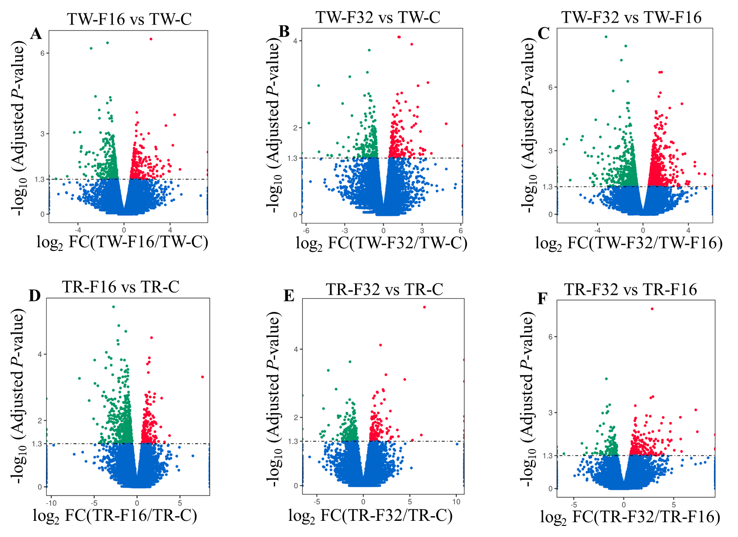
Fig. S4. Liver genes expression profile affected by dietary FA supplementation in twin- and triplet-born lambs. The green points indicated significant down-regulated genes and the red points indicated significant up-regulated genes, the blue points mean no significant difference between the two groups. TW-C, TW-F16 and TW-F32 represent newborn twin lambs from ewes fed control diet supplemented with 0, 16 and 32 mg/(kg·DM) FA, respectively. TR-C, TR-F16 and TR-F32 represent newborn triplet lambs from ewes fed with 0, 16 and 32 mg/(kg·DM) FA supplemented in control diet, respectively. FC, fold change.

