Supplementary table 1. Quality assessment of studies
First author (year) | Random sequence  generation | Allocation  concealment | Blinding | Blinding of outcome  assessment | Incomplete  outcome data | Selective  reporting | Other sources  of bias | Score | Overall  quality
Abenavoli et al.  (2017) | L | U |  | U | L | L | L | 4 | Good
Abenavoli et al.  (2015) | L | U |  | U | L | L | L | 4 | Good
Biolato et al.  (2019) | L | U |  | L | H | L | L | 4 | Good
Kastagoni et al.  (2018) | L | H |  | L | L | L | L | 5 | Good
Fraser et al.  (2008) | H | L |  | L | H | L | L | 4 | Good
Properzi et al.  (2018) | L | L |  | L | L | L | L | 6 | Good
Georgoulis et al.  (2020) | L | L |  | L | H | L | L | 5 | Good
Ryan et al.  (2013) | L | U |  | U | L | L | L | 4 | Good
Pinto et al. (2019) | L | U |  | U | L | L | L | 4 | Good
Cueto-Galan et al. (2017) | L | L |  | U | H | H | L | 3 | Good

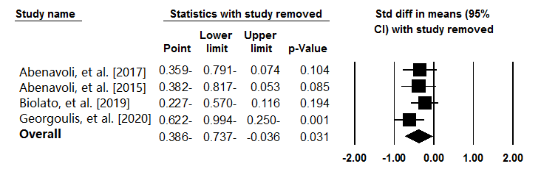
Supplementary Figure 1. Sensitivity analysis was conducted on AST level to determine whether a specific study or a particular group of studies have affected the conclusions.

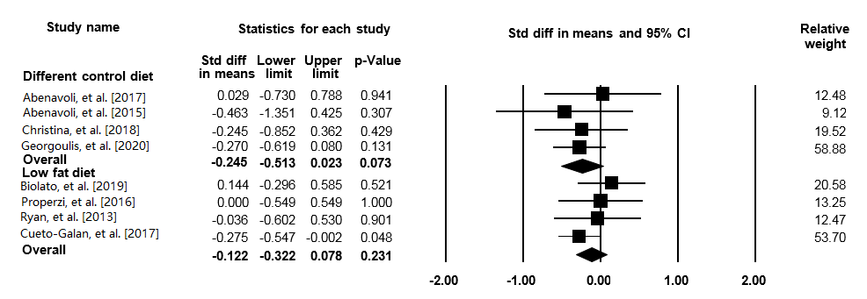Supplementary Figure 2. Forest plot illustrates weighted mean difference (represented by the black square) and 95 % CI (represented by horizontal line) for GGT concentration and Mediterranean diet based on the control group diet. Weights are from random effects analysis. The area of the black square is proportional to the specific study weight to the overall meta-analysis. The centre of the diamond displays the pool weighted mean difference and its width shows the pooled95%CI.

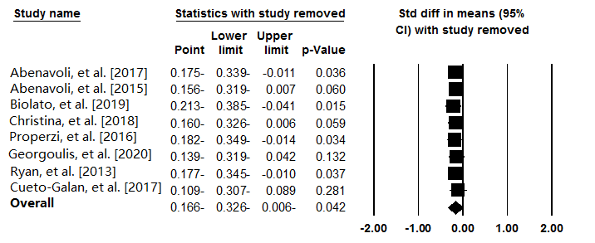
Supplementary Figure 3. Sensitivity analysis was conducted on GGT level to determine whether a specific study or a particular group of studies have affected the conclusions.

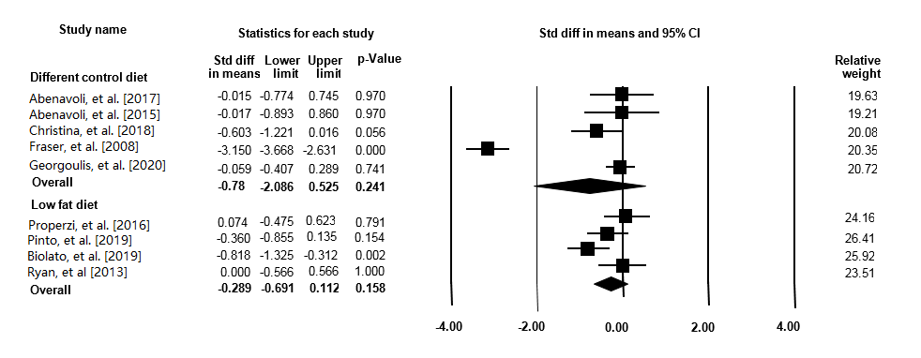
Supplementary Figure 4. Forest plot illustrates weighted mean difference (represented by the black square) and 95 % CI (represented by horizontal line) for ALT concentration and Mediterranean diet based on the control group diet. Weights are from random effects analysis. The area of the black square is proportional to the specific study weight to the overall meta-analysis. The centre of the diamond displays the pool weighted mean difference and its width shows the pooled95%CI.

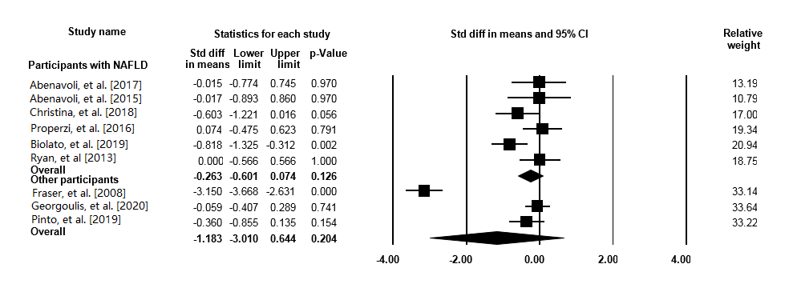
Supplementary Figure 5. Forest plot illustrates weighted mean difference (represented by the black square) and 95 % CI (represented by horizontal line) for ALT concentration and Mediterranean diet based on the participants' health status. Weights are from random effects analysis. The area of the black square is proportional to the specific study weight to the overall meta-analysis. The centre of the diamond displays the pool weighted mean difference and its width shows the pooled95%CI.

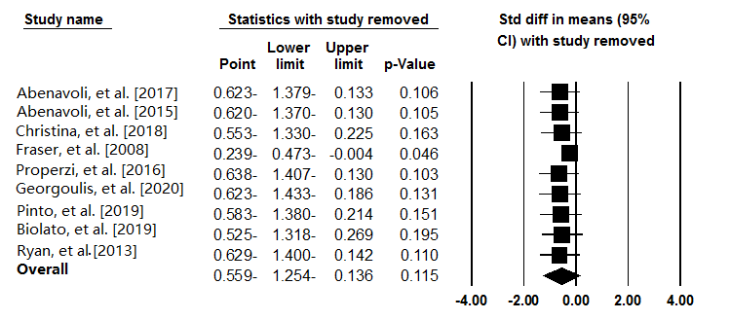
Supplementary Figure 6. Sensitivity analysis was conducted on ALT level to determine whether a specific study or a particular group of studies have affected the conclusions.

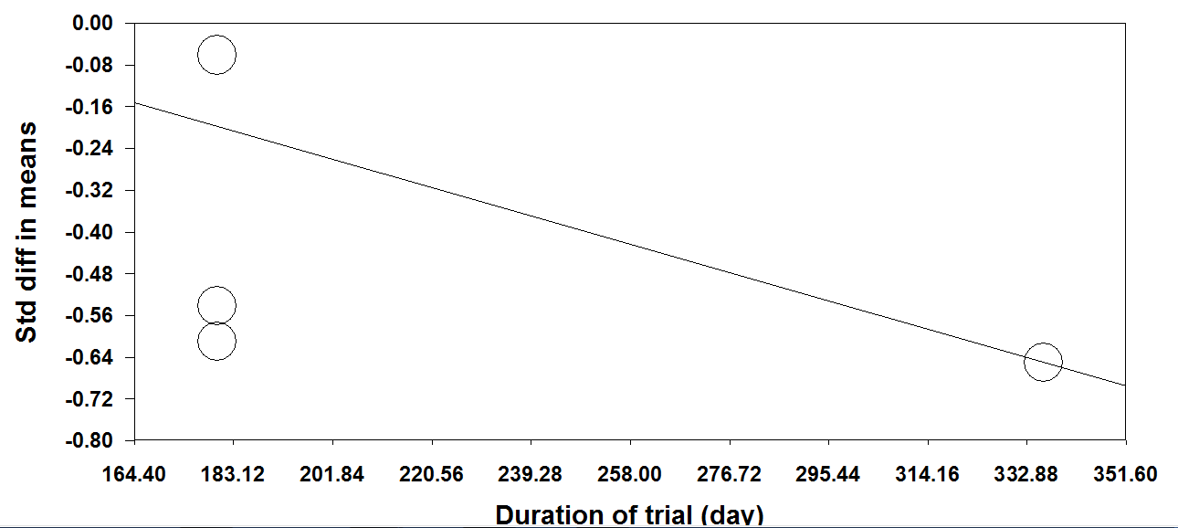
Supplementary Figure 7. Meta-regression plots of the association between standardized mean difference in plasma AST concentrations values with duration of trail. The size of each circle is inversely proportional to the variance of change.

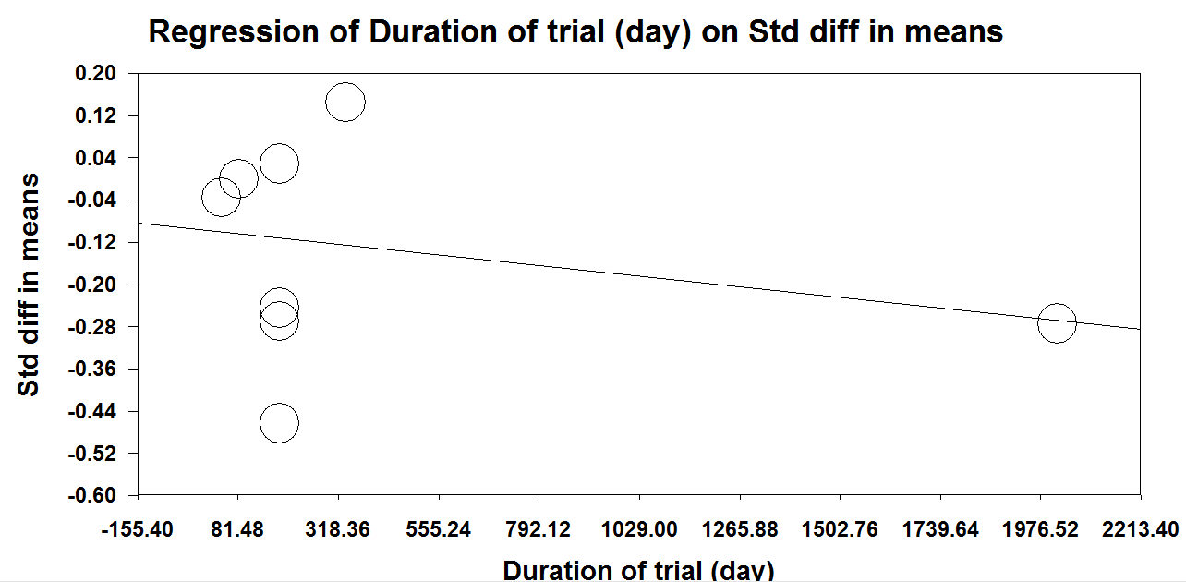
Supplementary Figure 8. Meta-regression plots of the association between standardized mean difference in plasma GGT concentrations values with duration of trail. The size of each circle is inversely proportional to the variance of change.

