Supplementary Material
Nutrition Module Design in Maintain Your Brain: An internet-based randomized controlled trial to prevent cognitive decline and dementia
Figure 1. Flow chart demonstrating reallocation of diet stream process during boosters stage. 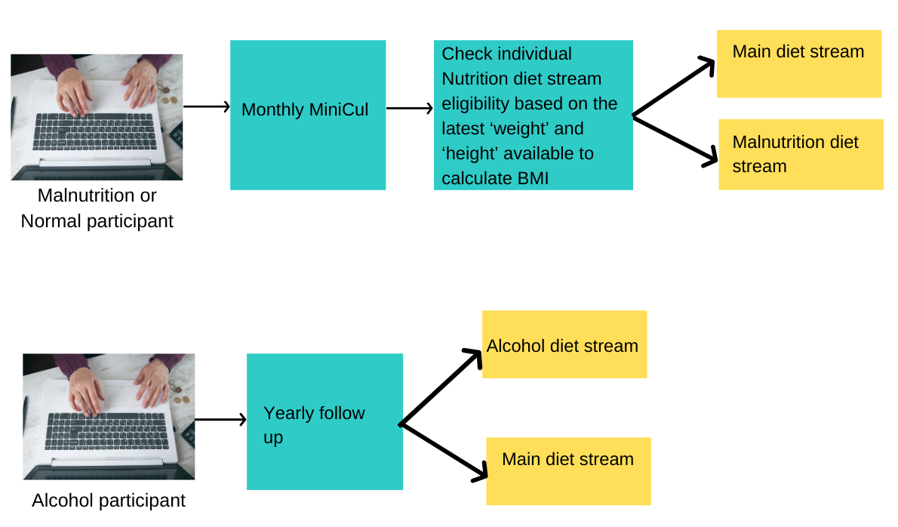

Figure 2. Flow chart demonstrating reallocation of diet stream process at follow-up.

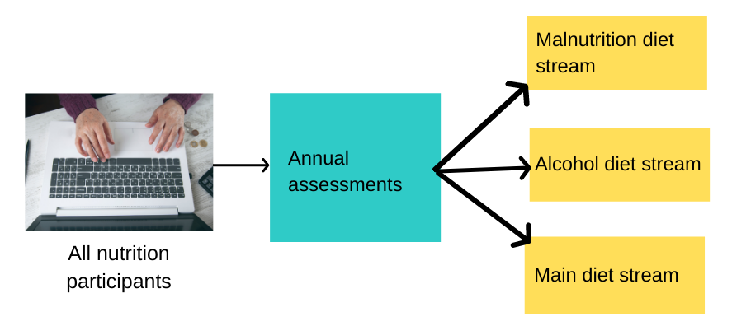

Figure 3. Logging into MYB system as a Nutrition Participant for the first time

Figure 4. Screenshot Nutrition Module Homepage

Figure 5. MedDiet Eating Plan - Food serve recommendations

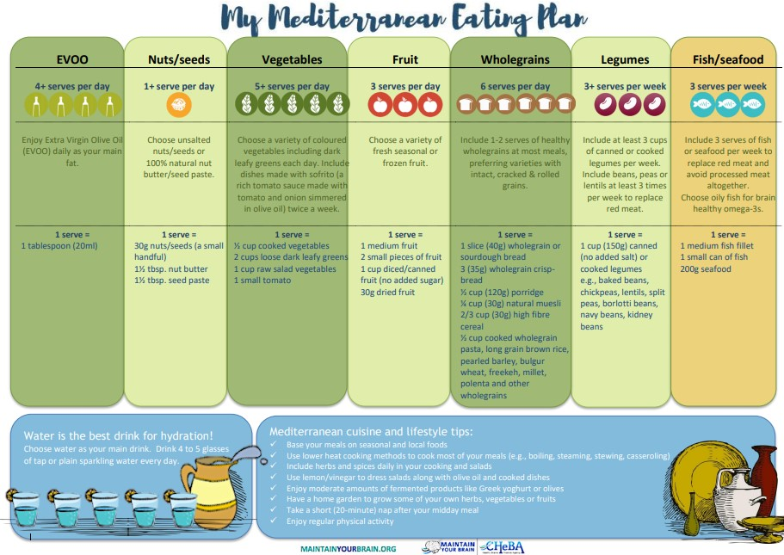
tbsp= Tablespoon
Figure 6. MedDiet Check List
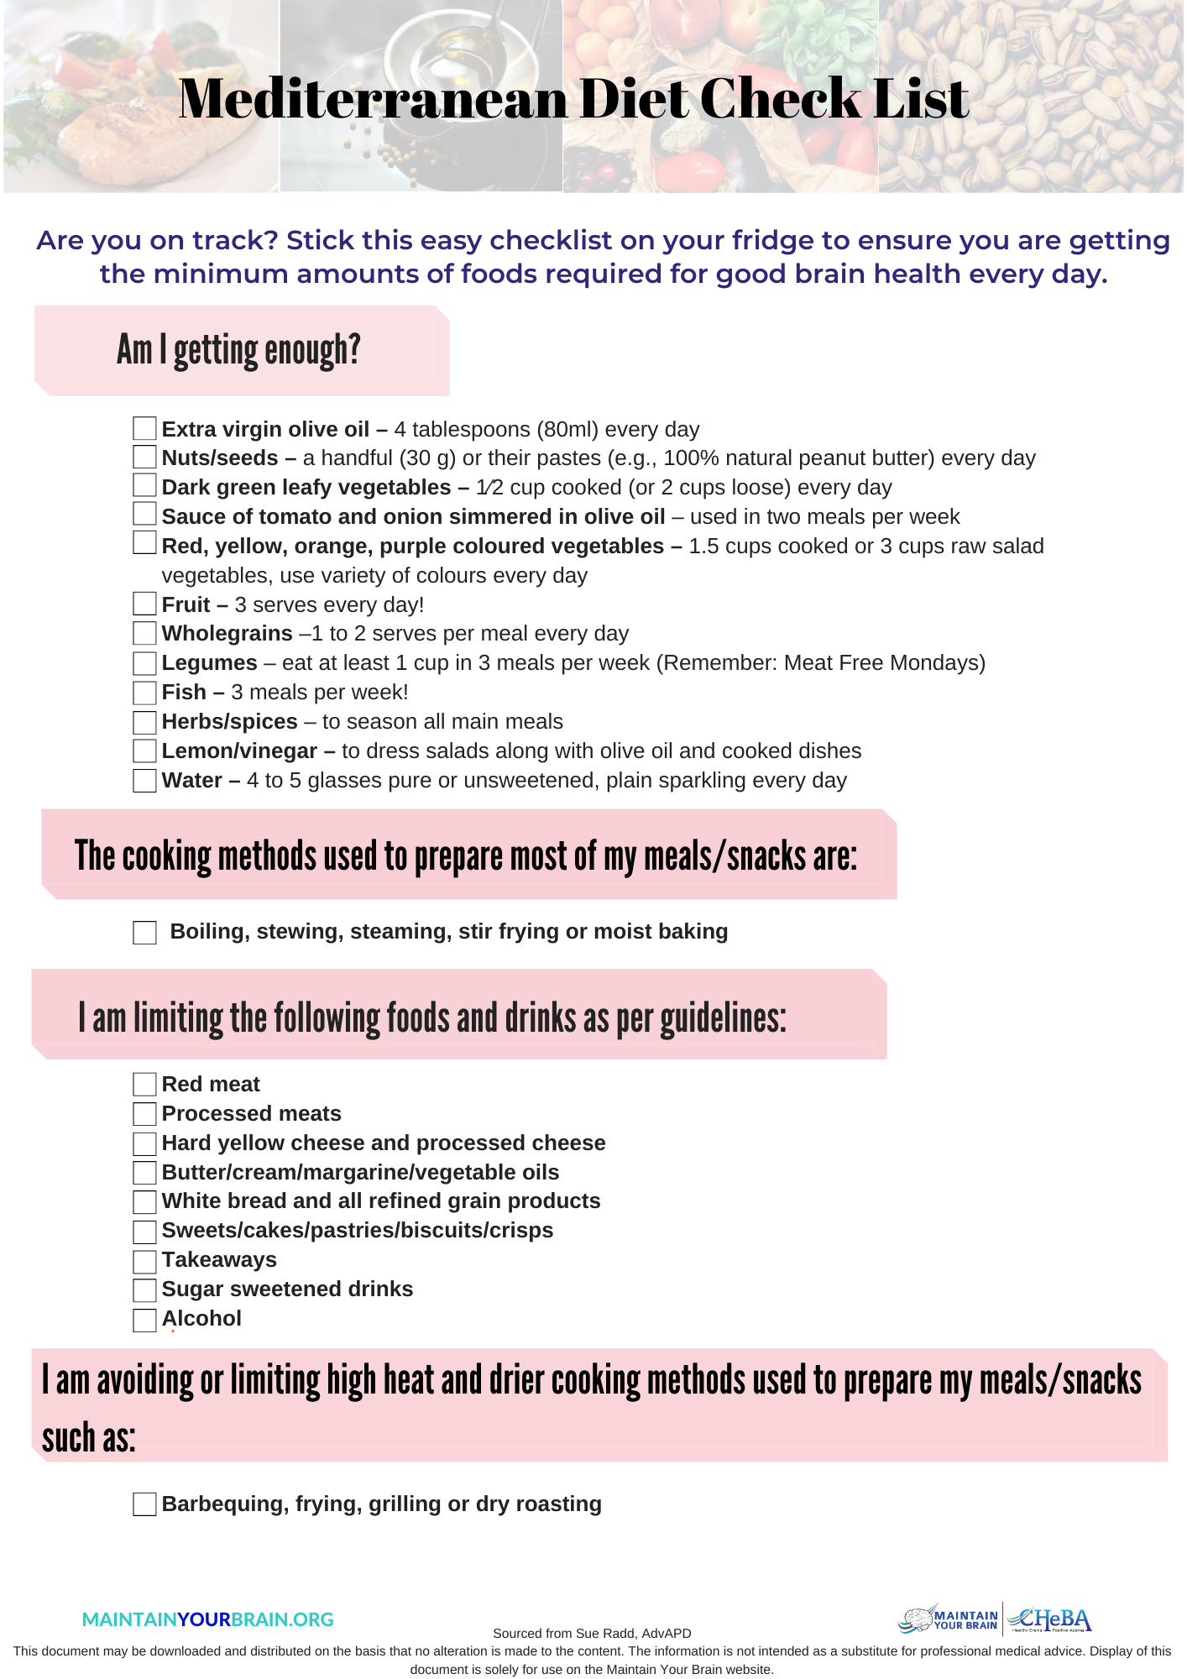

Figure 7. Overview of the Workflow in Nutrition Module
Nutrition module
3 diet streams:
1. Malnutrition
2. Alcohol
3. Main
Complete Minicul (i.e. MiniCul 1 – MiniCul 11)
System check MiniCul scoring to determine feedback messages:
If score is 0 (zero) out of 2 for alcohol:
- Discretionary foods - alcohol
If score <2 out of 2 on any of “Eat less of”:
1. Discretionary foods
  - Processed snacks and desserts
  - Sugary drinks
  - Takeaways
2. Animal protein foods- meat &poultry
If score <4 out of 4 on “Eat more of”:
3. Extra Virgin Olive Oil
If score <2 out of 2 on “Eat more of”:
4. Nuts and seeds
5. Vegetables
6. Fruits
7. Legumes
8. Wholegrains
9. Fish and seafood
10. Water
Diet stream specific feedback via food pyramid and dietary messages:
Week 2:
If scored low on > 4 food groups:
Maximum of 4 diet feedbacks/dietary messages are provided each week based on hierarchy of food groups with links back to the resource library for the specific food groups:
- Factsheets
- Recipes
- Shopping tips
- Health tips
Week 3-10:
If scored low on the same item food group, the following week:
A different dietary message (i.e. message 2) is generated for 1 more week on the same food group before cycling to the next food group from the hierarchy list with links back to the resource library for the specific food groups:
- Factsheets
- Recipes
- Shopping tips
- Health tips
Complete ‘My Action Plan’
Overview of Mediterranean diet and the ideal food pyramid is shown

Figure 8. Screenshot of My Action Plan
Figure 9. Screenshot of Fact sheets pop up menu

Figure 10. Example of Nutrition Module Newsletter
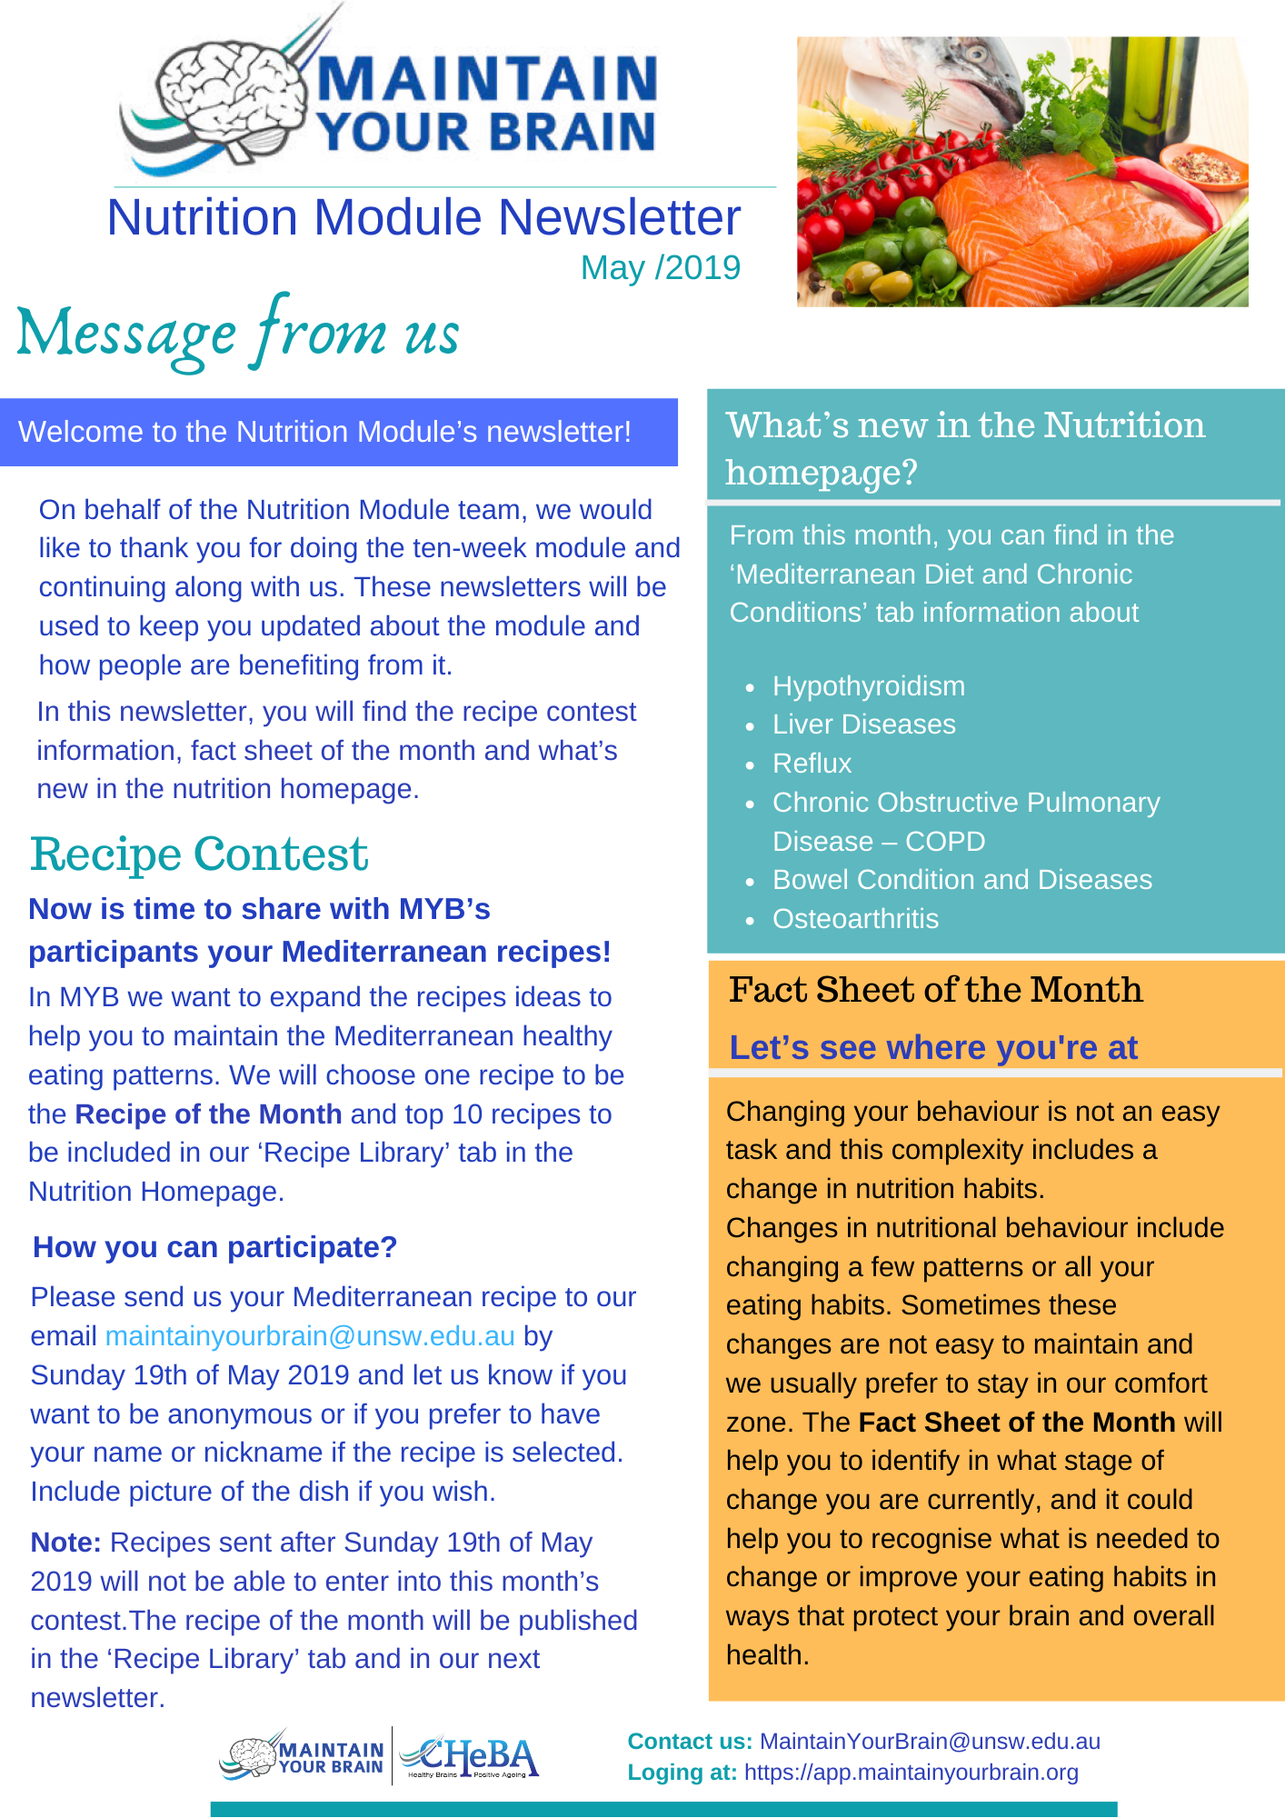

Figure 11. Example of Food Group Fact Sheet
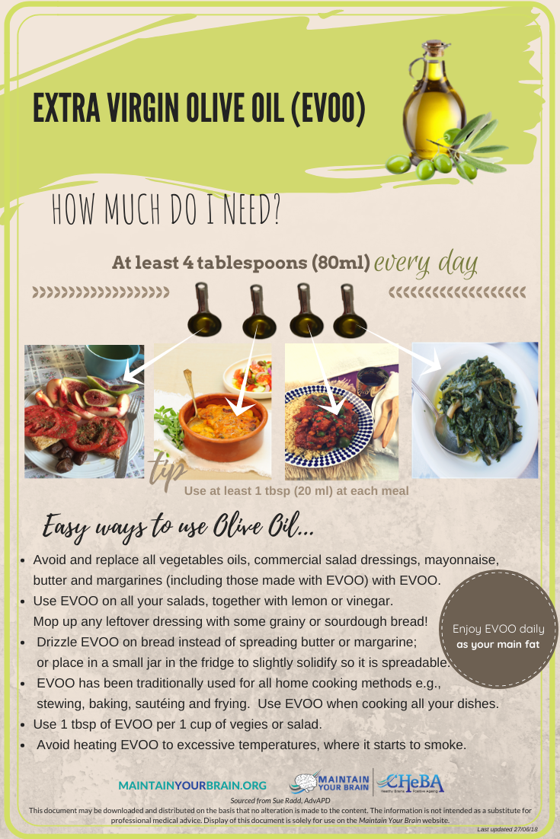
Figure 12. Example of Behavioural Fact Sheet
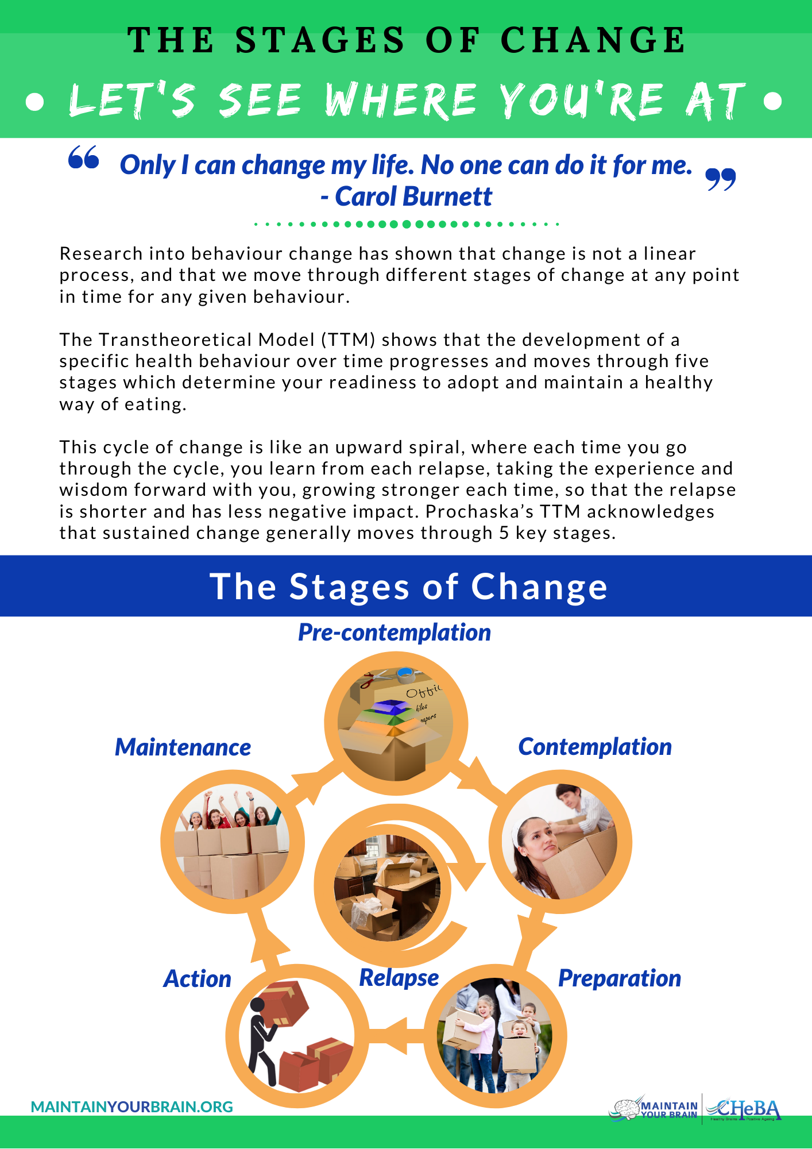

Figure 13. Example of MedDiet Fact Sheet
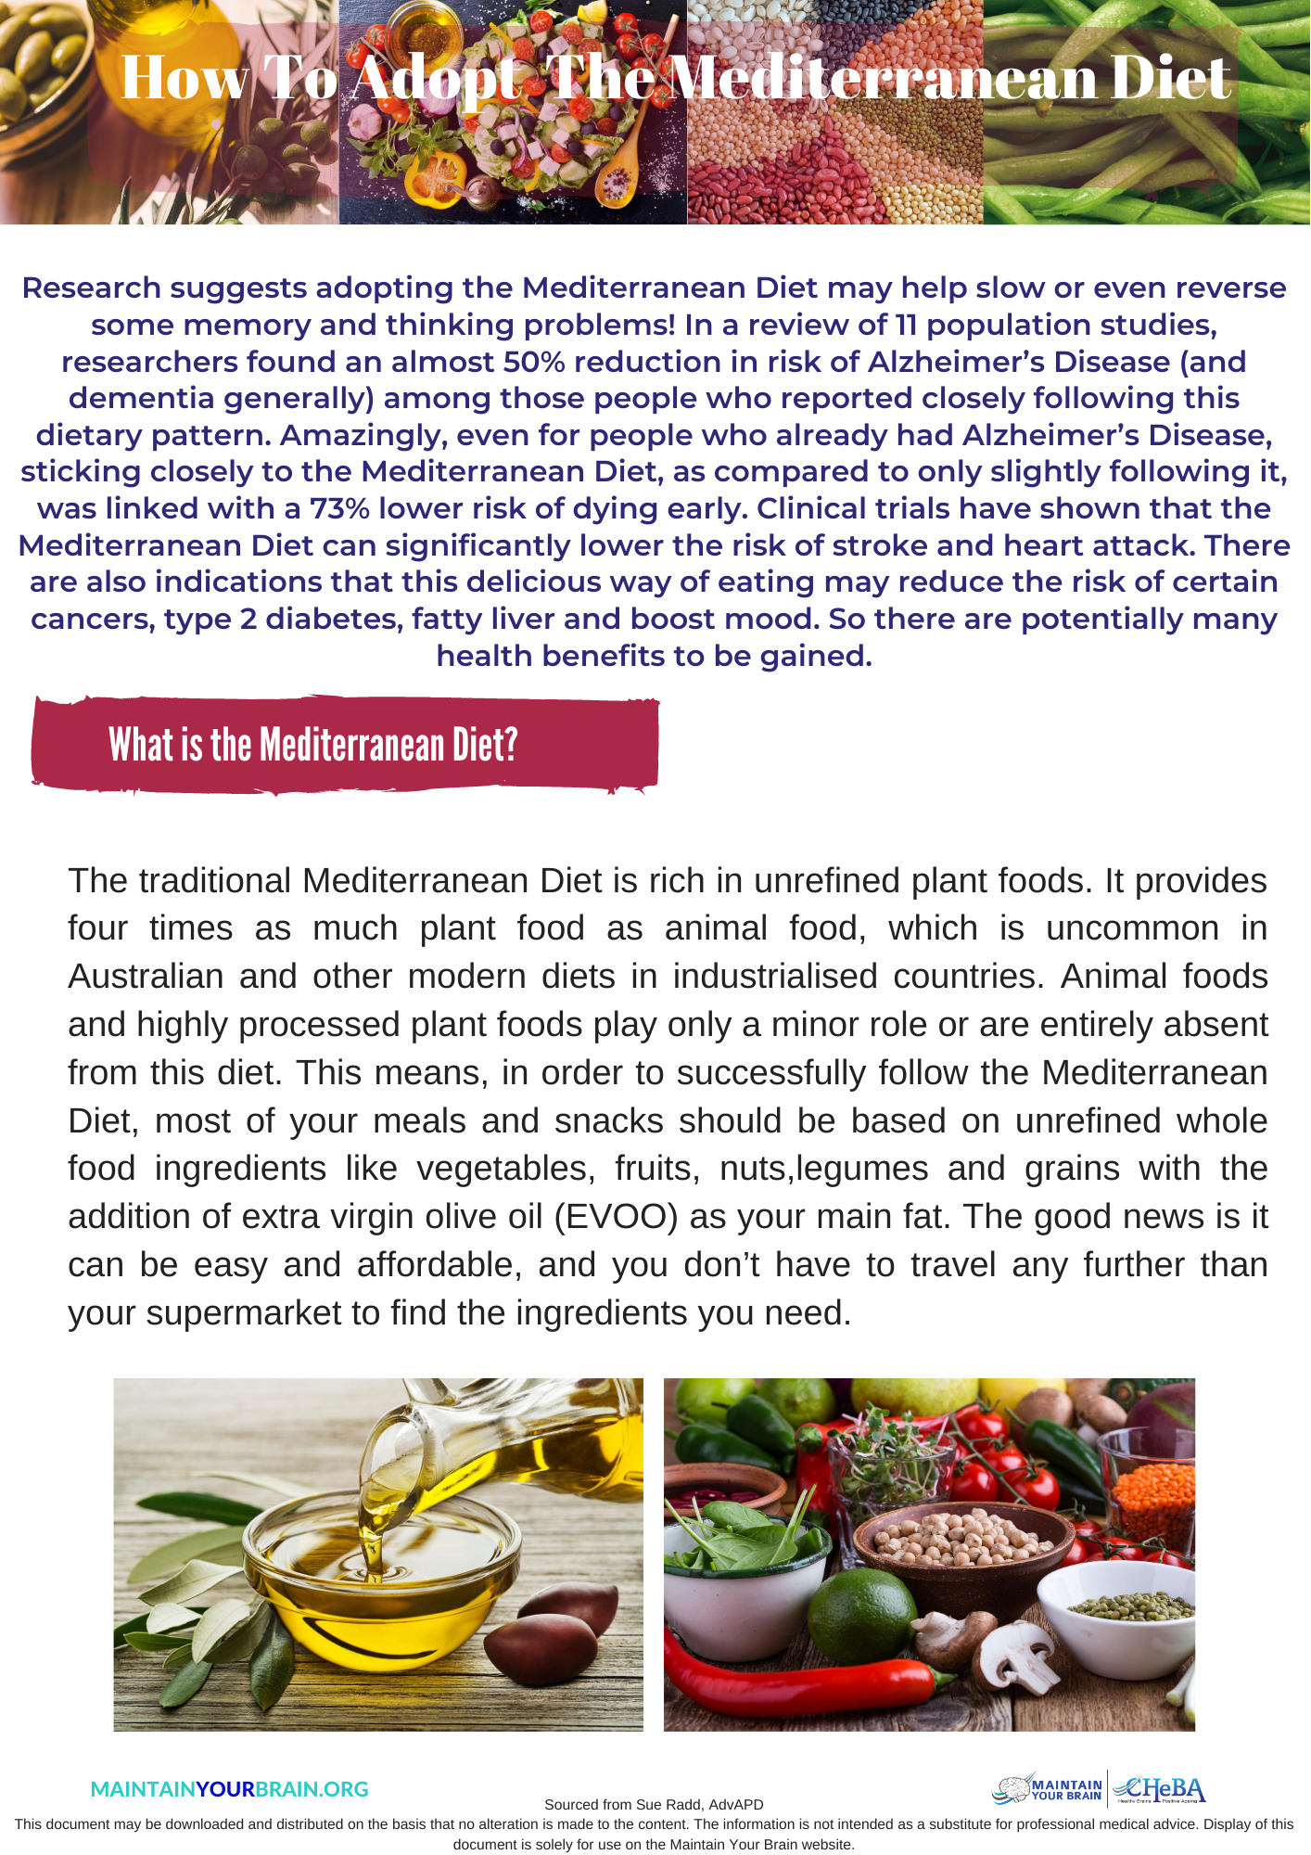

Figure 14. Example of Chronic Conditions Fact Sheet
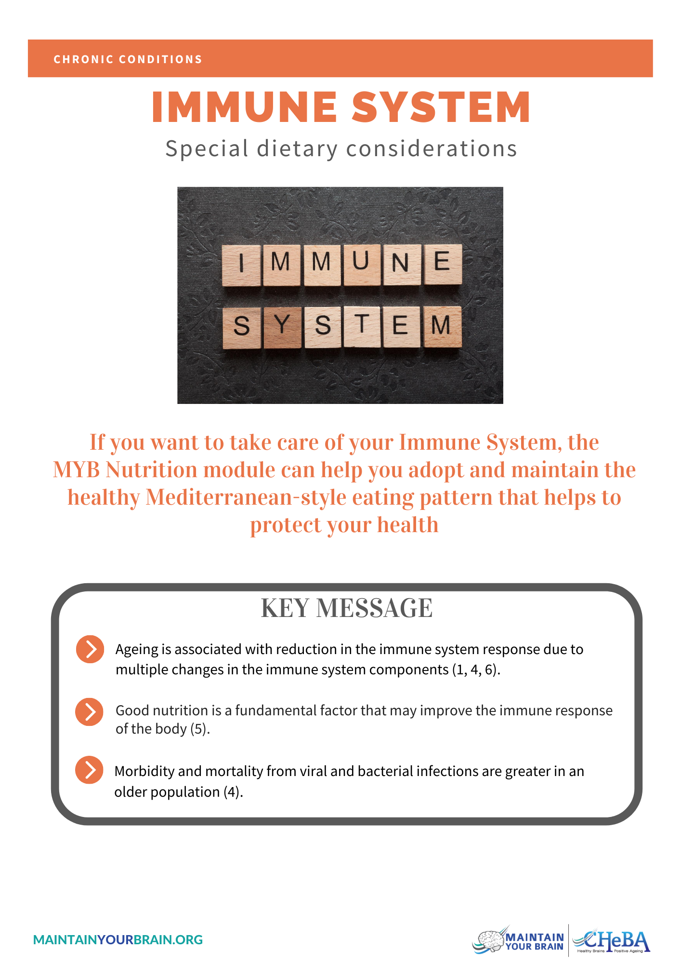

Figure 15. Example of Scientific Literature Fact Sheet
Figure 16. Example of a Recipe Card
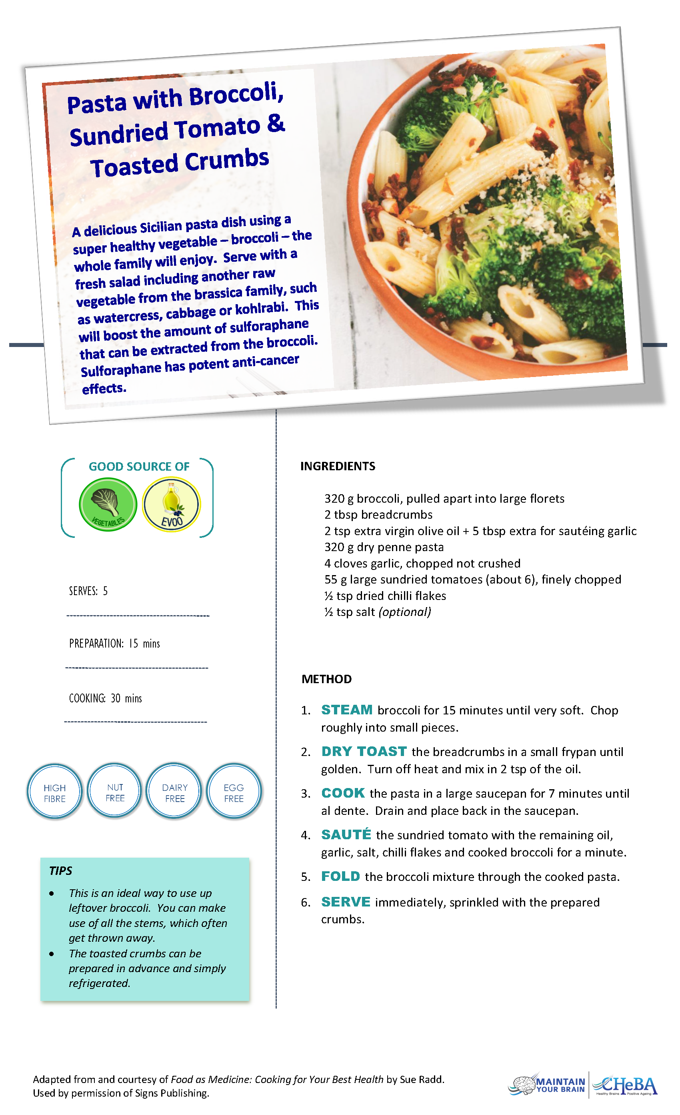
Figure 17. MiniCul Questionnaire

Short Dietary Survey: MiniCul Screening Tool
This is a survey about the food you ate recently. Read it carefully and identify the amounts that best describe your intake over the last week. It’s important that the answers you provide reflect what you personally ate, rather than what you think you should or shouldn’t be having, or what someone else wants you to eat. This survey will take approximately 10 minutes to complete.
For Question 1, if you didn’t eat the food item or drink water on a daily basis, please place a ‘0’ (zero) on the line.
- How many serves per day did you usually have of the following:
_______ Vegetables (1 serve is ½ cup cooked vegetables or 1 cup of salad vegetables).

_______ Fruit (Do not count juice) (1 serve is 1 medium piece or 2 small pieces of fruit or 1 cup of diced/canned fruit or 30 g dried fruit e.g. 4 dried apricot halves, 1 ½ tablespoons sultanas).

_______ Water (1 serve is 1 cup (250 ml); 1 litre equals 4 cups; An average water bottle is 600 ml).

Questions 2 – 4 ask about serves per week. If you didn’t eat or drink the item in the last week, please place a ‘0’ (zero) on the line.

- How many serves of the following meats/alternatives did you have over the last week?

______ Red meat (e.g., beef, veal, lamb, kangaroo or pork): Include all steaks, chops, roasts, mince, stir-fries and casseroles. (1 serve equals 100-150 g).

______ Processed meat (e.g., sausages, bacon, ham, devon, frankfurts, salami, luncheon meats or meat pies). (1 serve equals 1 ½ thick or 2 thinner sausages, 2 rashers bacon, 4 slices processed meats (100 g), 1 meat pie/pastie/sausage roll, 6 chicken nuggets).

______ White meat (e.g., chicken, turkey or rabbit): Include all fillets, pieces, roasts, mince, stir-fries and casseroles. (1 serve is 100-150 g).

______ Fish or seafood: Include fresh fish/seafood and canned fish. (1 serve is 1 small fish fillet or 1 small can of fish or 200 g seafood).

______ I didn’t eat any of these foods.

- How many serves of legumes did you have? Legumes include baked beans, canned 4-bean mix, lentils, split peas, chickpeas and any other canned or dried beans. (1 serve is 1 cup (150 g) cooked or canned beans). They do not include fresh peas and green beans.
________ serves during the last week.

- How many serves of nuts did you have? Nuts include peanuts, walnuts, Brazil nuts, cashews etc. (1 serve is 30 g nuts or a small handful, or 1 ½ tablespoons nut paste/peanut butter).
________ serves during the last week.

Questions 5-8 ask about the number of times a food item was eaten over the last week, regardless of serving size. If you didn’t eat the food over the last week put ‘0’ (zero) on the line.

- How many times in the last week did you eat raw or cooked green vegetables? Write a number next to each of the two groups below.
______ times last week of broccoli, peas, beans, zucchini, Brussels sprouts, bok choy, Chinese cabbage.

______ times last week of dark green leafy varieties such as kale, spinach, silverbeet, amaranth, dandelion, chicory, endive, rocket.

- How many times last week do you eat dishes cooked in a sauce made with tomato and onion simmered in olive oil? The sauce may also include garlic and herbs. (Exclude canned/bottled tomato sauces if onion and olive oil are not used).
________ times over the last week.

- How many times over the last week did you eat each of the following types of bread or wraps? Count also special dietary breads such as gluten free. Don’t worry about amounts. Place a ‘0’ (zero) on the line if you didn’t eat certain types of bread or wraps.
________ times last week white e.g. Tip Top, Wonder White, Molenberg.
________ times last week wholegrain e.g. Burgen, Helga’s, Schwob’s Swiss Bakery.
________ times last week wholemeal e.g. Buttercup, Glicks, Bill’s, Lawson’s.
________ times last week rye e.g. Country Life, Abbott’s Village Bakery, Van Der Meulin.
________ times last week sourdough e.g. Coles Bakery, Bill’s, Macro, Woolworths.

- How many times over the last week did you have the following:
________ Meals or snacks from takeaway food stores. Examples include McDonalds, Hungry Jacks, Pizza Hut, KFC, Red Rooster, fish/chicken shop or local take away food places and foods such as burgers, pizza, hot dogs, battered chicken or fish and chips.
________ Biscuits or cakes of any type. This includes sweet biscuits, muffins, sponge cakes, sweet buns, doughnuts and Danish pastries.

________ Ice cream.

________ Hot chips, French fries, wedges or fried potatoes.

________ Sugar sweetened/carbonated beverages. This includes soft drink, cordial, sports drink, vitamin water and energy drink. Do not count ‘diet’ drinks.

The next question asks about your alcohol intake.
- Did you drink alcohol in the last week?
- Yes
- No
If NO, skip to question 10.
How many drinks of each type in the amounts shown below, did you have in the last week?
Full strength beer  1 stubbie/can  375ml | Lite beer  1 stubbie/can  375ml | Red wine  1 glass  150ml | White wine or champagne  1 glass  150ml | Spirits  1 drink or nip  30ml
_____  per day OR  per week OR  I didn’t drink this type | ____  per day OR  per week OR  I didn’t drink this type | ____  per day OR  per week OR  I didn’t drink this type | ____  per day OR  per week OR  I didn’t drink this type | ____  per day OR  per week OR  I didn’t drink this type

For Question 10, we are asking you to focus on the number of days last week that you used specific fats and oils. If you didn’t use the fat or oil over the last week, please place a ‘0’ (zero) on the line.
- How many days last week did you use each of the following fats and oils? Fats and oils may have been used in your cooking, as spreads or on salads.
________ days last week butter.
________ days last week margarine.
________ days last week mayonnaise.
________ days last week vegetable oil e.g. sunflower, grapeseed, canola, rice bran.
________ days last week olive oil.
Scoring
Question | Scoring, score = response | Total
1a. Vegetables | 0= 0-2.99 serves / d  1= 3-4.99 serves / d  2= 5+ serves /d | 2
1b. Fruit | 0 = 0-0.99 serves / d  1 = 1-2.99 serves / d  2 = 3+ serves / d | 2
1c. Water | 0 = 0-2.99 serves / d  1 = 3-4.99 serves / d  2 = 5+ serves / d | 2
2a. Red meat | 0 = >3 serves / wk  1 = >1-3 serves / wk  2 = ≤1 serves / wk | 2
2b. Processed meat | 0 = >1 serves / wk  1 = 0.5-1 serves / wk  2 = 0-<0.5 serves / wk | 2
2c. White meat preference | 0 = red meat + processed meat > chicken + fish  1 = chicken + fish = red meat + processed meat  2 = chicken + fish > red meat + processed meat OR don’t eat any meats (i.e. assuming vegetarian) | 2
2d. Fish | 0 = 0-0.99 serves / wk  1 = 1-2.99 serves / wk  2 = ≥3 serves / wk | 2
3. Legumes | 0 = 0-0.99 serves / wk  1 = 1-2.99 serves / wk  2 = ≥3 serves / wk | 2
4. Nuts | 0 = 0-0.99 serves / wk  1 = 1-4.99 serves / wk  2 = 5+ serves / wk | 2
- Green vegetables | Only score the dark green leafy type (second part of q.)  0 = 0-1.99 times / wk  1 = 2-3.99 times / wk  2 = ≥4 times/ wk | 2
- Sofrito | 0 = 0-0.99 times / wk  1 = 1-1.99 times / wk  2 = 2+ times / wk | 2
- Wholegrains or lower GI (bread as proxy) | 0=If a zero i.e. ‘0’ is selected as the response for each bread type i.e. don’t eat any bread  0 = white > wholegrain + wholemeal + rye + sourdough;  1 = white is equal to wholegrain + wholemeal + rye + sourdough;  2 = white < wholegrain + wholemeal + rye + sourdough | 2
8a. Takeaways | 0 = ≥2 times / wk  1 = 1-1.99 times / wk  2 = 0-0.99 times / wk | 2
8b. Biscuits | 0 = ≥2 times / wk  1 = 1-1.99 times / wk  2 = 0-0.99 times / wk | 2
8c. Ice cream | 0= ≥2 times / wk  1= 1-1.99 times / wk  2 = 0-0.99 times / wk | 2
8d. Hot chips | 0 = ≥2 times / wk  1 = 1-1.99 times / wk  2 = 0-0.99 times / wk | 2
8e. Soft drinks | 0 = ≥2 times / wk  1 = 1-1.99 times / wk  2 = 0-0.99 times / wk | 2
9. Alcoholic beverages | Note: convert drinks to “standard drinks” before applying rules, see below*  0= >14 standard drinks per week (from question 9b)  1= >7-14 standard drinks per week of any alcohol (from question 9b)  1=>0 to 7 standard drinks where wine is not main drink (i.e. total std drinks wine divided by total std drinks all alcohol ≤50%)  2= NON-DRINKERS (from question 9a) OR  2= >0 to 7 standard drinks per week AND main drink is wine (from question 9b) (i.e. total std drinks wine divided by total std drinks all alcohol >50%) | 2
10. Fat types | 0=If a zero i.e. ‘0’ is selected as the response for each fat type i.e. don’t use any added fats  0 = Others total > olive oil  2 = Others total = olive oil  4= Others total < olive oil | 4
TOTAL |  | 40

*Standard Drink Conversions
Full Strength Beer (375 ml) = 1.4 standard drinks
Lite Beer (375 ml) = 0.8 standard drinks
Red Wine (150 ml) = 1.6 standard drinks
White Wine/champagne (150 ml) = 1.4 standard drinks
Spirits (30 ml) = 1 standard drinks

© Professor Victoria Flood and Dr Sue Radd-Vagenas, 2018.
The MiniCul tool may be used, reproduced and distributed without permission. It should be made available free of charge to patients. Written permission is required for any form of commercial or pharma use.
Acknowledgement: National Health and Medical Research Council for images of standard drinks of alcohol https://www.nhmrc.gov.au/about-us/publications/australian-guidelines-reduce-health-risks-drinking-alcohol

Table 1. Behavioral principles used in the Nutrition Module
Schedule | Nutrition Module component | Activity/ description | Behavioral change strategies
Week 1 | Introduction | Watch welcome video presented by Ita Buttrose (2013 Australian of the year) and the Study Physician about the MYB trial, dementia risk factors and the benefits of the nutrition program on improving health outcomes.  Watch an additional instructional video, explaining the Nutrition Module structure, the Ideal Mediterranean Pyramid, and how to navigate around the digital platform (Nutrition Module Portal). | Increasing knowledge: Addressing and identifying perceived susceptibility and severity of dementia risk level; as well as potential perceived benefits and barriers to dietary change.  Prompting health motivation and cues to action.
Week 1 | My Ideal Mediterranean Pyramid | Familiarize and explore My Ideal Mediterranean Pyramid.  My Ideal Mediterranean Pyramid is an interactive food pyramid, comprising clickable food group “puzzle pieces” which contain general information (e.g., what is the food, how much do I need to eat, ways to enjoy more/how to use less, etc.) along with a link to the resource library including:  - Fact sheets  - Videos  - Recipes  - Shopping and reading label tips  - Health tips  - A reference library of research article abstracts to support recommendations  The foundation block of the pyramid includes resources related to cuisine and lifestyle (e.g., main meals at lunch, short naps afterwards, meals with others/ cook and eat with friends, cooking at home, cooking methods, fasting, vegetable garden etc.). | Goal setting: Providing instructions on how to perform the behavior with set eating goals for each food group.
Weekly dietary assessment/review for the initial 10 weeks then monthly afterwards | Assessment of MedDiet adherence, personalized feedback, and tailored nutrition program | Complete MiniCul at scheduled times.  MiniCul is a short dietary questionnaire designed as a behavioral assessment tool. After completing each MiniCul, participants receive prompt automated individualized feedback messages including structured behavioral dietary change lessons to support adopting a MedDiet. A maximum of 4 diet feedback/missing puzzle pieces and corresponding nutrition goals are given each week to help plan and encourage small, manageable goals. Participants are encouraged to pick one goal per week that would be the easiest one to achieve to not feel overwhelmed. The dietary feedback messages relate to the recommended quantity (serves), food type and strategies to enjoy more/eat less of a food group; and inspiring facts related to brain health. All dietary messages are linked back to their corresponding resource library for specific food groups from week 1 - My Ideal Med Pyramid to help make dietary changes. | Providing tailored feedback on performance.  Prompting goal setting.  Providing instructions on how to perform the behavior.  Identifying perceived benefits and providing solutions to potential perceived barriers for change.
Weekly/monthly | My Progress and positive reinforcement | Receive results on progress displayed under My Progress. Feedback on the achievement of goals is given in the form of a MedDiet Score out of 40 and a new pyramid each week showing the 10 blocks filling in; colored blocks indicate new goals achieved based on individual MiniCul results. In addition to the visual pyramid feedback, the absolute score (point) change in MedDiet score is auto-calculated by comparing the difference between the current and previous MedDiet score. Using absolute point score change helps provide encouragement and positive reinforcement of small steps towards adopting a MedDiet eating pattern. | Rewarding positive and successful behavior change.  Promoting self-efficacy.
Weekly/monthly | My Mediterranean Goals & Action Plan | Log and keep a record of personalized goals using My Mediterranean Goals & Action Plan. My Mediterranean Goals & Action Plan is a personalized and fillable electronic diary to help facilitate goal setting, action planning, habit tracking and progress monitoring for dietary behavior change. Each week there is an option for personal goal setting related to each diet message to help achieve a top score for the 4 food groups prioritized for the week. This diary is easily accessible on the dashboard with the ability to review past and present goals and progress on them. | Goal setting.  Action planning.  Prompt self-monitoring of behavior.
Weekly/monthly | Self-measured weight and waist circumference | Provide self-measured weight and waist circumference at the end of each MiniCul entry. | Self-monitoring
Available for the entire duration of the trial | Virtual resource library including behavioral change materials | View resources from the resource library.  Full and unlimited access to the resource library is given from the start of the Nutrition Module. Participants can freely navigate the entire library at any time if they choose, to simulate the real world experience where all resources may be provided in advance, but goal setting occurs progressively so as not to overwhelm. The virtual resource library contains written handouts, infographics, and videos to show how to eat more of a MedDiet. For example:  - General information and overview of the MedDiet (fact sheet, meal ideas, sample meal plans, pantry/shopping lists, and recipes)  - Mediterranean culinary and lifestyle elements  - Special diet and disease information and tips  Also, behavioral change resources include topics such as:  - How to piece it together - Overview  - Strategies for behavior change - Self-monitoring  - Strategies for behavior change - Goal setting  - Strategies for behavior change - Feedback  - Strategies for behavior change - Positive reinforcement  - Strategies for behavior change - Contracting  - Strategies for behavior change - Managing barriers  - Strategies for behavior change - Generating varied experience  - Strategies for behavior change - Knowledge  - Strategies for behavior change - Self-Efficacy  - Strategies for behavior change - Outcome expectancy  - Strategies for behavior change - Environment context  - Stages of change – Let’s get started and see where you're at  - Stages of change -- Pre-Contemplation  - Stages of change -- Contemplation  - Stages of change -- Preparation  - Stages of change -- Action  - Stages of change -- Maintenance  - Stages of change -- Relapse  - Healthy eating whilst travelling  - My Mediterranean Eating Plan & Food Diary | Addressing stages of change.  Managing and preventing relapses.  Action planning.  Problem-solving.  Self-efficacy.  Knowledge.
Ad hoc | Motivational counselling and support | Nutrition consultation with a dietitian/nutritionist is available by request via online ticket system, email, or telephone to help provide additional support and encouragement. | Planning for social support and guidance.  Positive reinforcement.
Monthly | Boosters | Upload monthly, boosters material could be new fact sheets, scientific literature, or recipes to increase the library’s resources. | Enabling additional social support and guidance.  Knowledge.
Periodically | Newsletter | Upload periodically, the newsletter contains supplementary information related to MedDiet and health outcomes. It also promotes participant engagement with the Nutrition Module homepage. | Enabling additional social support and guidance.  Knowledge.  Increasing participant engagement.  Positive reinforcement.

