Supplementary data
YJ Wang, et al. Urinary sodium excretion and the risk of cardiovascular disease: a community-based cohort study in Taiwan

Table S1. Unadjusted Spearman partial correlation coefficients between various measurements and urinary sodium excretion among the study participants in the CCCC Study.
Table S2. Subgroup analyses for the risks of cardiovascular disease, CHD, and stroke according to the urinary sodium excretion categories
Table S3. Hazard ratios and 95% confidence intervals of total cardiovascular disease, coronary heart disease, and stroke according to the urinary sodium excretion and the metabolic syndrome status
Table S4. Hazard ratios and 95% confidence intervals of total cardiovascular disease, coronary heart disease, and stroke according to the urinary sodium excretion and the overweight status
Table S5. Hazard ratios and 95% confidence intervals of total cardiovascular disease, coronary heart disease, stroke, cerebral infarction, and cerebral hemorrhage according to quartiles of urinary sodium excretion after adjusted for potential confounders and 24-hour potassium excretion.
Table S6. Hazard ratios and 95% confidence intervals of total cardiovascular disease, coronary heart disease, and stroke according to the urinary sodium excretion and hypertension after adjusted for potential confounders and 24-hour potassium excretion.
Table S7. Association of urinary sodium excretion with incident CVD after adjustment for potential mediators.
Figure S1. Study flow chart of this study
Figure S2. The linear (A) and non-linear (B) association of urinary sodium excretion and HR of cardiovascular disease.
Figure S3. The linear (A) and non-linear (B) association of urinary sodium excretion and HR of stroke.
Figure S4. The linear (A) and non-linear (B) association of urinary sodium excretion and HR of coronary heart disease.
Figure S5. The proportion of CVD risk reduction for the highest group of urinary sodium excretion in the counterfactual framework approach.
Figure S6. Scatterplots and correlations for overnight urine sodium excretion, estimated 24-hour urine sodium excretion by the Kawasaki formula, and estimated 24-hour urine sodium excretion by the Tanaka formula.

Table S1. Unadjusted Spearman partial correlation coefficients between various measurements and urinary sodium excretion among the study participants in the CCCC Study.
 | SBP | DBP | CIMT | LVM | BMI | Metabolic syndrome | Uric acid | LDL-C | HDL-C | Fasting glucose
Urinary sodium | 0.110*** | 0.082*** | 0.048* | 0.060*** | 0.136*** | 0.032 | -0.037 | -0.018 | 0.054 | 0.068**
Abbreviations: BMI, body mass index; CIMT, Carotid Intima-Media Thickness; DBP, diastolic blood pressure; HDL-C, high-density lipoprotein cholesterol; LDL-C, low-density lipoprotein cholesterol; LVM, Left ventricular mass; SBP, systolic blood pressure.
* P<0.05. ** P<0.01. *** P<0.001.

Table S2. Subgroup analyses for the risks of cardiovascular disease, CHD, and stroke according to the urinary sodium excretion categories.
 | Quartiles of urinary sodium excretion, HR (95% CI) |  |  |  |  | P for interaction
 | Q1 | Q2 | Q3 | Q4 | P for trend
Cardiovascular disease
Genderª |  |  |  |  |  | 0.81
Men (n/N) | 36/255 | 46/246 | 29/241 | 49/233
HR | 1 | 1.28 (0.81, 2.03) | 0.88 (0.53, 1.46) | 1.69 (1.08, 2.64) | 0.04
Women (n/N) | 28/273 | 25/282 | 30/287 | 36/295
HR | 1 | 0.84 (0.49, 1.46) | 1.02 (0.60, 1.71) | 1.22 (0.74, 2.02) | 0.27
Age, yrs^{b} |  |  |  |  |  | 0.21
<65 (n/N) | 38/412 | 40/406 | 33/433 | 61/440
HR | 1 | 1.03 (0.65, 1.62) | 0.79 (0.49, 1.26) | 1.51 (1.00, 2.28) | 0.03
≥65 (n/N) | 26/116 | 31/122 | 26/95 | 24/88
HR | 1 | 1.04 (0.61, 1.78) | 1.09 (0.62, 1.91) | 1.24 (0.71, 2.19) | 0.43
Menopause status ^{d} |  |  |  |  |  | 0.77
Non-menopause (n/N) | 1/100 | 5/118 | 5/105 | 8/114
HR | 1 | 2.68 (0.29, 24.64) | 4.42 (0.50, 39.28) | 7.52 (0.92, 61.85) | 0.02
Menopause (n/N) | 24/153 | 19/142 | 19/160 | 25/160
HR | 1 | 0.87 (0.47, 1.60) | 0.76 (0.41, 1.40) | 1.01 (0.57, 1.79) | 0.92
eGFR, mL/min/1.73 m^{2 c} |  |  |  |  |  | 0.96
≥60 (n/N) | 47/397 | 56/415 | 46/420 | 67/415
HR | 1 | 1.06 (0.71, 1.57) | 0.90 (0.60 1.36) | 1.43 (0.88, 2.23) | 0.06
<60 (n/N) | 17/127 | 14/111 | 12/105 | 17/110
HR | 1 | 0.80 (0.37, 1.72) | 1.00 (0.46, 2.17) | 1.28 (0.63, 2.66) | 0.35
Coronary heart disease
Genderª |  |  |  |  |  | 0.44
Men (n/N) | 19/241 | 25/237 | 17/237 | 25/230
HR | 1 | 1.36 (0.73, 2.54) | 0.90 (0.46, 1.77) | 1.51 (0.81, 2.83) | 0.32
Women (n/N) | 14/250 | 11/269 | 14/264 | 12/275
HR | 1 | 0.69 (0.31, 1.52) | 0.87 (0.41, 1.86) | 0.70 (0.32, 1.55) | 0.53
Age, yrs^{b} |  |  |  |  |  | 0.49
<65 (n/N) | 21/385 | 21/387 | 19/411 | 27/420
HR | 1 | 0.99 (0.53, 1.83) | 0.77 (0.41, 1.46) | 1.10 (0.61, 1.97) | 0.76
≥65 (n/N) | 12/106 | 15/119 | 12/90 | 10/85
HR | 1 | 0.98 (0.45, 2.12) | 0.94 (0.41, 2.17) | 0.97 (0.40, 2.34) | 0.93
eGFR, mL/min/1.73 m^{2 c} |  |  |  |  |  | 0.41
≥60 (n/N) | 24/365 | 30/392 | 22/396 | 27/394
HR | 1 | 1.16 (0.67, 2.00) | 0.82 (0.45, 1.48) | 1.09 (0.62, 1.90) | 0.99
<60 (n/N) | 9/122 | 6/112 | 8/102 | 9/108
HR | 1 | 0.59 (0.18, 1.90) | 1.17 (0.44, 3.14) | 1.34 (0.49, 3.69) | 0.32
Menopause status ^{d}
Non-menopause (n/N) | 1/92 | 3/112 | 4/94 | 2/108 |  | 0.28
HR | 1 | 1.72 (0.16, 18.46) | 2.55 (0.26, 25.38) | 1.58 (0.13, 19.12) | 0.76
Menopause (n/N) | 12/140 | 8/136 | 8/150 | 10/147
HR | 1 | 0.60 (0.24, 1.50) | 0.54 (0.21, 1.39) | 0.68 (0.28, 1.61) | 0.48
Stroke
Genderª |  |  |  |  |  | 0.78
Men (n/N) | 18/251 | 22/246 | 16/242 | 31/235
HR | 1 | 1.10 (0.56, 2.13) | 0.96 (0.48, 1.93) | 1.96 (1.07, 3.61) | 0.02
Women (n/N) | 13/271 | 14/283 | 16/284 | 25/294
HR | 1 | 1.06 (0.49, 2.29) | 1.23 (0.59, 2.56) | 2.01 (1.02, 3.96) | 0.02
Age, yrs^{b} |  |  |  |  |  | 0.16
<65 (n/N) | 15/405 | 20/409 | 16/431 | 39/438
HR | 1 | 1.19 (0.59, 2.37) | 1.05 (0.52, 2.15) | 2.58 (1.41, 4.73) | <0.001
≥65 (n/N) | 16/117 | 16/120 | 16/95 | 17/91
HR | 1 | 0.92 (0.45, 1.88) | 1.14 (0.56, 2.32) | 1.31 (0.65, 2.66) | 0.35
eGFR, mL/min/1.73 m^{2 c} |  |  |  |  |  | 0.76
≥60 (n/N) | 23/393 | 26/414 | 25/419 | 45/416
HR | 1 | 0.99 (0.56, 1.76) | 1.00 (0.56, 1.77) | 1.92 (1.16, 3.19) | 0.003
<60 (n/N) | 8/125 | 8/112 | 7/104 | 10/110
HR | 1 | 0.97 (0.34, 2.79) | 1.25 (0.43, 3.59) | 1.60 (0.59, 4.34) | 0.28
Menopause status ^{d} |  |  |  |  |  | 0.02
Non-menopause (n/N) | 0/97 | 2/118 | 2/103 | 6/114
HR | 1 | NA ^{e} | NA ^{e} | NA ^{e} | 0.01
Menopause (n/N) | 11/153 | 11/143 | 11/160 | 16/159
HR | 1 | 0.87 (0.39, 2.21) | 0.89 (0.38, 2.08) | 1.42 (0.65, 3.11) | 0.25
Abbreviations: eGFR, estimation of glomerular filtration rate; HR, hazard ratio
a: Model was adjusted for age (35–44, 45–54, 55–64, 65–74, ≥75 years of age), body mass index (<18, 18 to 20.9, 21 to 22.9, 23 to 24.9, or ≥25 kg/m²), smoking (yes/no or abstinence), current alcohol drinking (regular/no), marital status (single, married and living with a spouse, or divorced and separated), regular exercise habit (yes/no), an education level (less than 9 years, at least 9 years), occupation (no work, labor, official or business), low-density lipoprotein (mg/dL), and glomerular filtration rate (<60,>=60 mL/min/1.73 m²).
b: Model was adjusted for sex, body mass index (<18, 18 to 20.9, 21 to 22.9, 23 to 24.9, or ≥25 kg/m²), smoking (yes/no or abstinence), current alcohol drinking (regular/no), marital status (single, married and living with a spouse, or divorced and separated), regular exercise habit (yes/no), an education level (less than 9 years, at least 9 years), occupation (no work, labor, official or business), low-density lipoprotein (mg/dL), and glomerular filtration rate (<60,>=60 mL/min/1.73 m²).
c:Model was adjusted for age (35–44, 45–54, 55–64, 65–74, ≥75 years of age), sex, body mass index (<18, 18 to 20.9, 21 to 22.9, 23 to 24.9, or ≥25 kg/m²), smoking (yes/no or abstinence), current alcohol drinking (regular/no), marital status (single, married and living with a spouse, or divorced and separated), regular exercise habit (yes/no), an education level (less than 9 years, at least 9 years), occupation (no work, labor, official or business), and low-density lipoprotein (mg/dL).
d: Model was adjusted for age (35–44, 45–54, 55–64, 65–74, ≥75 years of age), sex, body mass index (<18, 18 to 20.9, 21 to 22.9, 23 to 24.9, or ≥25 kg/m²), smoking (yes/no or abstinence), current alcohol drinking (regular/no), marital status (single, married and living with a spouse, or divorced and separated), regular exercise habit (yes/no), an education level (less than 9 years, at least 9 years), occupation (no work, labor, official or business), low-density lipoprotein (mg/dL), and glomerular filtration rate (<60,>=60 mL/min/1.73 m²).
e: Estimated hazard ratios cannot be calculated because none of the events occurred in the reference group.

Table S3. Hazard ratios and 95% confidence intervals of total cardiovascular disease, coronary heart disease, and stroke according to the urinary sodium excretion and the metabolic syndrome status.
 | Non-metabolic syndrome |  | Metabolic syndrome
Urinary sodium excretion (g/24hr) | Low (<2g/day) | High (>=2g/day) | Low (<2g/day) | High (>=2g/day)
Total cardiovascular disease
Events/participants | 31/396 | 121/1096 | 35/165 | 92/455
Model 1 | 1 | 1.42 (0.96, 2.11) | 2.71 (1.66, 4.41) | 2.94 (1.94, 4.44)
Model 2 | 1 | 1.38 (0.93, 2.06) | 2.62 (1.59, 4.33) | 2.84 (1.84, 4.37)
Model 3 | 1 | 1.36 (0.91, 2.02) | 2.53 (1.53, 4.19) | 2.67 (1.73, 4.13)
Coronary heart disease
Events/participants | 16/396 | 57/1096 | 19/165 | 49/455
Model 1 | 1 | 1.30 (0.73, 2.30) | 3.03 (1.52, 6.05) | 3.39 (1.89, 6.08)
Model 2 | 1 | 1.26 (0.71, 2.25) | 2.49 (1.22, 5.08) | 2.85 (1.55, 5.24)
Model 3 | 1 | 1.22 (0.68, 2.17) | 2.45 (1.20, 5.00) | 2.70 (1.46, 5.00)
Stroke
Events/participants | 16/396 | 71/1096 | 17/165 | 50/455
Model 1 | 1 | 1.59 (0.93, 2.74) | 2.32 (1.16, 4.63) | 2.62 (1.48, 4.65)
Model 2 | 1 | 1.60 (0.93, 2.75) | 2.62 (1.30, 5.30) | 2.94 (1.63, 5.33)
Model 3 | 1 | 1.55 (0.90, 2.68) | 2.52 (1.24, 5.15) | 2.91 (1.60, 5.29)
Model 1: adjusted for age (35–44, 45–54, 55–64, 65–74, ≥75 years of age) and sex
Model 2: Model 1 plus body mass index (<18, 18 to 20.9, 21 to 22.9, 23 to 24.9, or ≥25 kg/m²), smoking (yes/no or abstinence), current alcohol drinking (regular/no), marital status (single, married and living with a spouse, or divorced and separated), regular exercise habit (yes/no), an education level (less than 9 years, at least 9 years), occupation (no work, labor, official or business)
Model 3: Model 2 plus low-density lipoprotein (mg/dL), and glomerular filtration rate (<60,>=60 mL/min/1.73 m²)
P for interaction for total cardiovascular disease: 0.39
P for interaction for coronary heart disease: 0.81
P for interaction for stroke: 0.46

Table S4. Hazard ratios and 95% confidence intervals of total cardiovascular disease, coronary heart disease, and stroke according to the urinary sodium excretion and the overweight status.
 | Non-overweight (BMI<23.0) |  | Overweight (BMI>=23.0)
Urinary sodium excretion (g/24hr) | Low (<2g/day) | High (>=2g/day) | Low (<2g/day) | High (>=2g/day)
Total cardiovascular disease
Events/participants | 32/288 | 82/694 | 34/270 | 130/855
Model 1 | 1 | 1.00 (0.66, 1.50) | 1.04 (0.64, 1.69) | 1.43(0.97, 2.12)
Model 2 | 1 | 0.98 (0.65, 1.48) | 1.04 (0.64, 1.69) | 1.45 (0.98, 2.14)
Model 3 | 1 | 1.00 (0.66, 1.51) | 0.98 (0.60, 1.59) | 1.32 (0.89, 1.96)
Coronary heart disease
Events/participants | 14/288 | 32/694 | 21/270 | 73/855
Model 1 | 1 | 0.88(0.46, 1.69) | 1.49 (0.74, 3.00) | 1.98 (1.09, 3.59)
Model 2 | 1 | 0.88 (0.46, 1.68) | 1.46 (0.72, 2.95) | 2.03 (1.12, 3.69)
Model 3 | 1 | 0.91 (0.47, 1.75) | 1.44 (0.71, 2.91) | 1.88 (1.03, 3.44)
Stroke
Events/participants | 18/288 | 53/694 | 15/270 | 68/855
Model 1 | 1 | 1.18 (0.70, 2.01) | 0.79 (0.40, 1.58) | 1.20 (0.71, 2.02)
Model 2 | 1 | 1.16 (0.68, 1.98) | 0.79 (0.40, 1.57) | 1.21 (0.71, 2.04)
Model 3 | 1 | 1.15 (0.67, 1.97) | 0.72 (0.36, 1.45) | 1.11 (0.65, 1.89)
Model 1: adjusted for age (35–44, 45–54, 55–64, 65–74, ≥75 years of age) and sex
Model 2: Model 1 plus smoking (yes/no or abstinence), current alcohol drinking (regular/no), marital status (single, married and living with a spouse, or divorced and separated), regular exercise habit (yes/no), an education level (less than 9 years, at least 9 years), occupation (no work, labor, official or business)
Model 3: Model 2 plus low-density lipoprotein (mg/dL), glomerular filtration rate (<60,>=60 mL/min/1.73 m²), and diabetes status (yes/no)
P for interaction for total cardiovascular disease:0.29
P for interaction for coronary heart disease:0.40
P for interaction for stroke:0.47

Table S5. Hazard ratios and 95% confidence intervals of total cardiovascular disease, coronary heart disease, stroke, cerebral infarction, and cerebral hemorrhage according to quartiles of urinary sodium excretion after adjusted for potential confounders and 24-hour potassium excretion.
Quartiles of urinary sodium excretion | Q1 | Q2 | Q3 | Q4 | P for trend
Total cardiovascular disease | 1 | 1.07 (0.75, 1.51) | 0.97 (0.66, 1.40) | 1.60 (1.10, 2.31) | 0.01
Coronary heart disease | 1 | 1.13 (0.68, 1.87) | 1.00 (0.59, 1.69) | 1.34 (0.78, 2.32) | 0.34
Stroke | 1 | 0.98 (0.59, 1.61) | 0.98 (0.58, 1.64) | 1.75 (1.06, 2.86) | 0.009
Cerebral infarction | 1 | 0.64 (0.25, 1.61) | 0.81 (0.33, 1.98) | 2.16 (0.97, 4.84) | 0.007
Cerebral hemorrhage | 1 | 1.25 (0.39, 4.03) | 2.20 (0.72, 6.69) | 2.37 (0.76, 7.42) | 0.09
Adding adjusted for 24-hour potassium excretion groups (<17.4, 17.4 to 24.3, 24.3 to 33.0, ≥28.3 mmol)

Table S6. Hazard ratios and 95% confidence intervals of total cardiovascular disease, coronary heart disease, and stroke according to the urinary sodium excretion and hypertension after adjusted for potential confounders and 24-hour potassium excretion.
 |  | Normotensive |  |  | Hypertensive
Urinary sodium excretion (g/24hr) | Low (<2g/day) |  | High (>=2g/day) | Low (<2g/day) |  | High (>=2g/day)
Total cardiovascular disease | 1 |  | 1.46 (0.96, 2.24) | 2.69 (1.62, 4.47) |  | 2.72 (1.74, 4.24)
Coronary heart disease | 1 |  | 1.80 (0.99 ,3.27) | 2.83 (1.39, 5.78) |  | 2.32 (1.21, 4.42)
Stroke | 1 |  | 1.20 (0.67, 2.15) | 2.23 (1.09, 4.56) |  | 2.67 (1.48, 4.84)
 |  | Non-metabolic syndrome |  |  | Metabolic syndrome
Total cardiovascular disease | 1 |  | 1.39 (0.92, 2.08) | 2.52 (1.52, 4.18) |  | 2.74 (1.75, 4.28)
Coronary heart disease | 1 |  | 1.32 (0.73, 2.39) | 2.40 (1.17, 4.91) |  | 2.99 (1.59, 5.62)
Stroke | 1 |  | 1.41 (0.81, 2.47) | 2.62 (1.28, 5.35) |  | 2.58 (1.40, 4.75)
 |  | Non-overweight (BMI<23.0) |  |  | Overweight (BMI>=23.0)
Total cardiovascular disease | 1 |  | 1.03 (0.67, 1.57) | 0.98 (0.60, 1.61) |  | 1.37 (0.91, 2.07)
Coronary heart disease | 1 |  | 0.98 (0.50, 1.91) | 1.44 (0.71, 2.93) |  | 2.12 (1.13, 3.96)
Stroke | 1 |  | 1.06 (0.61, 1.84) | 0.71 (0.35, 1.45) |  | 0.98 (0.56, 1.71)
Adding adjusted for 24-hour potassium excretion groups (<17.4, 17.4 to 24.3, 24.3 to 33.0, ≥28.3 mmol)
Abbreviation: BMI, body mass index.

Table S7. Association of urinary sodium excretion with incident CVD after adjustment for potential mediators.
Factor |  | Quartiles of urinary sodium excretion, HR (95% CI)
 |  | Q1 | Q2 | Q3 | Q4
Basic model |  | 1 | 1.03 (0.73, 1.47) | 0.92 (0.64, 1.32) | 1.43 (1.02, 1.99)
Basic model plus each set of risk factors below added 1 factor at a time
 | Carotid Intima-Media Thickness | 1 | 0.97 (0.65, 1.45) | 0.85 (0.57, 1.28) | 1.28 (0.88, 1.86)
 | SBP | 1 | 1.12 (0.76, 1.66) | 0.99 (0.66, 1.49) | 1.29 (0.89, 1.87)
 | DBP | 1 | 1.10 (0.75, 1.63) | 0.99 (0.66, 1.49) | 1.37 (0.95, 1.99)
 | Left ventricular mass | 1 | 1.02 (0.71, 1.46) | 0.88 (0.61, 1.28) | 1.31 (0.93, 1.84)
Abbreviations: DBP, diastolic blood pressure; SBP, systolic blood pressure.
Basic model was adjusted for age (35–44, 45–54, 55–64, 65–74, ≥75 years of age), sex, body mass index (<18, 18 to 20.9, 21 to 22.9, 23 to 24.9, or ≥25 kg/m²), smoking (yes/no or abstinence), current alcohol drinking (regular/no), marital status (single, married and living with a spouse, or divorced and separated), regular exercise habit (yes/no), an education level (less than 9 years, at least 9 years), occupation (no work, labor, official or business), low-density lipoprotein(mg/dL), glomerular filtration rate (<60,≥60 mL/min/1.73 m²) and diabetes status (yes/no)
Adjusted models were adjusted for the variables in the basic model plus each of the risk factors added 1 factor at a time to separate models.
The proportion was calculated as (HR_{basic model} − HR_{adjusted model}) / (HR_{basic model} − 1) × 100%

Figure S1. Study flow chart of this study

Figure S2. The linear (A) and non-linear (B) association of urinary sodium excretion and HR of cardiovascular disease.
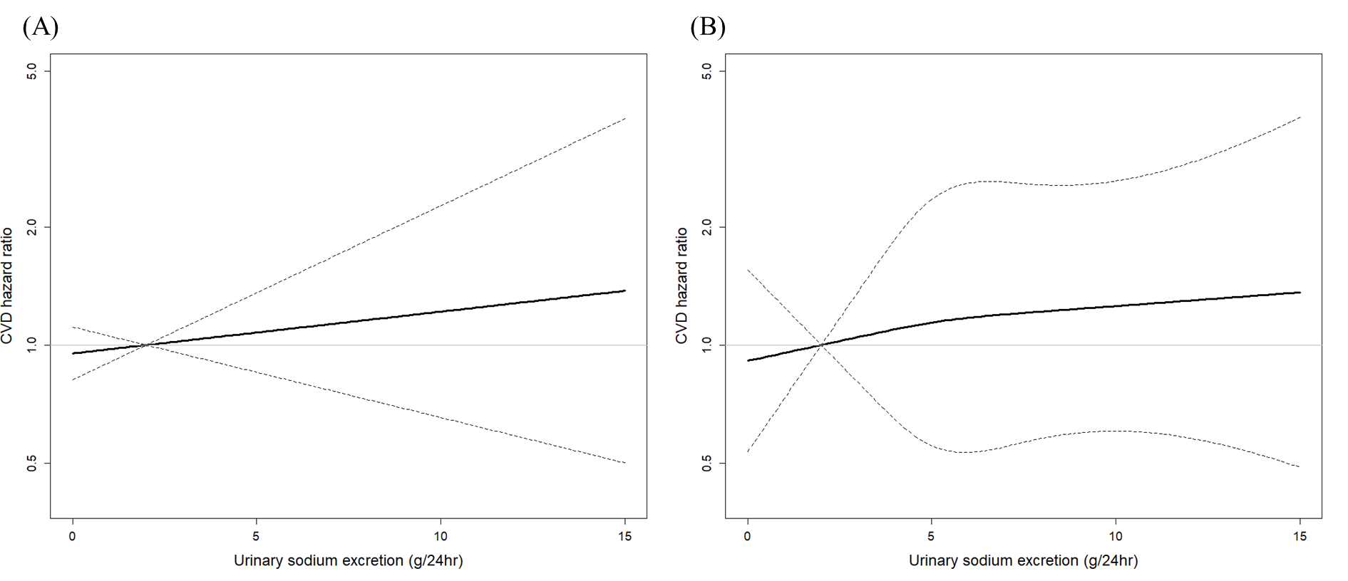
P for the linear model:0.54; P for non-linear model: 0.73; P for ANOVA test:0.87

Figure S3. The linear (A) and non-linear (B) association of urinary sodium excretion and HR of stroke.
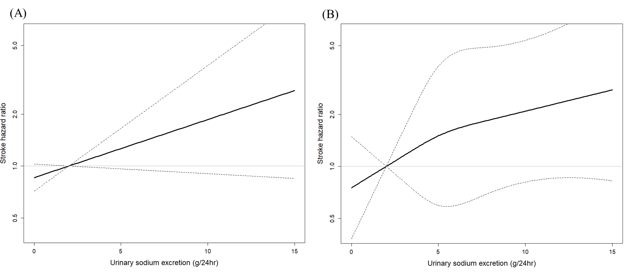
P for the linear model:0.09; P for non-linear model: 0.41; P for ANOVA test:0.70

Figure S4. The linear (A) and non-linear (B) association of urinary sodium excretion and HR of coronary heart disease.
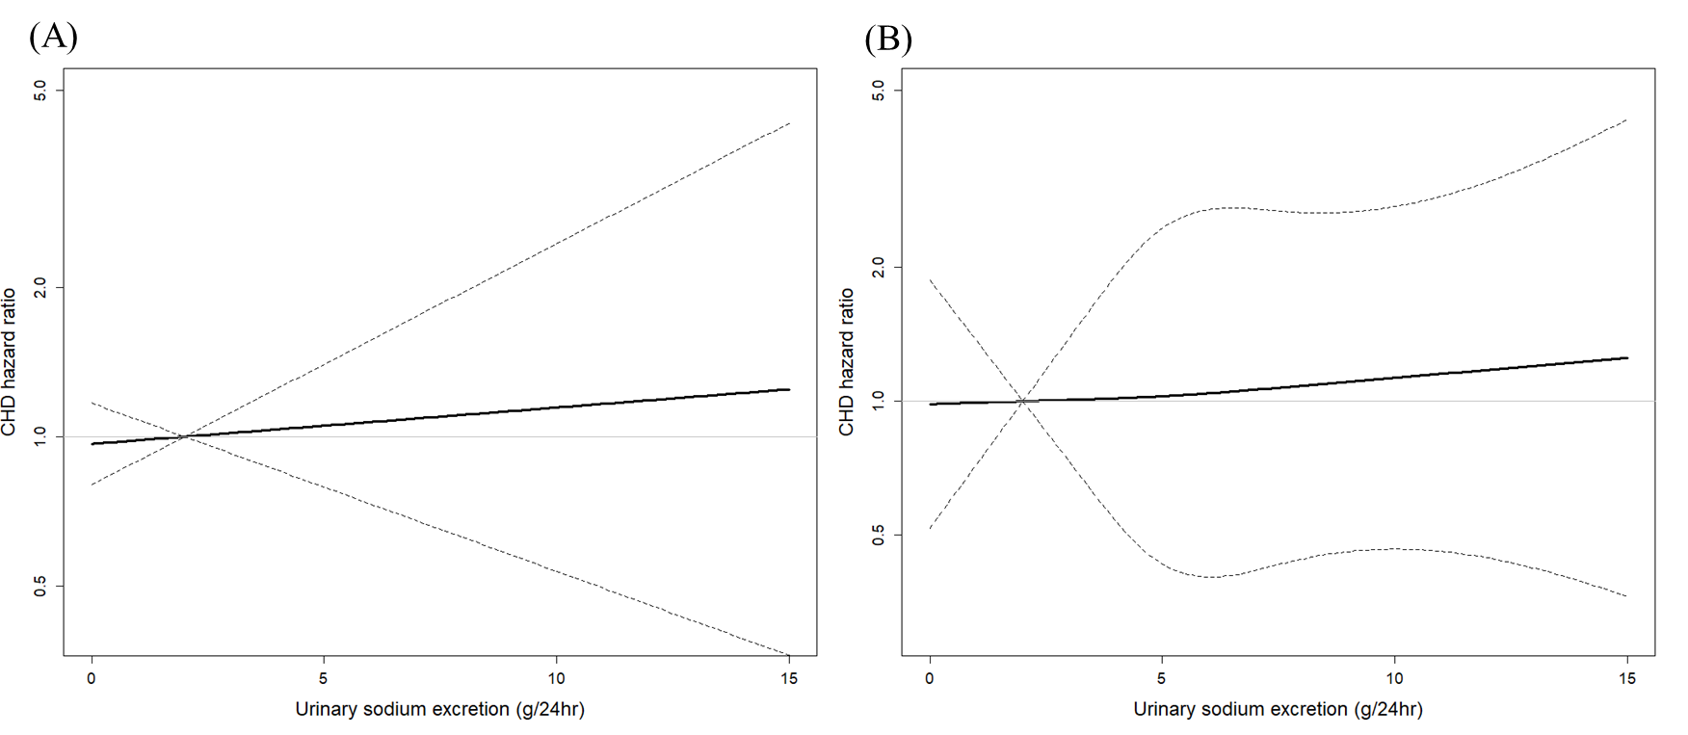
P for the linear model:0.73; P for non-linear model: 0.33; P for ANOVA test:0.96

Figure S5. The proportion of CVD risk reduction for the highest group of urinary sodium excretion in the counterfactual framework approach.
Figure S6. Scatterplots and correlations for overnight urine sodium excretion, estimated 24-hour urine sodium excretion by the Kawasaki formula⁽¹⁾, and estimated 24-hour urine sodium excretion by the Tanaka formula⁽²⁾.
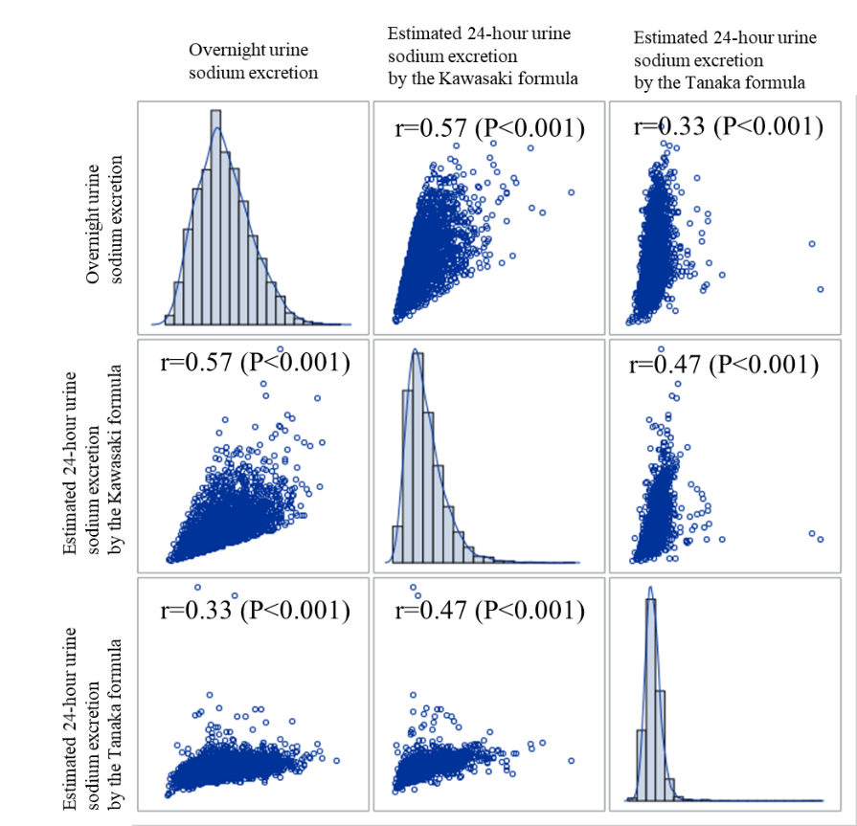
Reference
- Kawasaki T, Itoh K, Uezono K et al. (1993) A simple method for estimating 24 h urinary sodium and potassium excretion from second morning voiding urine specimen in adults. Clin Exp Pharmacol Physiol 20, 7-14.
- Tanaka T, Okamura T, Miura K et al. (2002) A simple method to estimate populational 24-h urinary sodium and potassium excretion using a casual urine specimen. Journal of Human Hypertension 16, 97-103.

