Supplementary table S1. Composition of the standard diet.
Ingredients (g/kg)
Wheat | 261∙987
Corn | 159∙992
Barley | 255∙897
Soybean meal | 189∙991
Wheat bran | 49∙998
Cane molasses | 29∙999
Fat | 20∙049
L-lysine-HCl | 2∙710
DL-methionine | 0∙420
L-threonine | 0∙300
Dicalcium phosphate | 5∙000
Calcium carbonate | 12∙859
Sodium chloride | 4∙500
Phytase, acidifier, vitamin and mineral premix* | 6∙300
Analyzed chemical composition† (%)
CP (N × 6.25) | 15∙80
Ash | 5∙28
Ether extract | 3∙61
Starch | 39∙50
Crude fiber | 3∙00
NDF | 11∙10
ADF | 3∙60
ADL | 0∙60
GE | 16∙54
Calculated chemical composition†‡
NE (MJ/kg) | 9∙825
SID lysine (g/MJ NE) | 0∙874
SID methionine + cystine (% SID lysine) | 63
SID threonine (% SID lysine) | 62
SID tryptophan (% SID lysine) | 20
SID valine (% SID lysine) | 79
SID isoleucine (% SID lysine) | 70
SID leucine (% SID lysine) | 128
GE, gross energy; NE, net energy; SID, standardized ileal digestible.
*The minerals and vitamins mixture provided the following ( /kg of diet): Vitamin A 5000 UI; vitamin D3 1000 UI; vitamin E 20 UI; vitamin B1 2 mg; vitamin B2 4 mg; pantothenic acid 10 mg; vitamin B6 1 mg; vitamin B12 0.02 mg; niacin 15 mg; vitamin K3 2 mg; folic acid 1 mg; biotin 0.2 mg; choline chloride 500 mg; iron 80 mg; copper 10 mg; zinc 100 mg; magnesium 40 mg; cobalt 0.1 mg; iodine 0.2 mg; selenium 0.15 mg.
†Adjusted for 88.8% DM.
‡Calculated from ingredient composition (Sauvant et al., 2002).
Supplementary table S2. Effect of dietary live yeast supplementation (Saccharomyces Cerevisiae var. Boulardii; CNCM I-1079, 1 × 10⁶ CFU/g of feed) on digestibility coefficients and N balance in finishing male pigs housed at thermoneutrality or high ambient temperature (n=10; LS-means).
 | Period (ambient temperature) |  |  |  | Significance*
 | 1 (22°C) | 2 (28°C) | 3 (28°C) |  | rSD | Diet | Period | D×P
Digestibility coefficient (%)
DM |  |  |  |  | 0∙8 | 0∙86 | 0∙21 | 0∙18
Non-supplemented diet | 85∙3 | 85∙1 | 85∙4
Supplemented diet | 84∙5 | 85∙6 | 85∙7
Organic matter |  |  |  |  | 0∙7 | 0∙98 | 0∙15 | 0∙17
Non-supplemented diet | 87∙0 | 86∙8 | 87∙1
Supplemented diet | 86∙2 | 87∙3 | 87∙4
N |  |  |  |  | 1∙5 | 0∙53 | 0∙07 | 0∙93
Non-supplemented diet | 84∙9 | 85∙7 | 86∙2
Supplemented diet | 85∙3 | 86∙3 | 87∙2
Energy |  |  |  |  | 0∙8 | 0∙74 | 0∙13 | 0∙14
Non-supplemented diet | 85∙3 | 85∙2 | 85∙4
Supplemented diet | 84∙4 | 85∙5 | 85∙8
CH₄ production (L/day) |  |  |  |  | 0∙7 | 0∙16 | <0∙01 | 0∙10
Non-supplemented diet | 5∙0 | 5∙2 | 5∙6
Supplemented diet | 4∙9 | 5∙9 | 6∙7
ME/DE (%) |  |  |  |  | 0∙7 | 0∙34 | 0∙54 | 0∙07
Non-supplemented diet | 95∙9 | 96∙2 | 95∙7
Supplemented diet | 95∙9 | 94∙9 | 95∙9
N balance
Digestible N intake (g/d) |  |  |  |  | 5 | <0∙01 | 0∙03 | 0∙15
Non-supplemented diet | 65 | 55 | 55
Supplemented diet | 72 | 68 | 72
N retention (g/d) |  |  |  |  | 5 | 0∙10 | 0∙23 | 0∙61
Non-supplemented diet | 34 | 30 | 29
Supplemented diet | 37 | 35 | 36
N retention (% of digestible N) |  |  |  |  | 5 | 0∙57 | 0∙76 | 0∙80
Non-supplemented diet | 53 | 56 | 54
Supplemented diet | 52 | 52 | 51
ME, metabolizable energy; DE, digestible energy
*Data were analyzed for the effects of diet, period and their interaction (D×P) with the pig as repeated unit between periods (Proc Mixed, SAS, 2004).

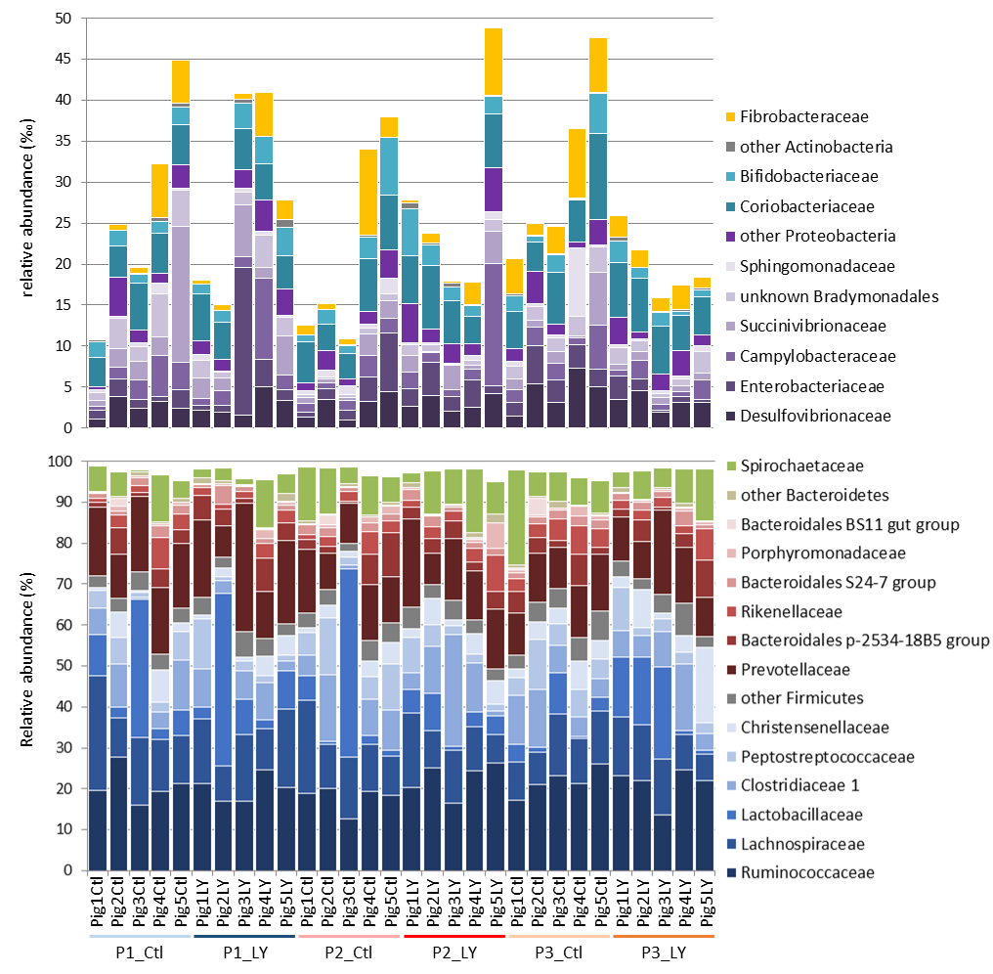
Supplementary Fig. S1. Bar plot representation of relative bacterial composition at the family level, in feces of pigs sampled at the end of the three experimental periods.
P1_Ctl, P2_Ctl, P3_Ctl, Pigs fed with the standard control diet and respectively sampled at the end of the P1 (22°C), P2 (28°C) and P3 (28°C) period; P1_LY, P2_ LY, P3_ LY, Pigs fed with the live yeast supplemented diet and respectively sampled at the end of the P1 (22°C), P2 (28°C) and P3 (28°C) period.

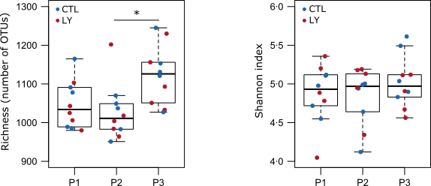

Supplementary Fig. S2. Effect of sampling date and live yeast supplementation on alpha-diversity.
CTL, control standard diet; LY, standard diet supplemented with live yeast.
* P < 0.05.

