Supplemental Table 1. Trajectory modelling and model fit characteristics in men (HPFS), postmenopausal women (NHS+ NHS II) and premenopausal women (NHS+ NHS II).
Men
Group | Name | Order | N | APP* | OCC*
1 | Medium-stable | Cubic | 680 | 0.89 | 21.7
2 | Lean-moderate increase | Quadratic | 880 | 0.91 | 18.6
3 | Lean-marked increase | Cubic | 557 | 0.84 | 21.7
4 | Medium-increase | Cubic | 314 | 0.92 | 74.7
Postmenopausal women
Group | Name | Order | N | APP | OCC
1 | Medium-stable | Quadratic | 2440 | 0.95 | 29.1
2 | Lean-moderate increase | Cubic | 1714 | 0.95 | 50.5
3 | Lean-marked increase | Cubic | 1085 | 0.89 | 36.8
4 | Medium-increase | Quadratic | 779 | 0.95 | 119.7
Premenopausal women
Group | Name | Order | N | APP | OCC
1 | Lean-stable/moderate increase | Cubic | 2173 | 0.91 | 13.0
2 | Lean-marked increase | Quadratic | 861 | 0.97 | 137.5
3 | Medium-stable/increase | Quadratic | 1511 | 0.84 | 11.6
4 | Heavy-stable/increase | Quadratic | 256 | 0.86 | 111.2
Abbreviations: APP, Average posterior probability; N: number of participants; OCC: Odds of correct classification; *Recommended criteria for APP: > 0.70; *Recommended criteria for OCC: > 5

Supplemental Table 2. Sensitivity analysis on women who have never been exposed to hormone therapy. Percentage difference in biomarker levels between the reference group (the medium-stable group in postmenopausal women and the lean-stable/moderate group in premenopausal women) and the other trajectory groups in postmenopausal (NHS+ NHS II) and premenopausal women (NHS+ NHS II)
Postmenopausal women
 | Medium-  Stable  (n=777) | Lean-  moderate increase  (n=562) | Lean-  marked increase  (n=458) | Medium-  Increase  (n=313)
Estrone | 0 (reference) | 5 (-1, 11) | 28 (20, 36) | 39 (29, 49)
Estradiol | 0 (reference) | 5 (-1, 12) | 53 (43, 64) | 70 (57, 84)
SHBG | 0 (reference) | -8 (-13, -3) | -34(-38, -30) | -35 (-39, -30)
Testosterone | 0 (reference) | 3 (-2, 9) | -2 (-8, 4) | 4 (-3, 12)
Free estradiol | 0 (reference) | 9 (1, 18) | 85 (70, 102) | 102 (83, 124)
Free testosterone | 0 (reference) | 11 (4,19) | 39 (29, 49) | 44 (33, 57)
Estradiol/ testosterone | 0 (reference) | -1 (-8, 6) | 49 (38, 60) | 62 (49, 77)
Premenopausal women
 | Lean-  stable/moderate increase  (n=1874) | Lean-  marked increase  (n=756) | Medium-stable/increase  (n=1291) | Heavy-stable/increase  (n=219)
Estrone | 0 (reference) | -1 (-6, 4) | -1 (-5, 3) | 5 (-3, 14)
Estradiol | 0 (reference) | 2 (-6, 11) | -6 (-12, 1) | -6 (-18, 7)
SHBG | 0 (reference) | 0 (-4, 4) | -6 (-9, -2) | -27 (-32, -22)
Testosterone | 0 (reference) | -2 (-6, 1) | -1 (-4, 2) | -4 (-9, 3)
Free estradiol | 0 (reference) | 1 (-8, 9) | -3 (-9, 3) | 9 (-5, 25)
Free testosterone | 0 (reference) | -5 (-9, 0) | 3 (-1, 7) | 22 (13, 32)
Estradiol/ testosterone | 0 (reference) | 5 (-4, 15) | -5 (-11, 2) | -4 (-17, 11)
SHBG, Sex-hormone Binding Globulin; BMI, Body Mass Index; NHS, Nurse’ Health Study; NHS II, Nurse’ Health Study II.
Multivariate linear regression analyses with covariates additionally adjusted for: age at blood draw, height, race, physical activity, alcohol consumption, smoking, multivitamin use, AHEI dietary score, fasting status, regular aspirin/NSAID use, hormone use

Supplement Figure1. Flowchart of study participants. a) Of 3053 eligible men in the HPFS, 2431 were included in the final study. b) Of 7860 eligible women in the NHS study and 4517 in the NHS 2, 4801 premenopausal and 6018 postmenopausal women were included in the final study.
a)
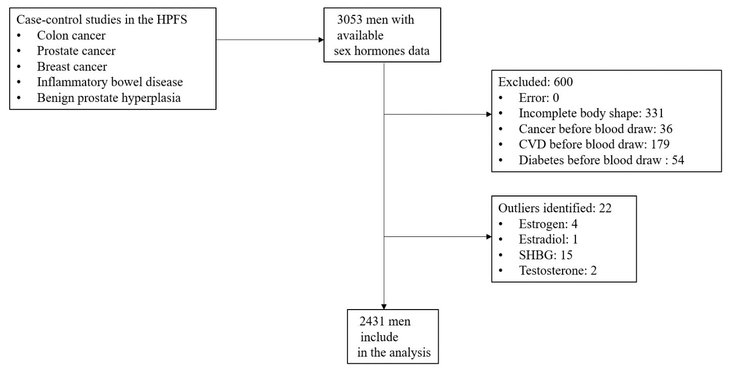
b)
