Supplemental Table 1 Relationship between kidney function at baseline and subsequent Hcy in participants without CVD or diabetes.
 | Model 1 |  | Model 2 |  | Model 3
 | β (95% CI) | P-value | β (95% CI) | P-value | β (95% CI) | P-value
Kidney function at baseline
eGFR, mL/min/1.73m² | -0.19 (-0.23, -0.15) | < 0.001 | -0.15 (-0.19, -0.10) | < 0.001 | -0.13 (-0.17, -0.08) | < 0.001
Time, year | 2.28 (1.40, 3.16) | < 0.001 | 2.79 (1.40, 3.16) | < 0.001 | 1.90 (0.91, 2.90) | < 0.001
eGFR × Time | -0.02 (-0.02, -0.01) | 0.002 | -0.02 (-0.02, -0.01) | 0.002 | -0.01 (-0.02, 0.00) | 0.043
Kidney function Quartiles
eGFR Q3 (> 91.79, ≤ 97.64) ^{Ŧ}
Q3 | 0.13 (-1.06, 1.32) | 0.833 | -0.15 (-1.31, 1.01) | 0.801 | -0.22 (-1.39, 0.96) | 0.721
Time | 0.75 (0.56, 0.94) | < 0.001 | 0.75 (0.56, 0.94) | < 0.001 | 0.76 (0.58, 0.96) | < 0.001
Q3 × Time | 0.10 (-0.17, 0.38) | 0.481 | 0.10 (-0.18, 0.37) | 0.481 | 0.09 (-0.20, 0.37) | 0.545
eGFR Q2 (> 86.25, ≤ 91.79) ^{Ŧ}
Q2 | 2.00 (0.61, 3.39) | 0.005 | 1.38 (-0.05, 2.81) | 0.063 | 1.29 (-0.17, 2.75) | 0.090
Time | 0.75 (0.57, 0.94) | < 0.001 | 0.75 (0.57, 0.94) | < 0.001 | 0.76 (0.57, 0.96) | < 0.001
Q2 × Time | 0.12 (-0.15, 0.38) | 0.392 | 0.11 (-0.15, 0.38) | 0.392 | 0.11 (-0.17, 0.38) | 0.442
eGFR Q1 (≤ 86.25) ^{Ŧ}
Q1 (≤ 86.25) | 4.31 (2.87, 5.74) | < 0.001 | 2.93 (1.34, 4.51) | < 0.001 | 2.75 (1.13, 4.38) | 0.001
Time | 0.75 (0.53, 0.97) | < 0.001 | 0.75 (0.53, 0.97) | < 0.001 | 0.76 (0.53, 0.99) | < 0.001
Q1 × Time | 0.31 (-0.01, 0.63) | 0.056 | 0.31 (-0.01, 0.63) | 0.056 | 0.30 (-0.03, 0.64) | 0.074
eGFR: estimated glomerular filtration rate,, Hcy: homocysteine, Model 1: Unadjusted; Model 2: Adjusted for age, sex, smoking, alcohol consumption, education, marital status, cardiovascular disease, diabetes, hypertension, chronic lung disease, cognitive function and sleep quality; Model 3: Adjusted for model 2 + Vitamin B₁₂, and body mass index. ^{Ŧ} compared with Kidney function Q4 (> 97.64 mL/min/1.73m²).

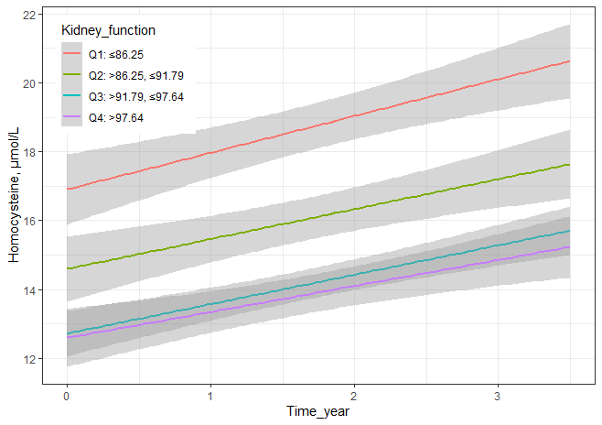
Supplemental Figure 1 Longitudinal association of eGFR with subsequent plasma homocysteine in participants without CVD or diabetes.

