Supplemental Figure 1
l
Maternal feeding practices across perceived weight status categories at 4 and 7 years of age.
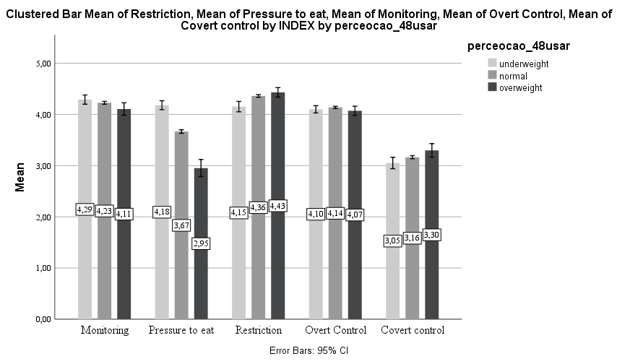
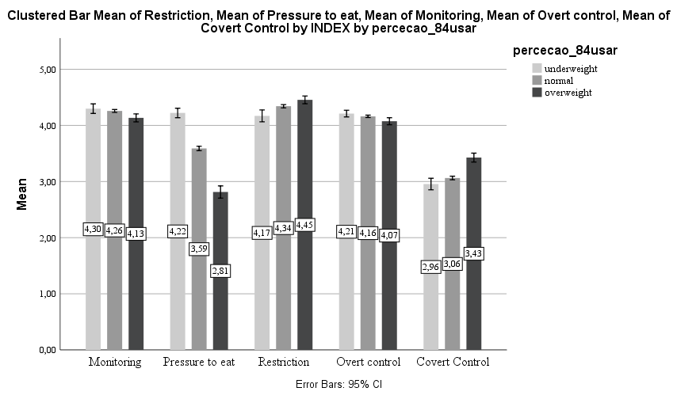
4 years of age
7 years of age
*
*
*
*
*
a
a
b
c
b
a
a
b
a
a
*
a
b
b
a
*
b
b
b
a
a
c
b
a, b
c
a

Values are means with their standard errors represented by vertical bars. The comparison of mean scores of feeding practices across perceived weight categories was performed using the ANOVA (analysis of variance). F (2,3230). * P> 0.05 for overall differences. Values with different letters are significantly different from each other (Bonferroni).

Supplemental Figure 2
l
Maternal feeding practices across concern about weight categories at 4 and 7 years of age.
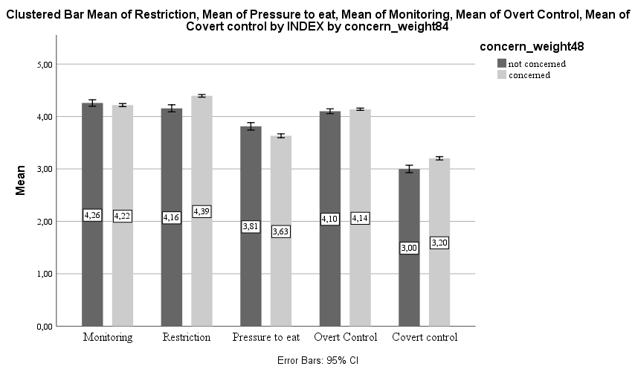
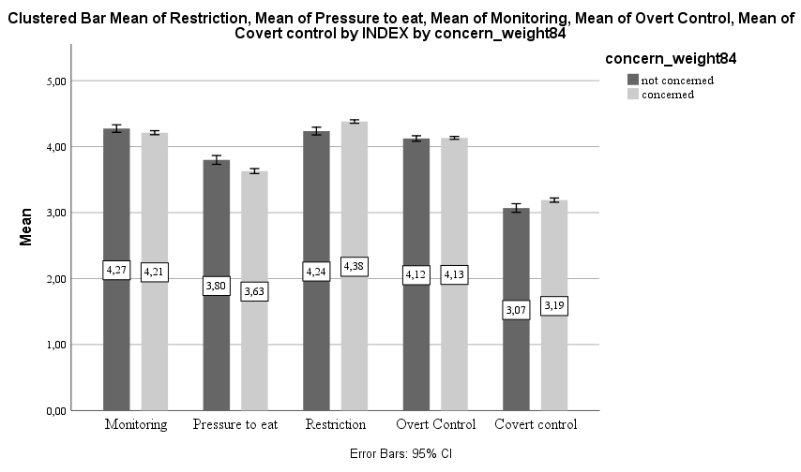
*
*
*
*

*
*

Values are means with their standard errors represented by vertical bars. The comparison of mean scores of feeding practices between not concerned and concerned was performed using a t-test. F (2,3231). * P> 0.05 for overall differences.

Supplemental Figure 3
l

Maternal feeding practices mean scores across dissatisfaction with child weight categories at 4 and 7 years of age.
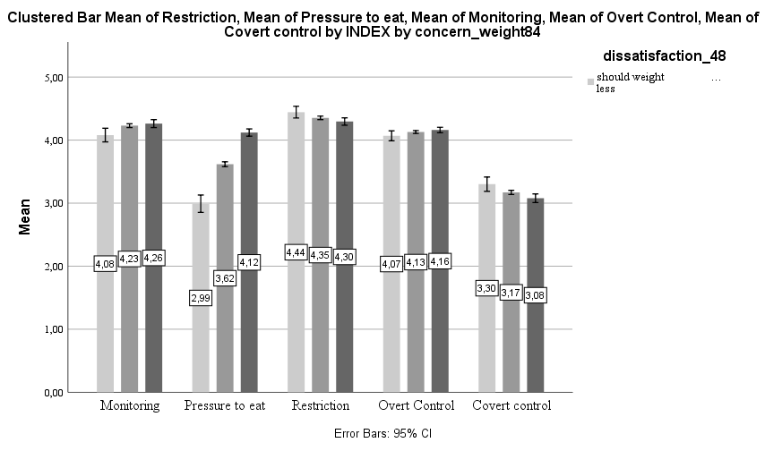
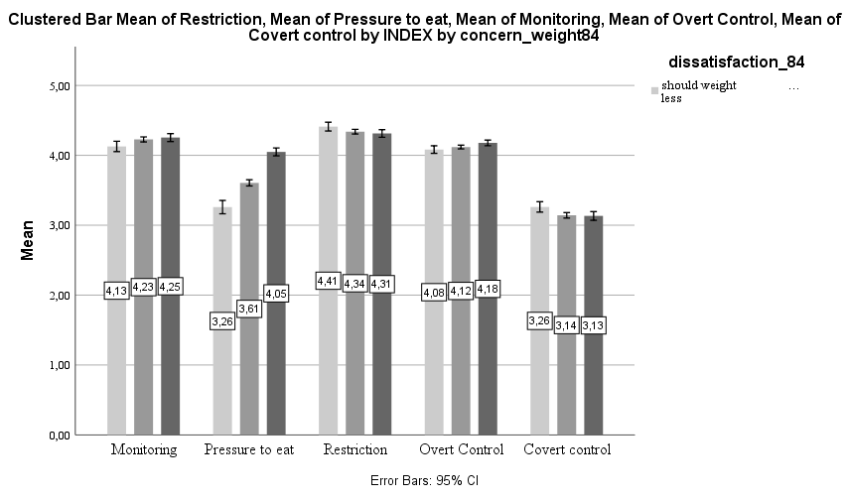
should weigh more
about right
should weigh less
*
a
b
*
b
*
*
*
*
a,b
bv
a
b
b
c
a
*
c
b
a ,b
a
*
b
*
b
b
b
a
a
b
a,b
a
a

Values are means, with their standard errors represented by vertical bars. The comparison of mean scores of feeding practices across dissatisfactions with weight gain was performed using the ANOVA (analysis of variance). F (2,3230). * P> 0.05 for overall differences. Values with different letters are significantly different from each other (Bonferroni).

