Appendix
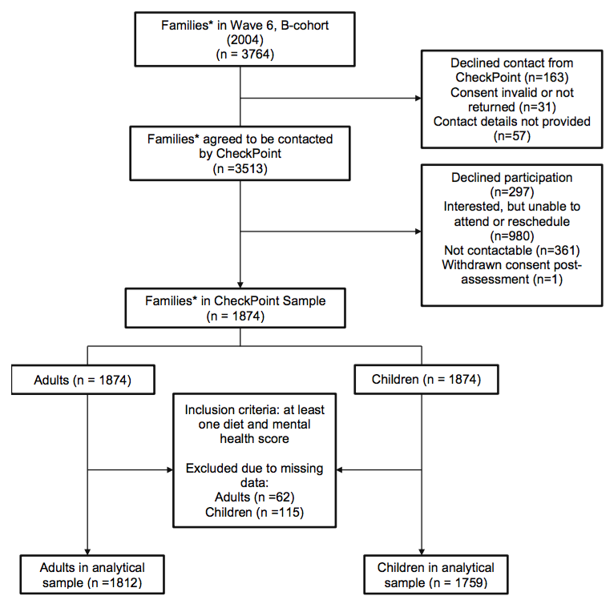

Appendix Figure 1: Participant flowchart
*Families refer to one child-adult (parent) dyad

Appendix Table 1. NaSSDA food items and generation of both literature-derived and data-derived scoring systems (Exposures)
Category  (Frequency) | Question | Response Options (Coded) | Literature-derived score frequency |  |  |  | Adult GlycA-derived scores for each category
 |  |  | Assigned frequency | Child  Mean (SD) | Adults  Mean (SD) |  | Final Model 2 coefficient for regression of NaSSDA item against GlycA (all p-values ≤.20)
Fish  (Weekly) | How often do you eat fish, including canned fish? | Never (0); Less than once a week (0.5); About 1-2 times a week (1.5)  About 3-4 times a week (3.5); About 5-6 times a week (5.5); Everyday (7) | 0: 0 or 0.5 times  -1: 1.5 or 3.5 times  -2: 5.5 or 7 times | -0.4 (0.5) | -0.6 (0.5) |  | -0.0131
Vegetables  (Daily) | How many serves of vegetables do you usually eat each day? | I don’t eat vegetables (0); Less than once serve a day (0.5); 1 serve (1)  2 serves (2); 3 serves (3)  4 serves (4); 5 serves (5)  6 serves or more (6) | 0: 0, 0.5 or 1 serves  -1: 2 or 3 serves  -2: 4, 5 or 6 or more serves | -0.9 (0.7) | -1.1 (0.6) |  | -0.0133
Fruit  (Daily) | How many serves of fruit do you usually eat each day? | I don’t eat fruit (0); Less than once serve a day (0.5); 1 serve (1)  2 serves (2); 3 serves (3)  4 serves (4); 5 serves (5)  6 serves or more (6) | 0: 0, 0.5 or 1 serves  -1: 2 or 3 serves  -2: 4, 5 or 6 or more serves | -1.0 (0.7) | -0.5 (0.6) |  | n/a^{b}
Chicken  (Weekly) | How often do you eat chicken? | Never (0); Less than once a week (0.5); About 1-2 times a week (1.5)  About 3-4 times a week (3.5); About 5-6 times a week (5.5); Everyday (7) | 0: 0 to 4 times  +1: 5 or more times | 0.0 (0.2) | 0.0 (0.2) |  | 0.0045
Red meat  (Weekly) | How often do you eat red meat? | Never (0); Less than once a week (0.5); About 1-2 times a week (1.5)  About 3-4 times a week (3.5); About 5-6 times a week (5.5); Everyday (7) | 0: 0 or 0.5 times  +1: 1.5 or 3.5 times  +2: 5.5 or 7 times | 0.9 (0.5) | 1.0 (0.4) |  | 0.0045
Meat products  (Weekly) | How often do you eat meat products? | Never (0); Less than once a week (0.5); About 1-2 times a week (1.5)  About 3-4 times a week (3.5); About 5-6 times a week (5.5)  Everyday (7) | 0: 0 or 0.5 times  +1: 1.5 times  +2: 3.5, 5.5 or 7 times | 1.3 (0.7) | 0.7 (0.7) |  | n/a^{b}
Bread  (Daily) | How many slices of bread do you usually eat each day? | I don’t eat bread (0); Less than one slice a day (0.5); 1 slice (1)  2 slices (2); 3 slices (3)  4 slices (4); 5-7 slices (6)  8 slices or more (8) | 0: 0, 0.5, 1 or 2 slices day  +1: 3 or 4 slices day  +2: 6 or 8 or more slices day | 0.4 (0.6) | 0.1 (0.4) |  | 0.0016
Milk  (Daily) | How much milk in total do you usually drink each day? | I don’t drink milk (0); Less than one cup a day (0.5); About 1 cup a day (1); About 2 cups a day (2)  About 3 cups a day (3); About 4 cups a day (4); About 5 cups or more a day (5) | 0: 0, 0.5, 1 or 2 cups day  +1: 3 or 4 cups day  +2: 5 or more cups day | 0.2 (0.5) | 0.1 (0.2) |  | n/a^{b}
Cheese  (Weekly) | How often do you eat cheese? | Never (0); Less than once a week (0.5); About 1-2 times a week (1.5);  About 3-4 times a week (3.5); About 5-6 times a week (5.5); Everyday (7) | 0: 0, 0.5, 1.5, 3.5 or 5.5 times  +1: 7 times | 0.1 (0.3) | 0.1 (0.3) |  | -0.0049
Milk products  (Weekly) | How often do you eat milk products such as yoghurt, chocolate milk, pudding etc.? | Never (0); Less than once a week (0.5); About 1-2 times a week (1.5);  About 3-4 times a week (3.5); About 5-6 times a week (5.5); Everyday (7) | 0: 0, 0.5, 1.5, 3.5 or 5.5 times  +1: 7 times | 0.1 (0.3) | 0.1 (0.3) |  | -0.0037
Fruit juice  (Weekly) | How much fruit juice do you usually drink? | I don’t drink fruit juice (0); Less than one cup a week (0.5); About 1-3 cups a week (2); About 4-6 cups a week (5); About 1-2 cups a day (10.5); About 3-4 cups a day (24.5);  5 cups or more a day (35) | 0: 0, 0.5, 2 cups  +1: 5 cups  +2: 10.5, 24.5 or 35 or more cups | 0.2 (0.6) | 0.1 (0.4) |  | 0.0059
Water  (Daily) | How much water do you usually drink each day? | I don’t drink water (0); Less than once cup a day (0.5); About 1 cup a day (1); About 2 cups a day (2);  About 3 cups a day (3); About 4 cups a day (4); About 5 cups or more a day (5) | 0: regardless of consumption | 0.0 (0.0) | 0.0 (0.0) |  | 0.0040
Sugar drinks  (Weekly) | How much soft drinks, cordials or sports drinks do you usually drink? | I don’t drink these drinks (0); Less than one cup a week (0.5); About 1-3 cups a week (2); About 4-6 cups a week (5); About 1-2 cups a day (10.5); About 3-4 cups a day (24.5);  5 cups or more a day (35) | 0: 0 or 0.5 cups  +1: 2 or 5 cups  +2: 10.5, 24.5 or 35 or more cups | 0.4 (0.6) | 0.2 (0.5) |  | 0.0020
Energy drinks  (Weekly) | How much energy drinks do you usually drink? | I don’t drink these drinks (0); Less than one cup a week (0.5); About 1-3 cups a week (2); About 4-6 cups a week (5); About 1-2 cups a day (10.5); About 3-4 cups a day (24.5); 5 cups or more a day (35) | 0: 0 or 0.5 cups  +1: 2 or 5 cups  +2: 10.5, 24.5 or 35 or more cups | 0.0 (0.2) | 0.0 (0.2) |  | n/a^{b}
Pastas  (Weekly) | How often do you eat pasta, rice or noodles? | Never (0); Less than once a week (0.5); About 1-3 times a week (2); About 4-6 times a week (5); About once a day (7); 2 or more times a day (14) | 0: 0, 0.5, 2, 5 or 7 times  +1: 14 or more times | 0.0 (0.1) | 0.0 (0.1) |  | n/aª
Ice confection  (Weekly) | How often do you have ice cream, icy poles or ice blocks? | Never (0); Less than once a week (0.5); About 1-2 times a week (1.5); About 3-4 times a week (3.5); About 5-6 times a week (5.5); About once a day (7) | 0: 0, 0.5 or 1.5 times  +1: 3.5 or 5.5 times  +2: 7 times | 0.3 (0.5) | 0.1 (0.3) |  | n/a^{b}
Fried potato  (Weekly) | How often do you eat hot chips, French fries, wedges or fried potatoes? | Never (0); Less than once a week (0.5); About 1-2 times a week (1.5); About 3-4 times a week (3.5); About 5-6 times a week (5.5); About once a day (7) | 0: 0, 0.5 or 1.5 times  +1: 3.5 times  +2: 5.5 or 7 times | 0.1 (0.3) | 0.0 (0.2) |  | 0.0140
Chips/crisps  (Weekly) | How often do you eat potato crisps/chips or other salty snacks? | Never (0); Less than once a week (0.5); About 1-2 times a week (1.5); About 3-4 times a week (3.5); About 5-6 times a week (5.5);  About once a day (7) | 0: 0, 0.5 or 1.5 times  +1: 3.5 times  +2: 5.5 or 7 times | 0.3 (0.6) | 0.1 (0.3) |  | n/a^{b}
Takeaway  (Weekly) | How often do you have meals or snacks such as burgers, pizza, chicken or chips? | Never (0); Less than once a week (0.5); About 1-2 times a week (1.5); About 3-4 times a week (3.5); About 5-6 times a week (5.5); About once a day (7) | 0: 0 or 0.5 times  +1: 1.5 times  +2: 3.5, 5.5 or 7 times | 0.4 (0.6) | 0.2 (0.4) |  | 0.0396
Confectionery  (Weekly) | How often do you eat confectionery? | Never (0); Less than once a week (0.5); About 1-2 times a week (1.5); About 3-4 times a week (3.5); About 5-6 times a week (5.5); About once a day (7) | 0: 0, 0.5, 1.5, 3.5 or 5.5 times  +1: 7 times | 0.0 (0.1) | 0.0 (0.2) |  | -0.0056
Sweet foods  (Weekly) | How often do you eat sweet foods, such as sweet biscuits, cakes or muffins? | Never (0); Less than once a week (0.5); About 1-2 times a week (1.5); About 3-4 times a week (3.5); About 5-6 times a week (5.5); About once a day (7) | 0: 0, 0.5, 1.5 or 3.5 times  +1: 5.5 times  +2: 7 times | 0.1 (0.4) | 0.1 (0.4) |  | -0.0086
Notes: Table excludes three NaSSDA food items (breakfast, cereals, diet drinks) because the nutritional content of cereal items are highly variable and because the inflammatory potential of diet drinks or skipping breakfast is unclear.
For the literature-derived score, the assigned frequency is bolded.
Multivariable Model 1: Included 20 NaSSDA items in which the p-value <.20 in Univariable Models regressing NaSSDA item against GlycA (see Methods).
Multivariable Model 2: Final model included the 14 of the 20 items from Multivariable Model 1 in which p-value <.20. Regression coefficients from this final model were used to calculate the GlycA NaSSDA score (see Methods).
ª Excluded from Multivariable Model 1 because p-value >.20 in Univariable Model regressing NaSSDA item on GlycA (see Methods).
^{b} Excluded from Multivariable Model 2 because p-value >.20 in Multivariable Model 1 regressing NaSSDA item on GlycA (see Methods).

