Supplementary Data
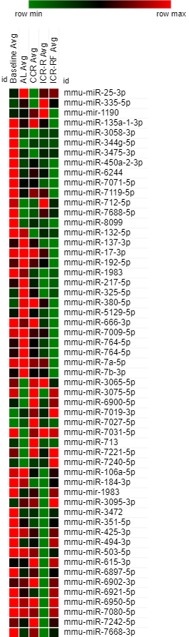
Supplementary Figure 1. K means hierarchical cluster of DE miRNAs with average expression (log2) of each group. K means clustering performed with five main divisions. High, middle and low expressions marked with red, black and green respectively.
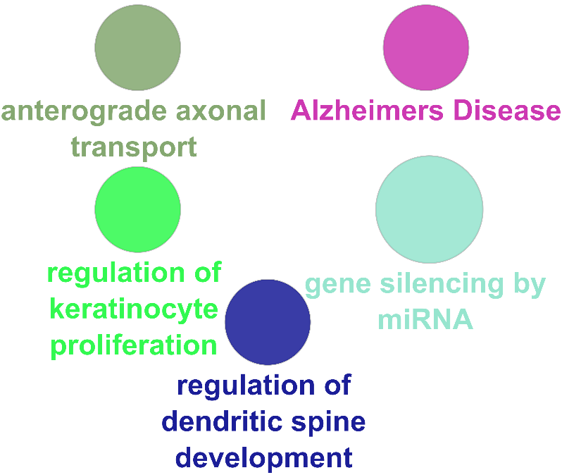
Supplementary Figure 2. Visualized ClueGO functional enrichment analysis of common predicted targets of CCR and ICR-R group compared to AL.
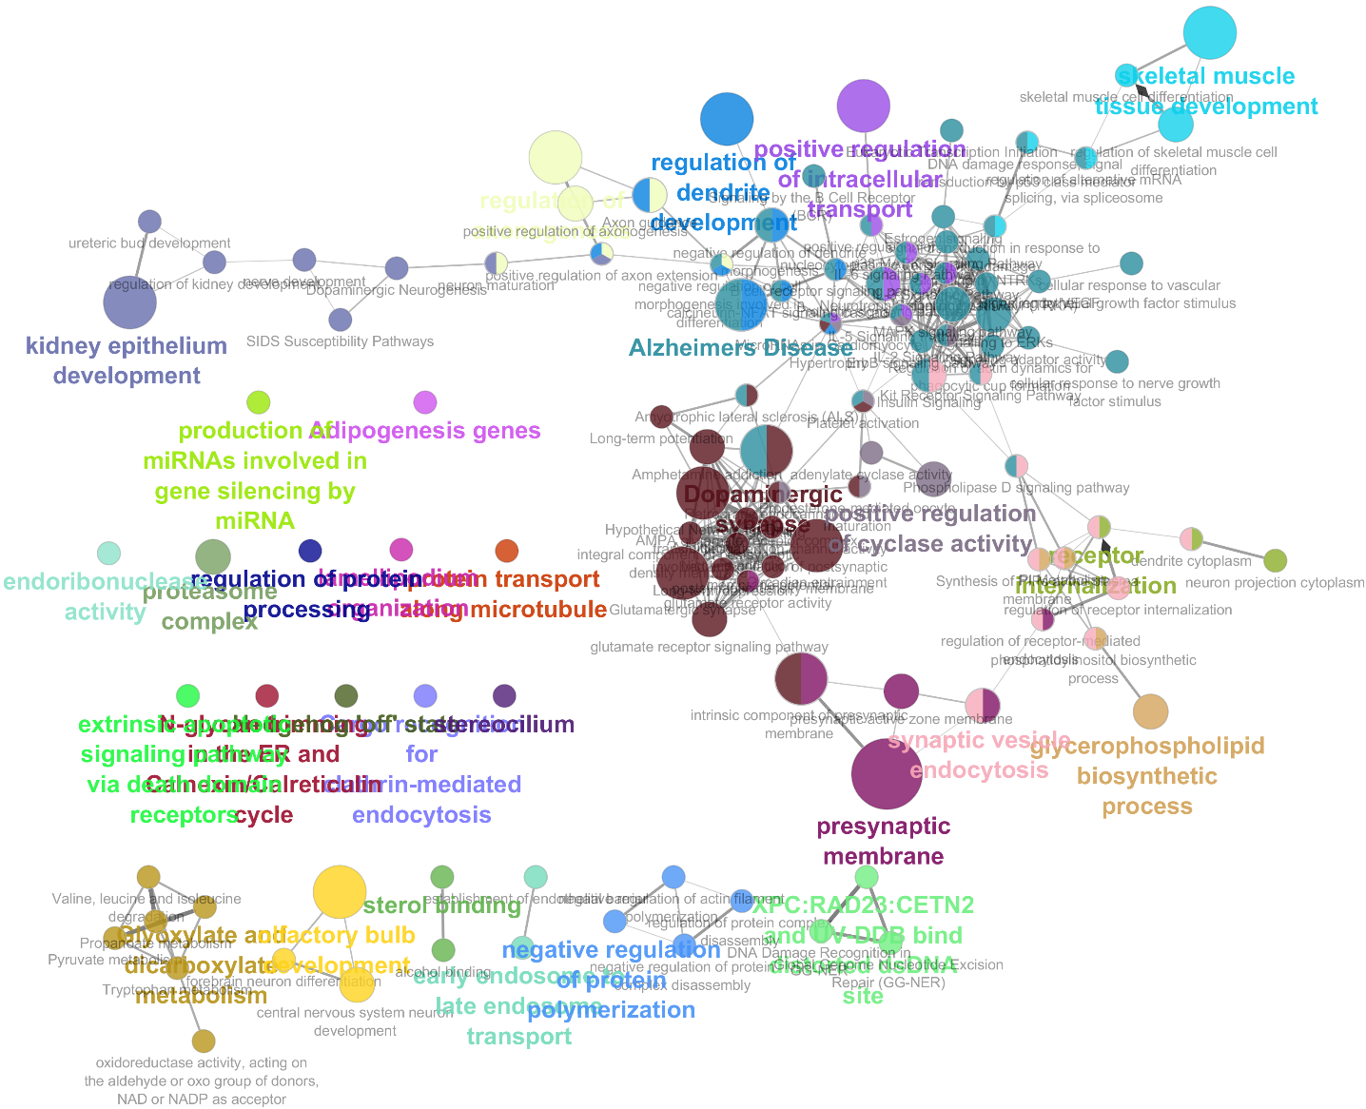
Supplementary Figure 3. Visualized ClueGO functional enrichment analysis of common predicted targets of AL, ICR-R and ICR-RF group compared to CCR.
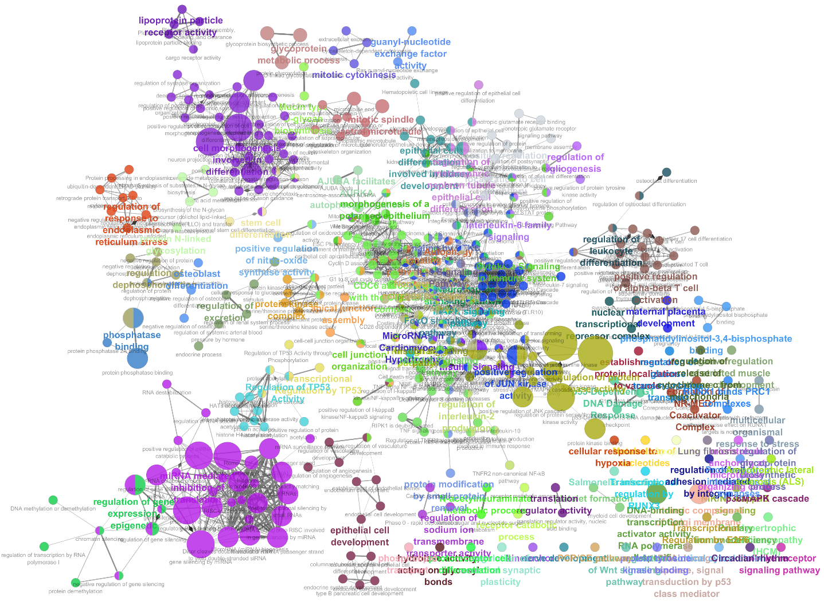
Supplementary Figure 4. Visualized ClueGO functional enrichment analysis of common predictive targets of CCR and ICR-R group compared to baseline.
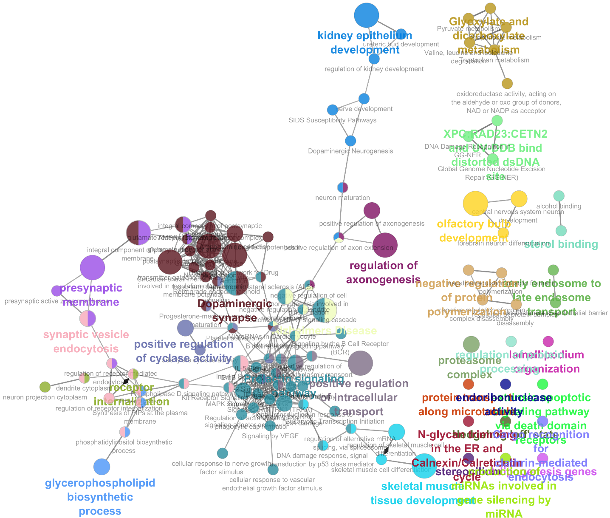

Supplementary Figure 5. Visualized ClueGO functional enrichment analysis of predicted targets for mmu-miR-713.

Supplementary Table 1. Numbers of validated and predicted targets of miRNAs changed with the application of different types of calorie restrictions (A) or by ageing (B) in brain tissue. “Com.” is the common genes in upregulated and downregulated predicted targets. Numbers of GO and KEGG pathway effected by predictive targets of DE miRNAs (C) were given in both different types of calorie restrictions and ageing.
A
Week 81/82 | Compared to | CCR |  |  | ICR-R |  |  | ICR-RF
 |  | Up | Down | Common | Up | Down | Common | Up | Down | Common
 | AL | 25 | 31 | - | 36 | 189 | 14 | 104 | - | - | Validated
 |  | 324 | 757 | 45 | 211 | 994 | 32 | 1210 | 625 | 97 | Predicted
 | CCR | - | - | - | 62 | 15 | - | 31 | - | - | Validated
 |  | - | - | - | 930 | 84 | 4 | 289 | - | - | Predicted
 | ICR-R | - | - | - | - | - | - | 17 | - | - | Validated
 |  | - | - | - | - | - | - | 133 | 130 | 6 | Predicted

B
Compared to | AL |  |  | CCR |  |  | ICR-R |  |  | ICR-RF
 | Up | Dwn | Com | Up | Dwn | Com | Up | Dwn | Com | Up | Dwn | Com
Baseline  (Week 10) | 2 | - | - | 53 | - | - | 148 | - | - | 31 | - | - | Validated
 | 426 | - | - | 864 | 698 | 67 | 1521 | - | - | 740 | 149 | 16 | Predicted

C
 | Compared to | AL | CCR | ICR-R | ICR-RF
Week 81/82 | AL | - | 271 | 420 | 568 | GO
 |  | - | 5 | 6 | 16 | KEGG
 | CCR | - | - | 227 | 15 | GO
 |  | - | - | 2 | 2 | KEGG
 | ICR-R | - | - | - | 10 | GO
 |  | - | - | - | - | KEGG
Week 10 | Baseline | 20 | 296 | 552 | 218 | GO
 |  | - | - | 19 | - | KEGG

Supplementary Table 2. Gene Ontology of predicted targets of DE miRNAs among CR groups. GO terms were given with their GO ids, sources, levels, percentage of associated genes and number of predicted genes that found in GO term. However, DE miRNAs in CCR group compared to AL group was given at table 2.
ICR-R vs AL
GOID | GO Term | GO Source | Bonferroni P Val. | GO Levels | % Assoc. Genes | Nr. Genes
GO:0007399 | Nervous system development | GO_BP | 7.61E-17 | [4, 5] | 9.37 | 251.00
GO:0022008 | Neurogenesis | GO_BP | 1.17E-10 | [4, 5, 6] | 9.25 | 184.00
GO:0048699 | Generation of neurons | GO_BP | 1.28E-10 | [5, 6, 7] | 9.42 | 174.00
GO:0050767 | Regulation of neurogenesis | GO_BP | 1.94E-10 | [5, 6, 7, 8] | 10.90 | 117.00
GO:0097458 | Neuron part | GO_CC | 2.20E-10 | [2, 3] | 8.94 | 199.00
GO:0030182 | Neuron differentiation | GO_BP | 1.77E-08 | [4, 6, 7, 8] | 9.25 | 154.00
GO:0007417 | Central nervous system development | GO_BP | 2.43E-08 | [4, 5, 6] | 10.18 | 117.00
GO:0048667 | Cell morphogenesis involved in neuron differentiation | GO_BP | 2.83E-08 | [5, 6, 7, 8, 9, 10] | 11.88 | 81.00
GO:0098793 | Presynapse | GO_CC | 8.44E-08 | [2, 3, 4] | 11.84 | 78.00
GO:0050808 | Synapse organization | GO_BP | 1.52E-07 | [3] | 12.62 | 66.00
ICR-RF vs AL
GOID | GO Term | GO Source | Bonferroni P Val. | GO Levels | % Assoc. Genes | Nr. Genes
GO:0007399 | Nervous system development | GO_BP | 6.54E-24 | [4, 5] | 13.59 | 364.00
GO:0097458 | Neuron part | GO_CC | 1.29E-20 | [2, 3] | 13.83 | 308.00
GO:0048699 | Generation of neurons | GO_BP | 5.43E-20 | [5, 6, 7] | 14.46 | 267.00
GO:0022008 | Neurogenesis | GO_BP | 7.66E-20 | [4, 5, 6] | 14.13 | 281.00
GO:0048666 | Neuron development | GO_BP | 2.74E-17 | [4, 5, 7, 8, 9] | 15.19 | 207.00
GO:0043005 | Neuron projection | GO_CC | 4.22E-17 | [3, 4, 5] | 14.21 | 245.00
GO:0030182 | Neuron differentiation | GO_BP | 3.58E-16 | [4, 6, 7, 8] | 14.18 | 236.00
GO:0097060 | Synaptic membrane | GO_CC | 4.47E-14 | [2, 3, 4, 5, 6, 7] | 18.87 | 107.00
GO:0051960 | Regulation of nervous system development | GO_BP | 6.85E-14 | [4, 5, 6] | 14.98 | 179.00
GO:0031175 | Neuron projection development | GO_BP | 1.69E-13 | [5, 6, 8, 9, 10] | 14.83 | 179.00
ICR-R vs CCR
GO ID | GO Term | GO Source | Bonferroni P Val. | GO Levels | % Assoc. Genes | Nr. Genes
GO:0007399 | Nervous system development | GO_BP | 8.17E-06 | [4, 5] | 6.91 | 185.00
GO:0036477 | Somatodendritic compartment | GO_CC | 1.25E-05 | [3, 4] | 8.25 | 100.00
GO:0007417 | Central nervous system development | GO_BP | 1.09E-04 | [4, 5, 6] | 8.09 | 93.00
GO:0097458 | Neuron part | GO_CC | 2.35E-04 | [2, 3] | 6.92 | 154.00
GO:0097060 | Synaptic membrane | GO_CC | 3.38E-04 | [2, 3, 4, 5, 6, 7] | 9.70 | 55.00
GO:0045664 | Regulation of neuron differentiation | GO_BP | 5.85E-04 | [5, 6, 7, 8, 9] | 8.46 | 74.00
GO:0030425 | Dendrite | GO_CC | 6.65E-04 | [4, 5, 6, 7] | 8.60 | 71.00
GO:0050767 | Regulation of neurogenesis | GO_BP | 6.83E-04 | [5, 6, 7, 8] | 8.01 | 86.00
GO:0043025 | Neuronal cell body | GO_CC | 7.37E-04 | [3, 4, 5] | 8.53 | 71.00
GO:0050770 | Regulation of axonogenesis | GO_BP | 7.63E-04 | [6, 7, 8, 9, 10, 11, 12, 13] | 12.95 | 29.00
ICR-RF vs CCR
GO ID | GO Term | GO Source | Bonferroni P Val. | GO Levels | % Assoc. Genes | Nr. Genes
GO:0042734 | presynaptic membrane | GO_CC | 7.78E-03 | [3, 4, 5, 6, 7, 8] | 5.15 | 12.00
GO:0021954 | Central nervous system neuron development | GO_BP | 1.55E-02 | [5, 6, 7, 8, 9, 10] | 7.02 | 8.00
GO:0098889 | Intrinsic component of presynaptic membrane | GO_CC | 1.67E-02 | [3, 4, 5, 6, 7, 8, 9] | 6.12 | 9.00
GO:0021537 | Telencephalon development | GO_BP | 2.44E-02 | [3, 4, 6, 7, 8, 9] | 4.05 | 14.00
GO:0050954 | Sensory perception of mechanical stimulus | GO_BP | 2.69E-02 | [5] | 5.21 | 10.00
GO:0099240 | Intrinsic component of synaptic membrane | GO_CC | 3.05E-02 | [2, 3, 4, 5, 6, 7, 8] | 4.41 | 12.00
GO:0043195 | Terminal bouton | GO_CC | 3.07E-02 | [3, 4, 5, 6, 7, 8, 9, 10] | 7.29 | 7.00
GO:0048787 | Presynaptic active zone membrane | GO_CC | 3.96E-02 | [3, 4, 5, 6, 7, 8, 9] | 10.64 | 5.00
GO:0021953 | Central nervous system neuron differentiation | GO_BP | 3.96E-02 | [5, 6, 7, 8, 9] | 4.56 | 11.00
ICR-RF vs ICR-R
GO ID | GO Term | GO Source | Bonferroni P Val. | GO Levels | % Assoc. Genes | Nr. Genes
GO:0032591 | Dendritic spine membrane | GO_CC | 3.28E-02 | [3, 4, 5, 6, 7, 8, 9, 10] | 18.75 | 3.00

Supplementary Table 3. Gene Ontology of predicted targets of DE miRNAs with ageing. GO terms were given with their GO ids, sources, levels, percentage of associated genes and number of predicted genes that found in GO term.
AL vs Baseline
GO ID | GO Term | GO Source | Bonferroni P Val. | GO Levels | % Assoc. Genes | Nr. Genes
GO:0048666 | Neuron development | GO_BP | 9.54E-06 | [4, 5, 7, 8, 9] | 4.18 | 57.00
GO:0050770 | Regulation of axonogenesis | GO_BP | 1.06E-04 | [6, 7, 8, 9, 10, 11, 12, 13] | 8.04 | 18.00
GO:0031175 | Neuron projection development | GO_BP | 1.07E-04 | [5, 6, 8, 9, 10] | 4.14 | 50.00
GO:0061564 | Axon development | GO_BP | 1.50E-04 | [6, 7, 9, 10, 11] | 5.35 | 30.00
GO:0007409 | Axonogenesis | GO_BP | 6.47E-04 | [6, 7, 8, 9, 10, 11, 12] | 5.30 | 27.00
GO:0048667 | Cell morphogenesis involved in neuron differentiation | GO_BP | 1.39E-03 | [5, 6, 7, 8, 9, 10] | 4.69 | 32.00
GO:0045664 | Regulation of neuron differentiation | GO_BP | 2.08E-03 | [5, 6, 7, 8, 9] | 4.23 | 37.00
GO:0010975 | Regulation of neuron projection development | GO_BP | 3.20E-03 | [6, 7, 8, 9, 10, 11] | 4.53 | 31.00
GO:0050772 | Positive regulation of axonogenesis | GO_BP | 2.01E-02 | [5, 6, 7, 8, 9, 10, 11, 12, 13, 14] | 8.70 | 10.00
CCR vs Baseline
GO ID | GO Term | GO Source | Bonferroni P Val. | GO Levels | % Assoc. Genes | Nr. Genes
GO:0007399 | Nervous system development | GO_BP | 4.22E-09 | [4, 5] | 10.19 | 273.00
GO:0097458 | Neuron part | GO_CC | 1.33E-08 | [2, 3] | 10.51 | 234.00
GO:0036477 | Somatodendritic compartment | GO_CC | 3.47E-06 | [3, 4] | 11.39 | 138.00
GO:0043005 | Neuron projection | GO_CC | 5.39E-06 | [3, 4, 5] | 10.50 | 181.00
GO:0022008 | Neurogenesis | GO_BP | 5.46E-06 | [4, 5, 6] | 10.21 | 203.00
GO:0030424 | Axon | GO_CC | 6.36E-06 | [4, 5, 6] | 12.30 | 106.00
GO:0048699 | Generation of neurons | GO_BP | 2.96E-05 | [5, 6, 7] | 10.18 | 188.00
GO:0007417 | Central nervous system development | GO_BP | 5.30E-05 | [4, 5, 6] | 11.14 | 128.00
GO:0014069 | Postsynaptic density | GO_CC | 1.03E-04 | [3, 4, 5] | 14.00 | 64.00
GO:0050767 | Regulation of neurogenesis | GO_BP | 2.22E-04 | [5, 6, 7, 8] | 11.09 | 119.00
ICR-R vs Baseline
GO ID | GO Term | GO Source | Bonferroni P Val. | GO Levels | % Assoc. Genes | Nr. Genes
GO:0022008 | Neurogenesis | GO_BP | 4.65E-20 | [4, 5, 6] | 12.82 | 255.00
GO:0007399 | Nervous system development | GO_BP | 5.47E-20 | [4, 5] | 11.84 | 317.00
GO:0048699 | Generation of neurons | GO_BP | 4.85E-19 | [5, 6, 7] | 12.94 | 239.00
GO:0030182 | Neuron differentiation | GO_BP | 2.48E-16 | [4, 6, 7, 8] | 12.86 | 214.00
GO:0048666 | Neuron development | GO_BP | 4.96E-15 | [4, 5, 7, 8, 9] | 13.35 | 182.00
GO:0050767 | Regulation of neurogenesis | GO_BP | 2.40E-14 | [5, 6, 7, 8] | 14.17 | 152.00
GO:0097458 | Neuron part | GO_CC | 6.26E-14 | [2, 3] | 11.54 | 257.00
GO:0031175 | Neuron projection development | GO_BP | 1.26E-13 | [5, 6, 8, 9, 10] | 13.50 | 163.00
GO:0048667 | Cell morphogenesis involved in neuron differentiation | GO_BP | 2.52E-13 | [5, 6, 7, 8, 9, 10] | 15.98 | 109.00
GO:0051960 | Regulation of nervous system development | GO_BP | 1.19E-12 | [4, 5, 6] | 13.31 | 159.00
ICR-RF vs Baseline
GO ID | GO Term | GO Source | Bonferroni P Val. | GO Levels | % Assoc. Genes | Nr. Genes
GO:0097458 | Neuron part | GO_CC | 4.52E-13 | [2, 3] | 7.50 | 167.00
GO:0043005 | Neuron projection | GO_CC | 1.38E-08 | [3, 4, 5] | 7.37 | 127.00
GO:0030424 | Axon | GO_CC | 1.07E-05 | [4, 5, 6] | 8.24 | 71.00
GO:0007399 | Nervous system development | GO_BP | 2.98E-05 | [4, 5] | 6.09 | 163.00
GO:0022008 | Neurogenesis | GO_BP | 4.25E-04 | [4, 5, 6] | 6.28 | 125.00
GO:0048699 | Generation of neurons | GO_BP | 6.33E-04 | [5, 6, 7] | 6.33 | 117.00
GO:0098793 | Presynapse | GO_CC | 7.86E-04 | [2, 3, 4] | 8.19 | 54.00
GO:0001505 | Regulation of neurotransmitter levels | GO_BP | 4.18E-03 | [3] | 9.13 | 38.00
GO:0043009 | Chordate embryonic development | GO_BP | 4.52E-03 | [5, 6] | 7.33 | 63.00
GO:0098888 | Extrinsic component of presynaptic membrane | GO_CC | 4.78E-03 | [3, 4, 5, 6, 7, 8, 9] | 50.00 | 6.00

Supplementary Table 4. KEGG pathway analysis of predicted targets of DE miRNAs among CR groups. KEGG pathways were given with their Term IDs, number of predicted genes that found in KEGG pathway, percentage of associated genes and genes. However, DE miRNAs in CCR group compared to AL group was given at Table 3.
ICR-R vs AL
Term ID | KEGG Pathway | Count | % | Bonferroni P Val. | Genes
mmu05205 | Proteoglycans in cancer | 30 | 2.56 | 9.04E-04 | TFAP4, ERBB4, WNT3A, PDCD4, TIMP3, KRAS, WNT3, PIK3CA, PIK3R3, CAMK2A, PIK3R1, TWIST1, PRKCA, PIK3CB, ROCK2, MET, ESR1, IGF1, FZD5, PPP1CB, FZD7, ITPR2, KDR, FZD6, PTPN11, CTSL, CCND1, VEGFA, HBEGF, WNT7A
mmu04550 | Signaling pathways regulating pluripotency of stem cells | 22 | 1.88 | 7.85E-03 | BMI1, PIK3CB, WNT3A, IGF1, REST, FZD5, MEIS1, ZIC3, FZD7, ACVR1C, FZD6, WNT3, KRAS, RIF1, PIK3CA, AXIN2, PIK3R3, ZFHX3, WNT7A, PIK3R1, KAT6A, BMPR1A
mmu04360 | Axon guidance | 21 | 1.79 | 9.20E-03 | ABLIM1, PLXNA2, ROCK2, MET, PPP3R1, NTNG1, SLIT1, EPHA2, EPHA4, EPHA7, KRAS, PAK2, ROBO1, SEMA7A, SEMA3E, SEMA4C, SEMA3D, PPP3CA, SEMA3A, SEMA4D, RASA1
mmu04960 | Aldosterone-regulated sodium reabsorption | 11 | 0.94 | 1.49E-02 | PRKCA, ATP1B1, KRAS, ATP1B3, PIK3CB, NR3C2, IGF1, PIK3CA, PIK3R3, INSR, PIK3R1
mmu04310 | Wnt signaling pathway | 21 | 1.79 | 3.28E-02 | CER1, PRKCA, AF366264, NKD1, ROCK2, WNT3A, BTRC, PPP3R1, FZD5, FZD7, FZD6, CCND1, WNT3, CCND2, PPP3CA, AXIN2, PLCB1, FOSL1, CAMK2A, WNT7A, FBXW11
mmu04015 | Rap1 signaling pathway | 27 | 2.3 | 4.70E-02 | PRKCA, FGF5, FGF7, TLN2, PIK3CB, CSF1, MET, IGF1, FGF13, KIT, RALGDS, EPHA2, DOCK4, KDR, KRAS, GNAQ, CNR1, P2RY1, VEGFA, PIK3CA, RAP1B, PLCB1, RAPGEF2, PIK3R3, CRK, INSR, PIK3R1
ICR-RF vs AL
Term ID | KEGG Pathway | Count | % | Bonferroni P Val. | Genes
mmu04012 | ErbB signaling pathway | 24 | 1.38 | 5.98E-05 | PRKCA, NRG3, ERBB4, BRAF, PIK3CD, ELK1, RAF1, PRKCG, RPS6KB1, SRC, PAK6, CBLB, CDKN1B, EREG, NCK1, GSK3B, CAMK2B, SHC1, PIK3R5, PIK3R3, CRK, ABL2, PIK3R1, AKT2
mmu04015 | Rap1 signaling pathway | 41 | 2.36 | 9.14E-05 | FGF7, ADCY2, TLN2, EFNA3, FGF16, FGF11, LPAR4, CTNND1, KIT, SRC, PFN2, TEK, RAPGEF6, PIK3R5, THBS1, RAPGEF2, PLCB1, PIK3R3, INSR, PIK3R1, AKT2, PRKCA, MAGI2, BRAF, GRIN1, PIK3CD, SIPA1L2, RAF1, IGF1, PRKCG, KITL, PRKD1, VEGFC, MAPK14, EFNA5, RAP1B, PARD6G, CRK, PRKD3, CALM1, LCP2
mmu04150 | mTOR signaling pathway | 19 | 1.09 | 1.24E-04 | PRKCA, BRAF, PIK3CD, IGF1, PRKCG, RPS6KB1, RICTOR, RRAGD, DDIT4, EIF4B, PDPK1, TSC1, ULK2, PRKAA1, PIK3R5, MLST8, PIK3R3, PIK3R1, AKT2
mmu04151 | PI3K-Akt signaling pathway | 56 | 3.22 | 2.63E-04 | FGF7, PPP2R5A, EFNA3, PPP2R5C, FGF16, FGF11, LPAR4, RPS6KB1, CHAD, PDPK1, CREB3L2, MLST8, INSR, AKT2, SYK, PPP2R1B, PRKCA, SGK1, PIK3CD, PKN2, DDIT4, VEGFC, G6PC, CCND3, GNB1, CHRM1, EFNA5, PHLPP2, MCL1, COL3A1, GNG11, COL2A1, KIT, PPP2CA, TEK, PIK3R5, PRKAA1, PIK3R3, THBS1, PPP2R2D, PIK3R1, COL4A4, TNXB, RAF1, IGF1, ITGA4, KITL, EIF4B, ITGA9, HSP90B1, CDKN1B, TSC1, ITGA5, GSK3B, IKBKG, YWHAQ
mmu04910 | Insulin signaling pathway | 30 | 1.73 | 4.55E-04 | HK2, MKNK1, RHOQ, PDE3B, ELK1, RPS6KB1, PRKAR2B, PDPK1, HK3, PRKAA1, SHC1, PIK3R5, PIK3R3, INSR, PIK3R1, AKT2, IRS4, BRAF, PIK3CD, PRKAB1, RAF1, SOCS4, PPARGC1A, PPP1CB, CBLB, G6PC, TSC1, GSK3B, CRK, CALM1
mmu04810 | Regulation of actin cytoskeleton | 39 | 2.24 | 5.98E-04 | GNA13, FGD1, ENAH, FGF7, FGF16, SSH2, WASF2, FGF11, ABI2, ARHGAP35, ARPC5, PXN, IQGAP1, SRC, MYL9, PAK6, PFN2, ARPC2, PIK3R5, MSN, PIK3R3, PIK3R1, APC, BRAF, ARHGEF7, LIMK1, ARHGEF6, PIK3CD, RAF1, ITGA4, ARHGEF12, VAV2, PPP1CB, ITGA9, ITGA5, CHRM1, CYFIP2, CRK, PIP4K2C
mmu05100 | Bacterial invasion of epithelial cells | 21 | 1.21 | 6.22E-04 | CAV1, CLTA, SEPT3, WASF2, PIK3CD, ARPC5, CLTC, CD2AP, SRC, ELMO2, PXN, CBLB, ARPC2, ITGA5, SHC1, PIK3R5, PIK3R3, CRK, DNM1, SEPT8, PIK3R1
mmu04510 | Focal adhesion | 37 | 2.13 | 2.02E-03 | CAV1, TLN2, COL3A1, ELK1, ARHGAP35, COL2A1, PXN, SRC, MYL9, CHAD, PAK6, PDPK1, PIK3R5, SHC1, THBS1, PIK3R3, PIK3R1, AKT2, PRKCA, COL4A4, TNXB, BRAF, PIK3CD, RAF1, IGF1, PRKCG, ITGA4, VAV2, CAPN2, PPP1CB, ITGA9, VEGFC, CCND3, ITGA5, GSK3B, RAP1B, CRK
mmu04152 | AMPK signaling pathway | 26 | 1.5 | 6.85E-03 | PPP2R1B, IRS4, RAB2A, PFKFB4, PPP2R5A, PPP2R5C, PIK3CD, PRKAB1, IGF1, RPS6KB1, PPARGC1A, LEP, PDPK1, G6PC, TSC1, PPP2CA, RAB11B, CREB3L2, EEF2K, PIK3R5, PRKAA1, PIK3R3, INSR, PPP2R2D, PIK3R1, AKT2
mmu04713 | Circadian entrainment | 22 | 1.27 | 7.15E-03 | PRKCA, ADCY2, GRIN1, CACNA1I, PRKCG, GNG11, GRIA4, KCNJ3, FOS, GRIA2, GRIA1, GNB1, RYR3, PER2, GUCY1A2, CACNA1G, CACNA1H, CAMK2B, PLCB1, RASD1, CACNA1D, CALM1
ICR-R vs CCR
Term ID | KEGG Pathway | Count | % | Bonferroni P Val. | Genes
mmu04630 | Jak-STAT signaling pathway | 20 | 1.98 | 1.34E-02 | PIK3CG, IL2RA, IL23R, IL5, OSMR, IL6ST, GRB2, IL7, STAT5A, LIFR, IL7R, IL22, IFNAR2, CCND1, IL23A, PRLR, CCND2, PRL, PIK3R1, GHR
mmu04071 | Sphingolipid signaling pathway | 18 | 1.78 | 1.86E-02 | PPP2R1B, PIK3CG, ADORA3, GNAI3, SPHK2, ROCK1, GNAI2, SGPP1, CERS5, CERS4, GAB2, CERS1, BCL2, MAPK14, ABCC1, PLCB1, PIK3R1, OPRD1
ICR-RF vs CCR
Term ID | KEGG Pathway | Count | % | Bonferroni P Val. | Genes
mmu04728 | Dopaminergic synapse | 11 | 3.81 | 2.38E-03 | PRKCA, SCN1A, GNAI3, GRIA2, MAPK14, GSK3B, PPP3CB, GRIA3, GRIA4, PPP3CA, ITPR2
mmu04724 | Glutamatergic synapse | 10 | 3.46 | 4.54E-03 | PRKCA, GRM4, GNAI3, GRIA2, ADCY7, PPP3CB, GRIA3, GRIA4, PPP3CA, ITPR2

Supplementary Table 5. KEGG pathway analysis of predicted targets of DE miRNAs with ageing. KEGG pathways were given with their term ids, number of predicted genes that found in KEGG pathway, percentage of associated genes and genes.
ICR-R vs Baseline
Term ID | KEGG Pathway | Count | % | Bonferroni P Val. | Genes
mmu04010 | MAPK signaling pathway | 47 | 3.09 | 4.21E-07 | FGF7, PDGFB, MRAS, FGF17, MKNK2, CACNB1, PPP3R1, GNG12, SRF, MAP3K5, KRAS, MAP3K2, MAP3K1, SOS1, JUND, FGF1, TRAF6, NFATC3, MAP2K7, AKT3, RASA2, TAOK1, TGFBR2, PTPRR, MAPK11, CACNG2, RPS6KA5, RPS6KA6, DUSP2, RPS6KA4, RPS6KA1, RASGRF2, MAPK12, PDGFRA, MAPK8IP2, RAP1A, MAPK9, RAP1B, MAP3K14, CACNA1C, MAP3K13, CRK, DUSP8, MAP3K12, DUSP7, CACNA1B, DUSP6
mmu04144 | Endocytosis | 41 | 2.7 | 6.98E-04 | CLTA, CLTB, RAB5B, RAB5C, CYTH1, TSG101, ASAP1, VPS37B, ARF6, EEA1, ARF5, AMPH, DAB2, GBF1, WIPF2, VPS4B, RAB11A, NEDD4L, WIPF1, TRAF6, IQSEC1, IQSEC2, STAMBP, GIT1, PARD6B, KIF5A, KIF5C, TGFBR2, SMAD3, LDLRAP1, EPS15, RAB11FIP5, ACAP3, PSD, IST1, RAB22A, PDGFRA, SMURF1, RAB10, VPS26A, RAB11FIP1
mmu04360 | Axon guidance | 26 | 1.71 | 8.73E-04 | PLXNA1, PPP3R1, LRRC4C, EPHB4, PAK7, KRAS, SEMA7A, SEMA3C, UNC5C, NFATC3, ROCK1, ROCK2, EFNB1, NTNG1, DPYSL5, NTN3, EPHA4, EPHA7, SEMA4G, SEMA4F, CFL2, SRGAP3, SEMA4C, SEMA4B, SEMA4D, SRGAP1
mmu04550 | Signaling pathways regulating pluripotency of stem cells | 27 | 1.78 | 9.64E-04 | IL6ST, WNT3A, BMPR2, REST, MEIS1, LIF, WNT1, KRAS, PCGF6, AKT3, PIK3R1, APC, TBX3, OTX1, SMAD5, LIFR, SMAD3, NEUROG1, MAPK11, FZD2, STAT3, MAPK12, WNT9B, WNT11, ZFHX3, WNT7A, BMPR1A
mmu04722 | Neurotrophin signaling pathway | 24 | 1.58 | 3.46E-03 | MAPK11, RPS6KA5, RPS6KA6, MAP3K5, PDPK1, KRAS, RPS6KA1, MAPK12, PRDM4, MAP3K1, SOS1, BCL2, GAB1, RAP1A, MAPK9, RAP1B, TRAF6, MAP2K7, CRK, FRS2, PIK3R1, AKT3, CALM1, SHC4
mmu04151 | PI3K-Akt signaling pathway | 48 | 3.16 | 4.14E-03 | PHLPP1, CRTC2, FGF7, PHLPP2, MCL1, PDGFB, FGF17, LPAR4, ITGA10, GNG12, IL7R, PTEN, CCNE1, PDPK1, LAMB3, KRAS, ITGB8, BCL2, SOS1, PPP2CA, PDGFC, PRKAA2, FGF1, THBS2, THBS3, AKT3, PIK3R1, GHR, RBL2, CREB1, PKN2, CDK6, BCL2L11, IL6RA, OSM, ITGA9, CCND1, CDKN1A, CDKN1B, YWHAH, LAMA3, CHRM2, CCND2, ITGA8, VEGFA, PDGFRA, IFNA12, PPP2R2A
mmu04068 | FoxO signaling pathway | 25 | 1.64 | 5.53E-03 | USP7, RBL2, TGFBR2, SMAD3, MAPK11, IL7R, PTEN, SIRT1, CCNG2, BCL2L11, STAT3, CCNB1, PDPK1, CCND1, CDKN1A, KRAS, CDKN1B, MAPK12, SLC2A4, CCND2, SOS1, MAPK9, PRKAA2, AKT3, PIK3R1
mmu05218 | Melanoma | 17 | 1.12 | 7.44E-03 | E2F1, E2F2, E2F3, FGF7, PDGFB, FGF17, CDK6, RB1, PTEN, CDKN1A, CCND1, KRAS, PDGFRA, PDGFC, FGF1, AKT3, PIK3R1
mmu04710 | Circadian rhythm | 11 | 0.72 | 9.10E-03 | NPAS2, BTRC, CREB1, RORB, RORA, PRKAA2, BHLHE40, ARNTL, BHLHE41, CLOCK, CUL1
mmu05215 | Prostate cancer | 19 | 1.25 | 9.66E-03 | E2F1, E2F2, E2F3, PDGFB, CREB1, RB1, PTEN, CCNE1, CDKN1A, CCND1, PDPK1, KRAS, CDKN1B, SOS1, BCL2, PDGFRA, PDGFC, AKT3, PIK3R1
Supplementary Table 6. Functional enrichment analysis of common predicted targets among CR groups. Results were given with their category, term, numbers of predicted genes that found in term, p value, Bonferroni corrected p value and fold enrichment.
Common between CCR and ICR-R compared to AL
Annotation Cluster 1 | Enrichment Score: 4.24
Category | Term | Count | % | P Value | Bonferroni | Fold Enrichment
UP_KEYWORDS | Transcription regulation | 21 | 28.00 | 7.97E-07 | 1.18E-04 | 3.53
UP_KEYWORDS | Transcription | 21 | 28.00 | 1.33E-06 | 1.97E-04 | 3.42
UP_KEYWORDS | Nucleus | 34 | 45.33 | 1.40E-06 | 2.07E-04 | 2.27
GOTERM_BP_DIRECT | GO:0006351~transcription, DNA-templated | 21 | 28.00 | 1.23E-05 | 6.88E-03 | 2.92
GOTERM_MF_DIRECT | GO:0000977~RNA polymerase II regulatory region sequence-specific DNA binding | 8 | 10.67 | 2.64E-05 | 5.31E-03 | 9.02
UP_KEYWORDS | Activator | 11 | 14.67 | 3.41E-05 | 5.03E-03 | 5.33
GOTERM_MF_DIRECT | GO:0003700~transcription factor activity, sequence-specific DNA binding | 14 | 18.67 | 3.63E-05 | 7.30E-03 | 3.95
GOTERM_BP_DIRECT | GO:0045893~positive regulation of transcription, DNA-templated | 11 | 14.67 | 5.48E-05 | 3.02E-02 | 5.00
GOTERM_BP_DIRECT | GO:0006355~regulation of transcription, DNA-templated | 22 | 29.33 | 5.93E-05 | 3.26E-02 | 2.53
GOTERM_MF_DIRECT | GO:0000978~RNA polymerase II core promoter proximal region sequence-specific DNA binding | 9 | 12.00 | 8.33E-05 | 1.67E-02 | 6.25
GOTERM_CC_DIRECT | GO:0005634~nucleus | 38 | 50.67 | 8.52E-05 | 1.36E-02 | 1.75
GOTERM_MF_DIRECT | GO:0001077~transcriptional activator activity, RNA polymerase II core promoter proximal region sequence-specific binding | 8 | 10.67 | 9.36E-05 | 1.87E-02 | 7.38
GOTERM_BP_DIRECT | GO:0045944~positive regulation of transcription from RNA polymerase II promoter | 13 | 17.33 | 3.02E-04 | 1.56E-01 | 3.42
UP_KEYWORDS | DNA-binding | 15 | 20.00 | 6.07E-04 | 8.59E-02 | 2.83
GOTERM_MF_DIRECT | GO:0003677~DNA binding | 16 | 21.33 | 5.04E-03 | 6.40E-01 | 2.16
GOTERM_MF_DIRECT | GO:0043565~sequence-specific DNA binding | 8 | 10.67 | 1.24E-02 | 9.19E-01 | 3.15
Annotation Cluster 2 | Enrichment Score: 2.05
Category | Term | Count | % | P Value | Bonferroni | Fold Enrichment
GOTERM_CC_DIRECT | GO:0043198~dendritic shaft | 4 | 5.33 | 1.34E-03 | 1.94E-01 | 18.16
GOTERM_CC_DIRECT | GO:0043197~dendritic spine | 4 | 5.33 | 1.58E-02 | 9.24E-01 | 7.48
GOTERM_CC_DIRECT | GO:0045202~synapse | 6 | 8.00 | 3.39E-02 | 9.96E-01 | 3.29
Common between AL, ICR-R, ICR-RF compared to CCR
Annotation Cluster 1 | Enrichment Score: 4.61
Category | Term | Count | % | P Value | Bonferroni | Fold Enrichment
UP_KEYWORDS | Transcription | 48 | 20.34 | 8.46E-09 | 2.12E-06 | 2.48
UP_KEYWORDS | Transcription regulation | 47 | 19.92 | 8.93E-09 | 2.24E-06 | 2.51
GOTERM_BP_DIRECT | GO:0006351~transcription, DNA-templated | 49 | 20.76 | 3.43E-07 | 4.31E-04 | 2.16
UP_KEYWORDS | Nucleus | 78 | 33.05 | 2.52E-06 | 6.31E-04 | 1.65
GOTERM_BP_DIRECT | GO:0006355~regulation of transcription, DNA-templated | 49 | 20.76 | 6.18E-05 | 7.49E-02 | 1.78
GOTERM_MF_DIRECT | GO:0003700~transcription factor activity, sequence-specific DNA binding | 24 | 10.17 | 2.06E-04 | 8.06E-02 | 2.36
GOTERM_CC_DIRECT | GO:0005634~nucleus | 95 | 40.25 | 2.37E-04 | 6.51E-02 | 1.37
UP_KEYWORDS | Activator | 17 | 7.20 | 8.43E-04 | 1.91E-01 | 2.62
GOTERM_BP_DIRECT | GO:0045944~positive regulation of transcription from RNA polymerase II promoter | 25 | 10.59 | 8.99E-04 | 6.78E-01 | 2.08
UP_KEYWORDS | DNA-binding | 31 | 13.14 | 1.23E-03 | 2.65E-01 | 1.86
GOTERM_MF_DIRECT | GO:0003677~DNA binding | 33 | 13.98 | 1.15E-02 | 9.91E-01 | 1.55
Annotation Cluster 2 | Enrichment Score: 2.21
Category | Term | Count | % | P Value | Bonferroni | Fold Enrichment
GOTERM_MF_DIRECT | GO:0008046~axon guidance receptor activity | 4 | 1.69 | 7.97E-05 | 3.21E-02 | 43.40
KEGG_PATHWAY | mmu04360:Axon guidance | 8 | 3.39 | 6.52E-04 | 1.19E-01 | 5.36
UP_KEYWORDS | Developmental protein | 21 | 8.90 | 2.98E-03 | 5.28E-01 | 2.07
UP_KEYWORDS | Neurogenesis | 9 | 3.81 | 4.36E-03 | 6.66E-01 | 3.50
UP_KEYWORDS | Differentiation | 15 | 6.36 | 7.65E-03 | 8.54E-01 | 2.23
GOTERM_BP_DIRECT | GO:0007275~multicellular organism development | 22 | 9.32 | 1.23E-02 | 1.00E+00 | 1.77
GOTERM_BP_DIRECT | GO:0007399~nervous system development | 11 | 4.66 | 1.60E-02 | 1.00E+00 | 2.42
GOTERM_BP_DIRECT | GO:0030154~cell differentiation | 17 | 7.20 | 2.62E-02 | 1.00E+00 | 1.81
GOTERM_BP_DIRECT | GO:0007411~axon guidance | 3 | 1.27 | 5.36E-01 | 1.00E+00 | 1.67

Supplementary Table 7. Functional enrichment analysis of common predicted targets changed with ageing. Functional enrichment results were given with their category, term, number of predicted genes that found in term, p value, bonferroni corrected p value and fold enrichment.
Common between CCR, ICR-R compared to Baseline
Annotation Cluster 1 | Enrichment Score: 6.09
Category | Term | Count | % | P Value | Bonferroni | Fold Enrichment
UP_KEYWORDS | Transcription regulation | 74 | 17.33 | 2.89E-10 | 7.33E-08 | 2.18
UP_KEYWORDS | Transcription | 75 | 17.56 | 5.04E-10 | 1.28E-07 | 2.14
UP_KEYWORDS | Nucleus | 135 | 31.62 | 1.09E-08 | 2.77E-06 | 1.58
GOTERM_BP_DIRECT | GO:0006351~transcription, DNA-templated | 76 | 17.80 | 2.90E-08 | 5.05E-05 | 1.92
GOTERM_BP_DIRECT | GO:0006355~regulation of transcription, DNA-templated | 80 | 18.74 | 3.26E-06 | 5.67E-03 | 1.67
GOTERM_CC_DIRECT | GO:0005634~nucleus | 161 | 37.70 | 7.51E-05 | 2.70E-02 | 1.30
GOTERM_MF_DIRECT | GO:0003677~DNA binding | 64 | 14.99 | 9.02E-05 | 4.66E-02 | 1.63
UP_KEYWORDS | DNA-binding | 51 | 11.94 | 2.97E-04 | 7.26E-02 | 1.69
GOTERM_MF_DIRECT | GO:0003700~transcription factor activity, sequence-specific DNA binding | 35 | 8.20 | 5.66E-04 | 2.59E-01 | 1.87
Annotation Cluster 2 | Enrichment Score: 5.69
Category | Term | Count | % | P Value | Bonferroni | Fold Enrichment
UP_KEYWORDS | Zinc-finger | 62 | 14.52 | 4.61E-08 | 1.17E-05 | 2.10
UP_KEYWORDS | Zinc | 74 | 17.33 | 1.83E-07 | 4.65E-05 | 1.87
UP_KEYWORDS | Metal-binding | 100 | 23.42 | 3.51E-06 | 8.91E-04 | 1.56
GOTERM_MF_DIRECT | GO:0008270~zinc ion binding | 46 | 10.77 | 9.22E-06 | 4.86E-03 | 2.02
GOTERM_MF_DIRECT | GO:0046872~metal ion binding | 101 | 23.65 | 1.25E-04 | 6.42E-02 | 1.42
Annotation Cluster 3 | Enrichment Score: 2.24
Category | Term | Count | % | P Value | Bonferroni | Fold Enrichment
UP_KEYWORDS | Cell cycle | 28 | 6.56 | 6.11E-05 | 1.54E-02 | 2.38
GOTERM_BP_DIRECT | GO:0007049~cell cycle | 25 | 5.85 | 2.61E-03 | 9.89E-01 | 1.94
UP_KEYWORDS | Cell division | 16 | 3.75 | 4.84E-03 | 7.09E-01 | 2.28
GOTERM_BP_DIRECT | GO:0051301~cell division | 16 | 3.75 | 1.25E-02 | 1.00E+00 | 2.04
UP_KEYWORDS | Mitosis | 10 | 2.34 | 5.62E-02 | 1.00E+00 | 2.05
GOTERM_BP_DIRECT | GO:0007067~mitotic nuclear division | 11 | 2.58 | 6.65E-02 | 1.00E+00 | 1.89
Annotation Cluster 4 | Enrichment Score: 2.09
Category | Term | Count | % | P Value | Bonferroni | Fold Enrichment
UP_KEYWORDS | Developmental protein | 34 | 7.96 | 8.63E-04 | 1.97E-01 | 1.85
GOTERM_BP_DIRECT | GO:0007275~multicellular organism development | 36 | 8.43 | 3.26E-03 | 9.97E-01 | 1.67
UP_KEYWORDS | Differentiation | 22 | 5.15 | 1.08E-02 | 9.37E-01 | 1.81
GOTERM_BP_DIRECT | GO:0030154~cell differentiation | 22 | 5.15 | 1.43E-01 | 1.00E+00 | 1.35
Annotation Cluster 5 | Enrichment Score: 2.05
Category | Term | Count | % | P Value | Bonferroni | Fold Enrichment
INTERPRO | IPR011011:Zinc finger, FYVE/PHD-type | 11 | 2.58 | 4.10E-04 | 2.69E-01 | 4.04
INTERPRO | IPR019786:Zinc finger, PHD-type, conserved site | 7 | 1.64 | 1.72E-03 | 7.33E-01 | 5.47
UP_SEQ_FEATURE | zinc finger region:PHD-type | 6 | 1.41 | 2.21E-03 | 9.41E-01 | 6.47
INTERPRO | IPR001965:Zinc finger, PHD-type | 8 | 1.87 | 2.30E-03 | 8.29E-01 | 4.39
INTERPRO | IPR019787:Zinc finger, PHD-finger | 7 | 1.64 | 4.38E-03 | 9.65E-01 | 4.54
SMART | SM00249:PHD | 8 | 1.87 | 6.54E-03 | 7.33E-01 | 3.61
UP_KEYWORDS | Chromatin regulator | 10 | 2.34 | 6.90E-02 | 1.00E+00 | 1.97
GOTERM_BP_DIRECT | GO:0016569~covalent chromatin modification | 9 | 2.11 | 1.95E-01 | 1.00E+00 | 1.61
GOTERM_MF_DIRECT | GO:0035064~methylated histone binding | 3 | 0.70 | 2.62E-01 | 1.00E+00 | 3.01

Supplementary Table 8. Functional enrichment analysis of predicted targets of mmu-miR-713. Functional enrichment results were given with their category, term, number of predicted genes that found in term, p value, bonferroni corrected p value and fold enrichment.
mmu-miR-713
Annotation Cluster 1 | Enrichment Score: 4.43
Category | Term | Count | % | P Value | Bonferroni | Fold Enrichment
UP_KEYWORDS | Transcription | 47 | 20.17 | 1.61E-08 | 4.02E-06 | 2.46
UP_KEYWORDS | Transcription regulation | 46 | 19.74 | 1.72E-08 | 4.31E-06 | 2.49
GOTERM_BP_DIRECT | GO:0006351~transcription, DNA-templated | 48 | 20.60 | 5.63E-07 | 7.04E-04 | 2.14
UP_KEYWORDS | Nucleus | 77 | 33.05 | 2.94E-06 | 7.35E-04 | 1.65
GOTERM_CC_DIRECT | GO:0005654~nucleoplasm | 42 | 18.03 | 5.72E-05 | 1.59E-02 | 1.91
GOTERM_BP_DIRECT | GO:0006355~regulation of transcription, DNA-templated | 48 | 20.60 | 8.81E-05 | 1.04E-01 | 1.77
GOTERM_MF_DIRECT | GO:0003700~transcription factor activity, sequence-specific DNA binding | 24 | 10.30 | 1.64E-04 | 6.46E-02 | 2.39
GOTERM_CC_DIRECT | GO:0005634~nucleus | 93 | 39.91 | 3.81E-04 | 1.01E-01 | 1.36
GOTERM_BP_DIRECT | GO:0045944~positive regulation of transcription from RNA polymerase II promoter | 25 | 10.73 | 7.38E-04 | 6.03E-01 | 2.11
UP_KEYWORDS | Activator | 16 | 6.87 | 2.02E-03 | 3.97E-01 | 2.50
UP_KEYWORDS | DNA-binding | 30 | 12.88 | 2.02E-03 | 3.97E-01 | 1.82
GOTERM_MF_DIRECT | GO:0003677~DNA binding | 32 | 13.73 | 1.59E-02 | 9.99E-01 | 1.53
Annotation Cluster 2 | Enrichment Score: 1.97
Category | Term | Count | % | P Value | Bonferroni | Fold Enrichment
UP_KEYWORDS | Golgi apparatus | 17 | 7.30 | 4.84E-03 | 7.02E-01 | 2.20
GOTERM_CC_DIRECT | GO:0005794~Golgi apparatus | 23 | 9.87 | 1.58E-02 | 9.88E-01 | 1.70
GOTERM_CC_DIRECT | GO:0000139~Golgi membrane | 11 | 4.72 | 1.65E-02 | 9.90E-01 | 2.41
Annotation Cluster 3 | Enrichment Score: 1.85
Category | Term | Count | % | P Value | Bonferroni | Fold Enrichment
GOTERM_MF_DIRECT | GO:0008046~axon guidance receptor activity | 4 | 1.72 | 7.62E-05 | 3.05E-02 | 44.06
KEGG_PATHWAY | mmu04360:Axon guidance | 7 | 3.00 | 3.30E-03 | 4.73E-01 | 4.74
UP_KEYWORDS | Developmental protein | 20 | 8.58 | 5.70E-03 | 7.60E-01 | 1.99
UP_KEYWORDS | Neurogenesis | 8 | 3.43 | 1.39E-02 | 9.70E-01 | 3.15
GOTERM_BP_DIRECT | GO:0007275~multicellular organism development | 21 | 9.01 | 2.02E-02 | 1.00E+00 | 1.72
UP_KEYWORDS | Differentiation | 13 | 5.58 | 3.42E-02 | 1.00E+00 | 1.96
GOTERM_BP_DIRECT | GO:0007399~nervous system development | 10 | 4.29 | 3.59E-02 | 1.00E+00 | 2.23
GOTERM_BP_DIRECT | GO:0030154~cell differentiation | 15 | 6.44 | 8.03E-02 | 1.00E+00 | 1.62
GOTERM_BP_DIRECT | GO:0007411~axon guidance | 3 | 1.29 | 5.29E-01 | 1.00E+00 | 1.69

