**Supplementary Material 1**

**The prevalence and influencing factors of anemia among pre-pregnant women in mainland China: A large population-based, cross-sectional study**

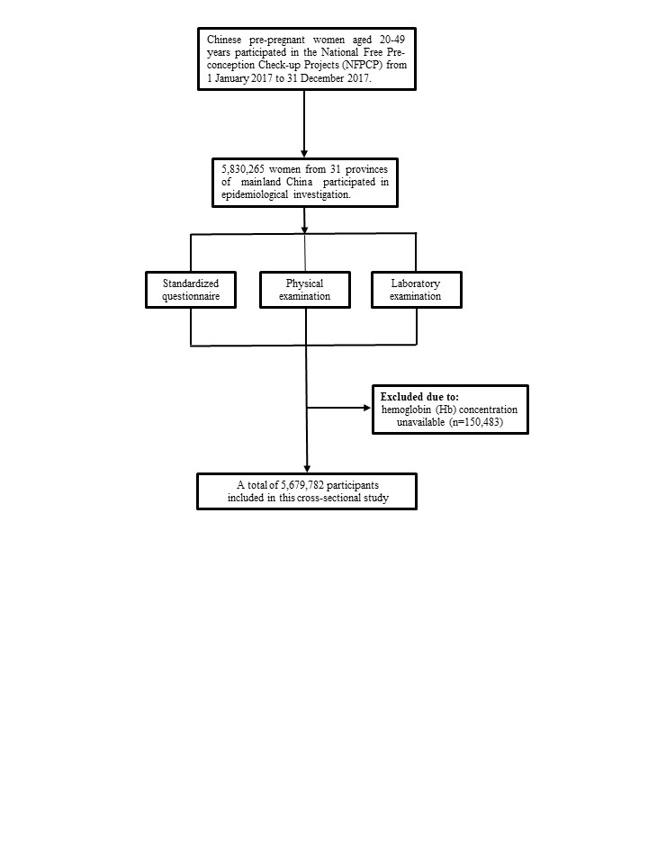

**Figure S1. Participant flow chart.**

|  |  |  |  |  |  |  |
| --- | --- | --- | --- | --- | --- | --- |
| **Table S1. Adjustments to measured hemoglobin concentrations according to the altitude.** | | | | | | |
| Attitude (m) | Measured Hb adjustment *  (g/L) | Anemia at sea level † | | | | |
| Mild anemia |  | Moderate anemia |  | Severe anemia |
| <1000 | 0 | 110 g/L≤ Hb < 120 g/L |  | 110 g/L < Hb ≤ 80 g/L |  | <80 g/L |
| 1000~ | -2 |  |  |
| 1500~ | -5 |  |  |
| 2000~ | -8 |  |  |
| 2500~ | -13 |  |  |
| 3000~ | -19 |  |  |
| 3500~ | -27 |  |  |
| 4000~ | -35 |  |  |
| ≥4500 | -45 |  |  |
| Abbreviations: Hb: hemoglobin; Altitude: meters above the sea level.  * The World Health Organization recommends adjusting hemoglobin concentrations according to altitude to determine anemia. Hb concentrations of women living in areas with altitude above 1000 meters were adjusted by subtracting the adjustment values from the original Hb concentrations in the current study. Anemia was then diagnosed by adjusted Hb concentrations comparing with those at sea level.  † According to the cut-off values of anemia recommended by the most recent WHO criteria, anemia of non-pregnant women at sea level who aged 15 year and above was defined as Hb < 120 g/L, among which, mild, moderate and severe anemia were defined as 110 g/L ≤ Hb < 120 g/L, 80 g/L≤ Hb < 110 g/L and Hb < 80 g/L, respectively. | | | | | | |

**Table S2. Adjustments to measured hemoglobin concentrations according to smoking status.**

|  |  |
| --- | --- |
| Smoking status | Measured Hb adjustment * (g/L) |
| Non-smoker | 0 |
| Smoker (all) | -0.3 |
| 1/2-1 packet / day | -0.3 |
| 1-2 packet / day | -0.5 |
| ≥ 2 packet / day | -0.7 |

Abbreviations: Hb: hemoglobin.

* The World Health Organization recommends adjusting hemoglobin concentrations according to smoking status to determine anemia. In our study, very few women smoked more than 1/2 packet per day, so we adjusted the hemoglobin concentration by subtracting 0.3 g/L from the measured hemoglobin concentration for all smokers additionally.

**Table S3. Prevalence of anemia among pre-pregnant women in mainland China.**

