SUPPLEMENTARY MATERIAL

Supplemental Table 1. Formulation and proximate composition of the experimental diets.
 | C | CT | HC | HCT
Formulation (%)
Fish meal | 8.00 | 8.00 | 8.00 | 8.00
Soybean meal | 26.00 | 26.00 | 26.00 | 26.00
Rapeseed meal | 17.00 | 17.00 | 17.00 | 17.00
Cottonseed meal | 17.00 | 17.00 | 17.00 | 17.00
Fish oil | 2.00 | 2.00 | 2.00 | 2.00
Soybean oil | 2.00 | 2.00 | 2.00 | 2.00
Corn starch | 12.00 | 12.00 | 25.00 | 25.00
Thiamine (mg/kg) | 0 | 1.5 | 0 | 1.5
Microcrystalline cellulose | 13.00 | 13.00 | 0.00 | 0.00
Calcium biphosphate | 1.80 | 1.80 | 1.80 | 1.80
Premix† | 1.20 | 1.20 | 1.20 | 1.20
Proximate composition (% air-dry basis)
Moisture | 6.96 | 6.42 | 6.85 | 6.95
Crude lipid | 5.93 | 6.11 | 5.71 | 5.66
Ash | 8.46 | 8.12 | 7.78 | 7.73
Crude protein | 29.82 | 30.06 | 30.12 | 30.03
Crude fiber | 16.97 | 18.26 | 5.68 | 5.80
Nitrogen-free extract‡ | 31.86 | 31.03 | 43.75 | 43.83
Energy (MJ kg⁻¹) | 19.09 | 19.09 | 19.24 | 19.31
C, the control diet; CT, the C diet supplemented with 1.5 mg kg⁻¹ thiamine; HC, the high-carbohydrate diet; HCT, the HC diet supplemented with 1.5 mg kg⁻¹ thiamine (the same below).
†Premix supplied the following minerals and/or vitamins (per kg): CuSO₄·5H₂O, 2.0 g; FeSO₄·7H₂O, 25 g; ZnSO₄·7H₂O, 22 g; MnSO₄·4H₂O, 7 g; Na₂SeO₃, 0.04g; KI, 0.026 g; CoCl₂·6H₂O, 0.1 g; Vitamin A, 900,000 IU; Vitamin D, 200,000 IU; Vitamin E, 4500 mg; Vitamin K₃, 220 mg; Vitamin B₂, 1090 mg; Vitamin B₅, 2000 mg; Vitamin B₆, 500 mg; Vitamin B₁₂, 1.6 mg; Vitamin C, 5000 mg; Pantothenate, 1000 mg; Folic acid, 165 mg; Choline, 60,000 mg.
‡Calculated by difference (100 - moisture - crude protein - crude lipid - ash - crude fiber).

SupplementalTable 2. Nucleotide sequences of the primers used to assay gene expressions by real-time PCR.
Target gene | Forward (5′-3 ) | Reverse (5′-3 ) | Accession  numbers or references
AMPKα1 | AGTTGGACGAGAAGGAG | AGGGCATACAAAATCAC | ARF07712.1
AMPKα2 | ACAGCCCTAAGGCACGATG | TGGGTCGGGTAGTGTTGAG | KX061841
PGC-1α | AAGGCATAAGGGTAATCGTA | GAACGAGCTGCACTTTTCCC | MH791034
PGC-1β | GTGAGGAACGGGGAGATTG | AGGGGGGTGAACAGGAAAC | ⁽⁴⁶⁾
β-globin | GAATGCTCATCGTCTACCCTCA | ATGGCTGTCATCACAGTTTTGC | ⁽⁴⁷⁾
TFAM | TCCGAAAGTTAGCAGAGA | ATGAAGATGTTGAAGGCG | KT380498.1
Mfn-1 | CTCCAGATGCTCATTCCCT | TTCCTTGGCTTTGGTTGTC | ⁽⁴⁶⁾
Opa-1 | CTTGTTGACTTGCCTGG | TTCATTACGGATGTGCT | ⁽⁴⁶⁾
Drp-1 | CAGAGGGACTGCGAGGTT | GGCTTGAGCAAAAGGGAA | ⁽⁴⁶⁾
Fis-1 | ATACAAGCAAAAAAGACGAT | ATACAAAATAAAAAAAGGGG | ⁽⁴⁶⁾
Mff | CCCGAGAGAATCGTAGTGG | GGCGTCTTGAGGGACAGTG | ⁽⁴⁶⁾
ND-1 | CTGACCACTAGCCGCAATA | GGAAGAAGAGGGCGAAGG | NC010341
CYTB | CATACACTATACCTCCGACAT | TCTACTGAGAAGCCACCT | NC010341
COX-1 | CATACTTTACATCCGCAACA | TCCTGTCAATCCACCCAC | NC010341
COX-2 | AACCCAGGACCTTACACCC | CCCGCAGATTTCAGAACA | NC010341
SGLT-1 | CTCCACTTGCCTGCTCA | CGGTTCCTGCTATTCCC | KM977634.1
GLUT-2 | ACGCACCCGATGTGAAAGT | TTGGACAGCAGCATTGATT | KC513421.1
EF1α | CTTCTCAGGCTGACTGTGC | CCGCTAGCATTACCCTCC | X77689.1
AMPKα1, AMP-activated protein kinase α1; AMPKα2, AMP-activated protein kinase α2;PGC-1α, peroxisome proliferator activated receptor-γ coactivator-1α; PGC-1β, peroxisome proliferator activated receptor-γ coactivator-1β;TFAM, mitochondrial transcription factor A; Mfn-1, mitofusin-1; Opa-1, optic atrophy-1; Drp-1, dynamin-related protein-1; Fis-1, fission-1; Mff, mitochondrial fission factor; ND-1, NADH dehydrogenase-1; CYTB, cytochrome B; COX-1 and 2, cytochrome c oxidase-1 and 2; SGLT-1, sodium/glucose cotransporter-1; GLUT-2, glucose transporter-2; EF1α, elongation factor 1 α.

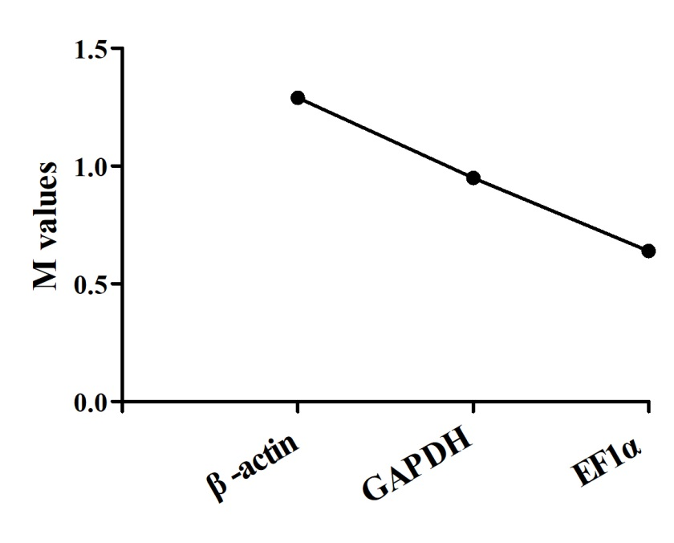
Supplemental Fig. 1. The M values of reference genes in the intestine of M. amblycephala. The high M value indicates low expression stability, while a low M value indicates high expression stability.

