Table S1 Primer sequences used in this study
Subject | Forward primer (5’-3’) | Reverse primer (5’-3’)
qRT-PCR (β-actin)¹ | GAGCACGGTATTGTGACCAACT | CTCTGTGAGCAGGACAGGGT
qRT-PCR (fabp4)² | CTTCCAGCGAGAACTTTGATGA | TCACCAGGTTGGGCTTTGC
qRT-PCR (PPARγ)³ | CACCGCAGAGCGAAGAACACC | GACGCCATAGTGAAACCCCG
fabp4 overexpression⁴ | CCCAAGCTTATGGTTGAGCAGTTTGTAGGAACC | CCGCTCGAGTTAAACCCTCTCGTAGGTCCTCAGT
cloning of fabp4 promoter⁵ | ACTAATACACGAGCATCGCCGT | AAGTCAAAGTCCAGGTTCCTACAA
cloning of fabp4 promoter⁵ | GGACTAGGGCTGCAACTAACC | CGGCGATGCTCGTGTATT
cloning of fabp4 promoter⁵ | AAAACCTCAAACGGCACA | AATGGTTAGTTGCAGCCCTA
D1⁶ | CGGGGTACCCAAATACAACTTTAACTCACCTGCC | CCCAAGCTTTGGTGAAGATGACGCTCAGATGT
D2⁶ | CGGGGTACCAGCAGGAGTGATTGGTTGGGA | CCCAAGCTTTGGTGAAGATGACGCTCAGATGT
D3⁶ | CGGGGTACCAATCGACAAGTTCTGCAGCTCTAG | CCCAAGCTTTGGTGAAGATGACGCTCAGATGT
D4⁶ | CGGGGTACCCATCAAACTATTCAGGGACCCAT | CCCAAGCTTTGGTGAAGATGACGCTCAGATGT
D5⁶ | CGGGGTACCTTCCCTTCAATCAAACACACC | CCCAAGCTTTGGTGAAGATGACGCTCAGATGT
D6⁶ | CGGGGTACCAATACAACTTTAACTCACCTGCCTT | CCCAAGCTTAGTACTGGTTTTAACCAGCAGATGG
construction of deletion mutant (F1, R1)⁶ | CGGGGTACCAATACAACTTTAACTCACCTGCCTT | CCCAAGCTTAGTACTGGTTTTAACCAGCAGATGG
construction of deletion mutant (F2, R2)⁷ | AGTTTTTGTTTTTCCGCAATGCAACA | TGTTGCATTGCGGAAAAACAAAAACT
¹The gene sequence of β-actin (KX987228.1) was obtained from NCBI, and the primers were designed in regions conserved with Epinephelus coioides β-actin (AY510710.2)
²The gene sequence of fabp4 (MN562216) was obtained from NCBI, and the primers were designed in regions conserved with Epinephelus coioides fabp4 gene (Epinephelus coioides fabp4 sequence was obtained from our non-public whole-genome sequencing data)
³The sequence of T.ovatus PPARγ was obtained from our non-published sequence provided by Dr. Li M M, and the primers were designed in heterogeneous regions with Epinephelus coioides PPARγ (Epinephelus coioides PPARγ sequence was obtained from our non-public whole-genome sequencing data)
⁴The bases underlined are the sites and protective bases for Hind Ш (5′-CCCAAGCTT-3′) and Xho I (5′-CCGCTCGAG-3′)
⁵The complete promoter sequence of fabp4 was obtained by three separate PCR amplification. Finally, the obtained sequences were spliced together
⁶The bases underlined are the sites and protective bases for Kpn I (5′-CGGGGTACC-3′) and Hind Ш (5′-CCCAAGCTT-3′)
⁷The bases bolded are the predicted binding site of PPARγ, and the bases underlined “CCG” are mutated from the original “AAG”.
Figure S1 Effect of dietary n-3 LC-PUFA on fabp4 gene expression in T. ovatus liver. Values are means ± SD. Means at a time without a common symbol are significantly different (P≤0.05).
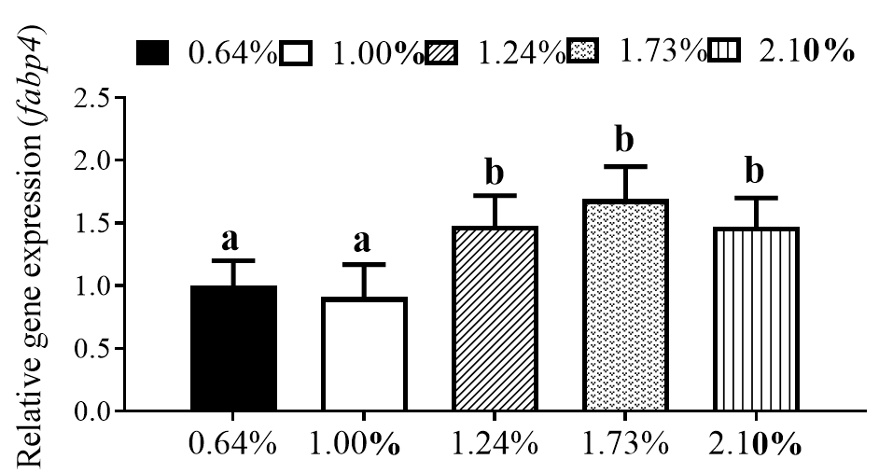
Figure S2 Effect of PPARγ overexpression, fabp4 overexpression, BMS309403, and GW9662 on the contents of fatty acids. Values are means ± SD.
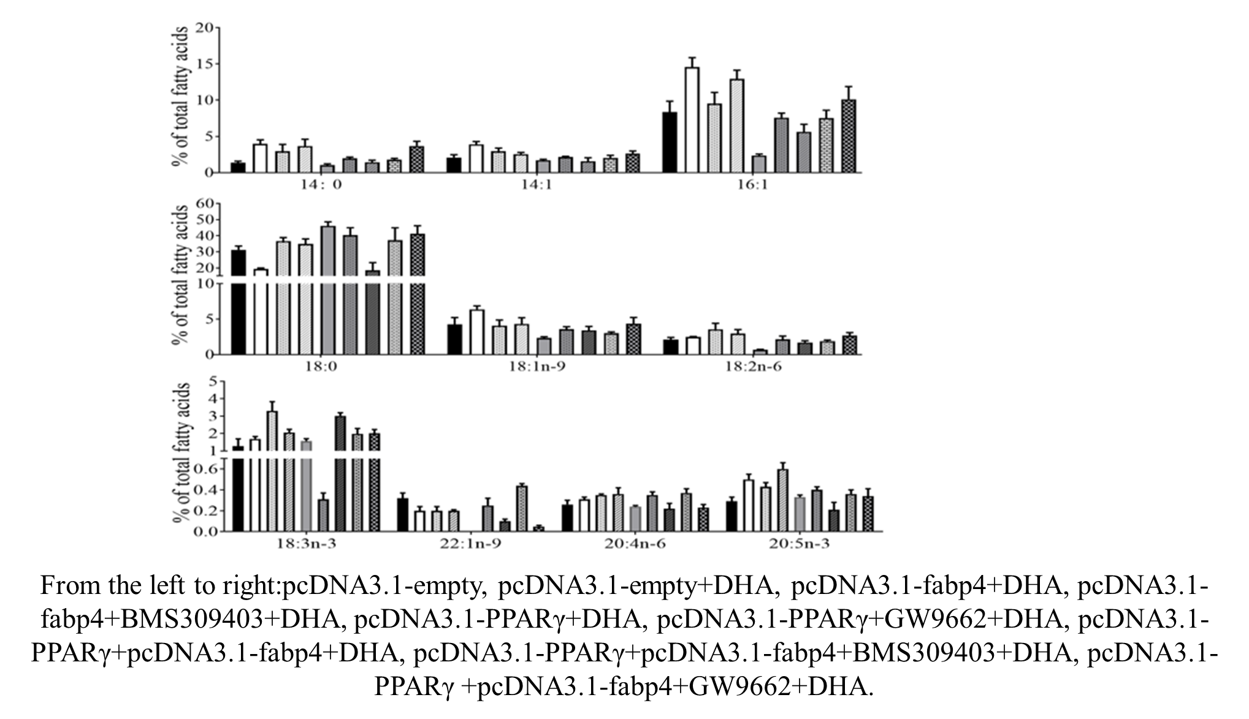

Figure S3 The distribution of possible PPARγ binding sites in T. ovatus fabp4 core promoter region. The bold sections represent the predicted binding sites that located at -1882bp to -1864bp and -1774bp and -1766bp, respectively.
