Supplemental material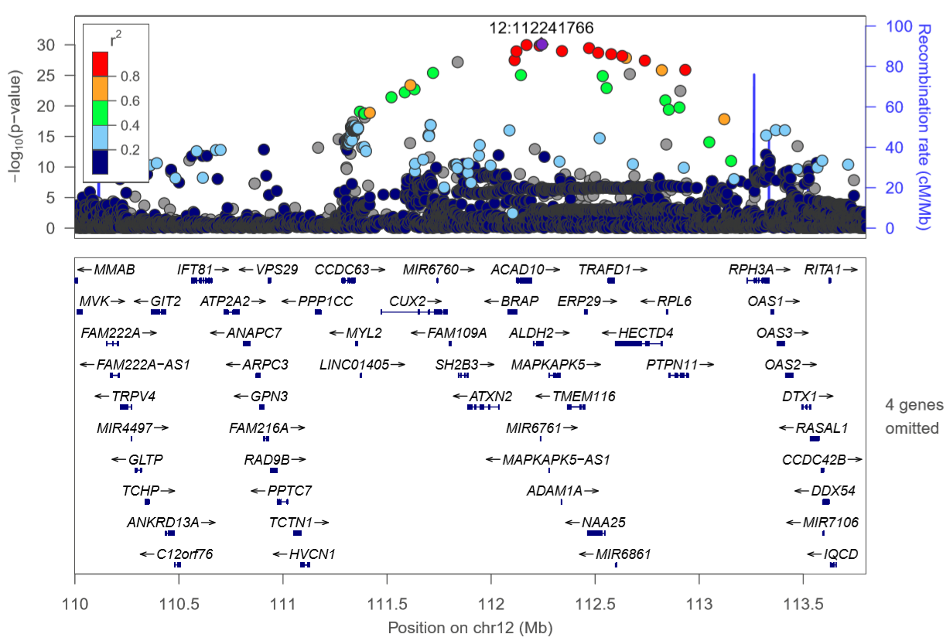

The x-axis represents chromosomal positions near the IFT81-RPH3A gene, and the y-axis represents -log10 P-values. Dot color for a variant represents the degree of linkage disequilibrium (R²) estimates between each variant. The LD (r2) was calculated based on the 1000 genomes phase 3 ASN individuals. We used the LocusZoom program online [27].

