Supplement Table 1. Numerical data of COX IV expression, CS activity and complex activity activity
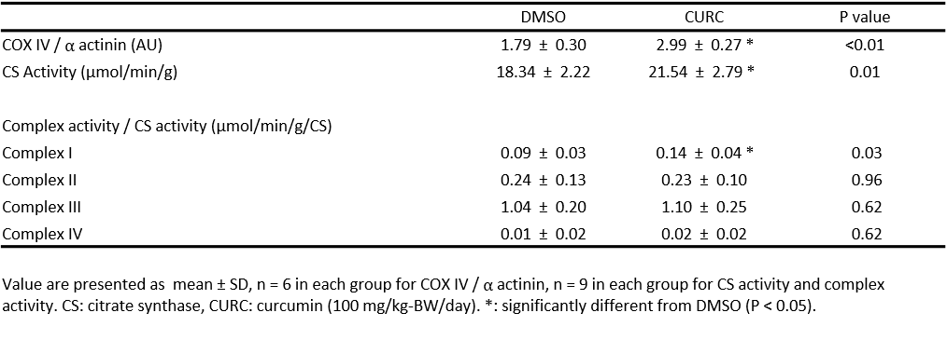

Supplement Table 2. Numerical data of mitochondrial respiration, RCR and CR ratio
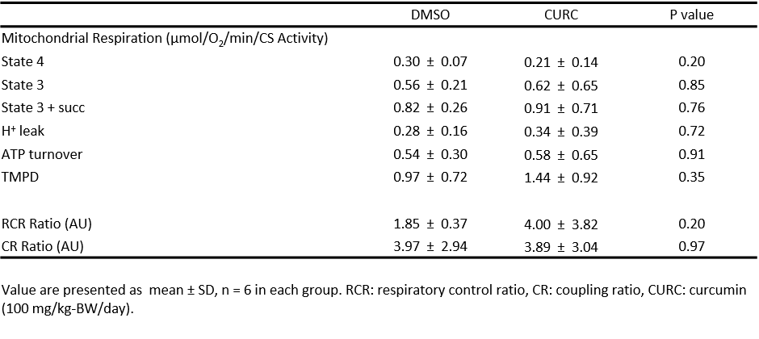

Supplement Table 3. Numerical data of cAMP level (pmol/mg protein)
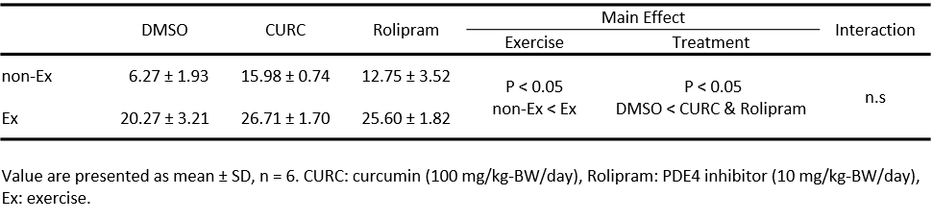

Supplement Table 4. Numerical data of p-PDE4A / t-PDE4A ratio (relative to DMSO, AU)
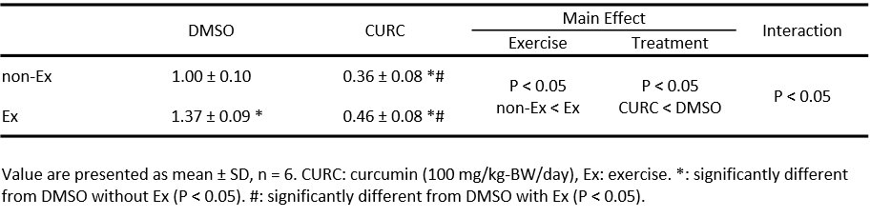

Supplement Table 5. Numerical data of p-AMPK (Thr-172)/t-AMPK ratio (relative to DMSO, AU)
 | DMSO | CURC | H89 | H89 + CURC | Main Effect |  | Interaction
 |  |  |  |  | Exercise | Treatment
non-Ex | 1.00 ± 0.09 | 1.27 ± 0.36 * | 0.72 ± 0.20 †#‡ | 0.70 ± 0.16 †#‡ | P < 0.05  non-Ex < Ex | P < 0.05  H89 & H89+CURC < DMSO < CURC | P < 0.05
Ex | 1.73 ± 0.32 *† | 1.83 ± 0.24 *† | 0.89 ± 0.07 #‡ | 0.75 ± 0.12 †#‡
Values are presented as mean ± SD, n = 6. CURC: curcumin (100 mg/kg-BW/day). H89 = PKA inhibitor (20 mg/kg-BW/day). Ex: Exercise.
*: significantly different from DMSO without exercise (P < 0.05). †: significantly different from curcumin without exercise (P < 0.05). #: significantly different from DMSO with exercise (P < 0.05). ‡: significantly different from curcumin with exercise (P < 0.05).

Supplement Table 6. Numerical data of acetylated PGC-1α expression (relative to DMSO, AU)
 | DMSO | CURC | H89 | H89 + CURC | Main Effect |  | Interaction
 |  |  |  |  | Exercise | Treatment
non-Ex | 1.00 ± 0.26 | 0.78 ± 0.21 | 0.93 ± 0.11 | 0.82 ± 0.06 | P < 0.05  Ex < non-Ex | P < 0.05  CURC < DMSO, H89 & H89 + CURC | n.s
Ex | 0.41 ± 0.05 | 0.32 ± 0.10 | 0.42 ± 0.06 | 0.30 ± 0.05
Values are presented as mean ± SD, n = 6. CURC: curcumin (100 mg/kg-BW/day). H89 = PKA inhibitor (20 mg/kg-BW/day). Ex: Exercise.

