**Title Page**

Associations between newborn Thyroid Stimulating Hormone concentration and neurodevelopment and growth of children at 18 months

**Author Names**

Molla Mesele Wassie, Lisa Gaye Smithers, Lisa Nicole Yelland, *Maria Makrides*, Shao Jia Zhou

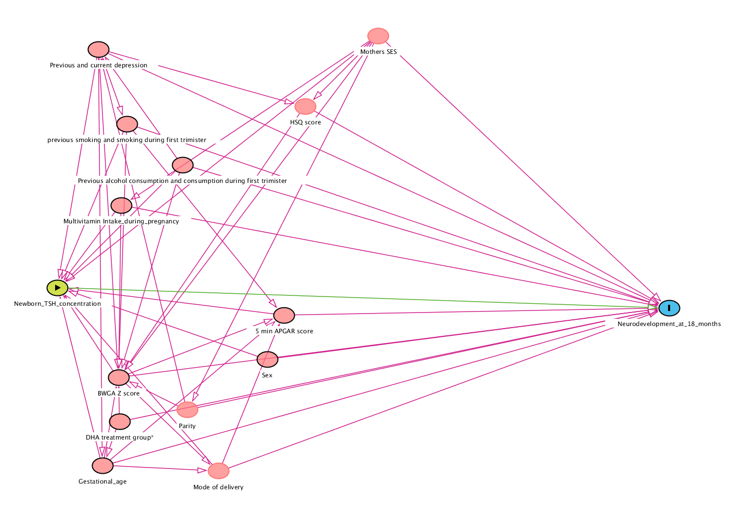

**Supplemental Figure 1** Direct Acyclic Graph for association between newborn TSH and child neurodevelopment.

BWGA Z score, birth-weight for gestational age z score; DHA, Docosahexaenoic acid; HSQ, home screening questionnaire; SES, socio-economic status; TSH, thyroid stimulating hormone.

*DHA treatment group was only for the DHA to Optimize Mother Infant Outcome (DOMInO) study (1).

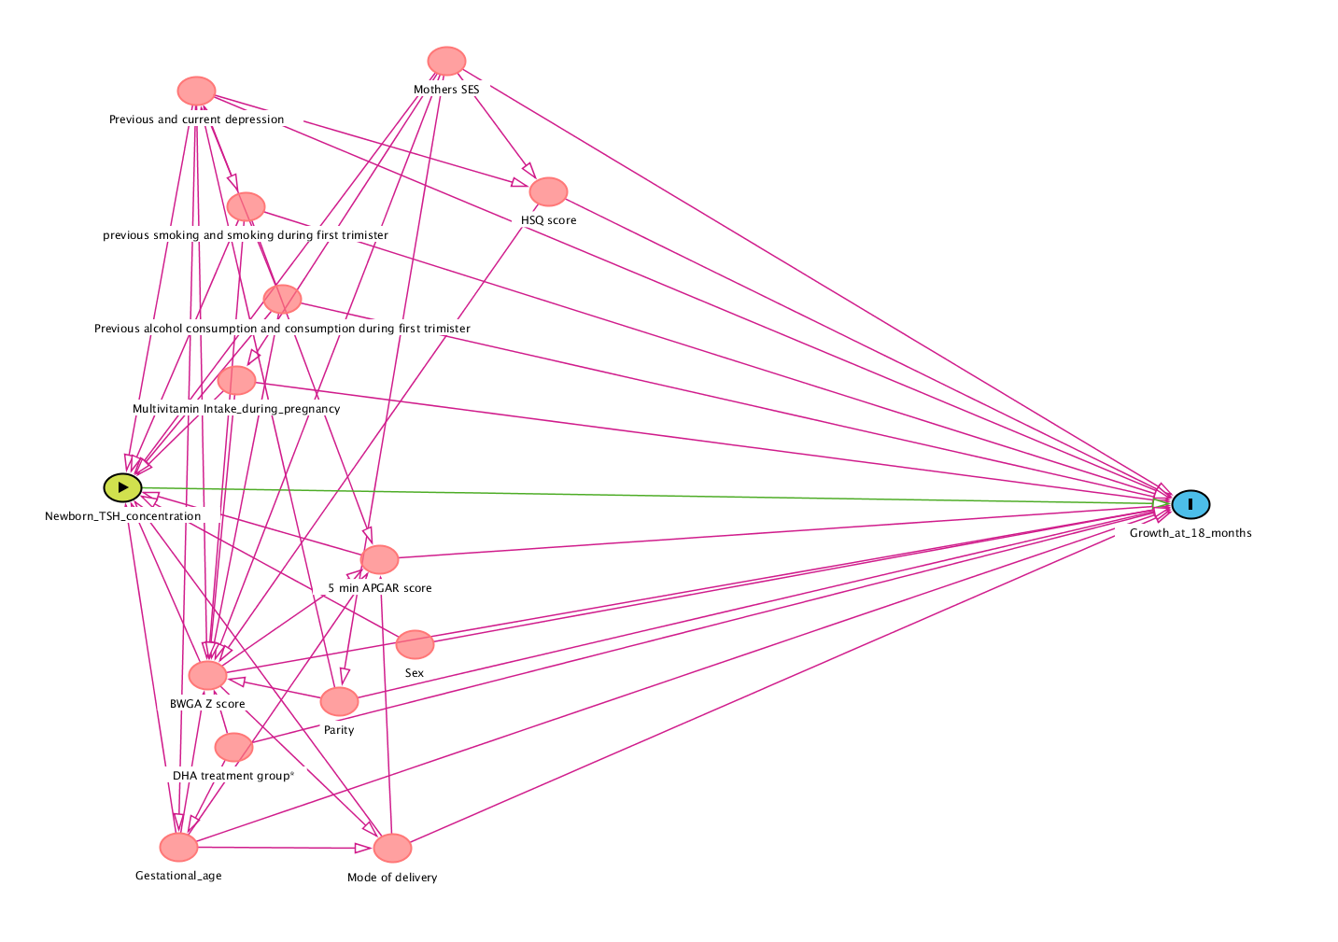

**Supplemental Figure** **2** Direct Acyclic Graph for association between newborn TSH and child growth.

BWGA Z score, birth-weight for gestational age z score; DHA, Docosahexaenoic acid; HSQ, home screening questionnaire; SES, socio-economic status; TSH, thyroid stimulating hormone. *DHA treatment group was only for the DHA to Optimize Mother Infant Outcome (DOMInO) study (1). ating hormone; WAZ, weight-for-age z score; WLZ, weight-for-length z score.



**Supplemental Figure 3** Associations between newborn TSH concentration and cognitive scores in DOMInO and PINK studies: results of linear regression analyses.

 4A 4B

**Supplemental Figure 4** Associations between newborn TSH as continuous exposure and A) Bayley-III scores and B) neurodevelopmental delay at 18 months of age.

CI, confidence interval; DOMInO, DHA to Optimize Mother Infant Outcome; MD, mean difference; PINK, Pregnancy Iodine and Neurodevelopment in Kids; RR, relative risk; TSH, thyroid-stimulating hormone.

 5A 5B

**Supplemental Figure 5** Associations between newborn TSH in quartiles and A) Bayley-III scores and B) neurodevelopmental delay at 18 months of age.

CI, confidence interval; DOMInO, DHA to Optimize Mother Infant Outcome; MD, mean difference; PINK, Pregnancy Iodine and Neurodevelopment in Kids; RR, relative risk; TSH, thyroid-stimulating hormone.

 6A 6B

**Supplemental Figure 6** Associations between newborn TSH as continuous exposure and A) anthropometric indices and B) growth delay at 18 months of age.

CI, confidence interval; DOMInO, DHA to Optimize Mother Infant Outcome; HAZ, length-for-age z score; HCZ, head circumference-for-age z score; MD, mean difference; PINK, Pregnancy Iodine and Neurodevelopment in Kids; RR, relative risk; TSH, thyroid-stimulating hormone; WAZ, weight-for-age z score; WLZ, weight-for-length z score.

7A 7B

**Supplemental Figure 7** Associations between newborn TSH in quartiles and A) anthropometric indices and B) growth delay at 18 months of age.

CI, confidence interval; DOMInO, DHA to Optimize Mother Infant Outcome; HAZ, length-for-age z score; HCZ, head circumference-for-age z score; MD, mean difference; PINK, Pregnancy Iodine and Neurodevelopment in Kids; RR, relative risk; TSH, thyroid-stimul

**References**

1. Makrides M, Gibson RA, McPhee AJ *et al.* (2010) Effect of DHA supplementation during pregnancy on maternal depression and neurodevelopment of young children: a randomized controlled trial. *JAMA* **304**, 1675-1683.