Supplementary material

eTable 1. Definition of variables included in the regression model
Variable name | Definition | Categories | Time period covered | Data source
Age | Maternal age in years | <=25; 26-30; 31-35; >35 | Maternal age at delivery | MBRN
Parity | Number of times the woman has given births to a fetus (live or stillborn) at GW >=24. | Nulliparous; 1; 2; 3; 4 or more | Status at start of current pregnancy | MBRN
Interpregnancy interval | Time from date of birth of the previous child to date of conception of the current pregnancy (date of birth minus length of gestation according to ultrasound scanning), rounded down to whole months | Nulliparous; <6 months; 6-11; 12-17; 18-23; 24-59 >=60 | Status at start of current pregnancy | MBRN
Participation year | Year of first participation in study | 2002-2003; 2003; 2004; 2005; 2006; 2007; 2008 | GW 15 | Questionnaire 1 (if missing, delivery year from MBRN)
Educational level | Completed education | <12 years; Upper secondary; Bachelor; Master | Current status in GW 15 | Questionnaire 1
Pre-pregnancy BMI | kg/m^2 | <18.5; 18.5-24.9; 25-29.9; >=30 | BMI prior to pregnancy | Questionnaire 1
Smoking during pregnancy | Cigarette smoking in pregnancy | No; Yes | From conception until GW 15 | Questionnaire 1
Former smoker | Any smoking prior to pregnancy ('have you ever smoked?') | No; Yes | Prior to pregnancy | Questionnaire 1
Alcohol during pregnancy | Units per month | No; <2; >=2 | Average intake first half of pregnancy | FFQ
Non-oral hormonal contraceptives | Use of a hormonal intrauterine device or hormone injection | No; Yes | Last 12 months before pregnancy | Questionnaire 1
Oral hormonal contraceptives (OC) use, recency | Use of hormonal OC (combined pill or progestin-only minipill) | Never; recent use (<=12 months); past use (lifetime duration >0, but not reported use last 12 months) | Last 12 months before pregnancy | Questionnaire 1
OC use, duration | Lifetime duration of OC use, months | No use; <1 year; 1-3; 4-6; 7-9; >=10 | Any previous use | Questionnaire 1
Regular menstruation cycle | Regular periods before pregnancy | No; Yes | Last 12 months before pregnancy | Questionnaire 1
Anaemia before pregnancy |  | No; Yes |  | Questionnaire 1
Iron intake from diet | mg/day | Quartiles | Average intake first half of pregnancy | FFQ
Iron intake form meat only | mg/day | Quartiles | Average intake first half of pregnancy | FFQ
Meat intake | Total intake of beef, pork, lamp, poultry, game and offal, g/day | Quartiles ª | Average intake first half of pregnancy | FFQ
Milk | g/day | No; <=200; 201-500; >500 | Average intake first half of pregnancy | FFQ
Tea, black | g/day | No; <=100; >100 | Average intake first half of pregnancy | FFQ
Tea, herbal | g/day | No; <=100; >100 | Average intake first half of pregnancy | FFQ
Coffee | g/day | No; <=100; >100 | Average intake first half of pregnancy | FFQ
Total vitamin C intake | mg/day, combined from diet and supplements | Tertiles | Average intake first half of pregnancy | FFQ
Fibre | g/day | Tertiles | Average intake first half of pregnancy | FFQ
Iron intake from supplements | mg/day, single and multisupplements | No; <=15; 15-30; 30-50; >50 | Average intake first half of pregnancy | FFQ
Iron from supplement, time of initiation | Self-reported use of single iron supplement in the period 8 weeks before conception to GW 20 | No; 26-9 weeks before conception; 8-0 weeks before conception; GW 0-4; GW 5-8; GW 9-12; GW 13-16; GW 17-20 | 26 weeks before conception until GW 20 | Questionnaire 1 (up to GW 12) and questionnaire 3 (13-20 weeks)
Iron supplement duration | Number of days that iron supplement was taken in the given time period | No; 1-20;121-210 | 8 weeks before conception to GW 20 | Questionnaire 1 (up to GW 12) and questionnaire 3 (13-20 weeks)
Multisupplement use | Use of supplements containing more than one trace element | No use; Yes, multisupplement with iron; Yes, multisupplement without iron | Average intake first half of pregnancy | FFQ
Iron from multisupplement only | Supplemental iron intake >0, but is not taking single iron | No; Yes | Average intake first half of pregnancy | FFQ
Chronic disease | Asthma, diabetes, inflammatory bowel disease, rheumatic disease, epilepsy, multiple sclerosis or cancer | No; Yes | Before or in pregnancy, GW 0-15 | Questionnaire 1
Recent infection | Throat infection, ear infection, influenza, pneumonia, kidney infection, urinary tract infection | No; Yes | GW 13+ | Questionnaire 1
Recent cold | Common cold | No; Yes | GW 13+ | Questionnaire 1
ª As very few women (2 %) reported to exclude meat completely from their diet, we instead included meat consumption quartiles in the analysis.

eTable 2. Associations between plasma transferrin (g/L) and selected variables with regression coefficients (relative difference (%) from geometric mean with 95% CI) from log-linear (ordinary least squares) regression.
 |  |  |  |  | Log-linear model, adjusted
 | Mean (SD) | Median | IQR |  | Relative change % | CI 2.5% | CI 97.5%
All | 2.8 (0.4) | 2.8 | 2.6-3.1
Age (1 SD, 4.2 years) |  |  |  |  | -0.6 | -1.4 | 0.2
Education
<12 years | 2.8 (0.4) | 2.8 | 2.5-3.1 |  | 2.5 | -0.8 | 5.9
Upper secondary | 2.9 (0.4) | 2.9 | 2.6-3.2 |  | 1.6 | 0.0 | 3.3
Bachelor | 2.9 (0.4) | 2.9 | 2.6-3.2 |  | 0.0 (Reference)
Master | 2.8 (0.4) | 2.8 | 2.6-3.1 |  | 0.7 | -0.9 | 2.3
Pre-pregnancy BMI
<18.5 | 2.8 (0.4) | 2.8 | 2.5-3.1 |  | 4.0 | 0.5 | 7.6
18.5-24.9 | 3.0 (0.4) | 3.0 | 2.8-3.2 |  | ref.
25-29.9 | 2.8 (0.4) | 2.8 | 2.5-3.1 |  | 1.0 | -0.5 | 2.6
>=30 | 2.9 (0.4) | 3.0 | 2.7-3.2 |  | 1.6 | -1.0 | 4.4
Parity
Nulliparous | 2.8 (0.4) | 2.8 | 2.5-3.0 |  | 0.0 (Reference)
1 child | 2.9 (0.4) | 2.9 | 2.6-3.2 |  | 3.9 | 1.7 | 6.1
2 children | 2.9 (0.4) | 2.9 | 2.6-3.2 |  | 5.7 | 3.0 | 8.4
>=3 children | 3.1 (0.4) | 3.1 | 2.8-3.3 |  | 9.5 | 4.9 | 14.3
Interpregnancy interval, parous women
<9 months | 3.1 (0.4) | 3.1 | 2.8-3.3 |  | 4.0 | -1.0 | 9.4
9-11 months | 3.0 (0.4) | 3.0 | 2.7-3.2 |  | 2.8 | -1.7 | 7.5
12-23 months | 2.9 (0.4) | 2.9 | 2.6-3.2 |  | 1.5 | -0.8 | 3.9
24-35 months | 2.9 (0.4) | 2.9 | 2.6-3.2 |  | 1.9 | -0.6 | 4.5
>=36 months | 2.9 (0.4) | 2.8 | 2.6-3.2 |  | 0.0 (Reference)
Smoking
No | 2.8 (0.4) | 2.8 | 2.6-3.1 |  | 0.0 (Reference)
Sometimes or daily | 2.8 (0.4) | 2.8 | 2.5-3.1 |  | -2.5 | -4.2 | -0.8
Anaemia before pregnancy
No | 2.8 (0.4) | 2.8 | 2.6-3.1 |  | 0.0 (Reference)
Yes | 2.9 (0.5) | 2.9 | 2.6-3.2 |  | 1.7 | -1.7 | 5.1
Non-oral hormonal contraceptives (IUD)
No | 2.8 (0.4) | 2.8 | 2.6-3.1 |  | 0.0 (Reference)
Yes | 2.8 (0.4) | 2.7 | 2.5-3.0 |  | -6.6 | -9.3 | -3.8
Oral hormonal contraceptives, duration of use
No use | 2.9 (0.4) | 2.9 | 2.6-3.2 |  | 0.0 (Reference)
<1 years | 2.9 (0.4) | 2.9 | 2.6-3.1 |  | -1.0 | -3.3 | 1.4
1-3 years | 2.8 (0.4) | 2.8 | 2.6-3.1 |  | -0.8 | -3.1 | 1.6
4-6 years | 2.9 (0.4) | 2.8 | 2.6-3.1 |  | 0.0 | -2.3 | 2.4
7-9 years | 2.8 (0.4) | 2.8 | 2.5-3.1 |  | 0.0 | -2.4 | 2.5
>=10 years | 2.8 (0.4) | 2.8 | 2.5-3.1 |  | 0.1 | -1.5 | 1.8
Meat intake (g/day)
<113 | 2.8 (0.4) | 2.8 | 2.6-3.1 |  | 0.0 (Reference)
113-134 | 2.9 (0.4) | 2.8 | 2.6-3.1 |  | 0.8 | -1.0 | 2.5
135-154 | 2.8 (0.4) | 2.8 | 2.6-3.1 |  | 0.7 | -1.1 | 2.5
>154 | 2.8 (0.4) | 2.8 | 2.5-3.1 |  | -0.1 | -3.4 | 3.3
High-dose iron supplement use
No | 2.8 (0.4) | 2.8 | 2.5-3.1 |  | 0.0 (Reference)
Yes | 2.9 (0.4) | 2.9 | 2.6-3.1 |  | 1.2 | -0.8 | 3.2
Iron from supplements, time of initiation
No reported use | 2.8 (0.4) | 2.8 | 2.6-3.1 |  | 0.0 (Reference)
26-9 weeks before | 2.8 (0.4) | 2.8 | 2.5-3.1 |  | -1.5 | -4.1 | 1.1
8-0 weeks before | 2.8 (0.4) | 2.8 | 2.6-3.1 |  | -0.1 | -1.9 | 1.8
GW 0-8 | 2.8 (0.4) | 2.8 | 2.5-3.1 |  | -1.2 | -3.0 | 0.7
GW 9-20 | 2.9 (0.4) | 2.8 | 2.6-3.1 |  | 0.1 | -0.5 | 0.7
ª The regression model includes all variables in the table, and in addition chronic illness, reported recent cold, measured CRP and gestational age at the time of blood sampling.
eTable 3. P-Fe concentrations and use of single iron supplement across the study participation years.
 | P-Fe (µg/L) |  |  |  | % users of single iron supplement
Participation year | n (%) | Geometric mean (SD) | Median | IQR
2002-2003¹ | 376 (13) | 33 (2.2) | 33.6 | 20-57 | 17
2004 | 1024 (34) | 35 (2.1) | 34.4 | 21-58 | 27
2005 | 1031 (34) | 33 (2.1) | 32.9 | 20-53 | 24
2006 | 367 (12) | 33 (2.1) | 32.6 | 20-56 | 13
2007 | 147 (5) | 29 (2.0) | 27.8 | 18-47 | 14
2008 | 45 (2) | 28 (2.2) | 26.7 | 17-51 | 18
¹ n=1 participant was recruited in 2002, n=375 in 2003.

eTable 4. Associations between lowest measured Hb (g/dL) and variables associated with iron status in pregnancy from linear regression models, complete cases (n=39,322). All variables were mutually adjusted for each other.
 | Hb, lowest measured in pregnancy, g/dL
 | Mean difference (95% CI)
Age (1 SD, 4.2 years) | -0.03 (-0.04, -0.02)
Education
<12 years | -0.20 (-0.24, -0.16)
Upper secondary | -0.08 (-0.10, -0.05)
Bachelor | 0.0 (Reference)
Master | 0.02 (-0.01, 0.04)
Pre-pregnancy BMI
<18.5 | -0.19 (-0.25, -0.13)
18.5-24.9 | 0.0 (Reference)
25-29.9 | 0.19 (0.17, 0.21)
>=30 | 0.33 (0.29, 0.36)
Interpregnancy interval and parity
<6 months | -0.06 (-0.18, 0.06)
6-11 months | 0.03 (-0.03, 0.09)
12-17 months | 0.00 (-0.05, 0.05)
18-23 months | -0.09 (-0.13, -0.06)
24-59 months | 0.0 (Reference)
>=60 months | -0.08 (-0.13, -0.03)
Primiparae | -0.01 (-0.04, 0.03)
Smoking
No | 0.0 (Reference)
Sometimes or daily | -0.06 (-0.10, -0.02)
Non-oral hormonal contraceptives
No | 0.0 (Reference)
Yes | 0.07 (0.05, 0.10)
Oral hormonal contraceptives, duration of use
No use | 0.0 (Reference)
<1 years | 0.07 (0.04, 0.09)
1-3 years | 0.10 (0.08, 0.13)
4-6 years | 0.04 (0.00, 0.08)
7-9 years | 0.03 (-0.01, 0.07)
>=10 years | 0.05 (0.01, 0.08)
Meat intake (g/day)
<113 | 0.0 (Reference)
113-134 | 0.08 (0.04, 0.11)
135-156 | 0.08 (0.04, 0.11)
>156 | 0.08 (0.04, 0.12)
Iron from supplements, time of initiation
No reported use | 0.0 (Reference)
26-9 weeks before | -0.21 (-0.25, -0.18)
8-0 weeks before | -0.20 (-0.25, -0.15)
GW 0-8 | -0.23 (-0.26, -0.20)
GW 9-20 | -0.30 (-0.33, -0.28)
Supplementary iron from multi-supplements only
No | 0.0 (Reference)
Yes | 0.21 (0.18, 0.24)

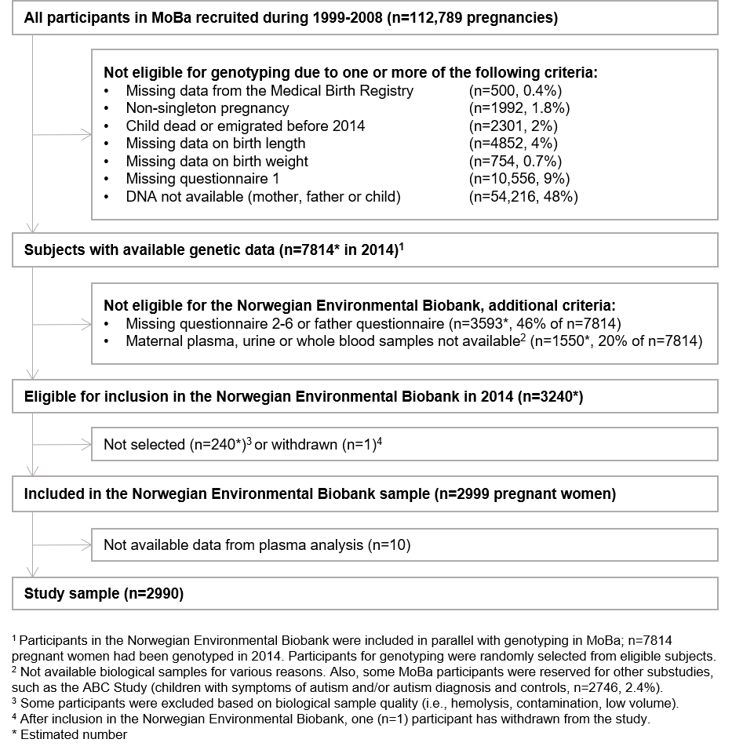
eFigure 1. Inclusion criteria for the Norwegian Environmental Biobank and current study.

eFigure 2. Additive effects on plasma ferritin (P-Fe, µg/L) when using a smoothing function (thin plate regression splines) for change in plasma ferritin (P-Fe) concentration. P-Fe was measured in gestational week 18 (mean 18.5, SD 2.1). All associations are mutually adjusted, and in addition adjusted for educational level, parity, interpregnancy interval, smoking, black tea intake, anaemia before pregnancy, IUD use, duration of OC use, high-dose iron supplement use, timing of iron supplement initation, iron-containing multisupplement use, inflammation status (CRP), chronic illness and gestational week of blood sampling. Associations are based on complete-case analysis (n=1959), and fibre and meat include only subjects with total energy intakes within 5th-95th percentiles (n=1757).

